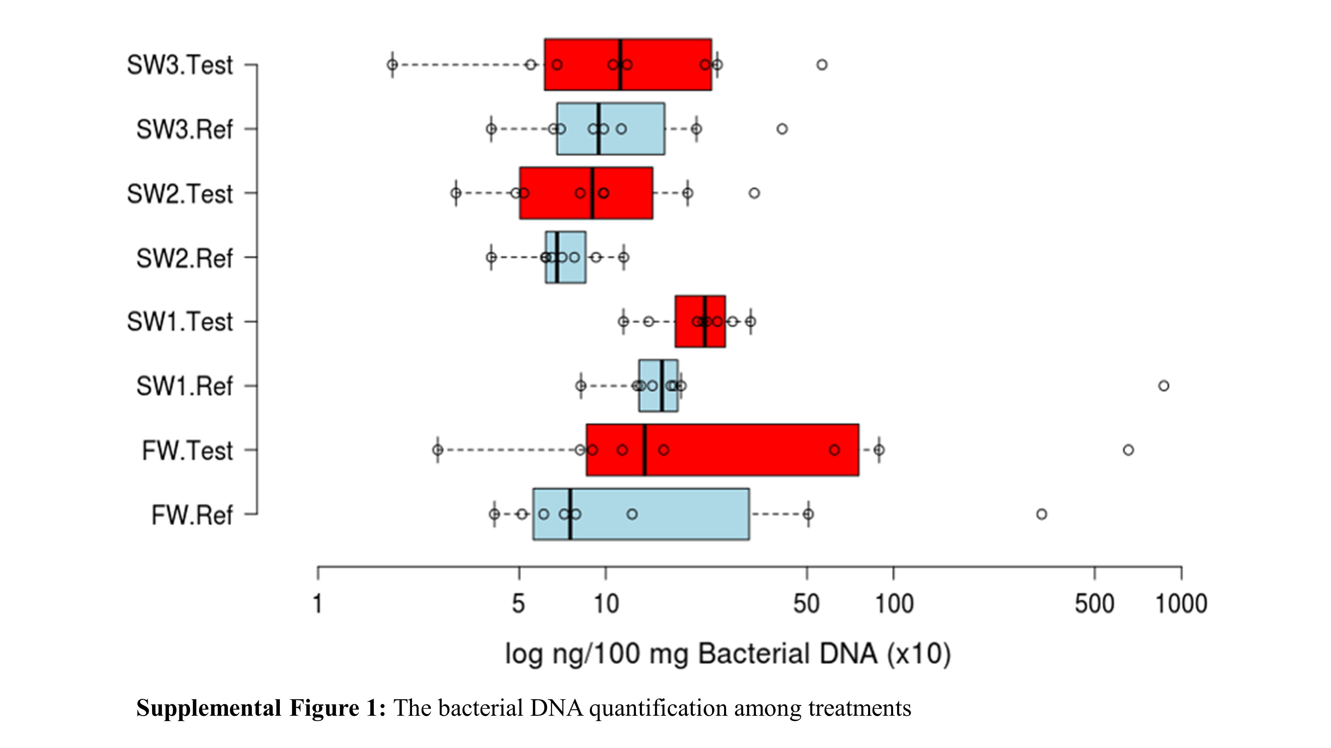
Figure S1. The bacterial DNA quantification among treatments.

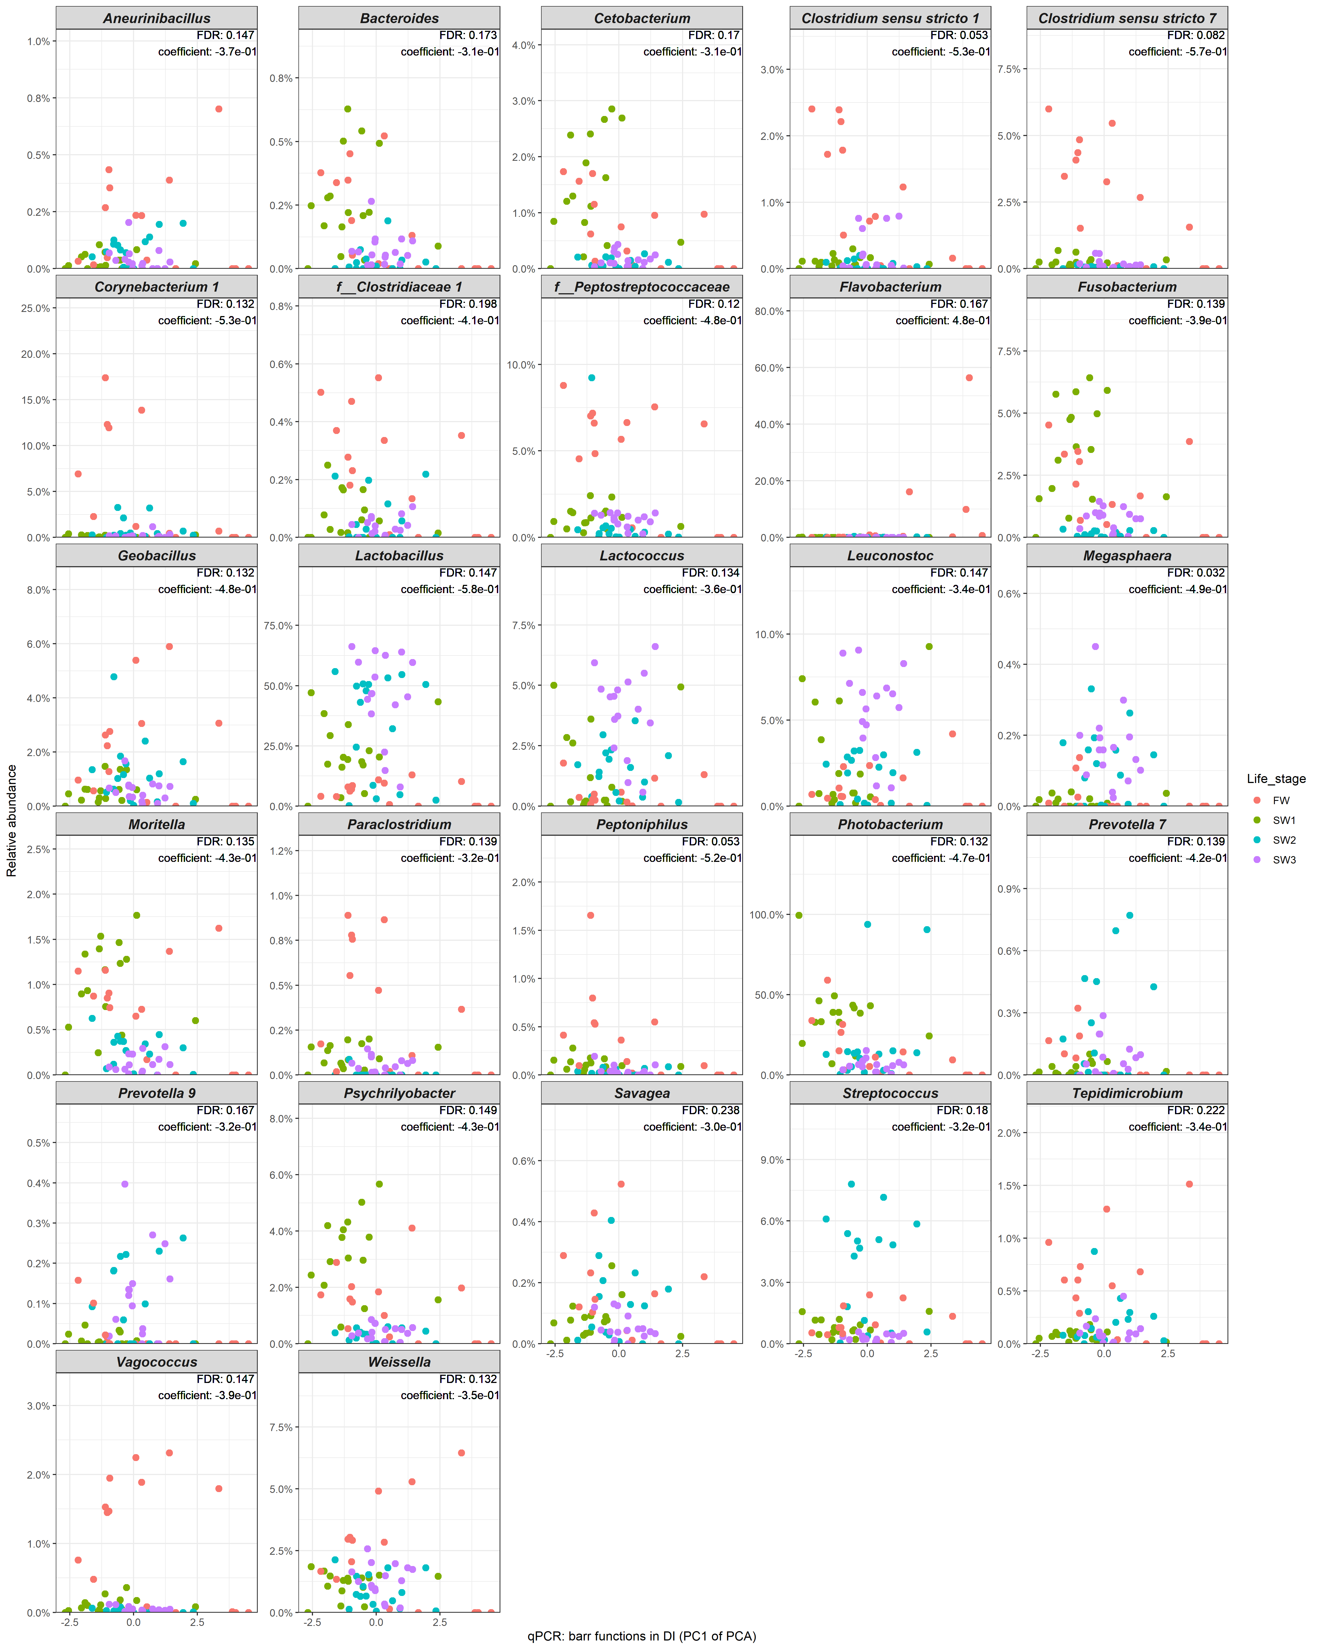
Figure S2. Microbial clades showing significant associations with expressions of barrier function related genes in the distal gut. Since the expression levels of barrier function related genes were highly correlated, we ran a principle component analysis (PCA) and used the first principle component (PC1) for the association testing to avoid multicollinearity and reduce the number of association testing. Except Flavobacterium, 26 differentially abundant taxa showed a clear negative correlation with expression levels of gut barrier function genes, which decreased as PC1 of the PCA increased. FDR, false discovery rate.
Figure S3. The experimental conditions of salinity (A), temperature and oxygen (B) in water through the production cycle.

