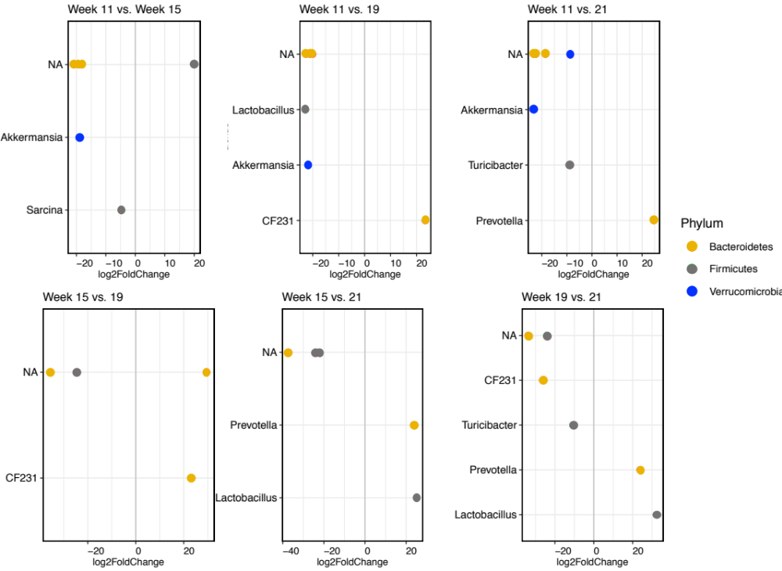
Figure S4. Differential bacterial genus abundance in different weeks of sampling the cecum and ileum of thirteen-lined ground squirrels. NA includes sequences that could not be confidently classified to genus level. Colors represent different phyla that the displayed genera belong in. Genera were considered differentially abundance if the adjusted p-value < 0.01.

