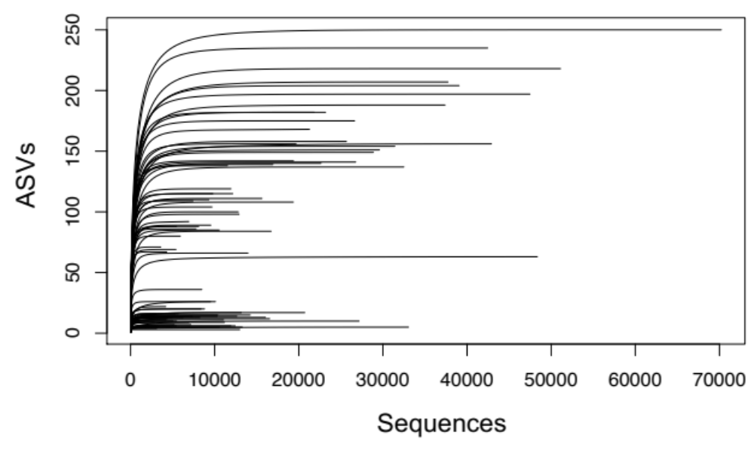
Figure S5. Rarefaction curve of microbiome samples collected from thirteen-lined ground squirrels during the active season.

