Supplemental Table 1: Statistical outputs for pairwise PERMANOVA comparisons of significant models identified in Table 1. p-values are Benjamini-Hochberg adjusted for multiple comparisons. Significant p-values are denoted with asterisks (p < 0.05 = *, p < 0.01 = **, p < 0.001 = ***). B.C. = Burwood Takahē Centre, C.S. = Cape Sanctuary, F.S.I. = Foveaux Strait island, M.I. = Mana Island, M.T.I. = Motutapu Island, M.M. = Te Puhi-a-Noa Murchison Mountains, R.I. = Rotoroa Island, and T.M.I. = Tiritiri Matangi Island.
 | Pairwise PERMANOVA for Bray-Curtis matrix |  |  | Pairwise PERMANOVA for gUniFrac matrix
Covariate | p - value | F | R² | p - value | F | R2
Location
B.C. vs C.S. | 0.01* | 5.30 | 0.25 | 0.02* | 6.79 | 0.30
B.C. vs F.S.I. | 0.006** | 5.58 | 0.25 | 0.02* | 5.49 | 0.24
B.C. vs M.I. | 0.006** | 5.02 | 0.19 | 0.03* | 3.63 | 0.01
B.C. vs MT.I. | 0.006** | 4.68 | 0.23 | 0.02* | 3.57 | 0.18
B.C. vs M.M. | 0.006** | 8.55 | 0.30 | 0.02* | 8.55 | 0.30
B.C. vs R.I. | 0.03* | 3.02 | 0.15 | 0.03* | 2.87 | 0.14
B.C. vs T.M.I. | 0.006** | 4.25 | 0.18 | 0.04* | 2.42 | 0.11
C.S. vs F.S.I. | 0.09 | 1.73 | 0.20 | 0.14 | 1.33 | 0.16
C.S. vs M.I. | 0.09 | 1.79 | 0.13 | 0.09 | 2.15 | 0.15
C.S. vs MT.I. | 0.04* | 2.33 | 0.28 | 0.05 | 6.18 | 0.51
C.S. vs M.M. | 0.02* | 2.87 | 0.22 | 0.02* | 2.60 | 0.21
C.S. vs R.I. | 0.03* | 2.36 | 0.25 | 0.03* | 3.98 | 0.36
C.S. vs T.M.I. | 0.08 | 1.82 | 0.17 | 0.08 | 3.33 | 0.27
F.S.I. vs M.I. | 0.07 | 1.97 | 0.13 | 0.09 | 1.95 | 0.13
F.S.I. vs MT.I. | 0.03* | 2.91 | 0.29 | 0.05 | 3.83 | 0.35
F.S.I. vs M.M. | 0.01* | 2.97 | 0.21 | 0.03* | 2.65 | 0.19
F.S.I. vs R.I. | 0.03* | 2.34 | 0.23 | 0.08 | 2.40 | 0.23

F.S.I. vs T.M.I. | 0.05 | 2.09 | 0.17 | 0.10 | 2.26 | 0.19
M.I. vs MT.I. | 0.01* | 2.48 | 0.17 | 0.05 | 2.58 | 0.18
M.I. vs M.M. | 0.04* | 2.76 | 0.15 | 0.05 | 2.60 | 0.14
M.I vs R.I. | 0.07 | 1.96 | 0.13 | 0.12 | 1.69 | 0.12
M.I. vs T.M.I. | 0.07 | 1.95 | 0.12 | 0.20 | 1.34 | 0.08
MT.I. vs M.M. | 0.009** | 5.32 | 0.35 | 0.02* | 8.12 | 0.45
MT.I. vs R.I. | 0.09 | 1.64 | 0.19 | 0.09 | 2.00 | 0.22
MT.I. vs T.M.I. | 0.32 | 1.12 | 0.11 | 0.26 | 1.27 | 0.12
M.M. vs R.I. | 0.01* | 4.17 | 0.28 | 0.02* | 4.96 | 0.31
M.M. vs T.M.I. | 0.01* | 3.82 | 0.23 | 0.03* | 4.32 | 0.25
R.I. vs T.M.I. | 0.16 | 1.43 | 0.13 | 0.26 | 1.21 | 0.11
Supplemental feeding
Regular vs None | 0.003** | 4.03 | 0.07 | 0.005** | 4.71 | 0.09
Regular vs Occasional | 0.005** | 2.28 | 0.05 | 0.02* | 2.37 | 0.05
None vs Occasional | 0.003** | 4.76 | 0.24 | 0.003** | 6.33 | 0.30

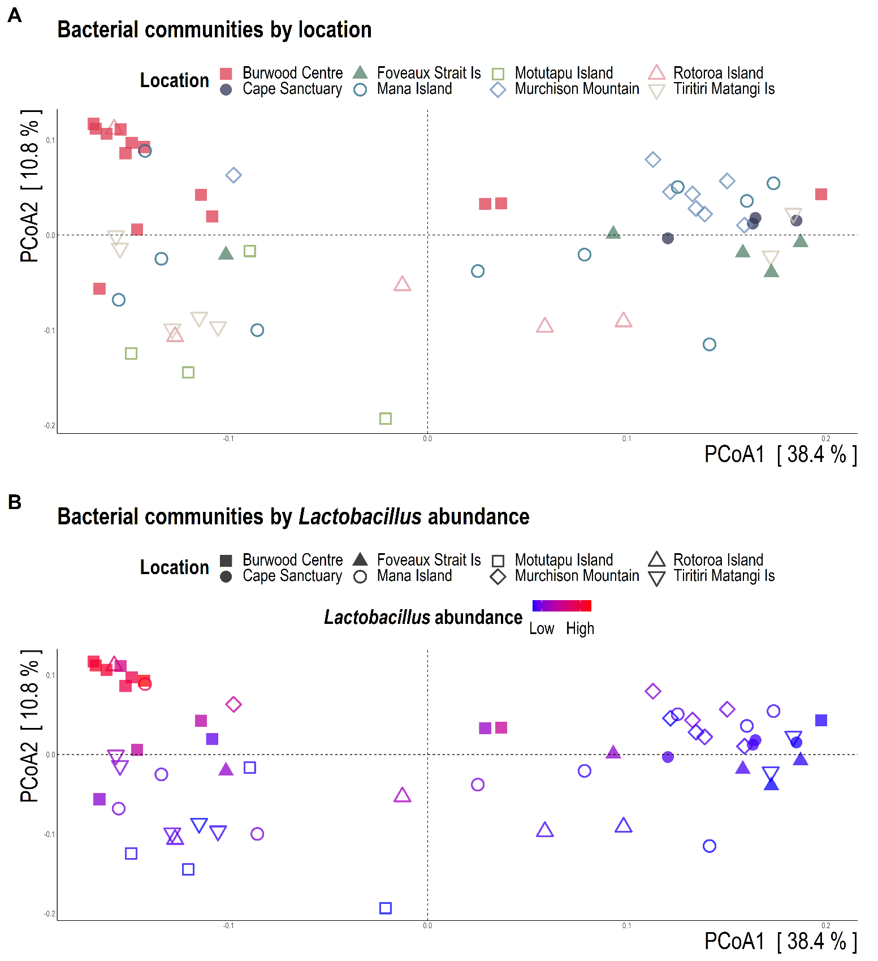

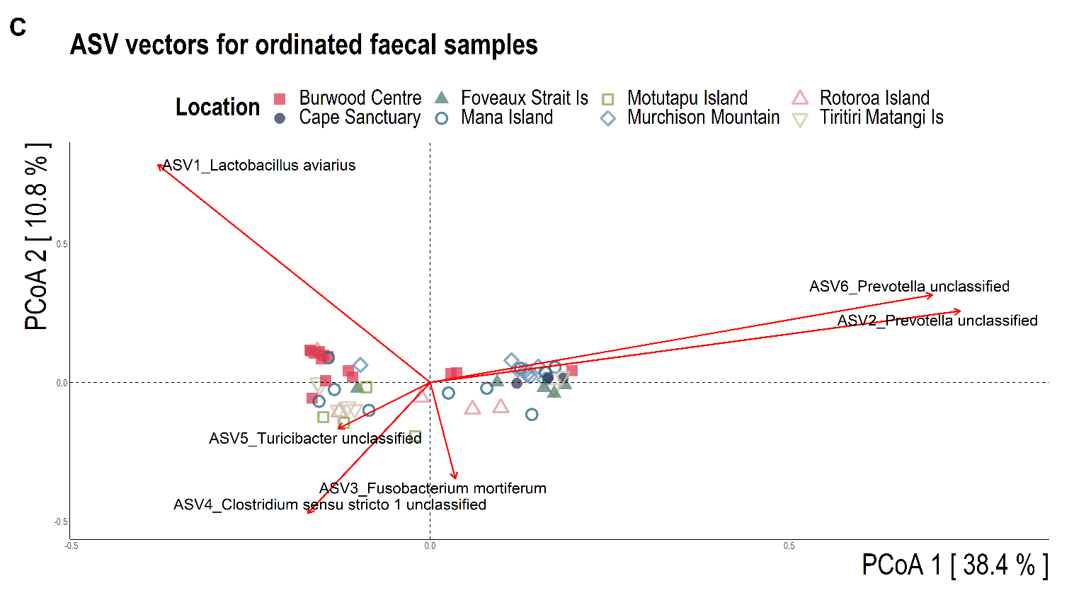
Supplemental Figure 1 16S rRNA gene sequence-based generalised GUniFrac dissimilarity distances visualised via principal coordinate multidimensional scaling ordination. Each dot of the PCoA represents the microbiota of a single takahē faecal sample. [A] bacterial communities coloured and shaped by location. [B] bacterial communities coloured by relative Lactobacillus abundance with location groupings as different shapes. [C] bacterial communities coloured and shaped by location with the 6 most abundant ASVs plotted as vectors using the vegan::envfit function.
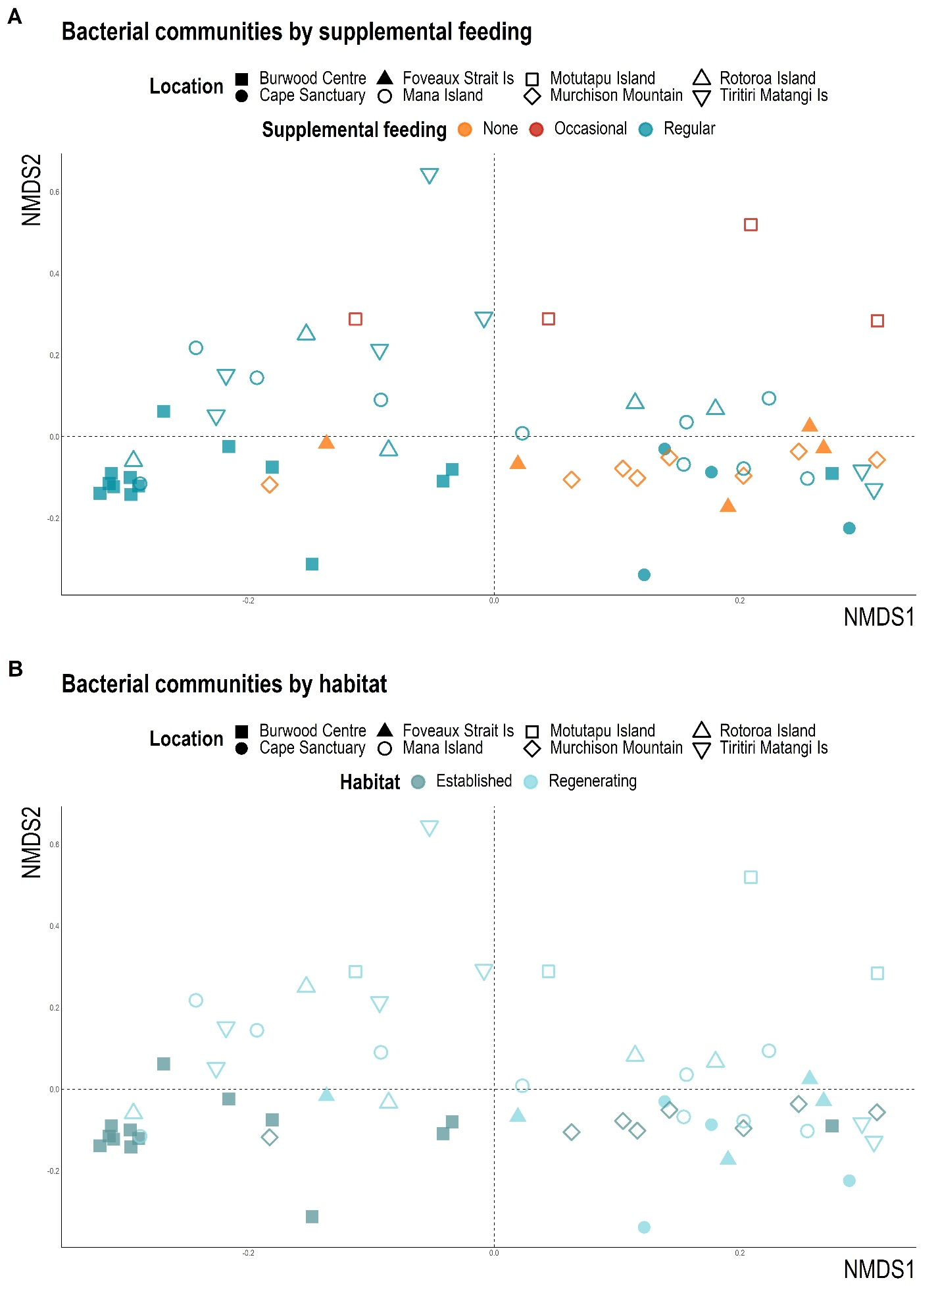
Supplemental Figure 2 16S rRNA gene sequence-based Bray-Curtis dissimilarity distances visualised via non-metric multi-dimensional scaling ordination. [A] coloured by supplemental feeding status and shaped by location. [B] coloured by habitat type and shaped by location. Each dot of the NMDS represents the microbiota of a single takahē faecal sample (MDS stress = 0.17).

Supplemental Figure 3 Alpha-diversity measures grouped by [A] location [B] supplemental feeding, and [C] habitat type. Benjamini–Hochberg adjusted p-values are denoted for comparisons that differed significantly. Significant comparisons are denoted by asterisks (p < 0.05 = *, p < 0.01 = **, p < 0.001 = ***).

