ADDITIONAL FILE 1

Identifying Bovine Respiratory Disease through the Nasal Microbiome
- Ruth Eunice Centeno-Martinez, Natalie Glidden, Suraj Mohan, Josiah Levi Davidson, Esteban Fernández-Juricic, Jacquelyn P. Boerman, Jon Schoonmaker, Deepti Pillai, Jennifer Koziol, Aaron Ault, Mohit S. Verma, Timothy A. Johnson

RESULTS

Mock community, DNA extraction negative controls analysis, and identification of contaminants.
Three mock community samples were amplified and sequenced. From 648,634 sequences, a total of 54 amplicon sequence variants (ASVs) were identified in the three mock communities used in the study. After comparing the unknown ASVs to the 20 known bacteria strains, 18 out of 20 of the reference bacteria were identified. The contaminant ASVs in the mock community samples were rare and assigned to the class Chloroplast (abundance < 0.0001%), order Ruminococcaceae (0.001%), and species Lysobacter enzymogenes (< 0.0001%) and unclassified Faecalibacterium (0.0004%). For the DNA extraction negative controls, a total of 719 ASVs and 2,706,853 sequences were obtained in the study. 299 ASVs were shared between the DNA extraction negative controls and the swab samples. These shared ASVs were mostly composed at the family level by Moraxellaceae (5.016%), Xanthomonadaceae (4.34%), and Burkolderiaceae (3.67%). At the genus level by Corynebacterium 1 (2.67%), and Strenotrophomonas (2.67%); however, only two ASVs assigned to as either Pseudoalteromonas or Vibrio composed >10% of the community in DNA extraction negative controls (see Additional File 1: Figure S1). Because of this, these two ASVs were considered contaminants and were removed from all nasal swab samples. When comparing the ASVs obtained from the mock community and DNA extraction negative controls, no shared ASVs were observed.

Nasal microbiome alpha diversity
We found that time of year and animal age both impacted the alpha diversity of the nasal microbial community (see Additional File 1: Figure S2 and Table S1). Observed ASVs (F 1, 120.00= 18.740, p < 0.0001; Fig. 2a), Chao 1 (F 1, 120.00=16.5301, p < 0.0001; Fig. 2b), evenness (F 1, 119.99= 37.0722, p < 0.0001; Fig. 2c) and phylogenetic diversity (F 1,119.89=15.047, p < 0.0001; Fig. 2d), were all significantly lower in nasal samples collected later in the study. In regards to animal age, observed ASVs (F 1,119.87= 5.424, p <0.02), Chao 1 (F 1,119.70= 4.9954, p <0.02), evenness (F 1, 119.99=6.6816, p <0.01), and phylogenetic diversity (F 1,119.34=4.007, p <0.04) were all significantly positively associated with animal age (see Additional File 1: Figure S2).
One possible factor that could have contributed to the decrease in alpha diversity from the beginning to the end of the study is the environmental temperature. Samples were collected from July (summer) to December (winter) 2020. To identify if the environmental temperature could affect the difference in alpha diversity of the nasal cavity, the average temperature of the dates when the samples were collected was retrieved from wunderground.com. Average daily temperature data was retrieved from the closest weather station to the farm where the samples were collected. Correlation using Pearson’s correlation indicated a significant positive correlation between the average temperature and date when the samples were collected in this study (t 122=12.901; R=0.76, p < 0.0001). A general linear mixed model was performed using average daily temperature as a continuous factor and pen as random factor with random slope. The bacterial richness estimated by Observed ASVs (F 1, 110.82=7.4379, p <0.007) and Chao1 (F 1, 111.12=6.4313, p < 0.01), evenness estimated by Pielou_e (F 1, 112.5=13.595, p < 0.0004) and phylogenetic diversity estimated by Faith_pd (F 1, 115.68=5.4671, p < 0.021) The nasal alpha diversity metrics were positively associated with average temperature (see Additional File 1: Figure S3).

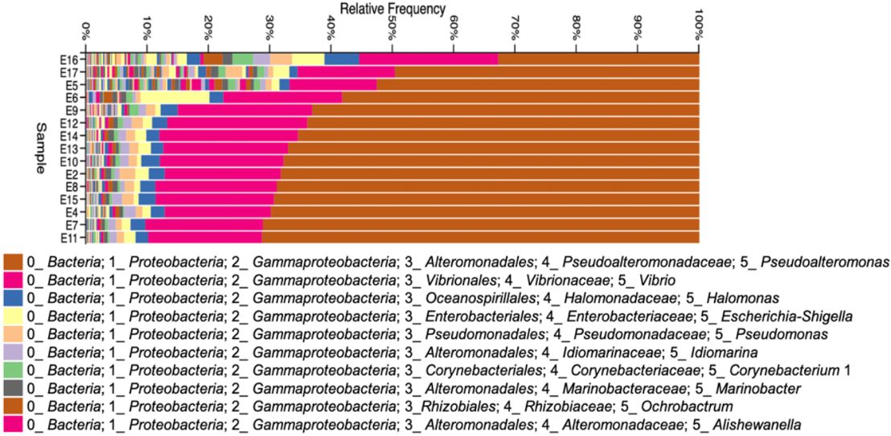

Figure S1. Top 10 most abundant genera present in the DNA extraction negative controls used as a negative control in the DNA extraction and sequencing step.

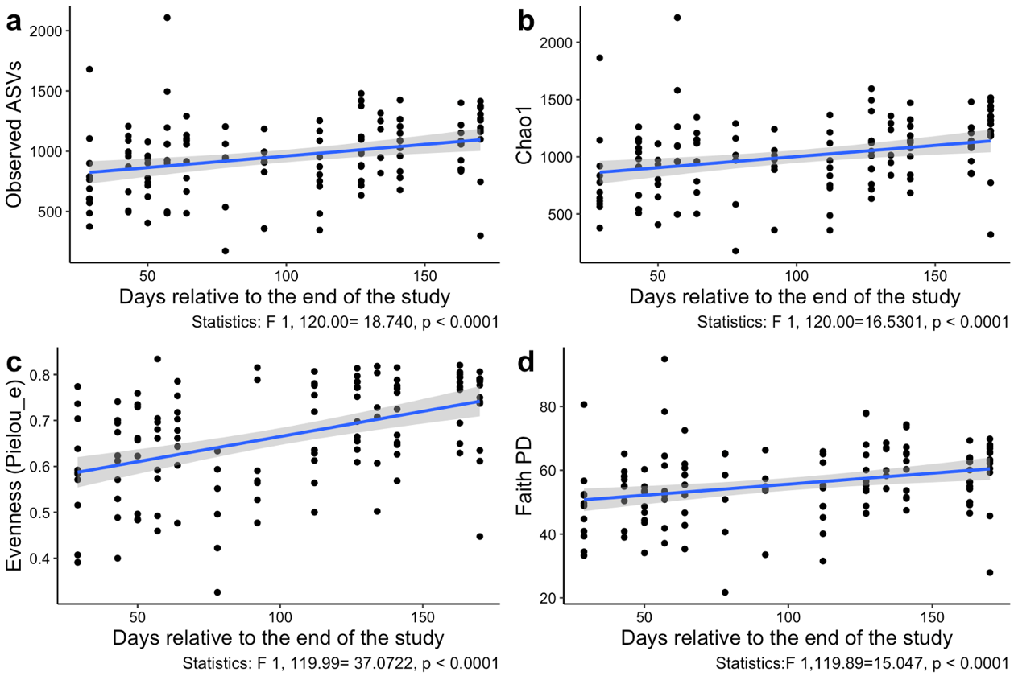

Figure S2. Holstein steer nasal microbiome alpha diversity relative to the date of collection. Variation in the cattle nasal microbiome alpha diversity estimated by Observed ASVs (a), Chao1 (b), Pielou (c) and Faith’s PD (d) (± 95% confident bands) relative to the date of collection. High values in the x axis represent the dates of samples collected at the beginning of the study (July, 2020); low values represent the dates of samples collected at the end of the study (December, 2020). Alpha diversity metrics measured using General Linear Mixed Model.

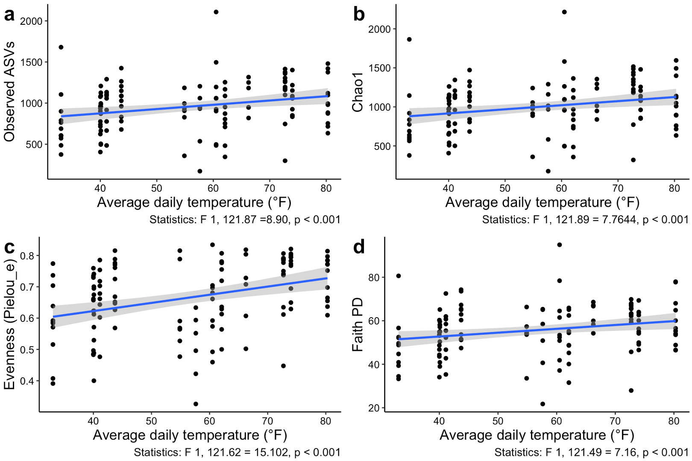

Figure S3. Variation in the cattle’s nasal alpha diversity estimated relative to the average daily temperature (°F). Variation in the cattle nasal alpha diversity estimated by Observed ASVs (a), Chao1 (b), Pielou (c) and Faith’s PD (d) (± 95% confident bands). Alpha diversity metrics measured using General Linear Mixed Model.

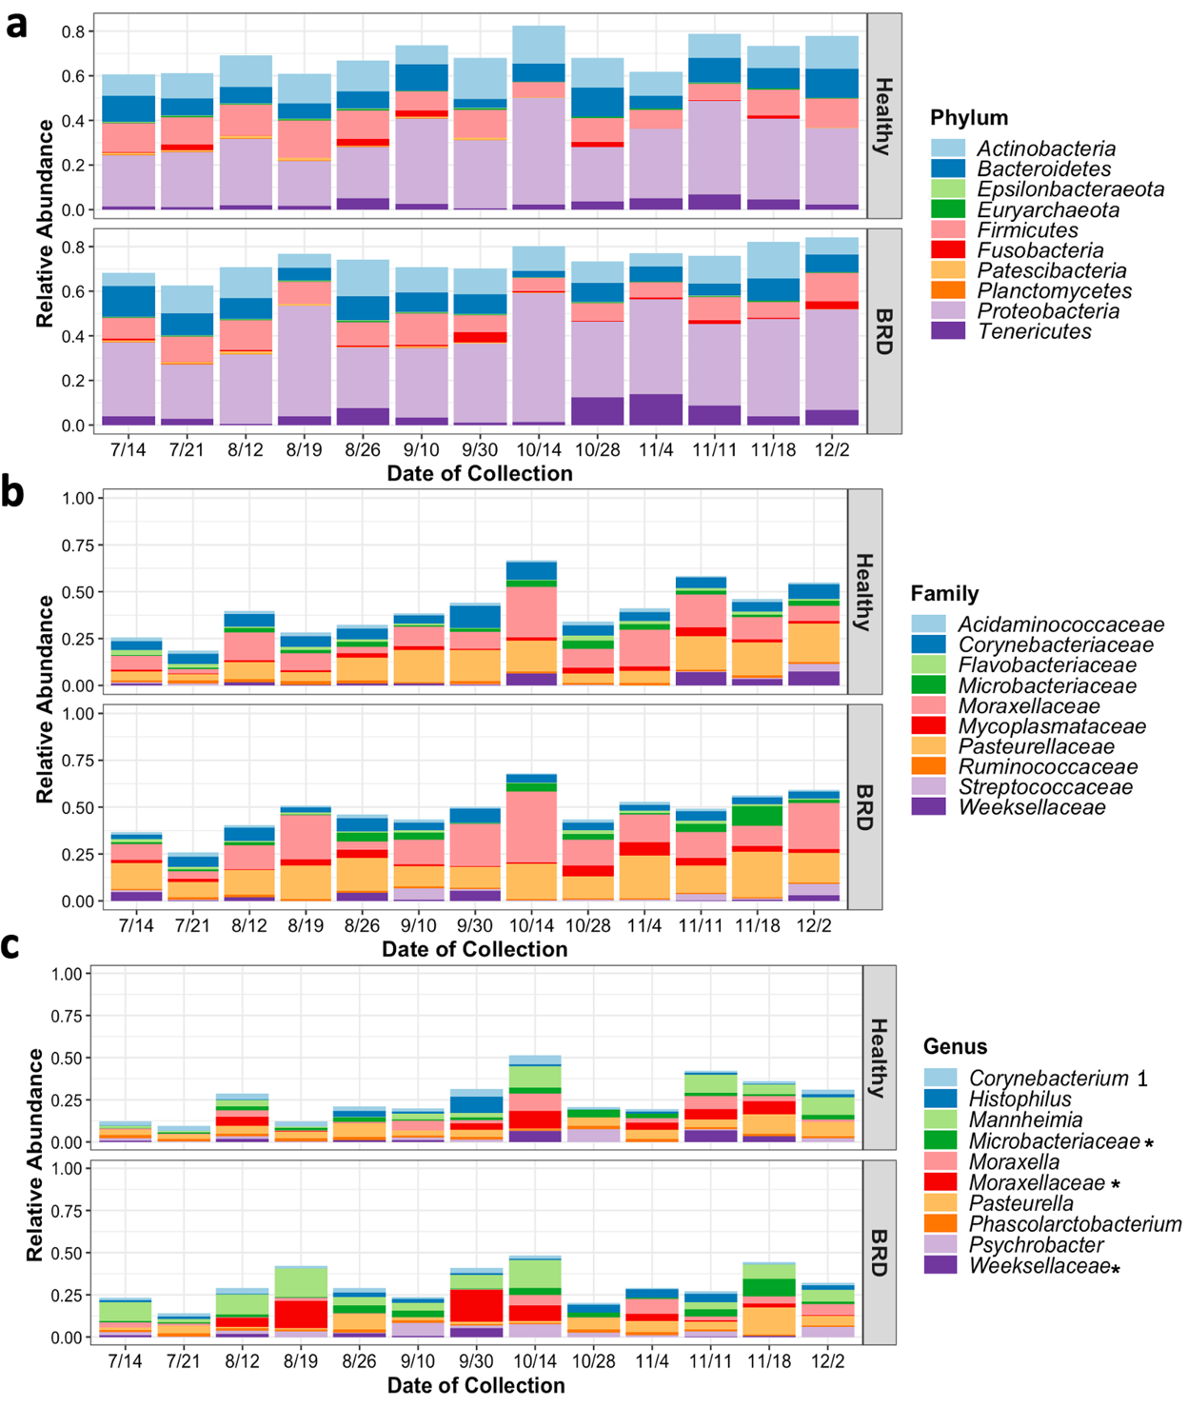

Figure S4. Average relative abundance of the 10 most abundant phyla (a), family (b) and genera (c) present in the nasal microbiome of BRD and healthy animals. * represents ASVs there were unclassified at the genus level.

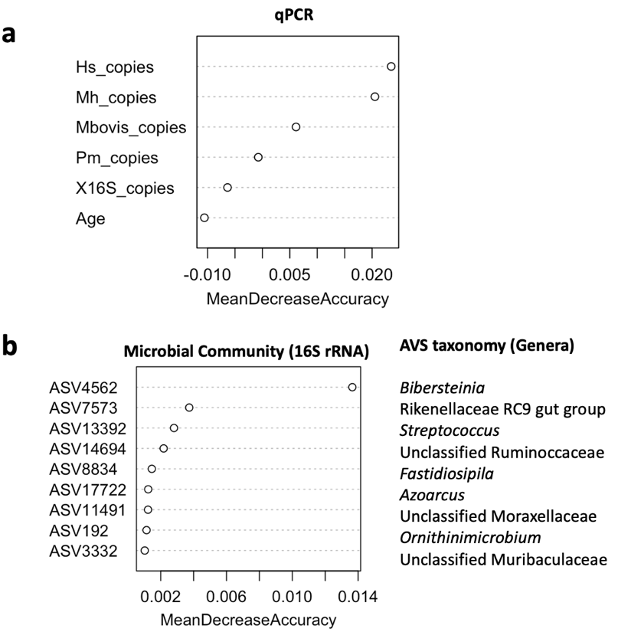

Figure S5. Variable importance measured by random forest indicated by the mean decrease accuracy. Variable importance measured the abundance of BRD pathobionts, 16S rRNA gene abundance and animal age (qPCR) (a) or by using microbial community composition determined by 16S rRNA gene sequencing (b).

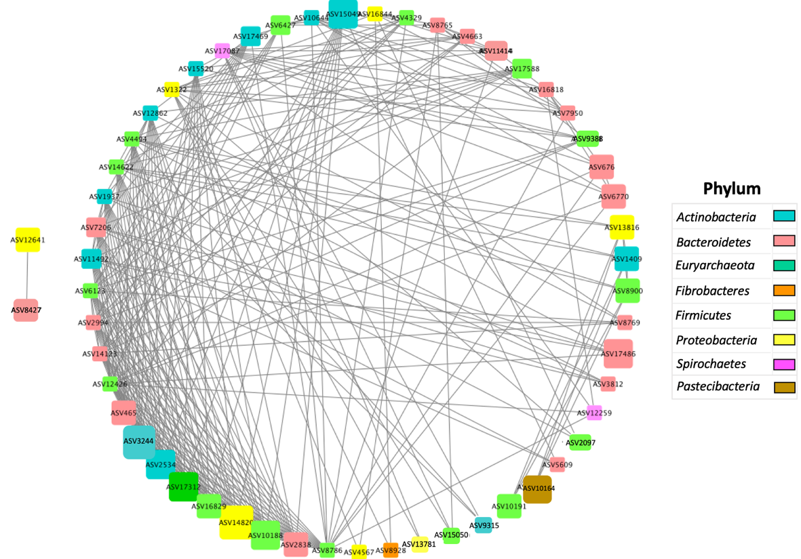

Figure S6. Visual representation of the positive ASV co-occurrence analysis in the healthy group (n=74) with a probability of occurrence in the same sample > 0.9. Box sizes represent the total samples where the co-occurrence was observed (min value 69 and max value 73 samples). Color indicates the phylum classification. Lines indicate co-occurrence between ASVs.

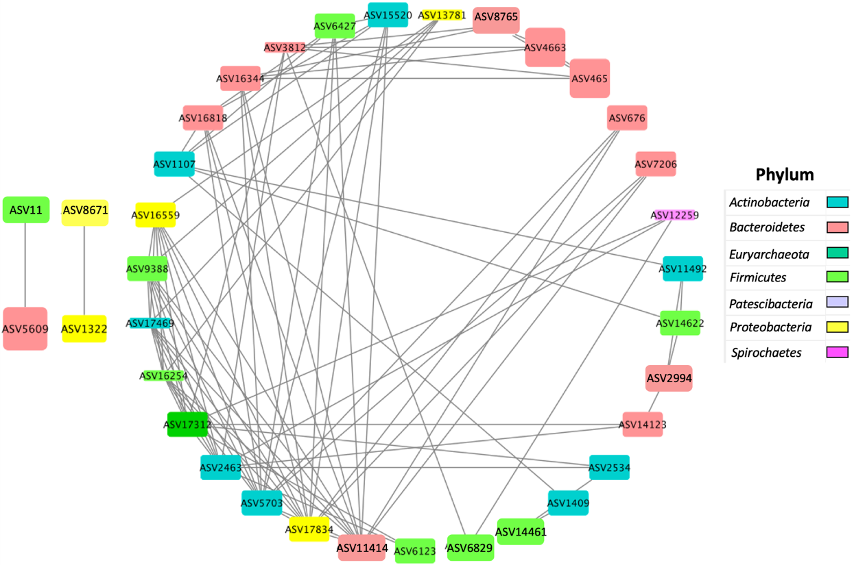

Figure S7. Visual representation of the positive ASV co-occurrence analysis in the BRD group (n=57) with a probability of occurrence in the same sample > 0.9. Box sizes represent the total samples where the co-occurrence was observed (min value 54 and max value 56 samples). Color indicates the phylum classification. Lines indicate co-occurrence between ASVs.

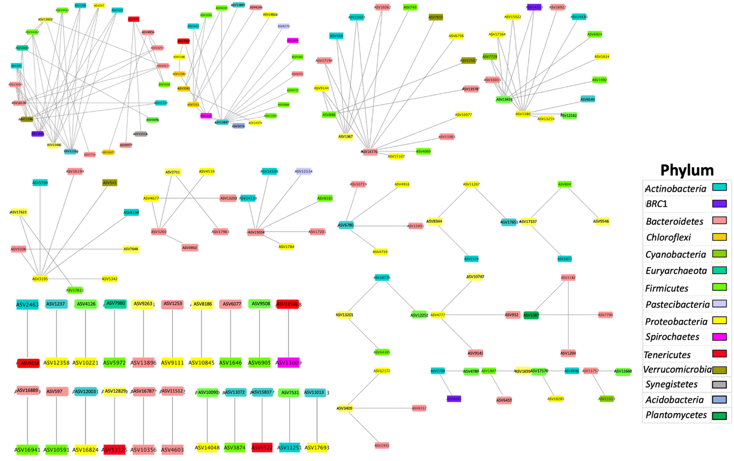

Figure S8. Visual representation of the negative ASV co-occurrence analysis of the healthy group (n=74) with a probability of occurrence in the same sample < 0.05. Color indicates the phylum classification. Lines indicate negative associations between ASVs.
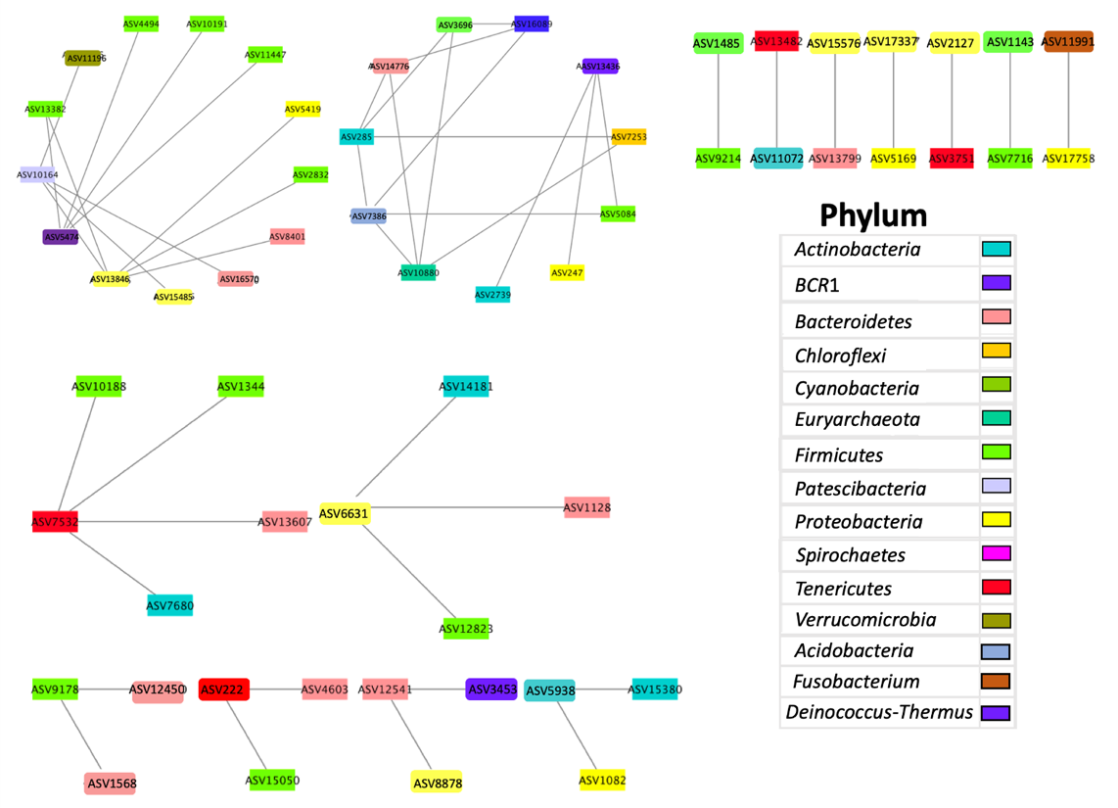

Figure S9. Visual representation of the negative ASV co-occurrence analysis in the BRD group (n=57) with a probability of occurrence in the same sample < 0.05. Color indicates the phylum classification. Lines indicate negative associations between ASVs.

Table S1. Variation in the cattle’s nasal alpha diversity relative to the animal age (months) analyzed using General Linear Mixed Model.
 |  | Age
Alpha diversity metric | DF | F-Value | P-Value
Observed ASVs | 1, 119.87 | 5.42 | <0.02
Chao 1 | 1, 119.70 | 4.99 | <0.02
Pielou_e | 1, 119.99 | 6.68 | <0.01
Faith_PD | 1, 119.34 | 4.00 | <0.04

Table S2. Sample average distance to the centroids of the BRD and healthy groups.
Beta diversity metric | BRD | Healthy | P-Value
Distance (Bray-Curtis) | 0.5001 | 0.4743 | 0.058
Distance (Weighted UniFrac) | 0.3369 | 0.3099 | 0.085
Table S3. Prevalence of ASVs assigned as P. multocida, H. somni and M. bovis the nasal cavity of BRD (n=75) and healthy (n=74) groups based on 16S rRNA gene sequencing.
 | P. multocida | M. haemolytica | M. bovis ASV13707 | M. bovis ASV13464 | M. bovis ASV2171 | M. bovis ASV15117 | M. bovis ASV10207
BRD | 55 (96%) | 1 (2%) | 37 (65%) | 1 (2%) | 2 (4%) | 0 (0%) | 5 (9%)
Healthy | 72 (97%) | 0 (0%) | 30 (41%) | 0 (0%) | 1 (1%) | 1 (1%) | 1 (1%)

Table S4. Prevalence of the genera Pasteurella, Histophilus, Mannheimia or Mycoplasma in the nasal cavity of Holstein steers (n=131) and between BRD (n=75) and healthy (n=74) animals based on 16S rRNA gene sequencing.
 | Pasteurella | Histophilus | Mannheimia | Mycoplasma
BRD | 55 (96.5%) | 45 (78.9%) | 37 (64.9%) | 53 (93%)
Healthy | 72 (97.3%) | 55 (74.3%) | 43 (58.1%) | 60 (81.1%)
All | 127 (96.94%) | 100 (76.33%) | 80 (61.06%) | 113 (86.25%)

Table S5. Positive ASV pair combinations present in 73 out of 74 healthy samples with a probability of occurrence in the same sample > 0.9.
ASVs 1 | Genus_1 | ASVs 2 | Genus_2
ASV10188 | Romboutsia | ASV16829 | Guggenheimella
ASV10188 | Romboutsia | ASV2838 | Prevotellaceae NK3B31 group
ASV10188 | Romboutsia | ASV465 | Prevotellaceae NK3B31 group
ASV1409 | Georgenia | ASV13816 | Parapusillimonas
ASV1409 | Georgenia | ASV8900 | Uncultured Acidaminococcaceae
ASV14820 | Acinetobacter | ASV10188 | Romboutsia
ASV14820 | Acinetobacter | ASV16829 | Guggenheimella
ASV14820 | Acinetobacter | ASV17312 | Methanobrevibacter
ASV14820 | Acinetobacter | ASV2534 | Olsenella
ASV14820 | Acinetobacter | ASV2838 | Prevotellaceae NK3B31 group
ASV14820 | Acinetobacter | ASV465 | Prevotellaceae NK3B31 group
ASV16829 | Guggenheimella | ASV2838 | Prevotellaceae NK3B31 group
ASV16829 | Guggenheimella | ASV465 | Prevotellaceae NK3B31 group
ASV17312 | Methanobrevibacter | ASV10188 | Romboutsia
ASV17312 | Methanobrevibacter | ASV16829 | Guggenheimella
ASV17312 | Methanobrevibacter | ASV2534 | Olsenella
ASV17312 | Methanobrevibacter | ASV2838 | Prevotellaceae NK3B31 group
ASV17312 | Methanobrevibacter | ASV465 | Prevotellaceae NK3B31 group
ASV2534 | Olsenella | ASV10188 | Romboutsia
ASV2534 | Olsenella | ASV16829 | Guggenheimella
ASV2534 | Olsenella | ASV2838 | Prevotellaceae NK3B31 group
ASV2534 | Olsenella | ASV465 | Prevotellaceae NK3B31 group
ASV3244 | Corynebacterium 1 | ASV10188 | Romboutsia
ASV3244 | Corynebacterium 1 | ASV14820 | Acinetobacter
ASV3244 | Corynebacterium 1 | ASV16829 | Guggenheimella
ASV3244 | Corynebacterium 1 | ASV17312 | Methanobrevibacter
ASV3244 | Corynebacterium 1 | ASV2534 | Olsenella
ASV3244 | Corynebacterium 1 | ASV2838 | Prevotellaceae NK3B31 group
ASV3244 | Corynebacterium 1 | ASV465 | Prevotellaceae NK3B31 group
ASV465 | Prevotellaceae NK3B31 group | ASV2838 | Prevotellaceae NK3B31 group
ASV676 | Prevotellaceae NK3B31 group | ASV6770 | Fermentimonas
ASV8900 | Uncultured Acidaminococcaceae | ASV13816 | Parapusillimonas

Table S6. Co-occurrence analysis with positive ASV pair combinations present in 56 out of 57 BRD samples with a probability of occurrence in the same sample of 1.
ASV 1 | Genus_1 | ASV 2 | Genus_2
ASV11414 | Flavobacterium | ASV17834 | Halomonas
ASV5703 | Glutamicibacter | ASV17834 | Halomonas
ASV17312 | Methanobrevibacter | ASV2463 | Gulosibacter
ASV8765 | Prevotella 1 | ASV465 | Prevotellaceae NK3B31 group
ASV465 | Prevotellaceae NK3B31 group | ASV4663 | Prevotellaceae NK3B31 group
ASV8765 | Prevotella 1 | ASV4663 | Prevotellaceae NK3B31 group
ASV11 | Clostridium sensu stricto 1 | ASV5609 | Bacteroides
ASV11414 | Flavobacterium | ASV5703 | Glutamicibacter

Table S7. Co-occurrence analysis showing negative ASV pair combinations that are not likely to co-exist in the heathy group with a probability <0.04.
ASV 1 | Genus_1 | ASV 1 | Genus_2
ASV4603 | uncultured Bacteroides sp. | ASV11512 | uncultured Prevotellaceae bacterium
ASV2463 | uncultured Gulosibacter | ASV9158 | Mycoplasma bovirhinis
ASV285 | uncultured Bifidobacteriaceae | ASV11166 | Intrasporangiaceae
ASV13000 | Prevotellaceae UCG-003 | ASV11166 | Intrasporangiaceae
ASV14432 | uncultured Guggenheimella | ASV11166 | Intrasporangiaceae
ASV14432 | uncultured Guggenheimella | ASV15485 | Thermomonas
ASV13000 | Prevotellaceae UCG-003 | ASV15485 | Thermomonas
ASV285 | uncultured Bifidobacteriaceae | ASV15485 | Thermomonas
ASV13000 | Prevotellaceae UCG-003 | ASV1851 | uncultured Desulfocaldus sp.
ASV285 | uncultured Bifidobacteriaceae | ASV1851 | uncultured Desulfocaldus sp.
ASV14432 | uncultured Guggenheimella | ASV1851 | uncultured Desulfocaldus sp.
ASV1706 | Corynebacterium 1 | ASV11166 | Intrasporangiaceae
ASV14362 | uncultured Lysinibacillus | ASV11166 | Intrasporangiaceae
ASV1706 | Corynebacterium 1 | ASV15485 | Thermomonas
ASV14362 | uncultured Lysinibacillus | ASV15485 | Thermomonas
ASV14362 | uncultured Lysinibacillus | ASV1851 | uncultured Desulfocaldus sp.
ASV1706 | Corynebacterium 1 | ASV1851 | uncultured Desulfocaldus sp.
ASV7028 | Arthrobacter | ASV11166 | Intrasporangiaceae
ASV247 | uncultured Oligella | ASV11166 | Intrasporangiaceae
ASV12358 | uncultured Cellvibrio | ASV1237 | Microbacteriaceae
ASV7028 | Arthrobacter | ASV15485 | Thermomonas
ASV247 | uncultured Oligella | ASV15485 | Thermomonas
ASV247 | uncultured Oligella | ASV1851 | uncultured Desulfocaldus sp.
ASV7028 | Arthrobacter | ASV1851 | uncultured Desulfocaldus sp.
ASV10880 | Methanobrevibacter | ASV11196 | uncultured Chthoniobacteraceae
ASV10880 | Methanobrevibacter | ASV13602 | Paracoccus
ASV7532 | Mycoplasma bovirhinis | ASV15514 | uncultured Synergistaceae
ASV10880 | Methanobrevibacter | ASV16570 | Flavobacterium
ASV5038 | Aerococcus | ASV4856 | Prevotellaceae
ASV7532 | Mycoplasma bovirhinis | ASV5038 | Aerococcus
ASV7532 | Mycoplasma bovirhinis | ASV6977 | Taibaiella
ASV804 | Ruminococcus 1 | ASV9546 | Vitreoscilla
ASV10259 | Chishuiella sp. YIM 102668 | ASV11196 | uncultured Chthoniobacter
ASV10259 | Chishuiella sp. YIM 102668 | ASV16570 | Flavobacterium
ASV10259 | Chishuiella sp. YIM 102668 | ASV4856 | Prevotellaceae
ASV7754 | Paludibacter | ASV13602 | Paracoccus

Table S8. Co-occurrence analysis showing negative ASV pair combinations that are not likely to co-exist in the BRD group with a probability <0.04.
ASV_1 | Genus_1 | ASV_1 | Genus_2
ASV10164 | uncultured Absconditabacteriales (SR1) | ASV11196 | uncultured Chthoniobacter
ASV10164 | uncultured Absconditabacteriales (SR1) | ASV15485 | Thermomonas
ASV10164 | uncultured Absconditabacteriales (SR1) | ASV16570 | Flavobacterium
ASV15050 | uncultured Jeotgalibaca | ASV222 | Mycoplasma
ASV7680 | Corynebacterium sp. C3 | ASV7532 | Mycoplasma bovirhinis
ASV1344 | Planococcaceae | ASV7532 | Mycoplasma bovirhinis
ASV13607 | Sphingobacterium jejuense | ASV7532 | Mycoplasma bovirhinis
ASV7716 | Weissella paramesenteroides | ASV1143 | uncultured Murdochiella
ASV3751 | Mycoplasma bovoculi M165/69 | ASV2127 | Moraxella boevrei DSM 14165
ASV4603 | uncultured Bacteroides sp. | ASV222 | Mycoplasma
ASV12541 | uncultured Rikenellaceae RC9 | ASV3453 | Deinococcus
ASV10188 | Romboutsia | ASV7532 | Mycoplasma bovirhinis
ASV12541 | uncultured Rikenellaceae RC9 | ASV8878 | Moraxellaceae

Table S9. Evaluation of Pasteurella multocida, Histophilus somni, Mannheimia haemolytica and Mycoplasma bovis using qPCR assays.
qPCR assay |  | Pasteurella multocida | Histophilus somni | Mannheimia haemolytica | Mycoplasma bovis | 16S rRNA gene
Standard equation | Slope | -3.3 | -3.596 | -3.145 | -3.343 | -3.011
Standard equation | Intercept | 36.921 | 39.723 | 35.92 | 37.098 | 35.77
Standard equation | Replicates | 3 | 3 | 3 | 3 | 3
Efficiency (%) |  | 100.94 | 89.71 | 107.96 | 99.13 | 114.84
Dilutions |  | 9 | 9 | 9 | 9 | 9
Cq cut-off value^{Ψ} |  | 33.53 | 36.77 | 31.76 | 32.1 | 30.52
^{Ψ} Cq value corresponding to the last dilution in the standard curve (10⁰) at which samples tested positive.

