Additional file 1

Table S1. Comparison of microbial community richness (Chao1 diversity index) in the ileal content of birds from 4 genetic lines using Pairwise Kruskal-Wallis test (d 56).¹
Group 1 | Group 2 | H | p-value | q-value
ACRB | JF | 0.01 | 0.908 | 0.908
ACRB | L1995 | 0.36 | 0.544 | 0.653
ACRB | L2015 | 1.33 | 0.248 | 0.490
JF | L1995 | 0.96 | 0.326 | 0.490
JF | L2015 | 3.85 | 0.050 | 0.298
L1995 | L2015 | 1.02 | 0.312 | 0.490

Group 1 | Group 2 | H | p-value | q-value
HS | TN | 12.43 | <0.001 | <0.001
¹ Treatments include: Giant Jungle Fowl (JF), Athens Canadian Random Bred (ACRB), 1995 Random Bred (L1995), and Modern Random Bred (L2015) lines raised under thermoneutral (TN, d 29-56; 24°C) or subjected to chronic cyclic heat stress (HS; d 29-56; 36°C for 8 h/d) conditions.

Table S2. Group significance and pairwise PERMANOVA statistics based on unweighted UniFrac distance matrix on ileal content samples on d 56.¹
Number of groups | Test statistic | Sample size | p-value²
8 | 1.94 | 48 | 0.001

Group 1 | Group 2 | Sample size | pseudo-F | p-value² | q-value
L1995-HS | L1995-TN | 12 | 1.09 | 0.353 | 0.395
L1995-HS | L2015-HS | 12 | 0.66 | 0.811 | 0.811
L1995-HS | L2015-TN | 12 | 1.58 | 0.091 | 0.149
L1995-HS | ACRB-HS | 12 | 2.79 | 0.009 | 0.036
L1995-HS | ACRB-TN | 12 | 1.28 | 0.187 | 0.238
L1995-HS | JF-HS | 12 | 1.59 | 0.055 | 0.110
L1995-HS | JF-TN | 12 | 2.15 | 0.003 | 0.028
L1995-TN | L2015-HS | 12 | 1.12 | 0.347 | 0.395
L1995-TN | L2015-TN | 12 | 0.88 | 0.561 | 0.581
L1995-TN | ACRB-HS | 12 | 4.12 | 0.007 | 0.032
L1995-TN | ACRB-TN | 12 | 1.43 | 0.131 | 0.193
L1995-TN | JF-HS | 12 | 1.85 | 0.068 | 0.119
L1995-TN | JF-TN | 12 | 3.12 | 0.011 | 0.038
L2015-HS | L2015-TN | 12 | 1.31 | 0.199 | 0.242
L2015-HS | ACRB-HS | 12 | 3.48 | 0.006 | 0.032
L2015-HS | ACRB-TN | 12 | 1.82 | 0.016 | 0.044
L2015-HS | JF-HS | 12 | 1.89 | 0.026 | 0.066
L2015-HS | JF-TN | 12 | 2.81 | 0.003 | 0.028
L2015-TN | ACRB-HS | 12 | 4.51 | 0.005 | 0.032
L2015-TN | ACRB-TN | 12 | 1.70 | 0.032 | 0.068
L2015-TN | JF-HS | 12 | 1.97 | 0.031 | 0.068
L2015-TN | JF-TN | 12 | 4.03 | 0.002 | 0.028
ACRB-HS | ACRB-TN | 12 | 1.44 | 0.114 | 0.177
ACRB-HS | JF-HS | 12 | 1.23 | 0.164 | 0.218
ACRB-HS | JF-TN | 12 | 2.44 | 0.016 | 0.044
ACRB-TN | JF-HS | 12 | 1.00 | 0.428 | 0.460
ACRB-TN | JF-TN | 12 | 1.39 | 0.14 | 0.196
JF-HS | JF-TN | 12 | 1.35 | 0.068 | 0.119
¹ Treatments include: Giant Jungle Fowl (JF), Athens Canadian Random Bred (ACRB), 1995 Random Bred (L1995), and Modern Random Bred (L2015) lines raised under thermoneutral (TN, d 29-56; 24°C) or subjected to chronic cyclic heat stress (HS; d 29-56; 36°C for 8 h/d) conditions.
² P-values were calculated based on 999 permutation tests.
Table S3. Comparison of microbial community richness and evenness (Simpson’s diversity index) in the ileal mucosal scrapings of birds from 4 genetic lines using Pairwise Kruskal-Wallis test (d 56).¹
Group 1 | Group 2 | H | p-value | q-value
ACRB | JF | 2.43 | 0.119 | 0.267
ACRB | L1995 | 2.25 | 0.133 | 0.267
ACRB | L2015 | 3.41 | 0.065 | 0.267
JF | L1995 | 0.00 | 0.954 | 0.954
JF | L2015 | 0.00 | 0.954 | 0.954
L1995 | L2015 | 0.03 | 0.862 | 0.954

Group 1 | Group 2 | H | p-value | q-value
HS | TN | 8.57 | 0.003 | 0.003
¹ Treatments include: Giant Jungle Fowl (JF), Athens Canadian Random Bred (ACRB), 1995 Random Bred (L1995), and Modern Random Bred (L2015) lines raised under thermoneutral (TN, d 29-56; 24°C) or subjected to chronic cyclic heat stress (HS; d 29-56; 36°C for 8 h/d) conditions.

Table S4. Group and pairwise PERMANOVA statistics based on unweighted UniFrac distance matrix on ileal mucosal scraping samples on d 56.¹
Number of groups | Test statistic | Sample size | p-value²
8 | 1.170 | 47 | 0.041

Group 1 | Group 2 | Sample size | pseudo-F | p-value² | q-value
ACRB-HS | ACRB-TN | 12 | 1.16 | 0.157 | 0.366
ACRB-HS | JF-HS | 12 | 0.97 | 0.434 | 0.578
ACRB-HS | JF-TN | 12 | 1.13 | 0.224 | 0.418
ACRB-HS | L1995-HS | 12 | 0.83 | 0.797 | 0.807
ACRB-HS | L1995-TN | 11 | 1.08 | 0.280 | 0.446
ACRB-HS | L2015-HS | 12 | 0.90 | 0.605 | 0.678
ACRB-HS | L2015-TN | 12 | 1.07 | 0.284 | 0.446
ACRB-TN | JF-HS | 12 | 1.81 | 0.001 | 0.003
ACRB-TN | JF-TN | 12 | 1.62 | 0.032 | 0.205
ACRB-TN | L1995-HS | 12 | 1.26 | 0.022 | 0.205
ACRB-TN | L1995-TN | 11 | 1.43 | 0.089 | 0.266
ACRB-TN | L2015-HS | 12 | 1.54 | 0.009 | 0.126
ACRB-TN | L2015-TN | 12 | 1.37 | 0.060 | 0.240
JF-HS | JF-TN | 12 | 0.86 | 0.776 | 0.807
JF-HS | L1995-HS | 12 | 1.45 | 0.037 | 0.205
JF-HS | L1995-TN | 11 | 0.83 | 0.807 | 0.807
JF-HS | L2015-HS | 12 | 0.93 | 0.577 | 0.678
JF-HS | L2015-TN | 12 | 1.08 | 0.287 | 0.446
JF-TN | L1995-HS | 12 | 1.40 | 0.044 | 0.205
JF-TN | L1995-TN | 11 | 0.90 | 0.606 | 0.678
JF-TN | L2015-HS | 12 | 1.15 | 0.180 | 0.368
JF-TN | L2015-TN | 12 | 1.28 | 0.114 | 0.290
L1995-HS | L1995-TN | 11 | 1.34 | 0.095 | 0.266
L1995-HS | L2015-HS | 12 | 1.27 | 0.075 | 0.262
L1995-HS | L2015-TN | 12 | 1.18 | 0.184 | 0.368
L1995-TN | L2015-HS | 11 | 1.00 | 0.400 | 0.560
L1995-TN | L2015-TN | 11 | 0.87 | 0.571 | 0.678
L2015-HS | L2015-TN | 12 | 1.02 | 0.381 | 0.560
¹ Treatments include: Giant Jungle Fowl (JF), Athens Canadian Random Bred (ACRB), 1995 Random Bred (L1995), and Modern Random Bred (L2015) lines raised under thermoneutral (TN, d 29-56; 24°C) or subjected to chronic cyclic heat stress (HS; d 29-56; 36°C for 8 h/d) conditions.
² P-values were calculated based on 999 permutation tests.

Figure S1. Predicted functions of ileal mucosal scrapings microbiota in modern random bred chickens (L2015) compared to their ancestor jungle fowl (JF) on d 56. Differentially regulated metabolic pathways are shown. (n = 12/genetic line)
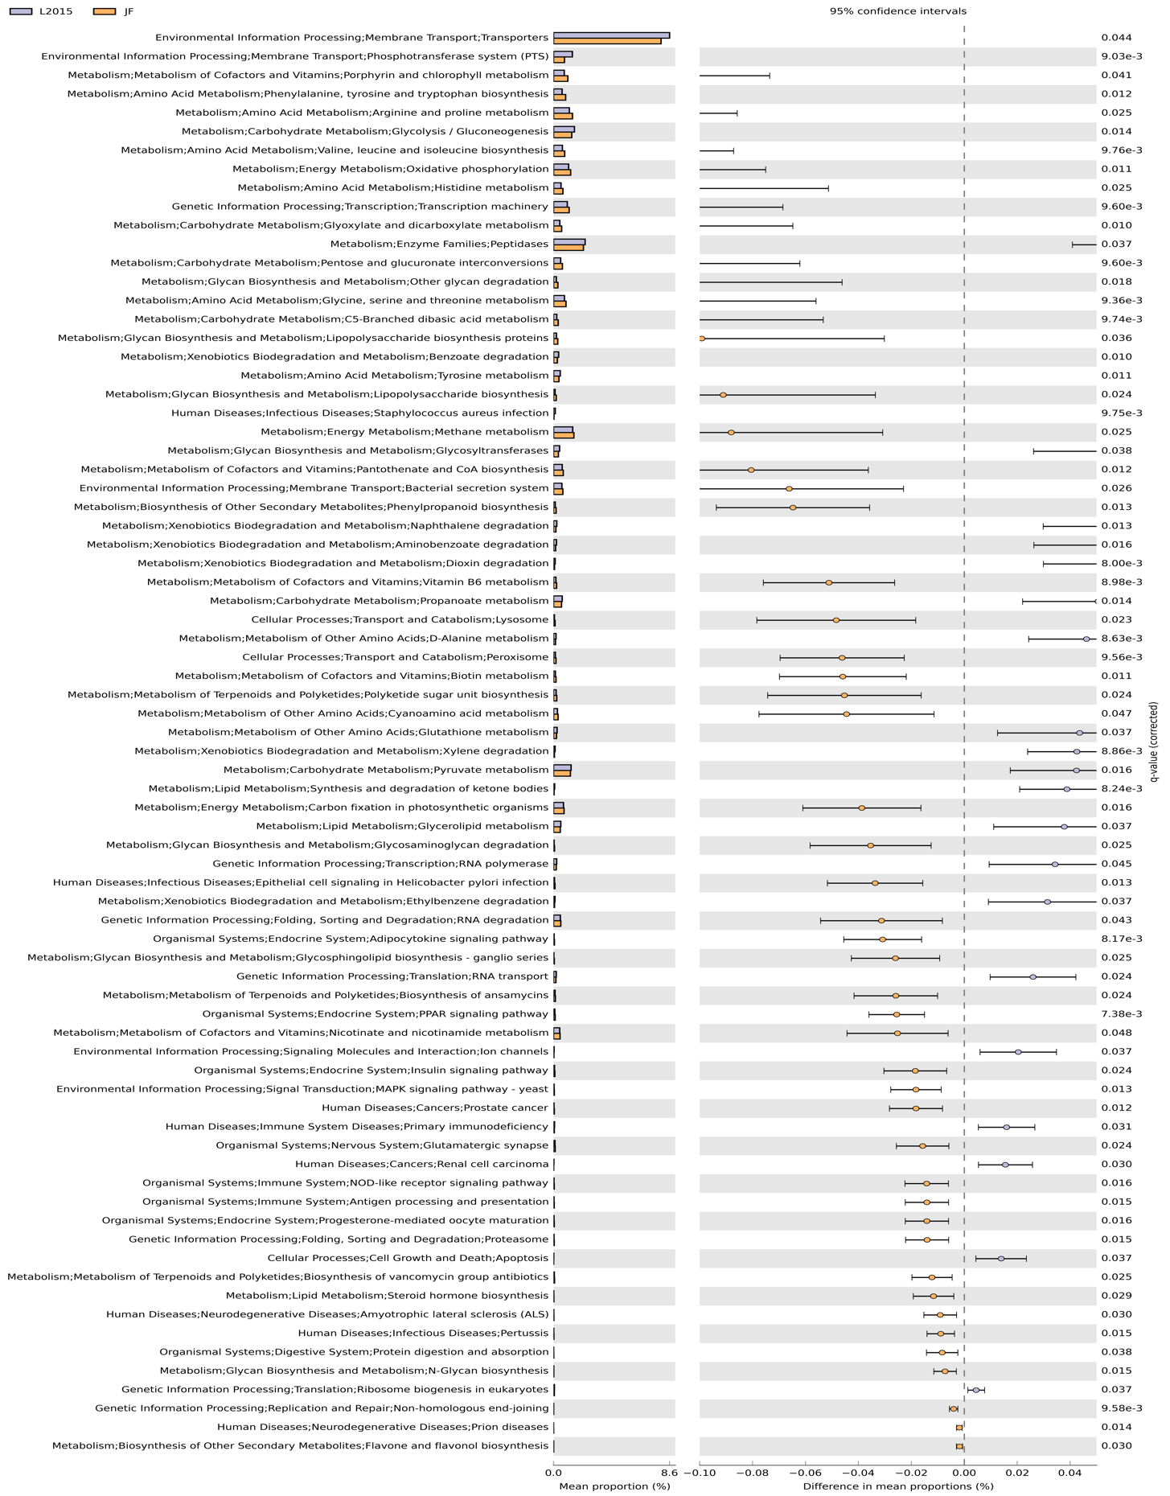
Figure S2. Predicted functions of ileal mucosal scrapings microbiota in modern random bred chickens (L2015) compared to Athens-Canadian Random bred chickens (ACRB) on d 56 Differentially regulated metabolic pathways are shown. (n = 12/genetic line).
