Figure S1. pH measured on rumen samples taken all along the experiment.
The rumen pH of the artificially reared (ART) and mothered lambs (MOT) are represented by white and grey boxes, respectively. Mixed-effects model (REML) showed effect of age (p<0.001), rearing mode (p<0.05) and interaction between them (p<0.01). Sidak’s multiple comparison test indicated that MOT rumen pH was higher than ART rumen pH at 28 days (p<0.001).

Figure S2. SCFA concentrations measured in the rumen of ART (white boxes) and MOT (grey boxes)lambs. Mixed-effects model (REML) showed effect of age (p_{T}), rearing mode (p_{R}) and interaction between them (p_{TxR}).
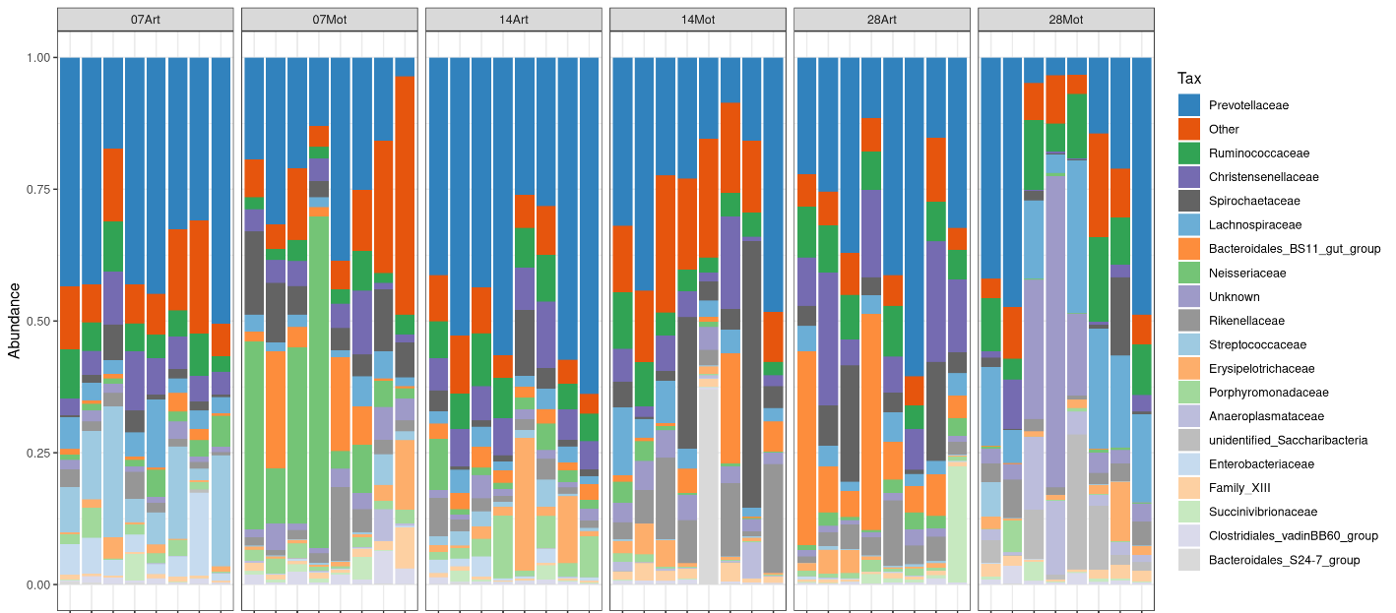
Figure S3: Composition of the microbiota of the individual rumen samples at the family level.

Figure S4. Parasite taxa identified in the rumen eukaryota community in ART and MOT lamb rumens.

Figure S5. Anaerobic fungi (A) and yeast (B) taxa identified the rumen of MOT and ART lambs.

Figure S6. qPCR quantification of selected bacterial group in the feces of ART (white boxes) and MOT (grey boxes) lambs. A: total bacteria; B: Lactobacillus/Leuconostoc/Pediococcus group; C: Faecalibacterium prausnitzii; D: Bifidobacterium.

Figure S7. Alpha diversity indices of the fecal bacteria populations of the two lamb groups.

Figure S8. Effect of rearing mode on fecal eukaryota of the two lamb groups.
A: alpha diversity (observed OTUs and Shannon index) of the fecal eukaryota of ART (white boxes) and MOT (grey boxes) lambs; B,C: composition of the fecal fungi communities (B, phyla; C, Saccharomycetales order); D: identified parasite taxa in the feces of the two groups. Differences between the two groups were analyzed by Mann Whitney non-parametric test.

Figure S9. pH (A) and relative weight of the digestive tract segments (B) in the ART (white boxes) and MOT (grey boxes) lambs.

Figure S10. Expression of selected genes in the rumen (normal frame) and colon (bold frame) epithelium in ART (white boxes) or MOT (grey boxes) lambs. Gene expression was expressed relative to β-actin gene expression (A) or GAPDH gene expression (B).

Figure S11. Experimental design of the animal trial and sampling

