SUPPLEMENTARY MATERIAL

Supplementary table S1. Number of unique OTUs identified at different taxonomic levels
Domain/sub-kingdom | % of total classified reads* | Phylum | Class | Order | Family | Genus | Species
Archaea | 1.365 | 7 | 18 | 31 | 48 | 140 | 351
Bacteria | 98.589 | 40 | 93 | 219 | 519 | 1909 | 8674
Other classification * | 0.046 | - | - | - | - | - | -
(*) Virus, protozoa, fungi or Human reads.

Supplementary Table S2. List of significantly differentially abundant genera between fence-line and truck weaned calves at post-weaning day (reference group: fence-line). Only genera with logFC > 0.5 or < -0.5 and average abundance > 5 are listed.
Genus | logFC | Average abundance | adj.P.Val
Rhodococcus | 2.09 | 6.86 | 1.17E-15
Agrobacterium | 3.14 | 7.16 | 4.46E-13
Anaerovibrio | 2.77 | 7.90 | 1.52E-09
Oribacterium | 2.43 | 12.15 | 7.35E-13
Plantibacter | 2.42 | 5.87 | 9.91E-13
Lachnoclostridium | 2.14 | 9.30 | 3.09E-10
Variovorax | 2.52 | 5.21 | 1.32E-11
Mogibacterium | 1.26 | 5.56 | 9.50E-11
Selenomonas | 1.99 | 12.67 | 1.69E-09
Microbacterium | 1.86 | 7.98 | 3.92E-12
Eubacterium | 1.60 | 10.15 | 1.53E-08
Arthrobacter | 0.91 | 5.49 | 9.17E-09
Succiniclasticum | 1.28 | 13.40 | 1.49E-04
Stenotrophomonas | 0.99 | 7.24 | 6.40E-04
Mycolicibacterium | 1.06 | 6.50 | 2.73E-07
Butyrivibrio | 0.95 | 14.36 | 1.30E-06
Berryella | 0.76 | 5.22 | 6.61E-06
Nocardioides | 1.03 | 6.62 | 8.16E-06
Pseudomonas | 0.72 | 9.66 | 1.76E-02
Rhizobium | 0.80 | 5.55 | 2.12E-05
Sodaliphilus | 0.75 | 6.02 | 3.47E-05
Methanobrevibacter | 0.71 | 11.41 | 4.71E-04
Bradyrhizobium | 0.96 | 6.23 | 8.03E-05
Vescimonas | 0.55 | 7.31 | 5.93E-04
Lachnobacterium | 0.73 | 6.20 | 5.24E-03
Kandleria | 1.65 | 6.96 | 6.15E-03
Methylorubrum | 0.56 | 5.27 | 1.06E-02
Methylobacterium | -0.69 | 8.50 | 3.88E-03
Bacteroides | -1.01 | 11.27 | 6.18E-05
Lachnospira | -1.06 | 7.76 | 7.29E-03
Petrimonas | -0.56 | 5.00 | 8.60E-03
Micromonospora | -0.53 | 6.09 | 1.05E-02
Fibrobacter | -1.12 | 14.26 | 1.23E-02
Sarcina | -1.21 | 12.07 | 9.07E-06
Ruminococcus | -1.38 | 13.07 | 3.80E-08
Streptococcus | -2.31 | 9.85 | 6.41E-13

Supplementary Table S3. List of significantly differentially abundant methane-associated genera and genes between fence-line and truck weaned calves at post-weaning day (reference group: fence-line). Only features with logFC > 0.5 or < -0.5 and average abundance > 5 are listed.

Feature |  | Gene pathway | logFC | Average abundance | adj.P.Val
Genera
 | Methanobrevibacter | - | 0.78 | 10.68 | 1.2E-05
 | Selenomonas | - | 0.82 | 7.74 | 3.4E-06
 | Fibrobacter | - | -1.19 | 8.50 | 6.2E-04
 | Candidatus Methanomethylophilus | - | -0.82 | 5.17 | 2.6E-03
 | Ruminococcus | - | -0.59 | 7.58 | 3.3E-05
Genes
 | echB | Central methanogenic pathway | 0.49 | 5.62 | 1.6E-04
 | fwdB | Hydrogenotrophic methanogenesis | 0.46 | 5.51 | 2.6E-04
 | echA | Central methanogenic pathway | 0.41 | 6.37 | 5.4E-04
 | fwdF | Hydrogenotrophic methanogenesis | 0.49 | 5.67 | 1.5E-03
 | mtmB | Methylotrophic methanogenesis | -1.40 | 5.05 | 1.0E-07
 | mtaB | Methylotrophic methanogenesis | -0.87 | 5.29 | 4.4E-08
 | glpX | Aerobic oxidation of methane | -0.60 | 7.51 | 5.5E-06
 | pqqF | Aerobic oxidation of methane | -0.55 | 8.02 | 3.5E-05
 | fdhA-K00148 | Aerobic oxidation of methane | -0.55 | 7.94 | 2.0E-05
 | fpoJ | Central methanogenic pathway | -0.53 | 5.50 | 4.7E-04
 | metF | Hydrogenotrophic methanogenesis | -0.51 | 9.45 | 1.1E-04
 | fpoC | Central methanogenic pathway | -0.50 | 5.61 | 6.2E-06
 | rnfD | Central methanogenic pathway | -0.50 | 10.38 | 4.7E-05

Supplementary Table S4. Number of reads per sample analyzed by 2 taxonomic profiling protocols (mean [min – max])
Step | Standard protocol |  |  |  | Customized protocol
Step | Sequencing reads per sample (x10⁶) | Proportion of initial sequencing reads (%) | Proportion of non-host reads (%) |  | Sequencing reads per sample (x10⁶) | Proportion of initial sequencing reads (%) | Proportion of non-host reads (%)
Raw sequences | 54.2 [30.5 - 75.8] | 100 | - |  | 54.2 [30.5 - 75.8] | 100 | -
Sequence trimming | 52.3 [29.2 - 73.2] | 96.5 | - |  | 52.3 [29.2 - 73.2] | 96.5 | -
Host decontamination | 41.9 [24.9 - 59.9] | 77.3 | 100 |  | 38.3 [23.3 - 55.2] | 70.7 | 100
Taxonomic classification
Confidence score = 0 | 5.9 [3.5 - 8.2] | 10.9 | 14.1 |  | 8 [4.9 - 11.3] | 14.8 | 21
Confidence score = 0.1 | 1.3 [0.7 - 2] | 2.4 | 3.1 |  | 1.6 [0.9 - 2.3] | 3 | 4.2

Supplementary Table S5. Read classification rates by taxonomic level.

Taxonomic Rank | Number of rank-specific classified reads/non-host reads (%) | Number of rank-specific classified reads/total number of classified reads (%)
Domain | 4.15 | 100.0
Kingdom | 3.99 | 96.2
Phylum | 3.99 | 96.2
Class | 3.95 | 95.1
Order | 3.94 | 94.9
Family | 3.87 | 93.2
Genus | 3.77 | 91.0
Species | 3.14 | 75.7

Supplementary Figure 1. Results of A) weight collection and B-C) average daily weight (ADG) calculation. Error bars in A represent standard deviation (SD), while in B and C boxes represent the 25th to 75th percentile, horizontal line represents the median and whiskers indicate 1.5× the interquartile range.

Supplementary Figure 2. Relative abundance of genus-level microbiome composition for A) Positive and B) Negative controls. Most abundant species are shown, and species < 1% abundance are grouped as “Others”. Each bar represents a single sample.

Supplementary Figure 3. Relative abundance plot of genus-level bacterial (A) and archaeal (B) composition, grouped by weaning strategy and collection day. Genera with < 1% abundance are grouped as “Others”. Each columns represents a single sample.

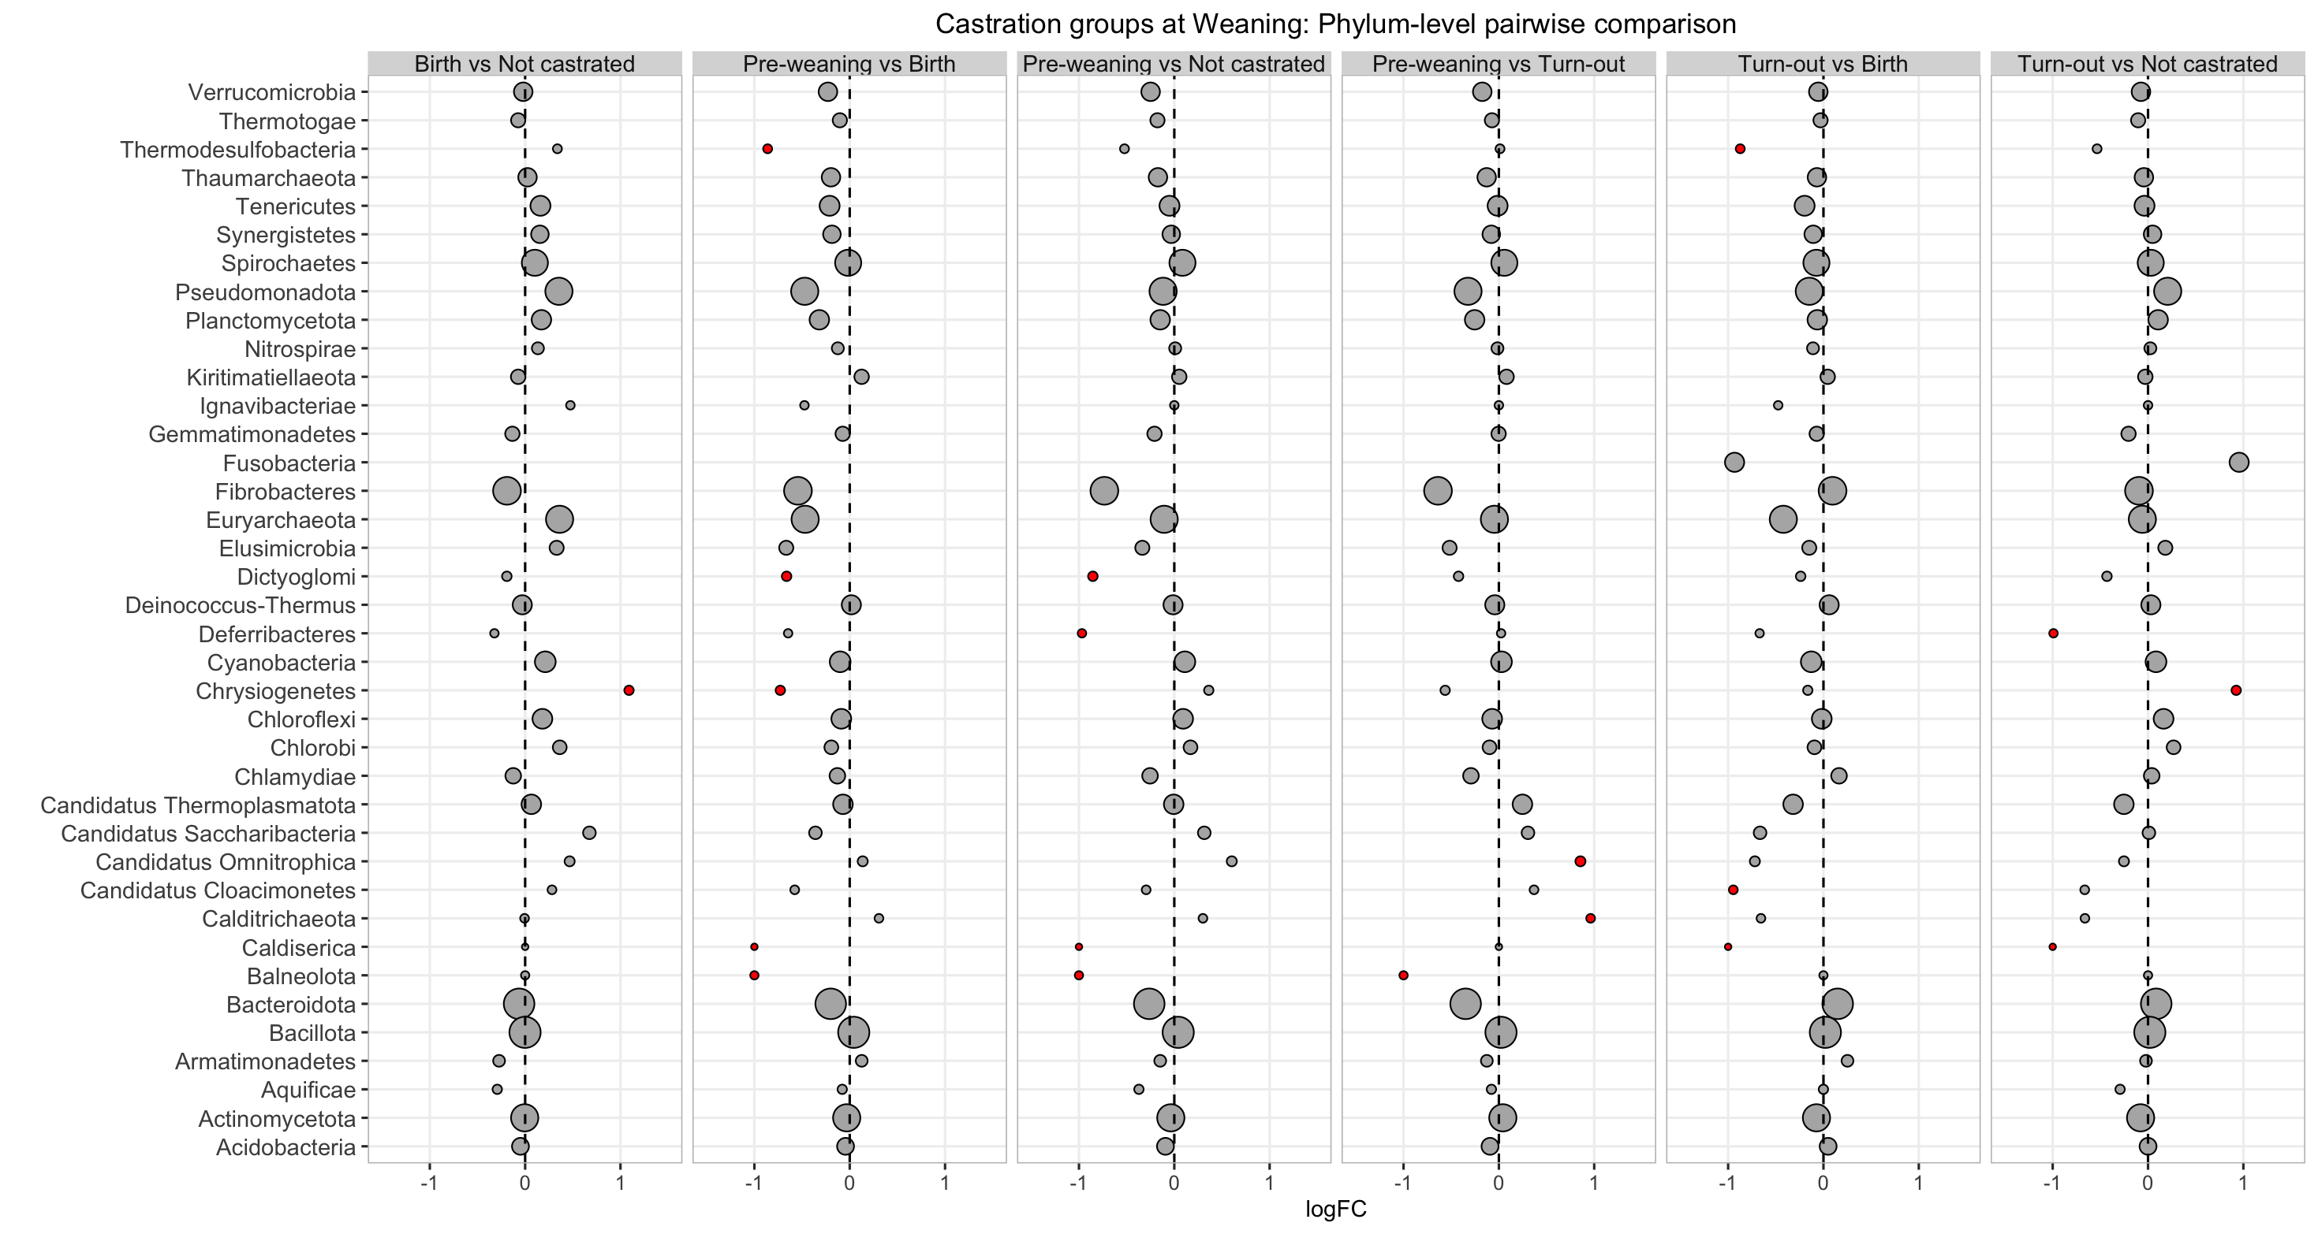

Supplementary Figure 4. Differential abundance of microbial phyla between castration timing groups at weaning day expressed as log2 fold change (LogFC). Statically significant logFC (adjusted P<0.05) are depicted in red and non-significant in grey. Circle diameter is proportional to the average abundance of each phylum across all samples.

Supplementary figure 5. Methane-associated genera and gene content in the rumen, stratified by collection day and weaning strategy. A) Relative abundance plot of genus-level methane-associated microbe composition grouped by collection day and weaning strategy. Taxa with < 1% relative abundance are grouped as “Others”. Each bar corresponds to an individual sample. B) Alpha and C) Beta diversity plots at the methane-associated gene level. Shannon Index is depicted as an alpha diversity index (Boxes represent the 25th to 75th percentile; horizontal line represents the median; and whiskers indicate 1.5× the interquartile range, p-values from Type-III ANOVA). Beta diversity is depicted in a Non-Metric Multidimensional Scaling (NMDS) ordination plot based on Bray–Curtis distances (P and R2 values from PERMANOVA testing).

