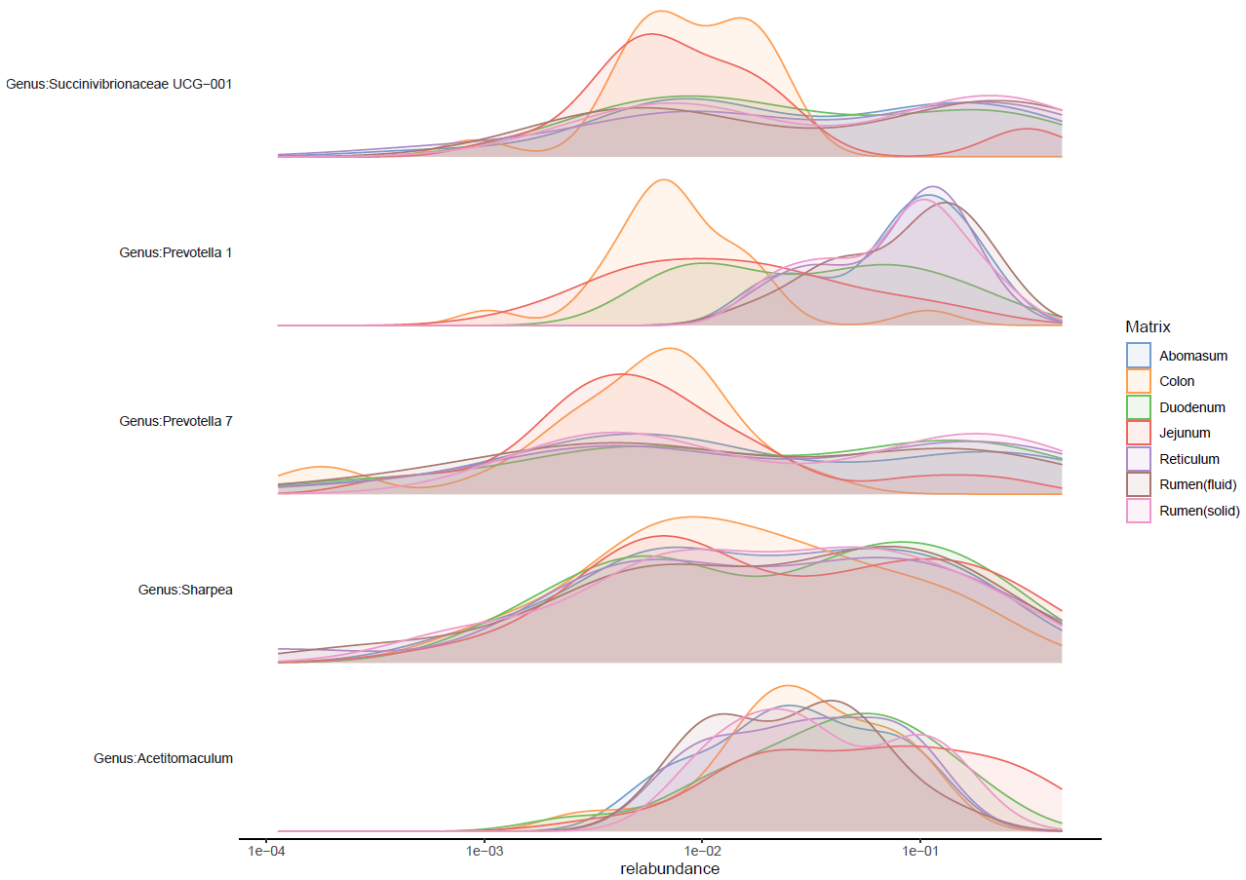
Supplementary Figure 1. Abundances of top five most abundant genera across the gastrointestinal tract of calves, irrespectively of fed starter diets.
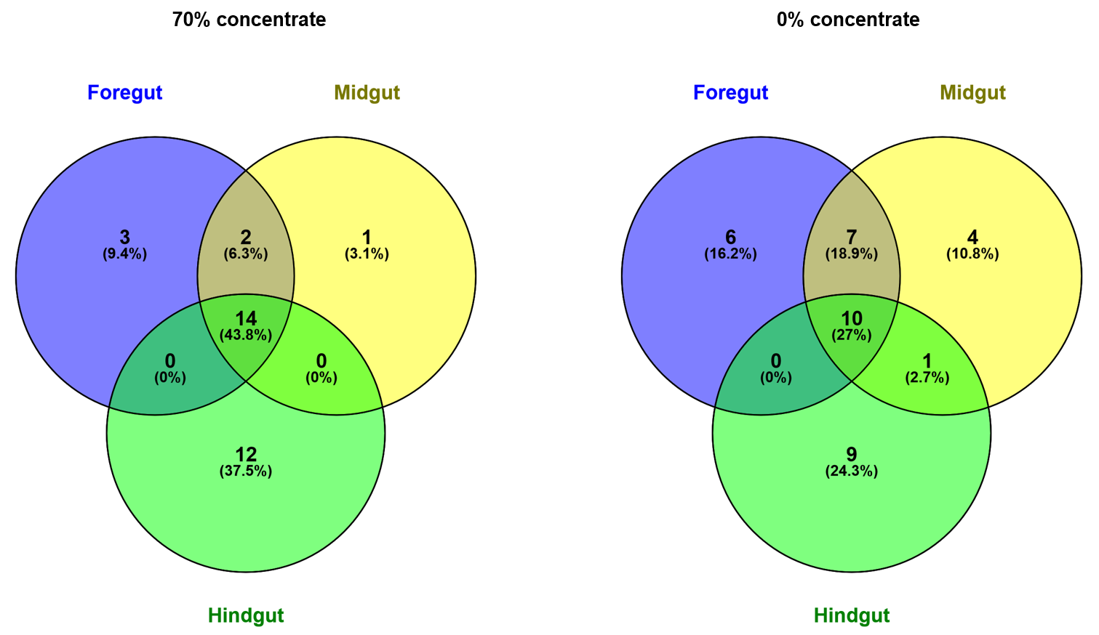
Supplementary Figure 2. Diet-associated common core microbiota at genus level of the three major gut regions fore-, mid- and hindgut in calves fed starter diets with or without 70% concentrate supplementation (on fresh matter basis).
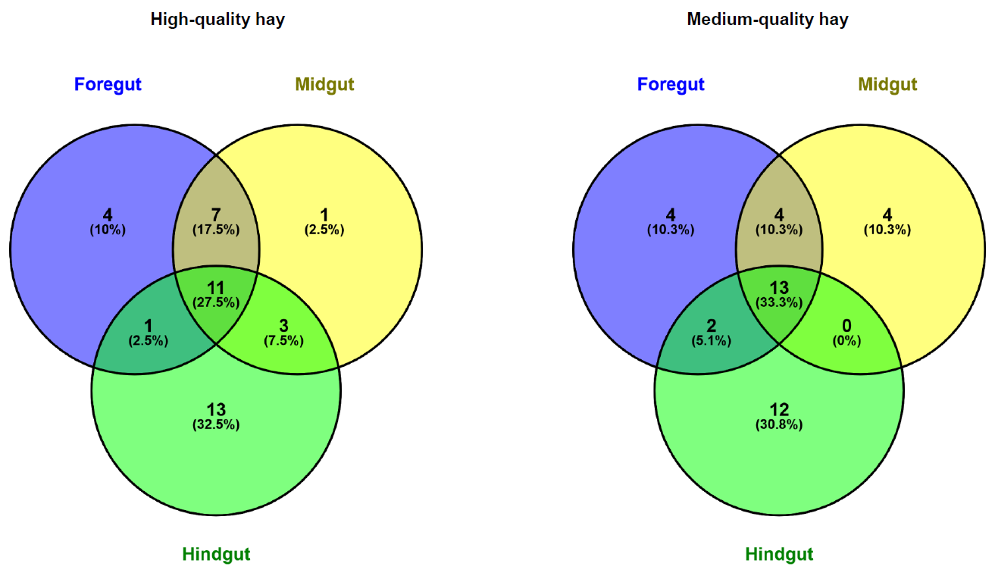
Supplementary Figure 3. Diet-associated common core microbiota at genus level of the three major gut regions fore-, mid- and hindgut in calves fed starter diets with high- or medium-quality hay.

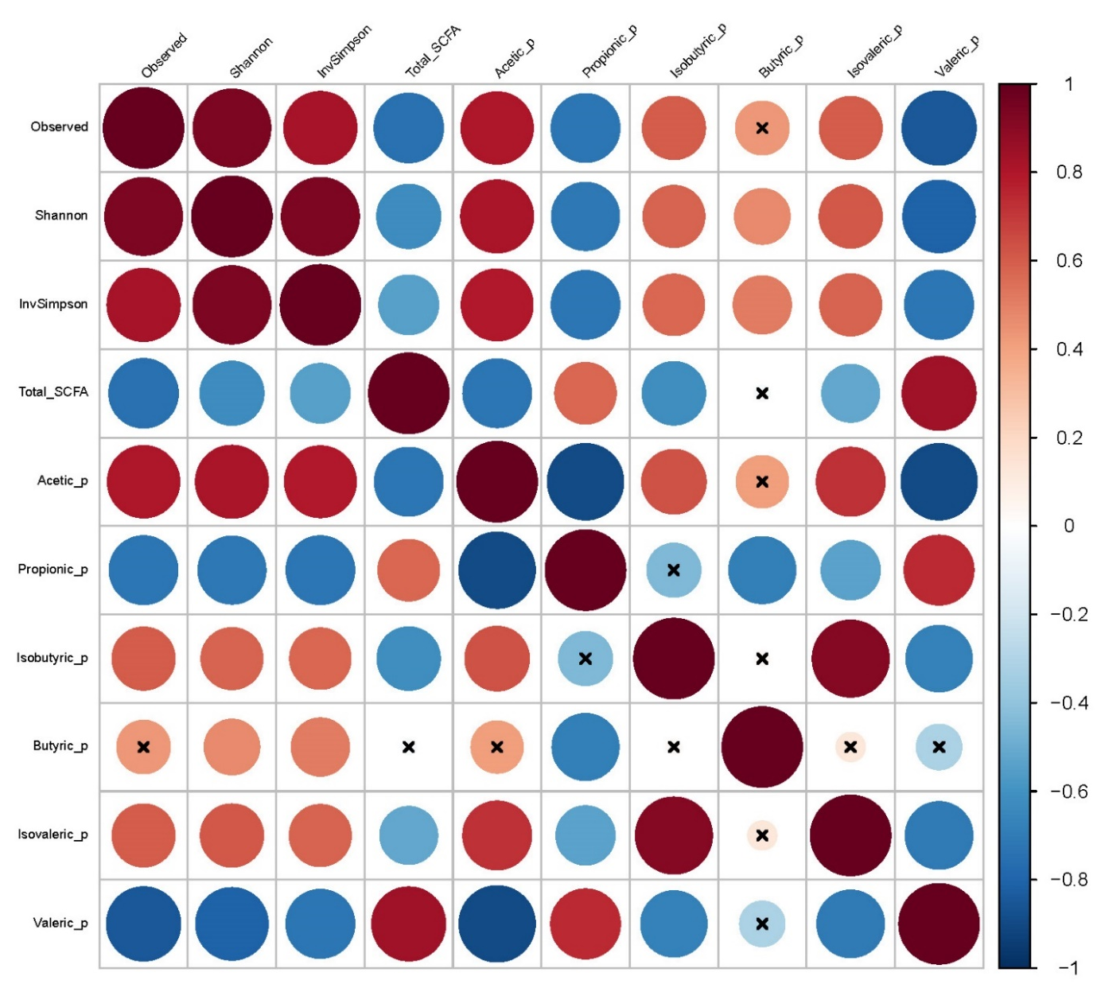
Supplementary Figure 4. Heatmap illustrating correlations between alpha diversity indices and SCFA profiles in the rumen liquid, considering Spearman correlations with P ≤ 0.05 and r > 0.70 or r < -0.70. Correlations not fulfilling these criteria are indicated by a cross.
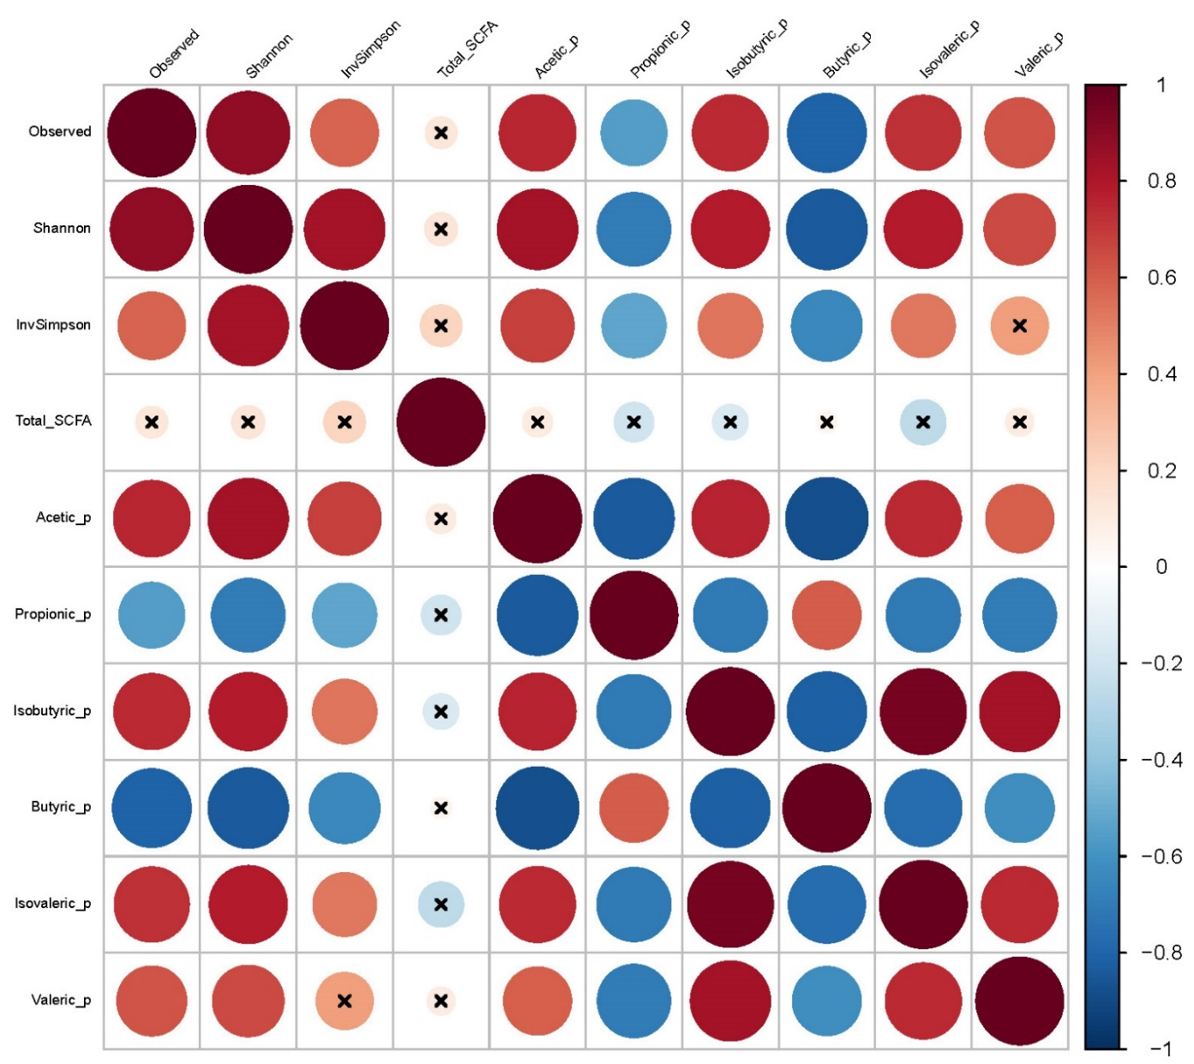
Supplementary Figure 5. Heatmap illustrating correlations between alpha diversity indices and SCFA profiles in the colon, considering Spearman correlations with P ≤ 0.05 and r > 0.70 or r < -0.70. Correlations not fulfilling these criteria are indicated by a cross.

