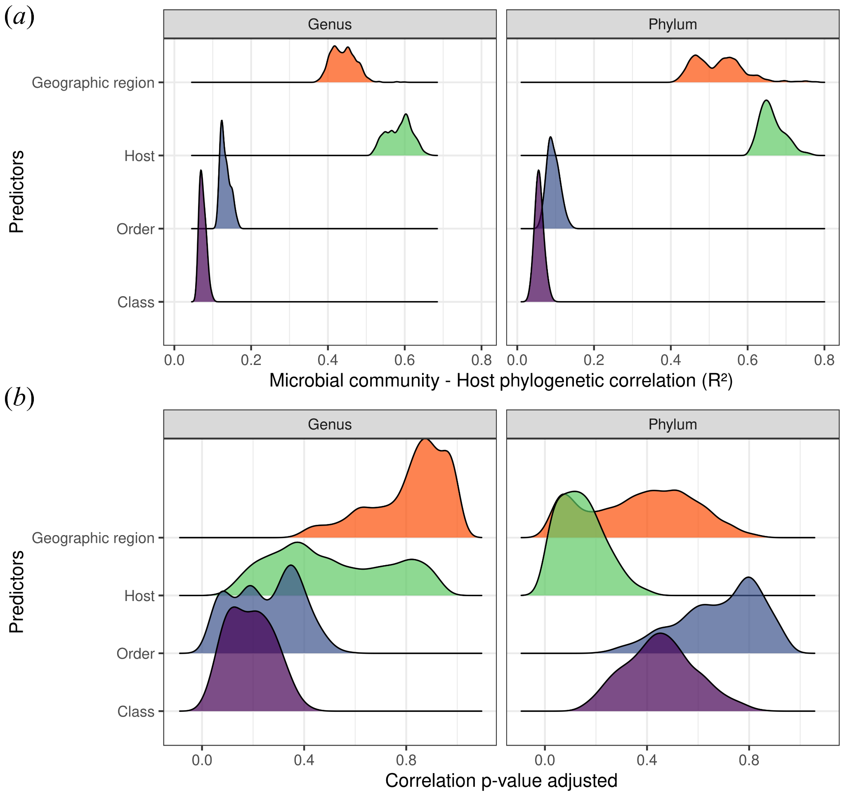

Fig. S1. PERMANOVA findings distribution after random subsampling for beta-diversity analysis: (a) microbial community-predictor correlation and (b) adjusted p-value for covariates (host taxonomy and geographic location) explaining variation in bacterial community structure. Hosts were classified into taxonomic groups (class, order, and species) and evaluated for bacterial taxa at the genus and phylum levels. No effect of host taxonomic grouping or geographic region was observed on the bacterial community structure.

