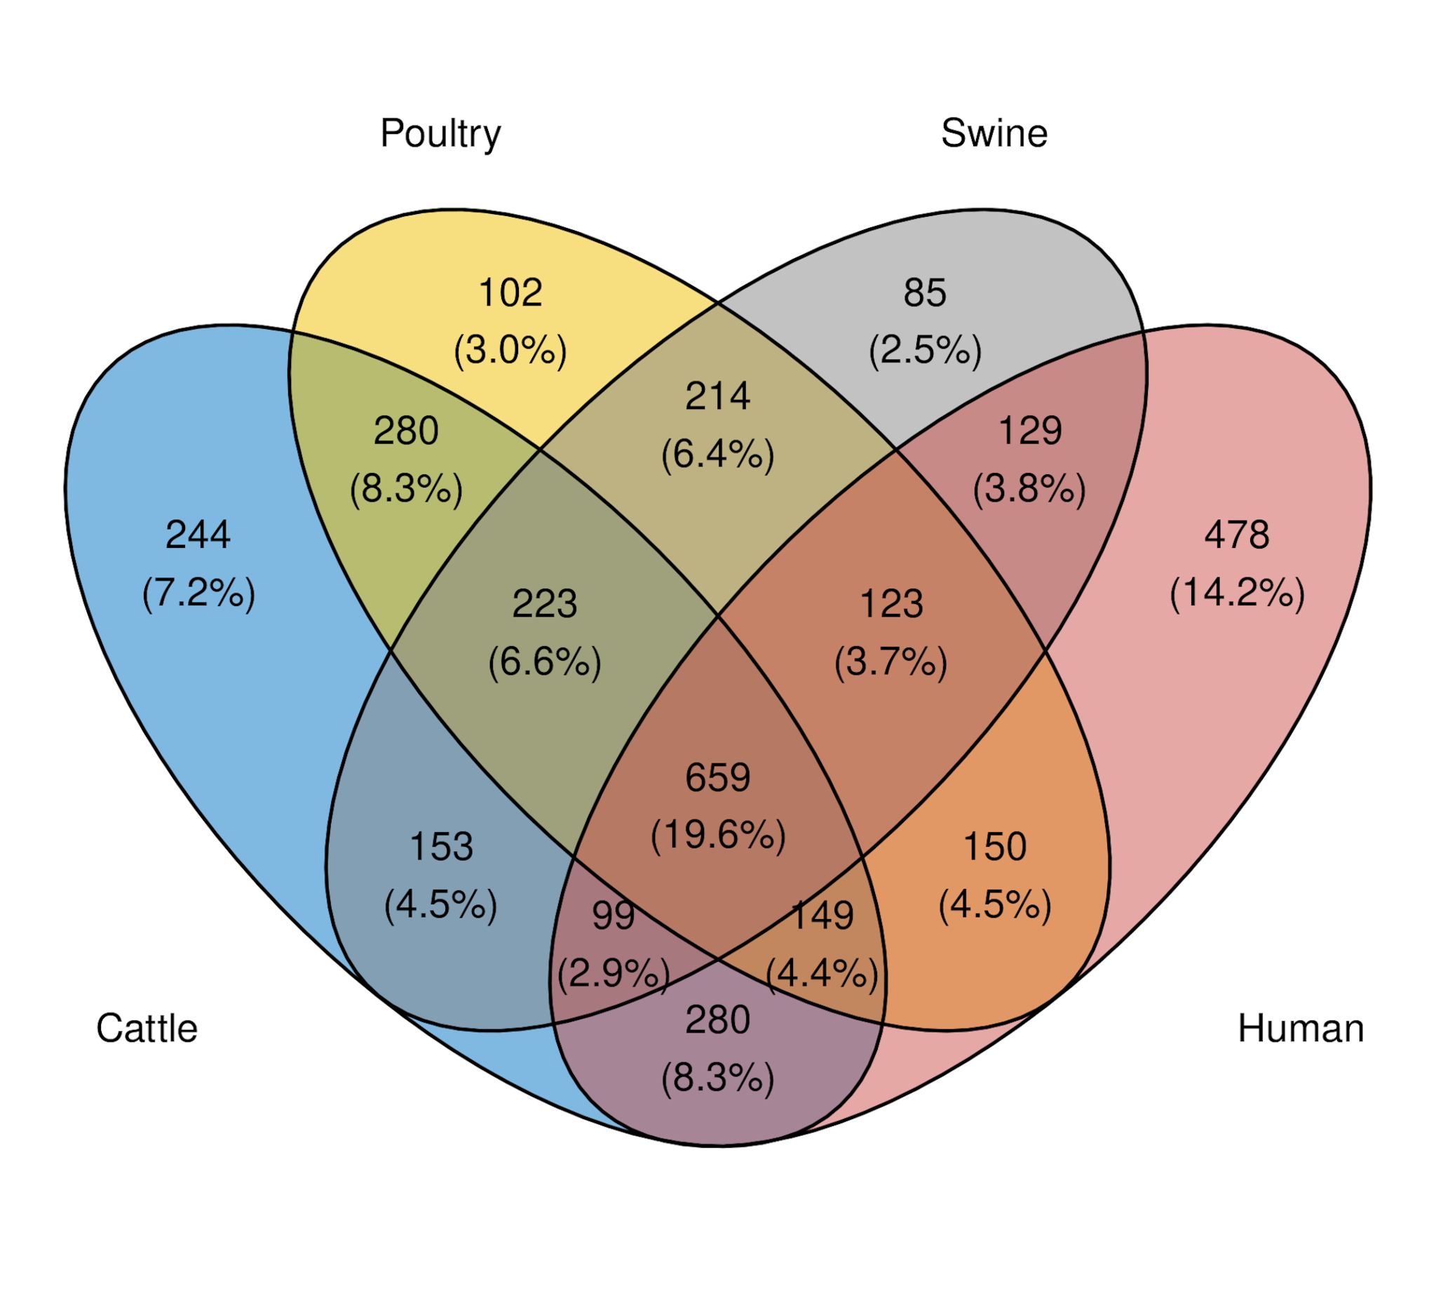
Fig. S2. Overview of common and exclusive monophyletic nodes among target and conspecific hosts and their conspecifics identified by ClaaTU.

