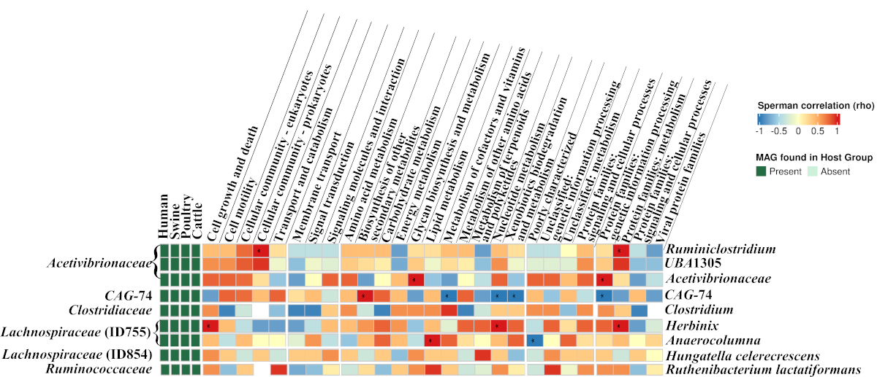

Fig. S3. Correlation between MAGs from sharing vertebrate clades and KEGG metabolic pathways (at the hierarchy level 2). Spearman’s rank correlations were performed with the MAGs’ finer taxonomic levels from each prevalent bacterial family to investigate crucial traits for their transmission and colonization among vertebrate guts.

