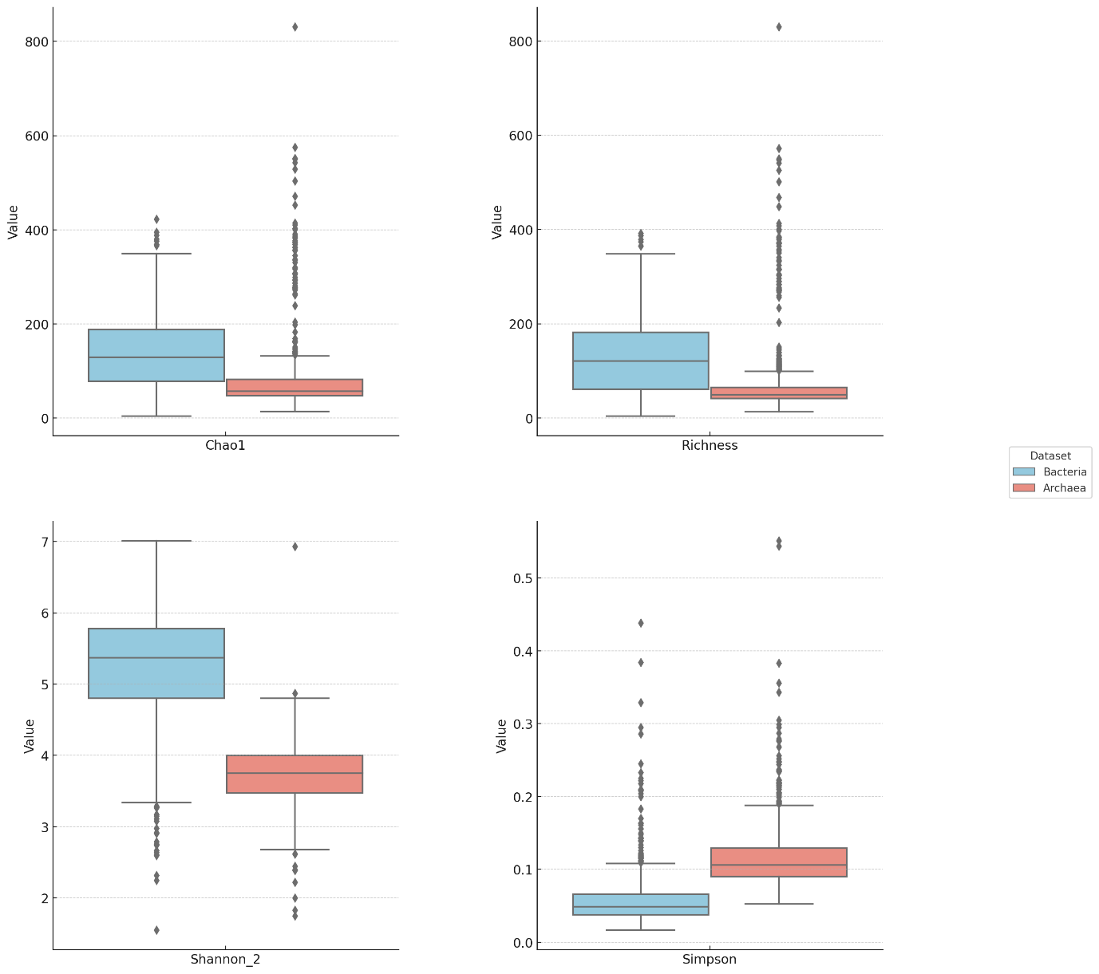
Suppplementary Figure 1: Microbial diversity distribution and variability across samples for Archaea and Bacteria. Alpha diversity: Boxplots display Chao1, richness, Simpson, and Shannon indices, summarizing the microbial diversity within individual samples. Chao1 and richness indices measure species richness, while Simpson and Shannon indices incorporate both richness and evenness. These plots highlight the distribution of diversity across samples for Archaea and Bacteria, reflecting the per-sample quality and variability in microbial diversity.

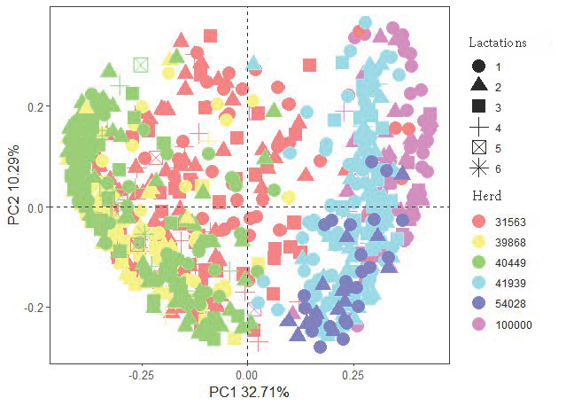
Supplemnentary Figure 2: Factors (lactation and herd) drive segregation of rumen microbiota (archaea and bacteria) visualized using principal component analysis (PCA). PCA was conducted using Bray-Curtis dissimilarity matrices.

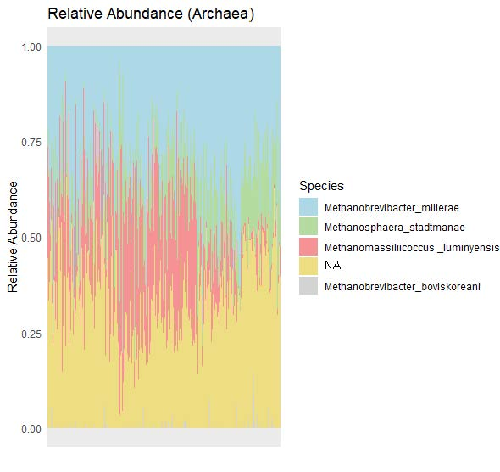
A

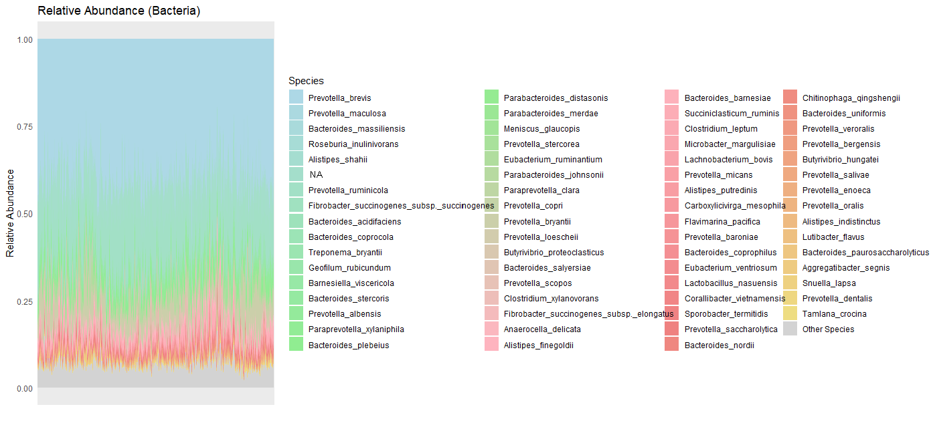
B
Supplementary Figure 3: Relative abundance of rumen microbiota in Holstein cattle. Archaeal and bacterial ASVs were summarized at species (A and B) level. NA in Supplementary Figure 3 means no annotations at species level.

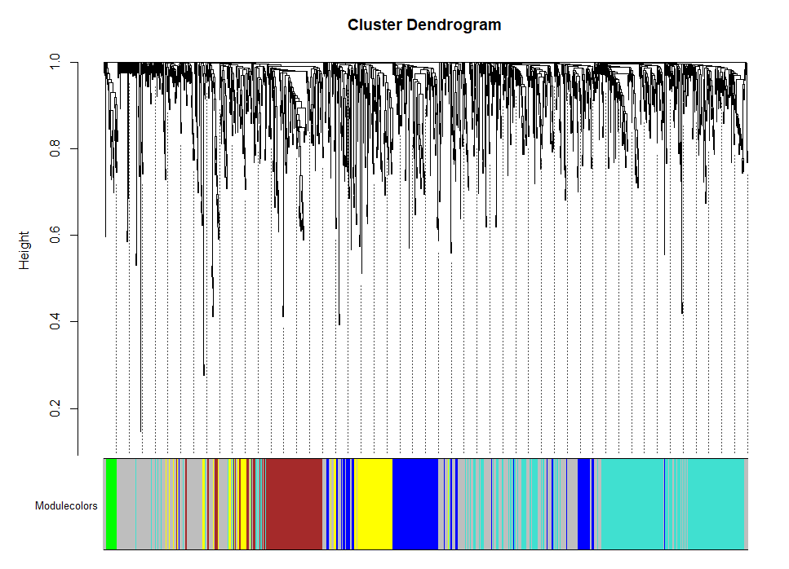

Supplementary Figure 4: Clustering dendrogram for rumen microbiota generated by WGCNA. There were 6 modules, MEgrey, MEgreen, MEyellow, MEbrown, MEblue, and MEturquoise.

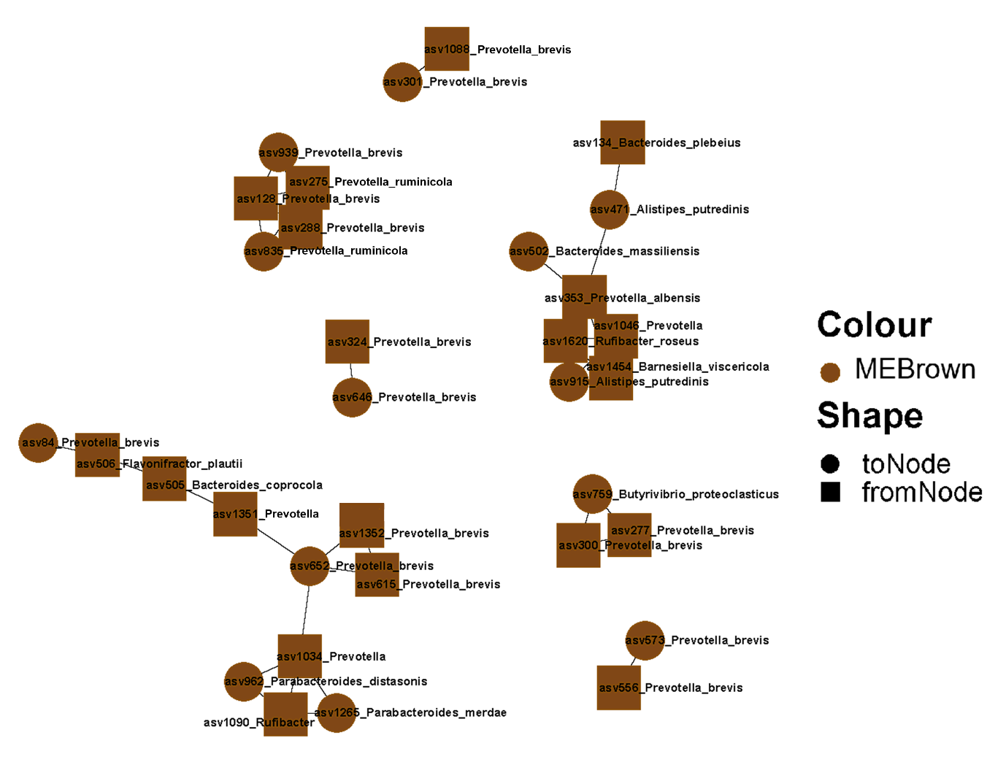

Supplementary Figure 5: WGCNA modules containing microbiota related to Herd with taxonomic annotations at highest level. These taxa were visualized alongside archaeal and bacterial species and genera nodes that significantly correlated to Herd. Nodes’ color represents their modules generated by WGCNA. Node’s shape represents the toNodes and fromNodes.

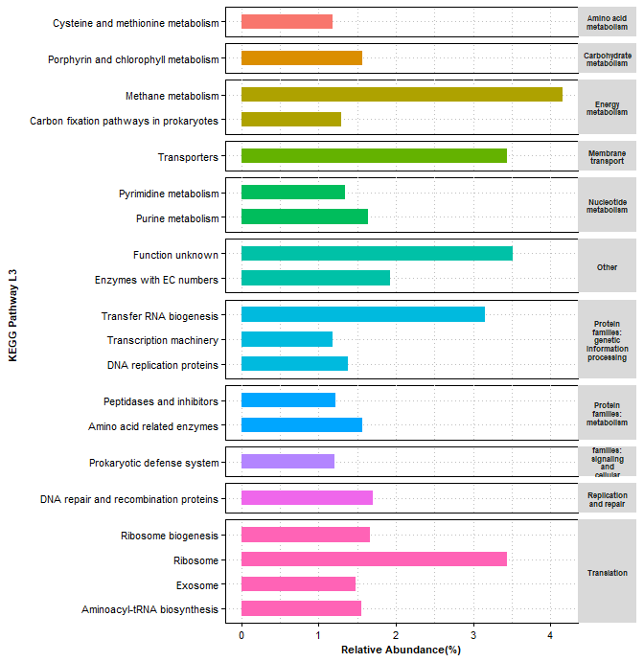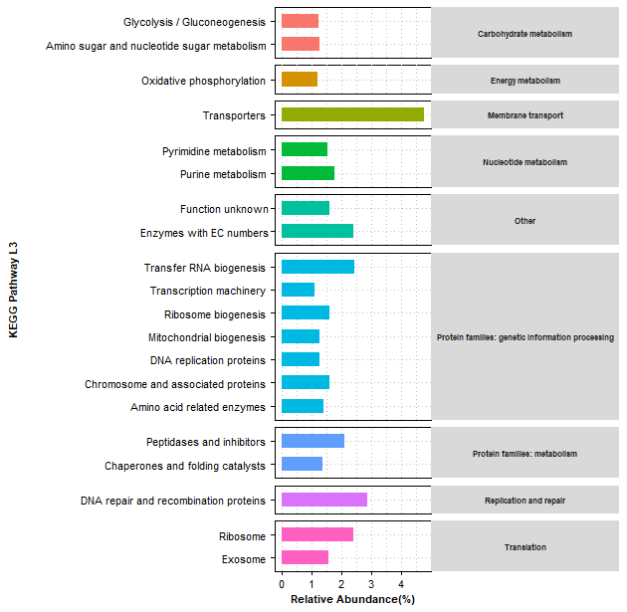
A

B

Supplementary Figure 6: The top abundant level 3 KEGG pathways for archaeal (A), bacterial (B) ASVs. Bar length means the relative abundance of level 3 pathways. Bar colors mean the different catalog of KEGG level 2 pathways.

