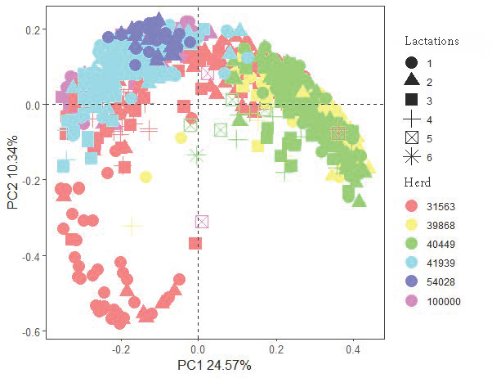
A

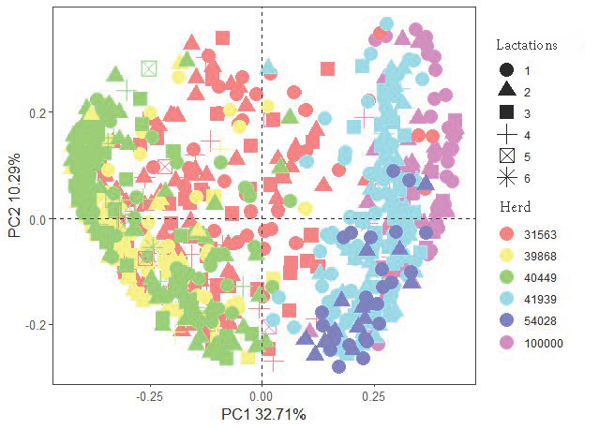
B
Supplemnentary Figure 1: PCA plot for archaea and bacteria. A: PCA plot for OTU samples of archaea and bacteria. B: PCA plot for ZOTU samples of archaea and bacteria. The color pattern represents different herds, and the point shape represents different lactations.

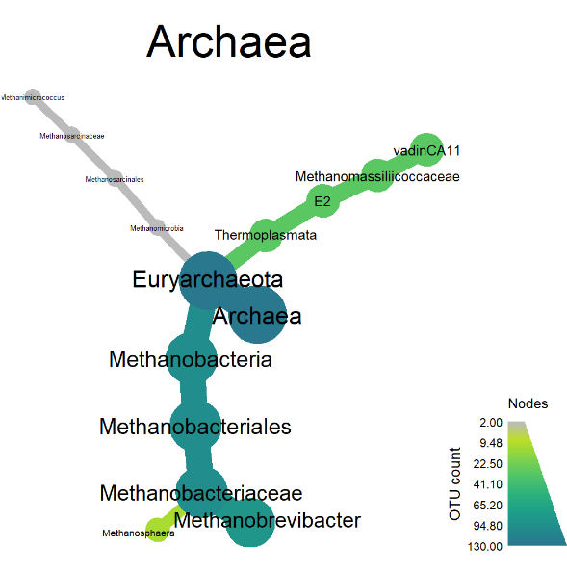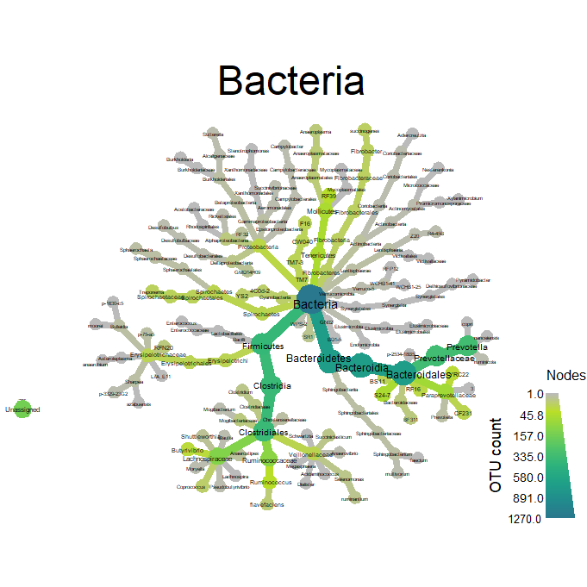
A
B
Supplementary Figure 2: Phylogenetic trees for archaea and bacteria OTUs
A: Archaeal OTUs. B: Bacterial OTUs. Each branch represents each OTU annotation at different taxonomic level. Nodes color represents the counts of OTU taxonomic annotation.

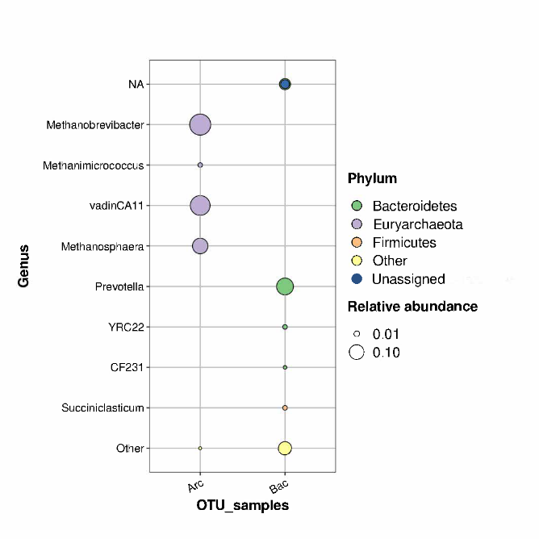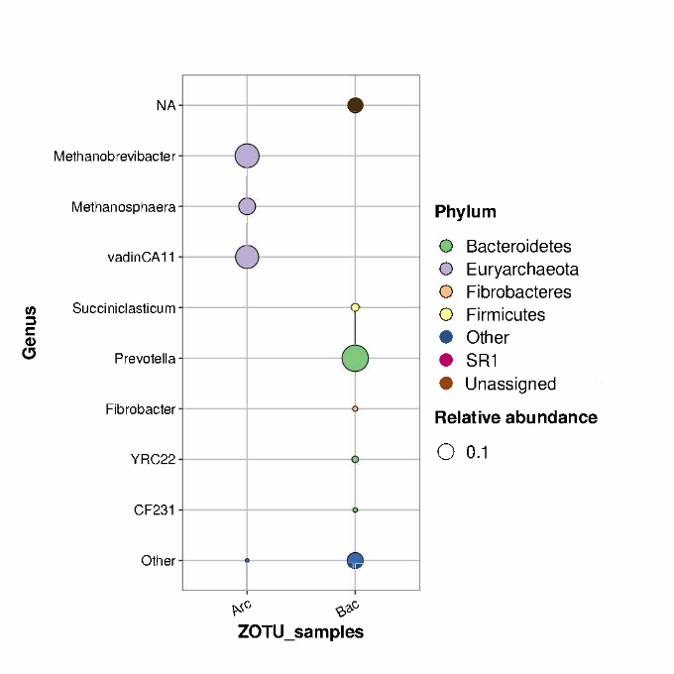
A
B
Supplementary Figure 3: Top relative abundance of OTUs and ZOTUs for archaea and bacteria.
A: Bubble plot for OTUs of archaea and bacteria. B: Bubble plot of ZOTUs of archaea and bacteria. Different colors represent different phylum levels. Bubble size represents the relative abundance of OTUs and ZOTUs for archaeal and bacterial samples.

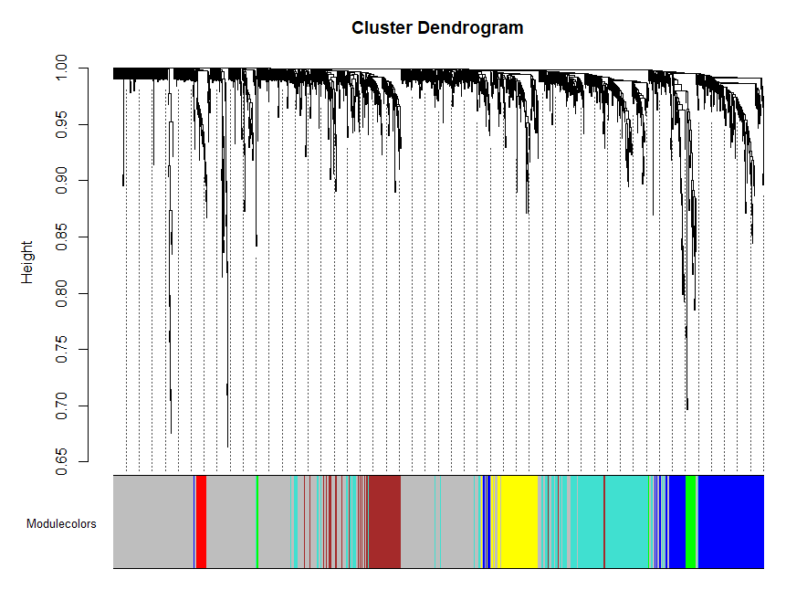
A
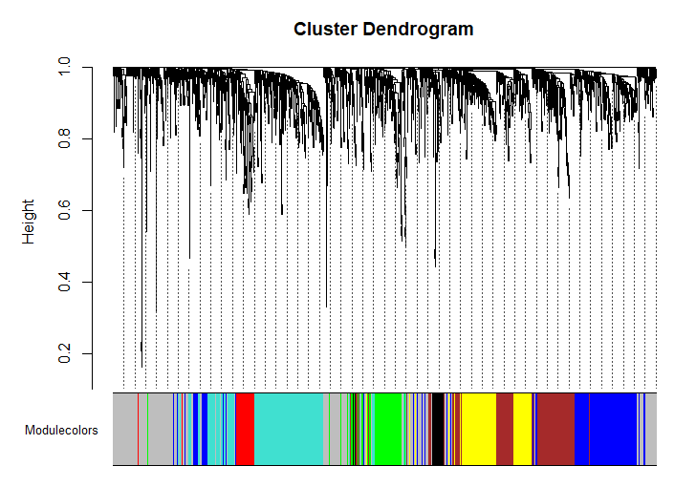
B

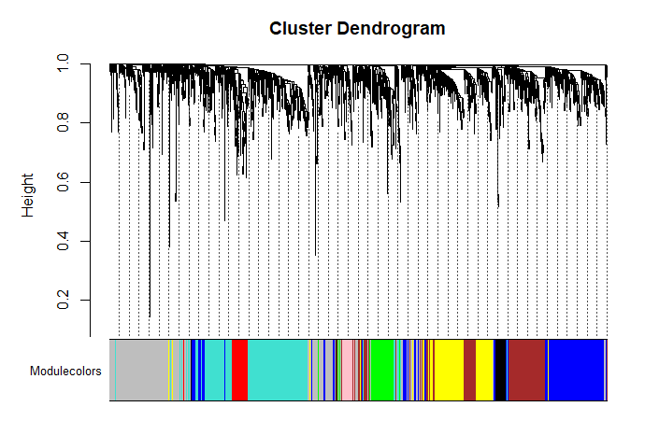
C
Supplementary Figure 4: Cluster dendrogram for OTUs and ZOTUs of archaeal and bacterial samples.
A: Cluster dendrogram for OTUs. B: Cluster dendrogram for ZOTUs. C: Cluster dendrogram for merged datasets. Clustering by height. Different colors represent different modules.

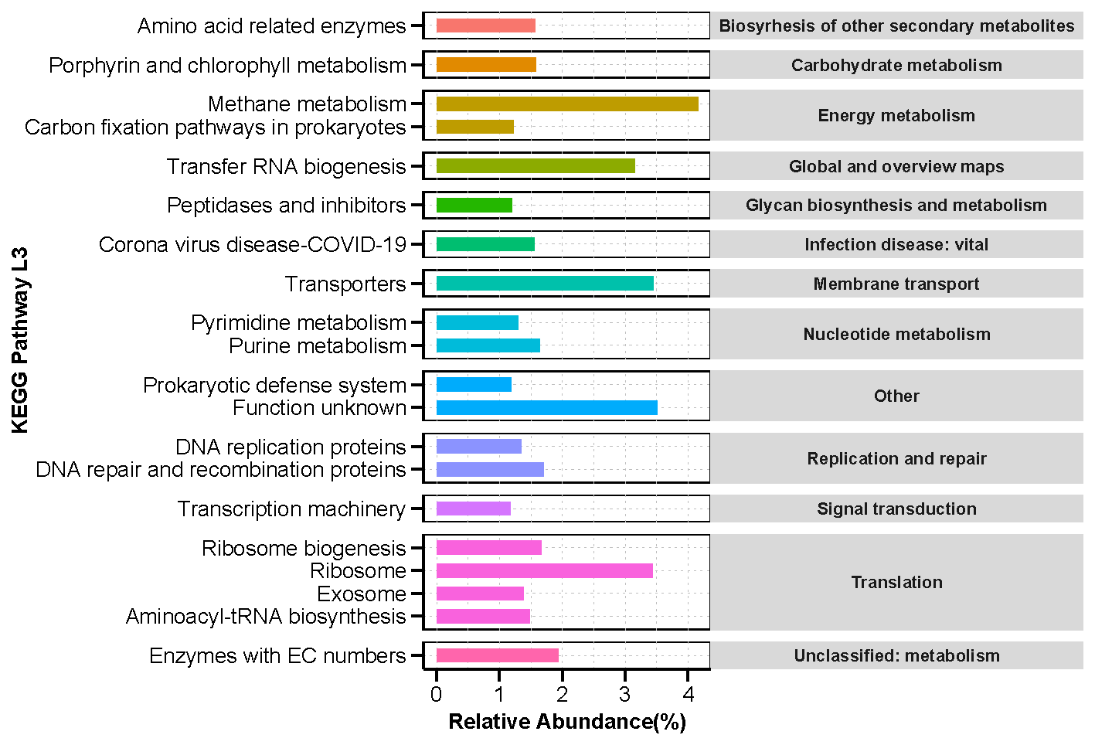
A

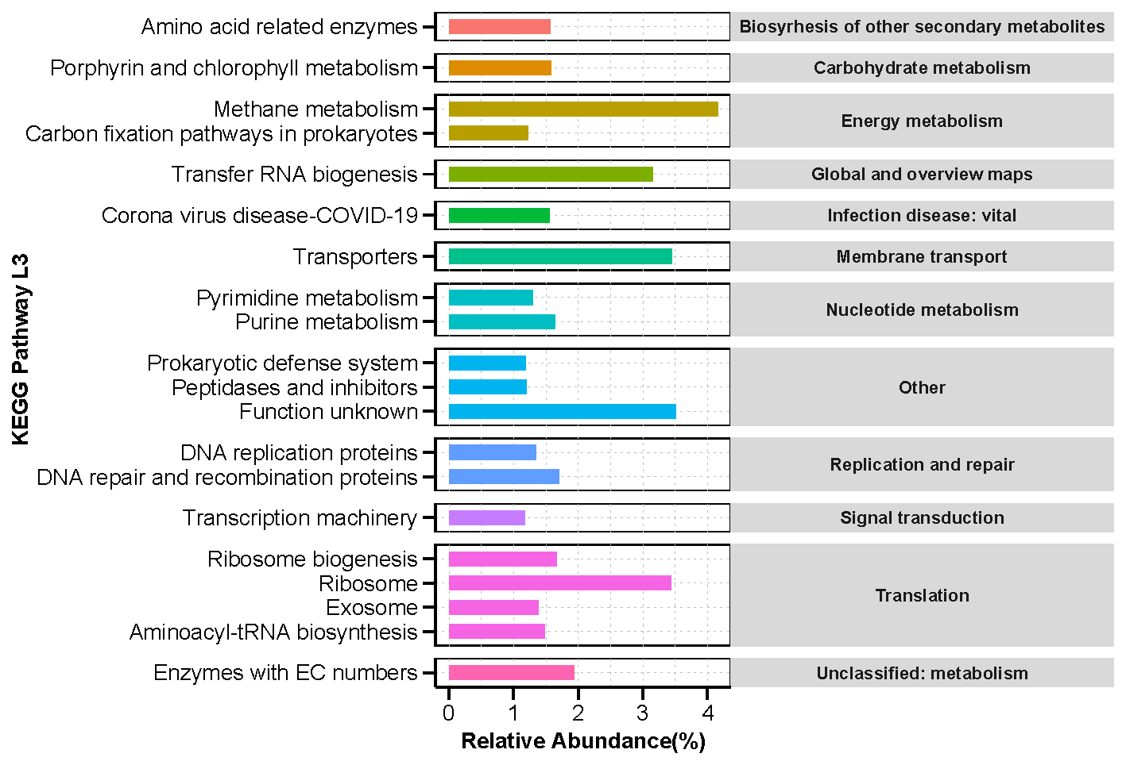
B

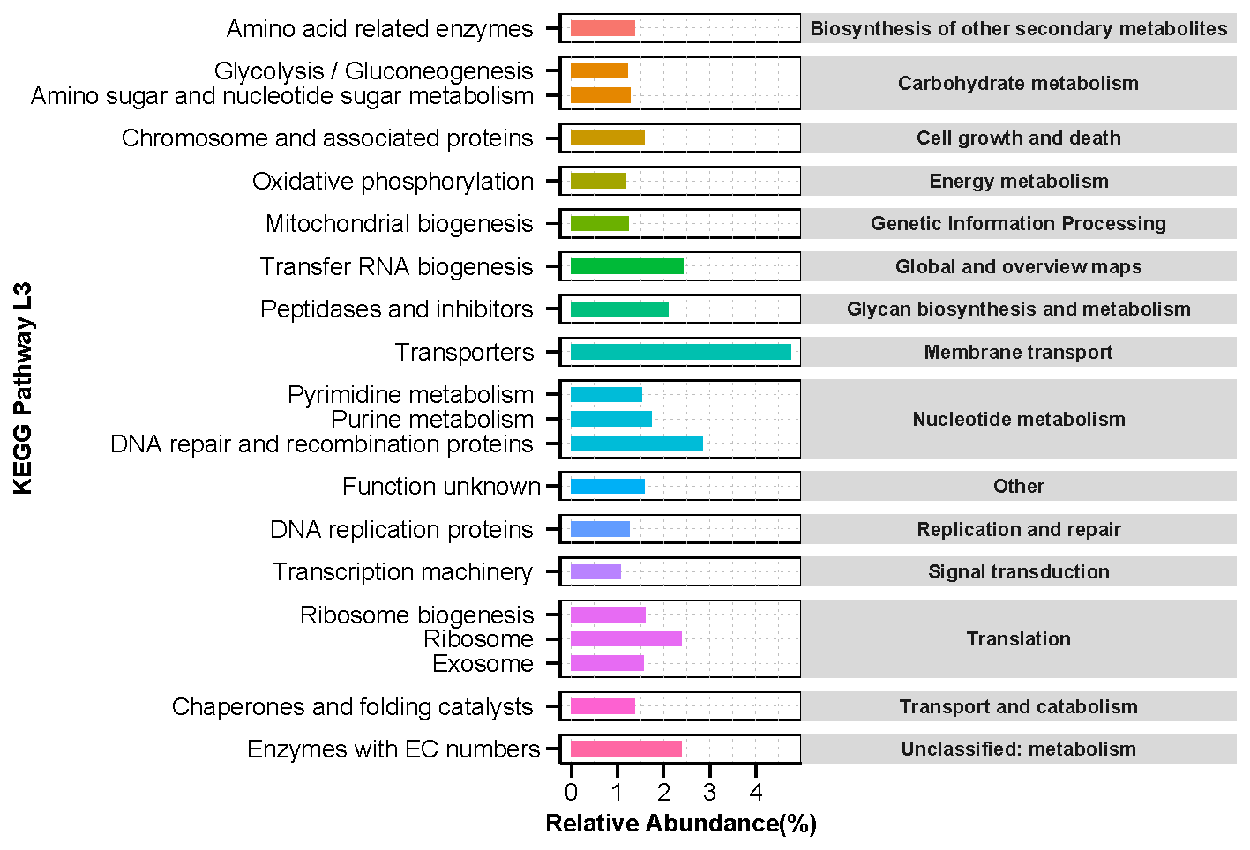
C

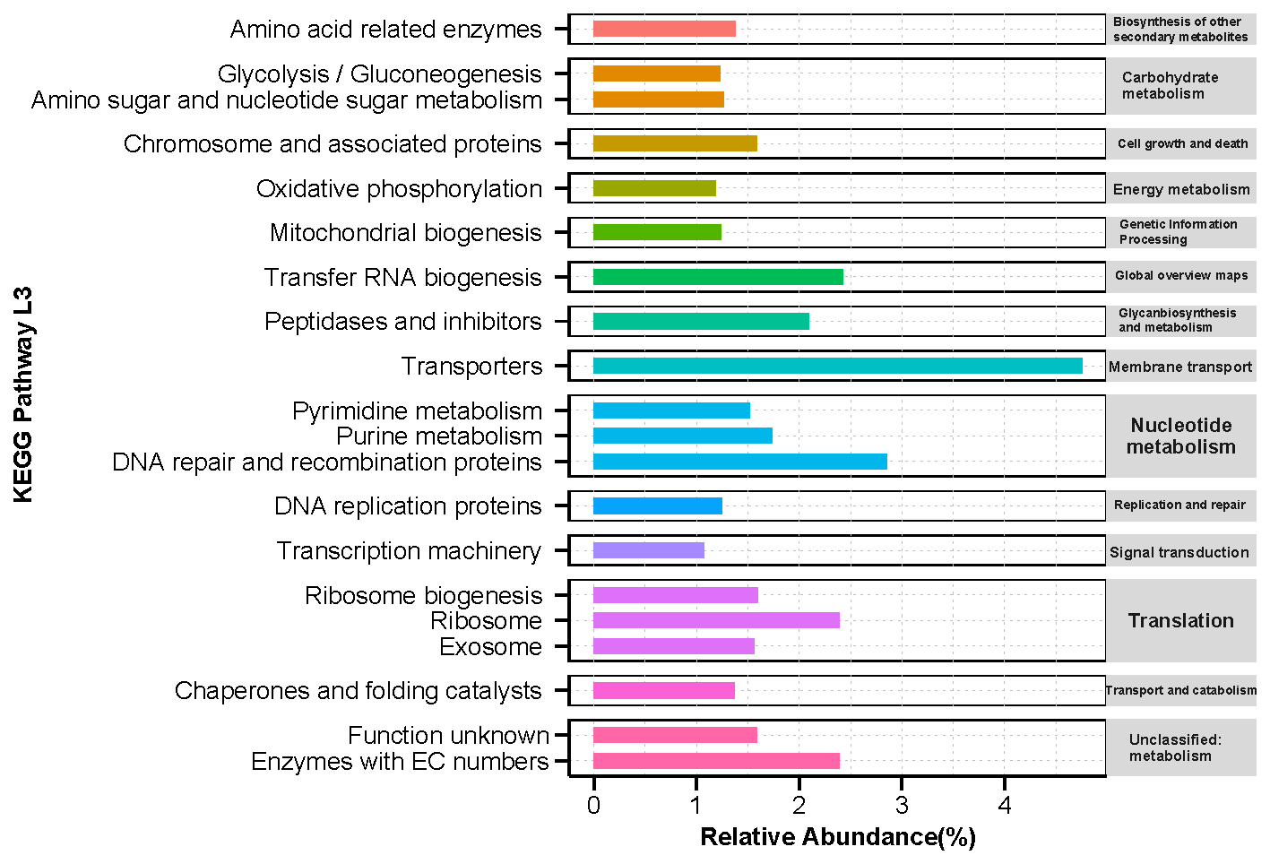
D
Supplementary Figure 5: Bar chart of top 20 KEGG pathways level-3 abundance of archaeal and bacterial OTUs/ZOTUs.
A: Bar chart of KEGG level-3 pathways abundance for archaeal OTUs. B: Bar chart of KEGG level-3 pathways abundance for archaeal ZOTUs. C: Bar chart of KEGG level-3 pathways abundance for archaeal OTUs. D: Bar chart of KEGG level-3 pathways abundance for archaeal ZOTUs. Bar length means the relative abundance of level-3 pathways. Bar colors mean the different catalog of KEGG level-2 pathways.

