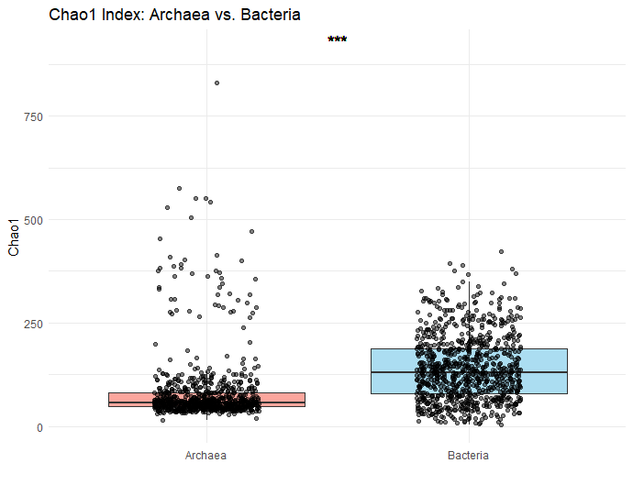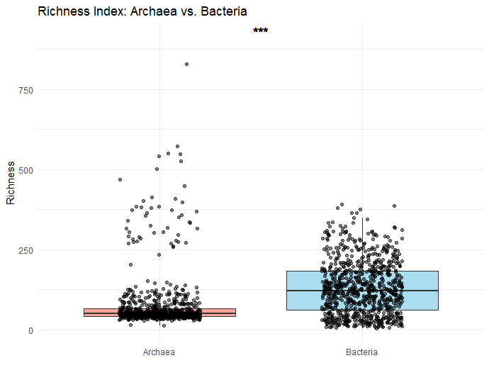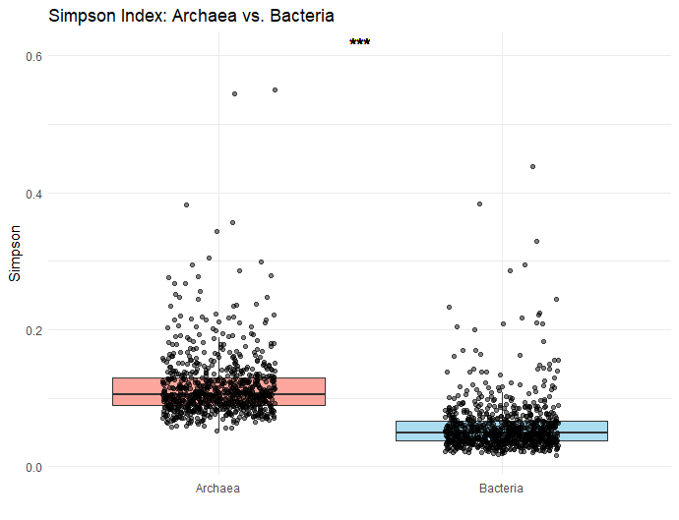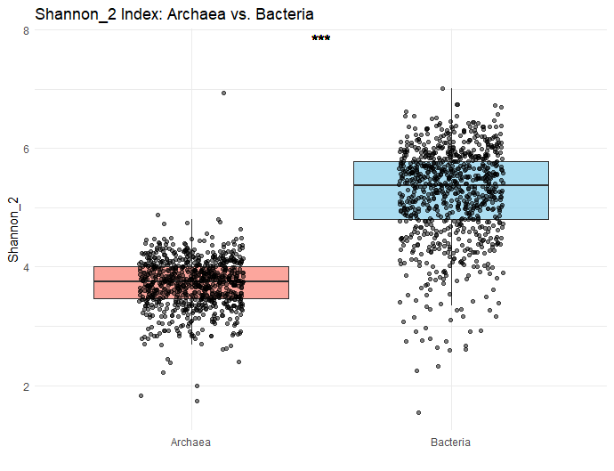
D
C
B
A
Suppplementary Figure 1: Microbial diversity distribution and variability across samples for Archaea and Bacteria. Alpha diversity: Boxplots display Chao1 (A), richness (B), Simpson (C), and Shannon (D) indices, summarizing the microbial diversity within individual samples. Chao1 and richness indices measure species richness, while Simpson and Shannon indices incorporate both richness and evenness. These plots highlight the distribution of diversity across samples for Archaea and Bacteria, reflecting the per-sample quality and variability in microbial diversity. The significant differences between archaea and bacteria alpha indices are shown as *** in figures (P < 0.001).

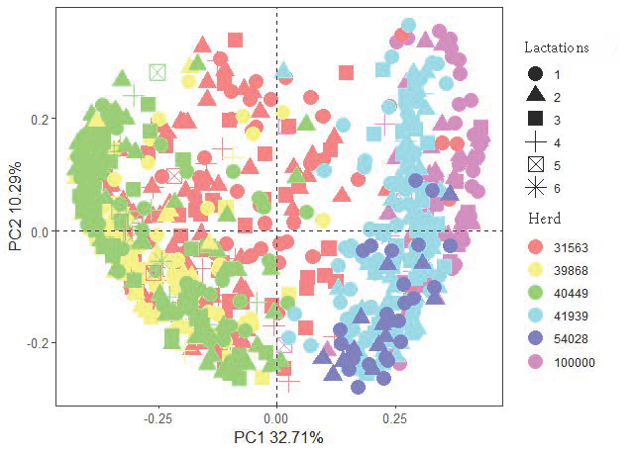
Supplemnentary Figure 2: Factors (lactation and herd) drive segregation of rumen microbiota (archaea and bacteria) visualized using principal component analysis (PCA). PCA was conducted using Bray-Curtis dissimilarity matrices using ASVs.

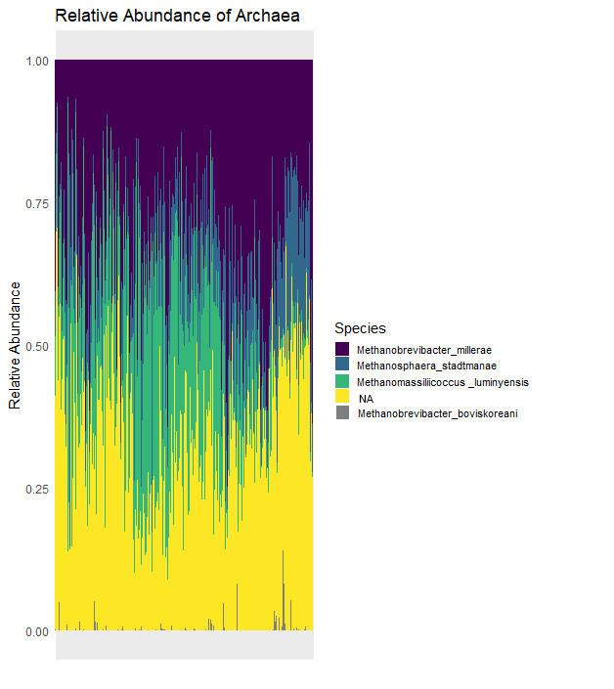
A

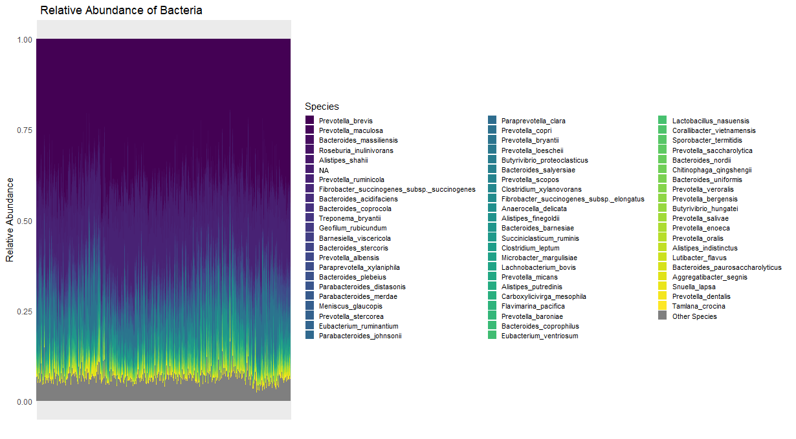
B
Supplementary Figure 3: Relative abundance of rumen microbiota in Holstein cattle. Archaeal and bacterial ASVs were summarized at species (A and B) level. NA means the non-annotations at species level for archaeal and bacterial community in Supplementary Figure 3.

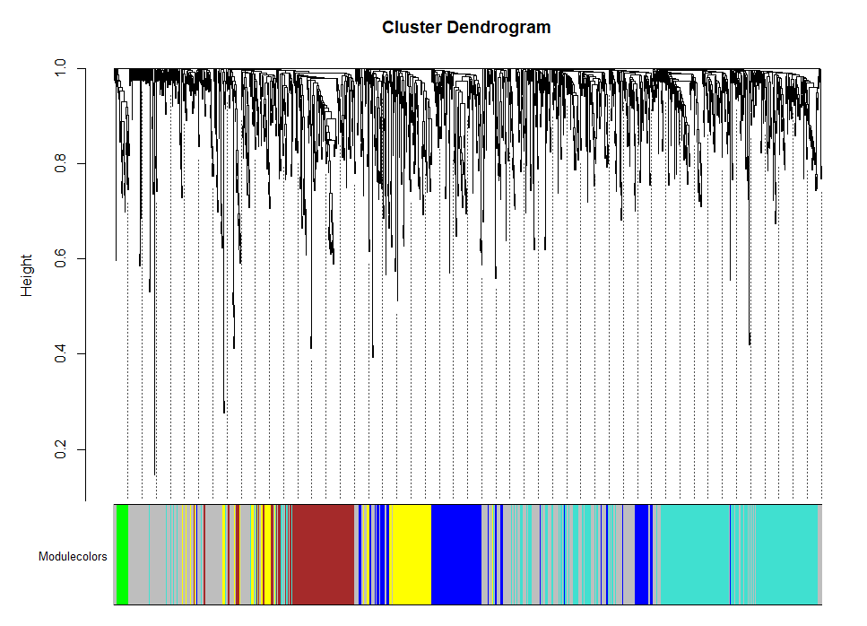

Supplementary Figure 4: Clustering dendrogram for rumen microbiota. There were 6 modules, MEgrey, MEgreen, MEyellow, MEbrown, MEblue, and MEturquoise.

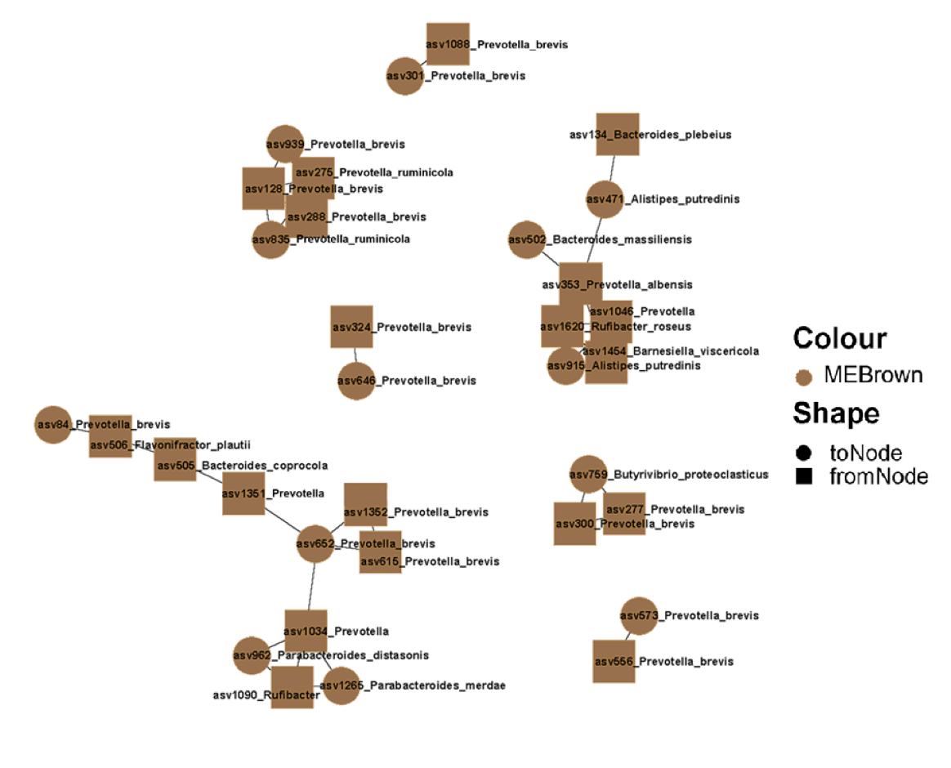

Supplementary Figure 5: WGCNA modules containing microbiota related to Herd with taxonomic annotations at highest level. These taxa were visualized alongside archaeal and bacterial species and genera nodes that significantly correlated to Herd. Nodes’ color represents their modules generated by WGCNA. Node’s shape represents the toNodes and fromNodes.

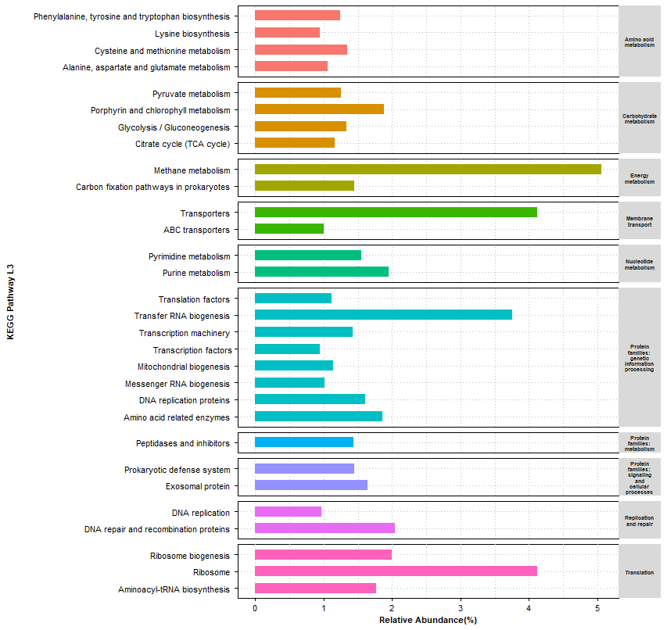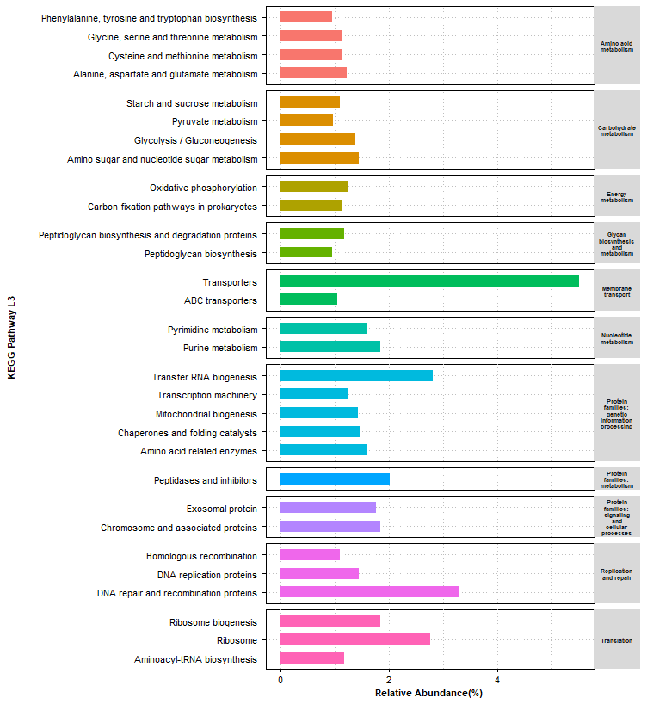
A

B
Supplementary Figure 6: The top 30 abundant level 3 KEGG pathways for archaeal (A) and bacterial (B) ASVs. Bar length means the relative abundance of level 3 pathways. Bar colors mean the different catalog of KEGG level 2 pathways.

