Supplementary materials
A
B
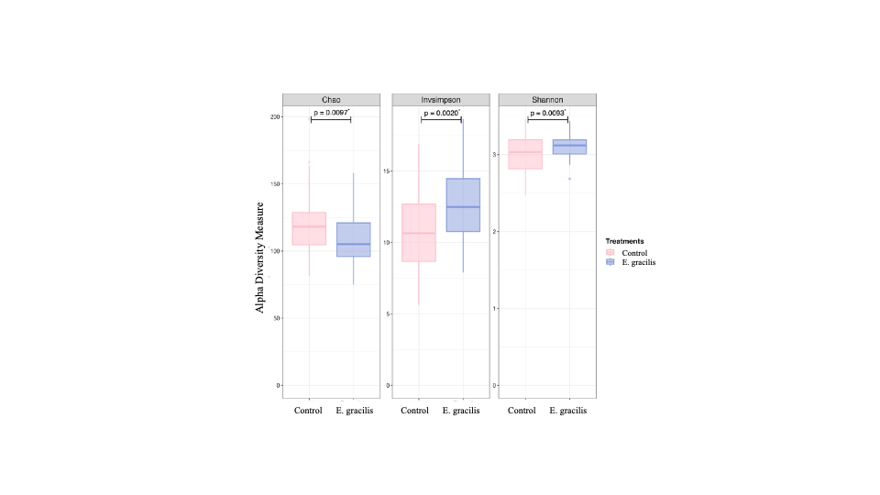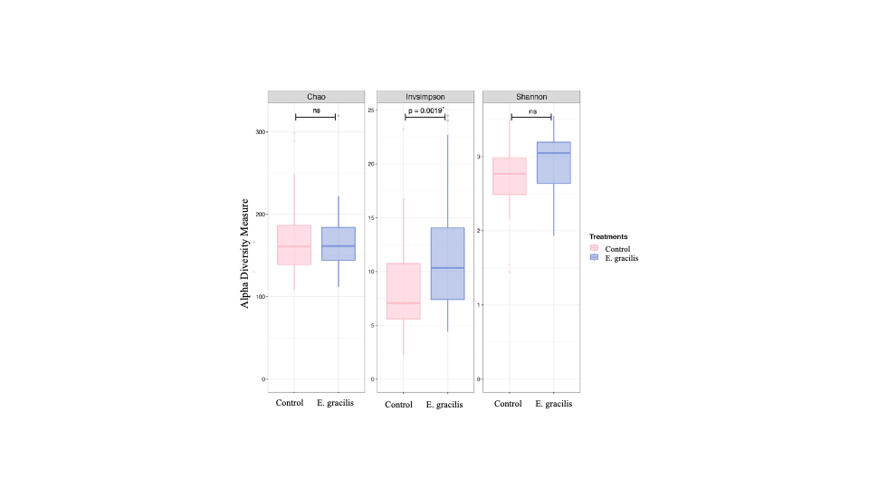
Fig. S1. Effects of E. gracilis on alpha diversity of microbial community estimated at the genus levels by Chao1, Inverse Simpson, and Shannon indices between control (n = 15 sows/group/timepoint; $∎$) and E. gracilis sows (n = 15 sows/group/timepoint; $∎$)(A), and piglets nursed by control sows (n = 15 piglets/group/timepoint; $∎$), and E. gracilis sows (n = 15 piglets/group/timepoint, $∎$) (B). Statistics were tested using ANOVA; P ≤ 0.05 represents a statistically significant difference, and ns represents a non-statistically significant difference.

