Cansado-Utrilla et al. Supplementary files.
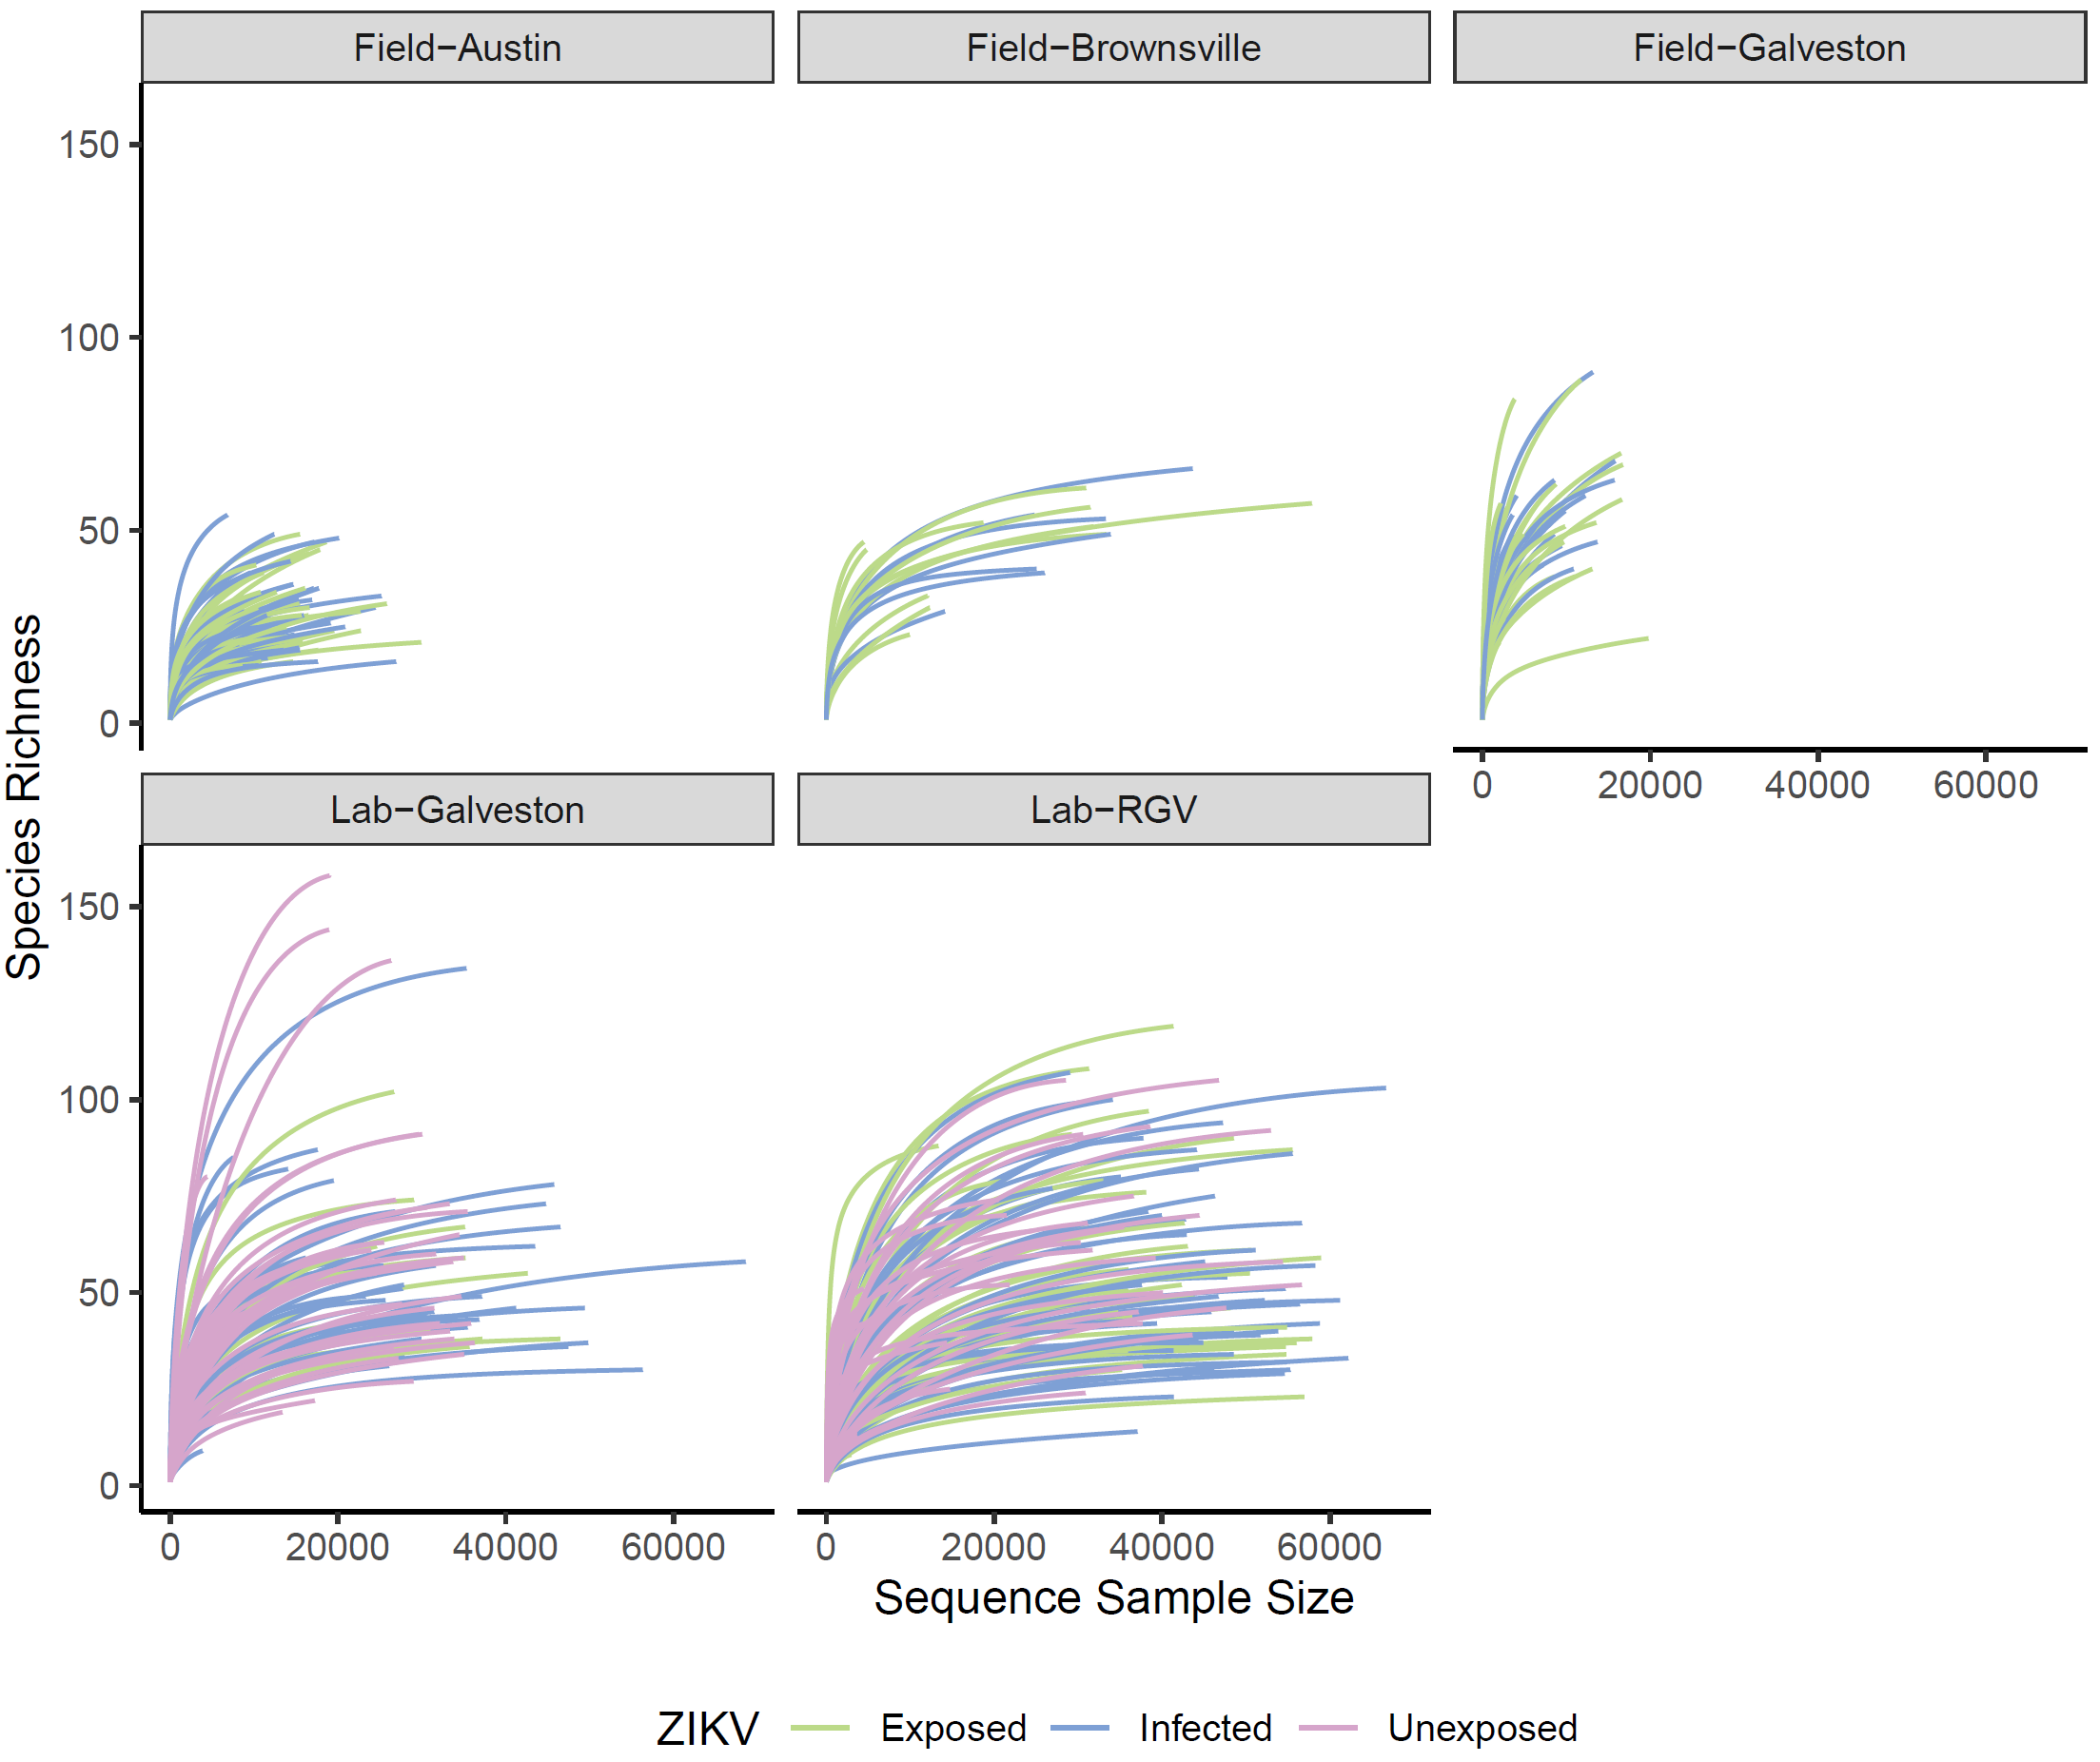

Supplementary Figure 1. Rarefactions curves of all 16S samples facetted by sample type and coloured according to ZIKV infection status. Samples with fewer than 2000 reads in total were removed prior to plotting.

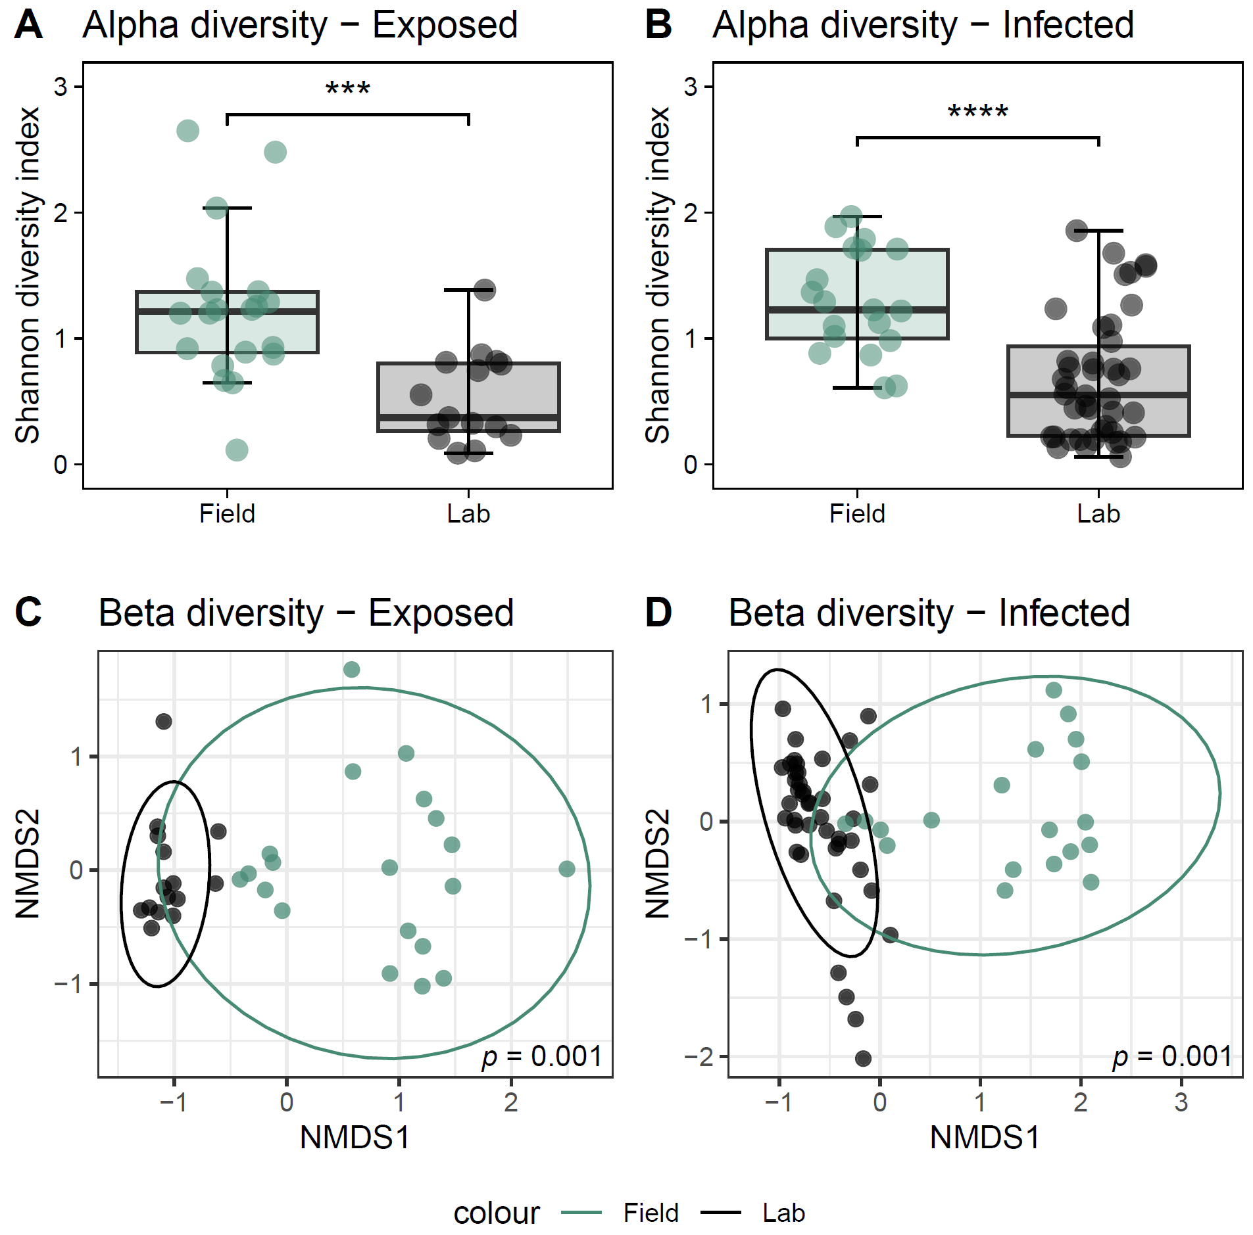

Supplementary Figure 2. Comparison of microbiome diversity and composition between the laboratory-reared line originally derived from Galveston and mosquitoes freshly collected from field traps in Galveston. ZIKV-exposed (A, C) and ZIKV-infected (B, D) mosquitoes were analysed separately. Statistical differences in alpha diversity are shown as **** (p<0.0001) and *** (p<0.001) (Wilcoxon Rank Test) (A, B). Pairwise PERMANOVA was used for statistical analysis of the Bray-Curtis dissimilarity distance of microbiomes (C, D). Beta diversity was significantly different between laboratory and field mosquitoes in the exposed and infected groups (PERMANOVA, p=0.001).

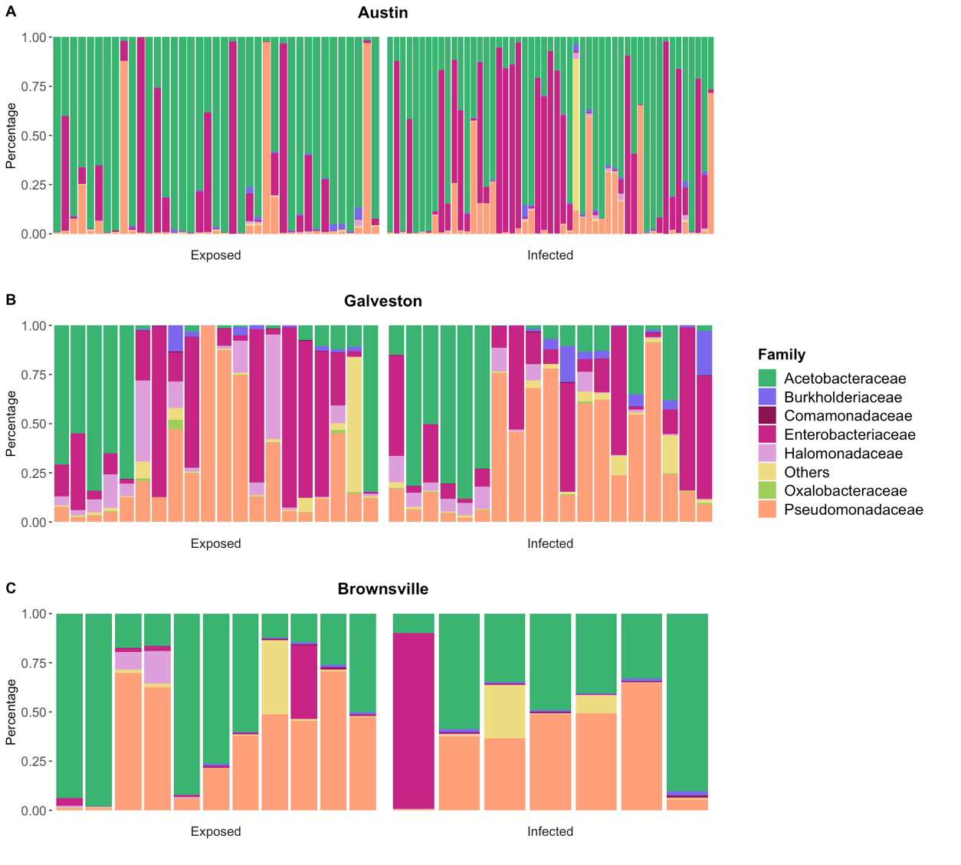
Supplementary Figure 3. Impact of ZIKV on the relative abundance of microbial taxa in field-collected Ae. aegypti mosquitoes. Relative abundance of bacterial families was explored in Austin (A), Galveston (B) and Brownsville (C) mosquitoes either ZIKV exposed or ZIKV infected.

