Probiotic effect of B. subtilis PS-216 in broiler chickens: modulation of weight, feed conversion, SCFA, microbiota and meat quality

Supplementary Information

Table S1. Composition and calculated nutrient content of the experimental diets fed to broiler chickens during the starter (1-15 d) and finisher (16-43 d) period.
 | Starter | Finisher
Composition of experimental diets¹, %
Maize | 42.65 | 42.76
Wheat | 15.00 | 20.00
Soya meal | 35.48 | 29.35
Molasses | 0.02 | -
Plant oil | 2.87 | 4.05
L-lysine-HCl | 0.28 | 0.29
DL-methionine | 0.21 | 0.22
L-threonine | 0.14 | 0.11
Monocalcium phosphate | 0.90 | 0.74
Limestone | 1.26 | 1.05
Salt | 0.22 | 0.23
Mineral-vitamin supplement^{2,3} | 0.50 | 0.50
Calculated energy and nutrient content
Metabolizable energy, MJ/kg | 12.40 | 13.10
Crude protein, % | 21.00 | 19.00
Lysine, % | 1.30 | 1.15
Methionine, % | 0.50 | 0.48
Calcium, % | 1.00 | 0.90
Available phosphorus, % | 0.57 | 0.52
Sodium, % | 0.18 | 0.18
¹All diets contain coccidiostat Maxiban® G160 (Elanco Products Co., Hook, Hampshire, UK).
²Calculated to meet the mineral and vitamin requirements for Ross 308 broiler starter diets and provided per kilogram of the diet: Cu 15 mg, Fe 50 mg, Mn 100 mg, Se 0.3 mg, Zn 80 mg, vitamin A 13.500 IU, vitamin D₃ 5000 IU, vitamin E 80 IU, vitamin K 4.08 mg, thiamine (B₁) 4.02 mg, riboflavin (B₂) 12.0 mg, niacin (B₃) 70.4 mg, pyridoxine (B₆) 5.05 mg, biotin 0.20 mg, folic acid 1.97 mg, vitamin B₁₂ 0.03 mg.
³Calculated to meet the mineral and vitamin requirements for Ross 308 broiler finisher diets and provided per kilogram of the diet: Cu 15 mg, Fe 40 mg, Mn 100 mg, Se 0.3 mg, Zn 74 mg, vitamin A 10.000 IU, vitamin D₃ 5000 IU, vitamin E 55 IU, vitamin K 3,2 mg, thiamine (B₁) 3.0 mg, riboflavin (B₂) 12.0 mg, niacin (B₃) 70.4 mg, pyridoxine (B₆) 3.05 mg, biotin 0.20 mg, folic acid 1.8 mg, vitamin B₁₂ 0.0016 mg.
Table S2. Proximate composition and concentration of minerals of the starter experimental diets.
Component | Dietary treatments¹
Component | Control/SW | SF1 | SF2
Dry matter, g/kg | 881.95 | 882.73 | 881.92
Crude protein, g/kg | 205.42 | 206.30 | 207.34
Crude fat, g/kg | 46.12 | 46.95 | 46.89
Crude ash, g/kg | 53.08 | 51.02 | 53.50
Crude fiber, g/kg | 37.70 | 36.87 | 38.12
Nitrogen free extract, g/kg | 539.63 | 541.59 | 536.07
K, g/kg | 11.85 | 12.04 | 11.90
Ca, g/kg | 8.08 | 8.47 | 8.61
P, g/kg | 5.88 | 5.52 | 5.34
Mg, g/kg | 2.13 | 2.19 | 2.13
Na, g/kg | 1.30 | 1.29 | 1.64
Fe, mg/kg | 191.75 | 166.63 | 170.13
Zn, mg/kg | 169.69 | 178.13 | 161.25
Mn, mg/kg | 146.31 | 160.31 | 160.81
Cu, mg/kg | 22.68 | 22.50 | 22.49
¹All values are means of two analyses per measured sample.

Table S3. Proximate composition and concentration of minerals of the finisher experimental diets.
Component | Dietary treatments¹
Component | Control/SW | SF1 | SF2
Dry matter, g/kg | 881.95 | 882.73 | 881.92
Crude protein, g/kg | 190.41 | 191.01 | 187.45
Crude fat, g/kg | 63.40 | 59.86 | 62.64
Crude ash, g/kg | 53.68 | 55.15 | 54.55
Crude fiber, g/kg | 38.05 | 38.30 | 38.13
Nitrogen free extract, g/kg | 543.14 | 545.60 | 548.19
K, g/kg | 10.44 | 10.85 | 10.27
Ca, g/kg | 8.94 | 8.91 | 9.05
P, g/kg | 5.34 | 5.43 | 5.37
Mg, g/kg | 2.10 | 2.12 | 2.10
Na, g/kg | 1.63 | 1.54 | 1.70
Fe, mg/kg | 173.88 | 166.44 | 176.88
Zn, mg/kg | 155.94 | 144.38 | 147.19
Mn, mg/kg | 196.88 | 164.00 | 153.38
Cu, mg/kg | 18.15 | 19.68 | 17.98
¹All values are means of two analyses per measured sample.

Table S4. Body weight of broiler chickens untreated control and treated with B. subtilis PS-216 spores in drinking water at the concentration of 10⁹ spores/L (SW), in feed at concentration of 10⁶ spores/kg of feed (SF1), and 10⁹ spores/kg of feed (SF2) at days 1, 8, 15, 22, 29, 36 and 42 with corresponding SEM and statistical significance (p value).
 | Body weight average (g)
Day | Control | SW | SF1 | SF2 | SEM | p - value
D1 | 43 | 43 | 43 | 43 | 0.1 | 0.971
D8 | 147 | 153 | 162 | 163 | 3.7 | 0.003
D15 | 411 | 421 | 432 | 437 | 5.9 | 0.205
D22 | 845 | 864 | 886 | 880 | 9.3 | 0.448
D29 | 1415 | 1418 | 1473 | 1492 | 19.3 | 0.396
D36 | 2124 | 2232 | 2252 | 2279 | 33.8 | 0.212
D43 | 2824 | 3034 | 3036 | 3052 | 54.3 | 0.026

Table S5. Feed conversion ratio (FCR) of broiler chickens untreated control and treated with B. subtilis PS-216 spores in drinking water at the concentration of 10⁹ spores/L (SW), in feed at concentration of 10⁶ spores/kg of feed (SF1), and 10⁹ spores/kg of feed (SF2) at days 8, 15, 22, 29, 36 and 42 with corresponding SEM and statistical significance (p value).
 | FCR
Day | Control | SW | SF1 | SF2 | SEM | p value
D8 | 2.22 | 2.22 | 2.05 | 1.93 | 0.07 | 0.367
D15 | 2.26 | 2.18 | 2.07 | 2.09 | 0.53 | 0.552
D22 | 2.23 | 2.23 | 1.62 | 2.18 | 0.15 | 0.008
D29 | 2.78 | 2.80 | 2.50 | 2.53 | 0.08 | 0.228
D36 | 2.49 | 2.22 | 2.38 | 2.19 | 0.07 | 0.144
D43 | 2.52 | 2.37 | 2.35 | 2.34 | 0.04 | 0.625

Table S6. Weight (g) and relative weight (%) of thymus, bursa of Fabricius and spleen of broiler chickens untreated control and treated with B. subtilis PS-216 spores in drinking water at the concentration of 10⁹ spores/L (SW), in feed at concentration of 10⁶ spores/kg of feed (SF1), and 10⁹ spores/kg of feed (SF2) at first sampling at 23 days of age with corresponding SEM and statistical significance (p value).
 | First sampling
Parameter | Control | SW | SF1 | SF2 | SEM | p value
Thymus (g) | 2.94 | 3.62 | 3.29 | 3.38 | 0.14 | 0.300
Thymus (%) | 0.32 | 0.35 | 0.32 | 0.33 | 0.01 | 0.695
Bursa of Fabricius (g) | 2.61 | 2.92 | 2.56 | 2.81 | 0.08 | 0.435
Bursa of Fabricius (%) | 0.28 | 0.29 | 0.25 | 0.28 | 0.01 | 0.598
Spleen (g) | 0.66 | 0.81 | 0.64 | 0.66 | 0.04 | 0.188
Spleen (%) | 0.07 | 0.08 | 0.06 | 0.07 | 0.00 | 0.243

Table S7. Weight (g) and relative weight (%) of thymus, bursa of Fabricius, spleen, abdominal fat, breast muscle meat with bone, breast muscle meat of left side, pH, drip loss, electrical conductivity and color (L*, a*, b*) of broiler chickens untreated control and treated with B. subtilis PS-216 spores in drinking water at the concentration of 10⁹ spores/L (SW), in feed at concentration of 10⁶ spores/kg of feed (SF1), and 10⁹ spores/kg of feed (SF2) at second sampling at 44 days with corresponding SEM and statistical significance (p value).
 | Second sampling
Parameter | Control | SW | SF1 | SF2 | SEM | p value
Thymus (g) | 7.94 | 10.23 | 10.25 | 10.25 | 0.58 | 0.009
Thymus (%) | 0.28 | 0.34 | 0.35 | 0.35 | 0.02 | 0.05
Bursa of Fabricius (g) | 5.48 | 6.14 | 6.25 | 6.81 | 0.27 | 0.293
Bursa of Fabricius (%) | 0.19 | 0.21 | 0.21 | 0.23 | 0.01 | 0.444
Spleen (g) | 2.96 | 3.00 | 3.32 | 3.00 | 0.08 | 0.505
Spleen (%) | 0.103 | 0.100 | 0.111 | 0.101 | 0.00 | 0.494
Abdominal fat (g) | 33.33 | 33.94 | 30.26 | 35.56 | 1.11 | 0.31
Abdominal fat (%) | 1.15 | 1.13 | 1.03 | 1.19 | 0.04 | 0.113
Breast muscle meat  with bone (g) | 761.7 | 770.3 | 810.0 | 776.0 | 10.6 | 0.790
Breast muscle  meat with bone (%) | 26.28 | 25.63 | 27.12 | 26.10 | 0.31 | 0.35
Breast muscle, left (g) | 328 | 327 | 346 | 332 | 4.40 | 0.867
Breast muscle, left (%) | 11.26 | 10.88 | 11.58 | 11.16 | 0.14 | 0.439
pH 15 min | 6.35 | 6.52 | 6.53 | 6.53 | 0.05 | 0.005
pH 24h | 5.85 | 5.84 | 5.93 | 5.86 | 0.02 | 0.29
Drip loss (%) | 0.79 | 0.71 | 0.77 | 0.79 | 0.02 | 0.896
Electrical conductivity (mS/cm) | 5.30 | 4.18 | 4.03 | 3.62 | 0.36 | 0.006
Color L* (lightness) | 57 | 60 | 59 | 59 | 0.54 | 0.186
Color a* (redness) | 1.67 | 1.29 | 1.42 | 1.42 | 0.08 | 0.636
Color b* (yellowness) | 17.9 | 18.9 | 18.5 | 18.8 | 0.23 | 0.467

Table S8: Alpha diversity measures presented as median values for observed number of OTUs, predicted number of OTUs (Chao1) and Shannon–Weaver diversity index of groups of broiler chickens untreated control and treated with B. subtilis PS-216 spores in drinking water at the concentration of 10⁹ spores/L (SW), in feed at concentration of 10⁶ spores/kg of feed (SF1), and 10⁹ spores/kg of feed (SF2).
 | 1st sampling
Median | Control | SW | SF1 | SF2
Shannon | 4.03 | 4.06 | 4.15 | 4.09
Chao1 | 384 | 375 | 394 | 424
Observed | 341 | 346 | 353 | 358
 | 2nd sampling
Shannon | 4.34 | 4.44 | 4.28 | 4.46
Chao1 | 464 | 474 | 449 | 465
Observed | 394 | 410 | 384 | 400

Table S9: Statistical significance presented as P values for Wilcoxon rank sum exact test, of alpha diversity measures of test groups of broiler chickens treated with B. subtilis PS-216 spores in drinking water at the concentration of 10⁹ spores/L (SW), in feed at concentration of 10⁶ spores/kg of feed (SF1), and 10⁹ spores/kg of feed (SF2) compared to untreated control.
 | 1st sampling
P | SW | SF1 | SF2
Shannon | 0.713 | 0.128 | 0.319
Chao1 | 0.755 | 0.799 | 0.017
Observed | 0.795 | 0.141 | 0.073
P | 2nd sampling
Shannon | 0.319 | 0.713 | 0.449
Chao1 | 0.114 | 0.478 | 0.413
Observed | 0.291 | 0.514 | 0.442

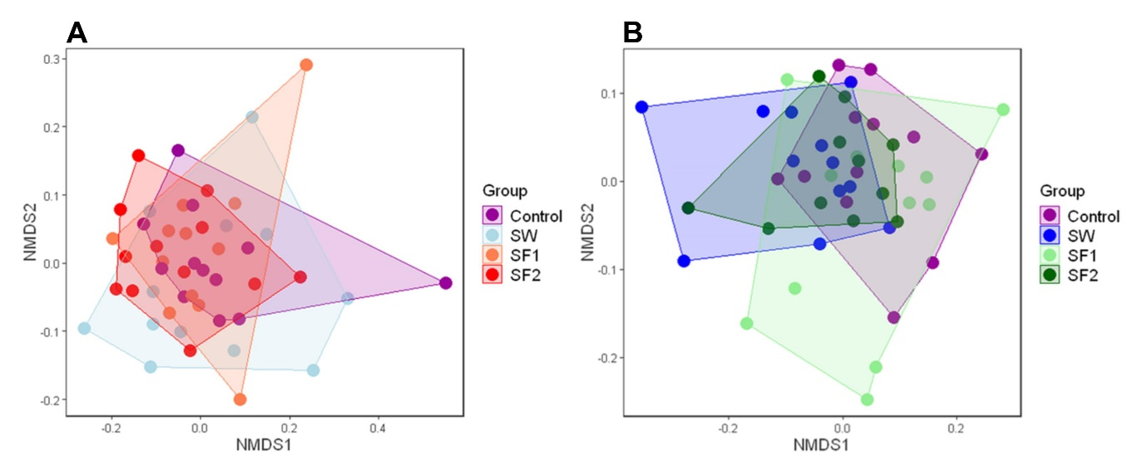
Figure S1. Non-metric multidimensional scaling of Bray-Curtis distances of analyzed microbiota in cecum of broiler chickens untreated control and treated with B. subtilis PS-216 spores in drinking water at the concentration of 10⁹ spores/L (SW), in feed at concentration of 10⁶ spores/kg of feed (SF1), and 10⁹ spores/kg of feed (SF2) at (A) first (23 days) and (B) second (at 44 days) sampling.

Table S10. Variance partitioning for Bray-Curtis distances with PairwiseAdonis2 (PERMANOVA). Test groups (SW, SF1, SF2) compared to control group.
1st sampling at 23 days
 | SW | SF1 | SF2
Pr | 0.0007 | 0.086 | 0.028
R² | 0.090 | 0.060 | 0.072
Pseudo-F | 2.18 | 1.40 | 1.72
2nd sampling at 44 days
Pr | 0.004 | 0.004 | 0.288
R² | 0.089 | 0.091 | 0.049
Pseudo-F | 2.14 | 2.20 | 1.12

Table S11. Statistical significance (p-values) of all comparisons for variance partitioning for Bray-Curtis distances with PairwiseAdonis2 (PERMANOVA).
1st sampling
p-value | Control | SW | SF1 | SF2
Control | -
SW | 7.00E-04 | -
SF1 | 0.0862 | 0.0052 | -
SF2 | 0.0277 | 4.00E-04 | 0.0042 | -
2nd sampling
Control | -
SW | 0.0042 | -
SF1 | 0.0041 | 0.0039 | -
SF2 | 0.2881 | 0.0061 | 0.0384 | -

Table S12. Statistically significant differences in cecum microbiota at phylum, family and genus level of broiler chickens treated with B. subtilis PS-216 spores in drinking water at the concentration of 10⁹ spores/L (SW), in feed at concentration of 10⁶ spores/kg of feed (SF1), and 10⁹ spores/kg of feed (SF2) compared to the untreated control, at first (23 days) and second (at 44 days) sampling presented as Log2 fold change (Log₂FC) and the adjusted p value.
Phylum
 | Log₂FC | P_{adjusted}
2nd sampling: SF2 vs Control
Mycoplasmatota | -3.01 | 0.0034
2nd sampling: SW vs Control
Mycoplasmatota | -4.07 | 0.0000
Family
 | Log₂FC | P_{adjusted}
1st sampling: SF2 vs Control
Turicibacteraceae | 3.80 | 0.0194
Peptococcaceae | 1.76 | 0.0407
Christensenellaceae | 1.34 | 0.0453
2nd sampling: SF2 vs Control
Selenomonadales unclassified | 23.20 | 0.0000
Clostridiaceae_1 | 5.22 | 0.0004
Anaeroplasmataceae | -3.02 | 0.0063
2nd sampling: SF1 vs Control
Selenomonadales unclassified | 21.63 | 0.0000
Staphylococcaceae | 1.97 | 0.0419
Brevibacteriaceae | 2.34 | 0.0419
2nd sampling: SW vs Control
Selenomonadales unclassified | 22.65 | 0.0000
Anaeroplasmataceae | -4.14 | 0.0000
Staphylococcaceae | 2.84 | 0.0002
Bacillaceae | 2.73 | 0.0003
Clostridiaceae_1 | 4.25 | 0.0032
Brevibacteriaceae | 2.66 | 0.0043
Dermabacteraceae | 2.76 | 0.0048
Carnobacteriaceae | 3.14 | 0.0073
Corynebacteriaceae | 2.12 | 0.0123
Genus
 | Log₂FC | P_{adjusted}
1st sampling: SF2 vs Control
Solibaculum | -2.68 | 0.0104
Turicibacter | 3.84 | 0.0179
1st sampling: SW vs Control
Anaerobutyricum | 1.54 | 0.0278
2nd sampling: SF2 vs Control
Selenomonadales unclassified | 23.08 | 0.0000
Clostridium sensu stricto | 5.34 | 0.0006
Anaeroplasma | -2.97 | 0.0161
2nd sampling: SF1 vs Control
Selenomonadales unclassified | 21.63 | 0.0000
Erysipelotrichaceae unclassified | -1.00 | 0.0143
2nd sampling: SW vs Control
Selenomonadales unclassified | 22.76 | 0.0000
Anaeroplasma | -3.95 | 0.0001
Mammaliicoccus | 2.75 | 0.0020
Bacillaceae unclassified | 2.52 | 0.0020
Jeotgalicoccus | 2.96 | 0.0020
Clostridium sensu stricto | 4.38 | 0.0035
Brevibacterium | 2.63 | 0.0092
Brachybacterium | 2.72 | 0.0107
Staphylococcus | 2.68 | 0.0124
Anaerotruncus | 2.18 | 0.0124
Jeotgalibaca | 3.12 | 0.0128
Corynebacterium | 2.07 | 0.0243
Pseudoflavonifractor | 1.29 | 0.0305

Figure S2. Statistically significant differences in cecum microbiota at Phylum level of broiler chickens treated with B. subtilis PS-216 spores in drinking water at the concentration of 10⁹ spores/L (SW), in feed at concentration of 10⁶ spores/kg of feed (SF1), and 10⁹ spores/kg of feed (SF2) compared to the untreated control, at second (at 44 days) sampling showing abundance of Mycoplasmatota.

Figure S3. Statistically significant differences in cecum microbiota at Family level of broiler chickens treated with B. subtilis PS-216 spores in drinking water at the concentration of 10⁹ spores/L (SW), in feed at concentration of 10⁶ spores/kg of feed (SF1), and 10⁹ spores/kg of feed (SF2) compared to the untreated control, at first sampling (23 days) showing abundance of Turibacteraceae, Peptococcaceae and Christensenellaceae.

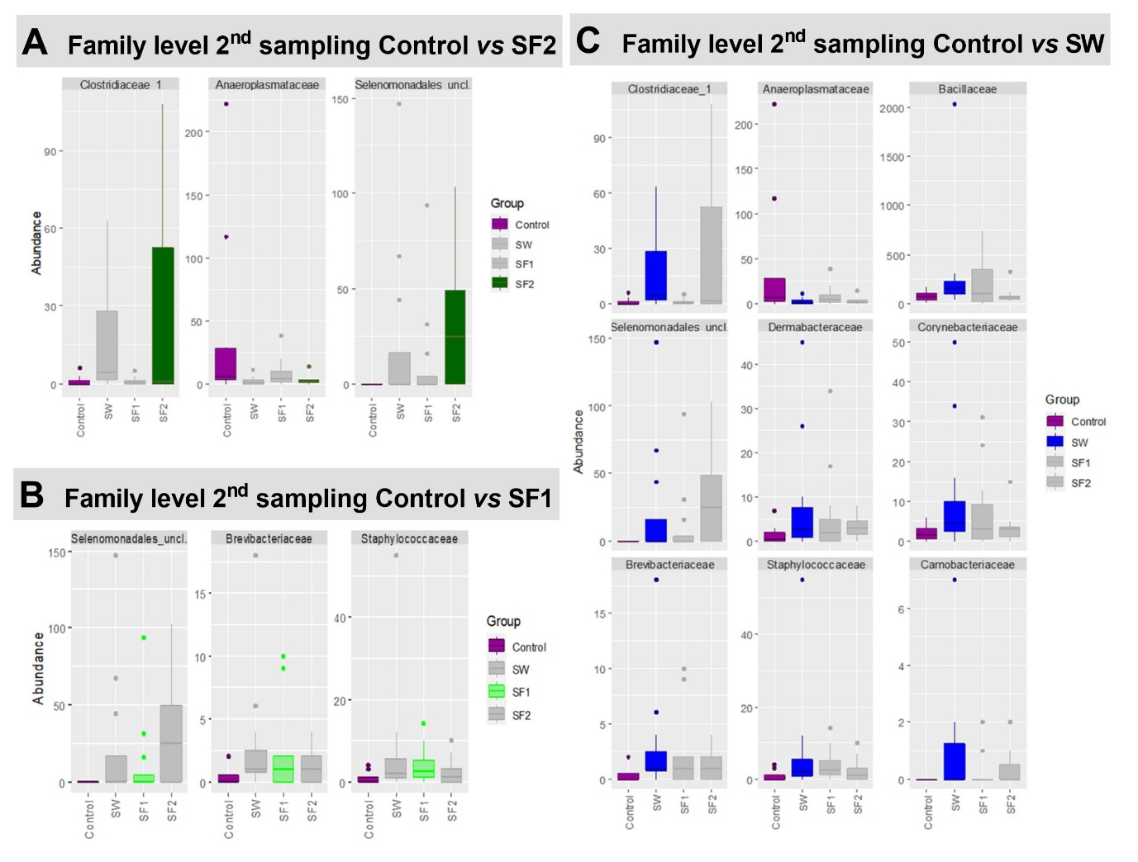
Figure S4. Abundance of cecum microbiota members at Family level with statistically significant differences in abundance in treatment groups (A) SF2 (spores in feed at concentration 10⁹ spores/kg of feed), (B) SF1 (spores in feed at concentration of 10⁶ spores/kg of feed) and (C) SW (B. subtilis PS-216 spores drinking water at the concentration of 10⁹ spores/L) compared to the untreated control, at second sampling (44 days).

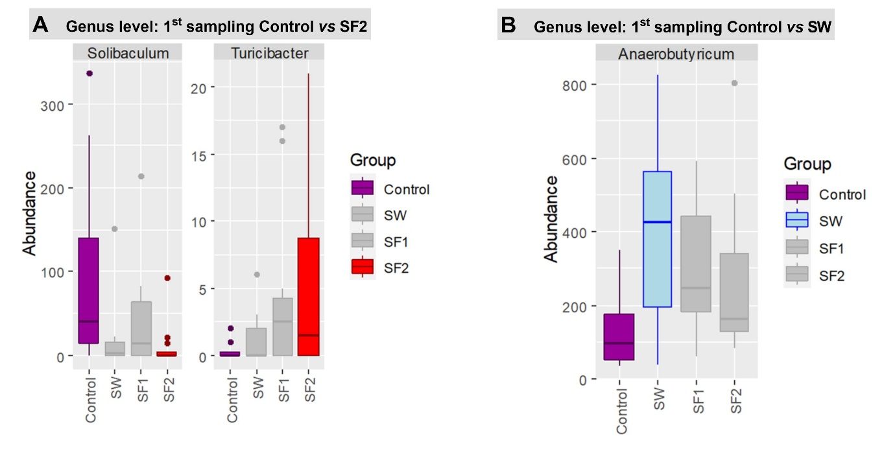
Figure S5. Abundance of cecum microbiota members at Genus level with statistically significant differences in abundance in treatment groups (A) SF2 (spores in feed at concentration 10⁹ spores/kg of feed), (B) SF1 (spores in feed at concentration of 10⁶ spores/kg of feed) and (C) SW (B. subtilis PS-216 spores drinking water at the concentration of 10⁹ spores/L) compared to the untreated control, at first sampling (23 days).
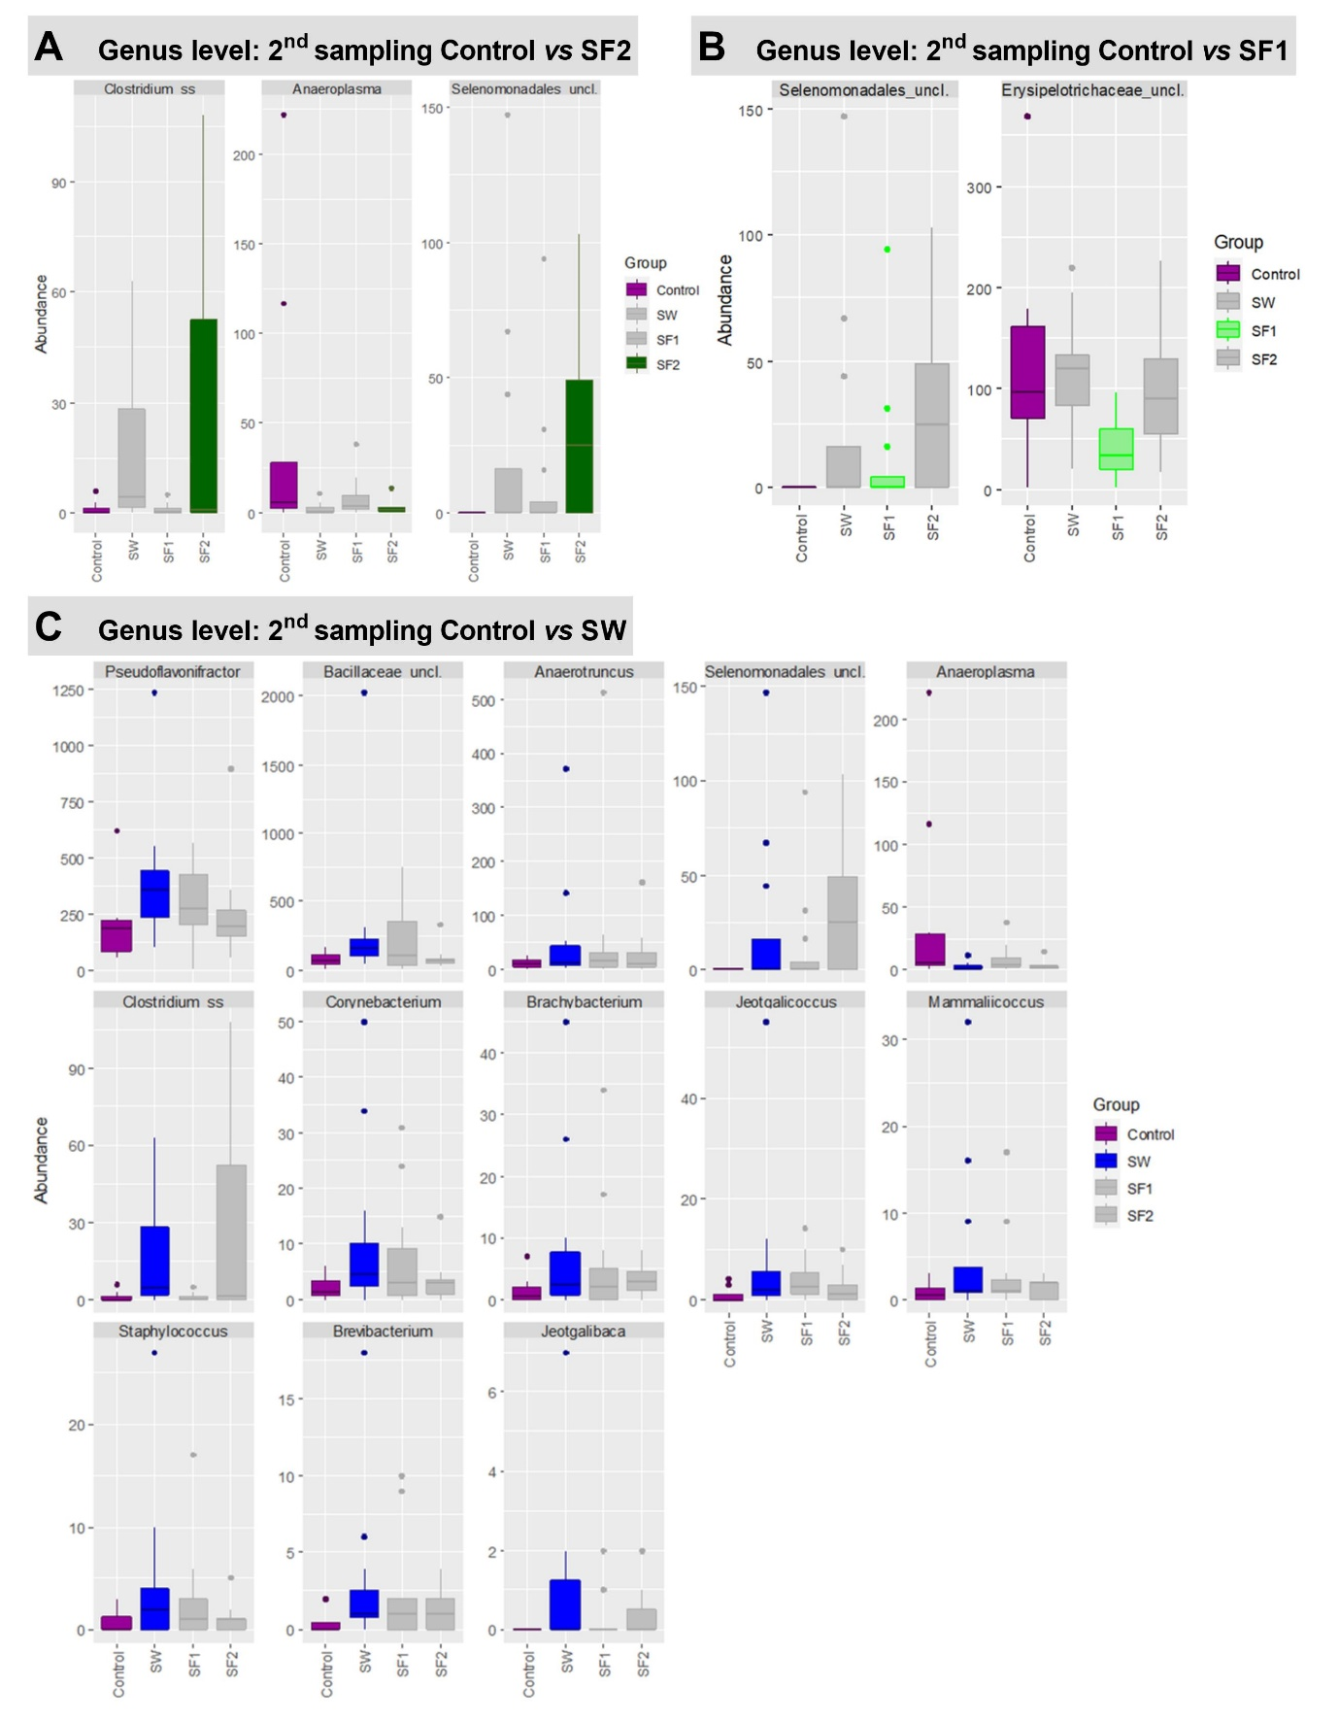
Figure S6. Abundance of cecum microbiota members at Genus level with statistically significant differences in abundance in treatment groups (A) SF2 (spores in feed at concentration 10⁹ spores/kg of feed), (B) SF1 (spores in feed at concentration of 10⁶ spores/kg of feed) and (C) SW (B. subtilis PS-216 spores drinking water at the concentration of 10⁹ spores/L) compared to the untreated control, at second sampling (44 days).

Table S13. Statistically significant differences in cecum microbiota at individual OUT level of broiler chickens treated with B. subtilis PS-216 spores in drinking water at the concentration of 10⁹ spores/L (SW), in feed at concentration of 10⁶ spores/kg of feed (SF1), and 10⁹ spores/kg of feed (SF2) compared to the untreated control, at first (23 days) and second (at 44 days) sampling presented as Log2 fold change (L2FC) and the adjusted p value.
 | SW |  | SF1 |  | SF2
 | L₂FC | p_{adj} | L₂FC | p_{adj} | L₂FC | p_{adj}
1st sampling day 23
OTU_165_Faecalicoccus_acidiformans_Erysipelotrichaceae_94_4 | 2.1 | 0.003 | 1.8 | 0.004
OTU_227_Massiliimalia_massiliensis_Oscillospiraceae_95_3 | 2.1 | 0.019 | -
OTU_233_Guopingia_tenuis_Christensenellaceae_84_7 | 4.8 | 0.001 | 3.7 | 0.030 | 4.0 | 0.005
OTU_331_Lawsonibacter_celer_Oscillospiraceae_97_5 | 3.0 | 0.003
OTU_367_Clostridium_fessum_Clostridiaceae_96 | 2.2 | 0.049 |  |  | 2.8 | 0.004
OTU_38_Anaerobutyricum_hallii_Lachnospiraceae_96_8 | 1.5 | 0.023
OTU_470_Anaerocolumna_chitinilytica_Lachnospiraceae_94_8 | -3.7 | 0.019
OTU_574_Butyricicoccus_pullicaecorum_Oscillospiraceae_96_3 | 9.1 | 0.003 |  |  | 9.3 | 0.003
OTU_624_Blautia_glucerasea_Lachnospiraceae_96 | 4.3 | 0.002
OTU_8_Blautia_glucerasea_Lachnospiraceae_99_8 | -2.5 | 0.003
OTU_247_Petroclostridium_xylanilyticum_Oscillospiraceae_87_3 |  |  | 4.6 | 0.035
OTU_43_Clostridium_fessum_Clostridiaceae_98_3 |  |  | -1.4 | 0.037
OTU_628_Pseudoflavonifractor_capillosus_Ocillospiraceae_96_8 |  |  | -2.7 | 0.004
OTU_18_Turicibacter_bilis_Turicibacteraceae_99_8 |  |  |  |  | 3.7 | 0.033
OTU_196_Guopingia_tenuis_Christensenellaceae_86_9 |  |  |  |  | 4.9 | 0.011
OTU_548_Mediterraneibacter_faecis_Lachnospiraceae_95_8 |  |  |  |  | -2.8 | 0.002
OTU_55_Aristaeella_lactis_Aristaeellaceae_93_1 |  |  |  |  | 9.8 | 0.000
OTU_622_Vescimonas_fastidiosa_Oscillospiraceae_92_3 |  |  |  |  | 2.2 | 0.034
2nd sampling day 44
OTU_122_Clostridium_saudiense_Clostridiaceae_100 | 4.3 | 0.020 |  |  | 5.2 | 0.004
OTU_154_Anaeroplasma_varium_Anaeroplasmataceae_90_3 | -3.8 | 0.001
OTU_21_Bacillus_salis_Bacillaceae_93_5 | 2.5 | 0.013
OTU_238_Aristaeella_hokkaidonensis_Aristaeellaceae_92_3 | 1.5 | 0.032
OTU_247_Petroclostridium_xylanilyticum_Oscillospiraceae_87_3 | -2.1 | 0.050
OTU_273_Anaerosinus_glycerini_Sporomusaceae_89_2 | 22.8 | 2E-24 | 21.6 | 5E-22 | 23.1 | 0.000
OTU_281_Mammaliicoccus_lentus_Staphylococcaceae_100 | 2.7 | 0.013
OTU_290_Ethanoligenens_harbinense_Oscillospiraceae_91_9 | -2.3 | 0.050
OTU_302_Brachybacterium_atlanticum_Dermabacteraceae_100 | 2.7 | 0.050
OTU_326_Corynebacterium_stationis_Corynebacteriaceae_98_8 | 2.2 | 0.050
OTU_358_Clostridium_leptum_Clostridiaceae_92_6 | 3.7 | 0.021
OTU_402_Jeotgalicoccus_aerolatus_Staphylococcaceae_100 | 3.0 | 0.013
OTU_502_Brevibacterium_senegalense_Brevibacteriaceae_100 | 4.0 | 0.029
OTU_509_Guopingia_tenuis_Christensenellaceae_85_9 | -1.0 | 0.050
OTU_56_Flintibacter_hominis_Gammaproteobacteria_incertae_sedis_91_6 | 2.5 | 0.050 | 2.6 | 0.036
OTU_580_Fumia_xinanensis_Oscillospiraceae_92_5 | 3.5 | 0.021
OTU_62_Staphylococcus_schweitzeri_Staphylococcaceae_100 | 2.6 | 0.050
OTU_622_Vescimonas_fastidiosa_Oscillospiraceae_92_3 | 1.6 | 0.050
OTU_103_Butyricicoccus_porcorum_Oscillospiraceae_98_5 |  |  | -10.8 | 0.036
OTU_129_Clostridium_polysaccharolyticum_Clostridiaceae_94_5 |  |  | 1.2 | 0.029
OTU_143_Vallitalea_okinawensis_Vallitaleaceae_86_8 |  |  | 2.2 | 0.030
OTU_161_Aristaeella_hokkaidonensis_Aristaeellaceae_93_1 |  |  | -1.1 | 0.025
OTU_177_Pseudoflavonifractor_capillosus_Ocillospiraceae_97_3 |  |  | -3.9 | 0.008
OTU_488_Blautia_argi_Lachnospiraceae_97_5 |  |  | -2.3 | 0.008
OTU_544_Mediterraneibacter_hominis_Lachnospiraceae_96_8 |  |  | 1.6 | 0.029
OTU_76_Gemmiger_gallinarum_Oscillospiraceae_98 |  |  | 2.3 | 0.029
OTU_77_Copranaerobaculum_intestinale_Erysipelotrichaceae_92_7 |  |  | -1.6 | 0.029

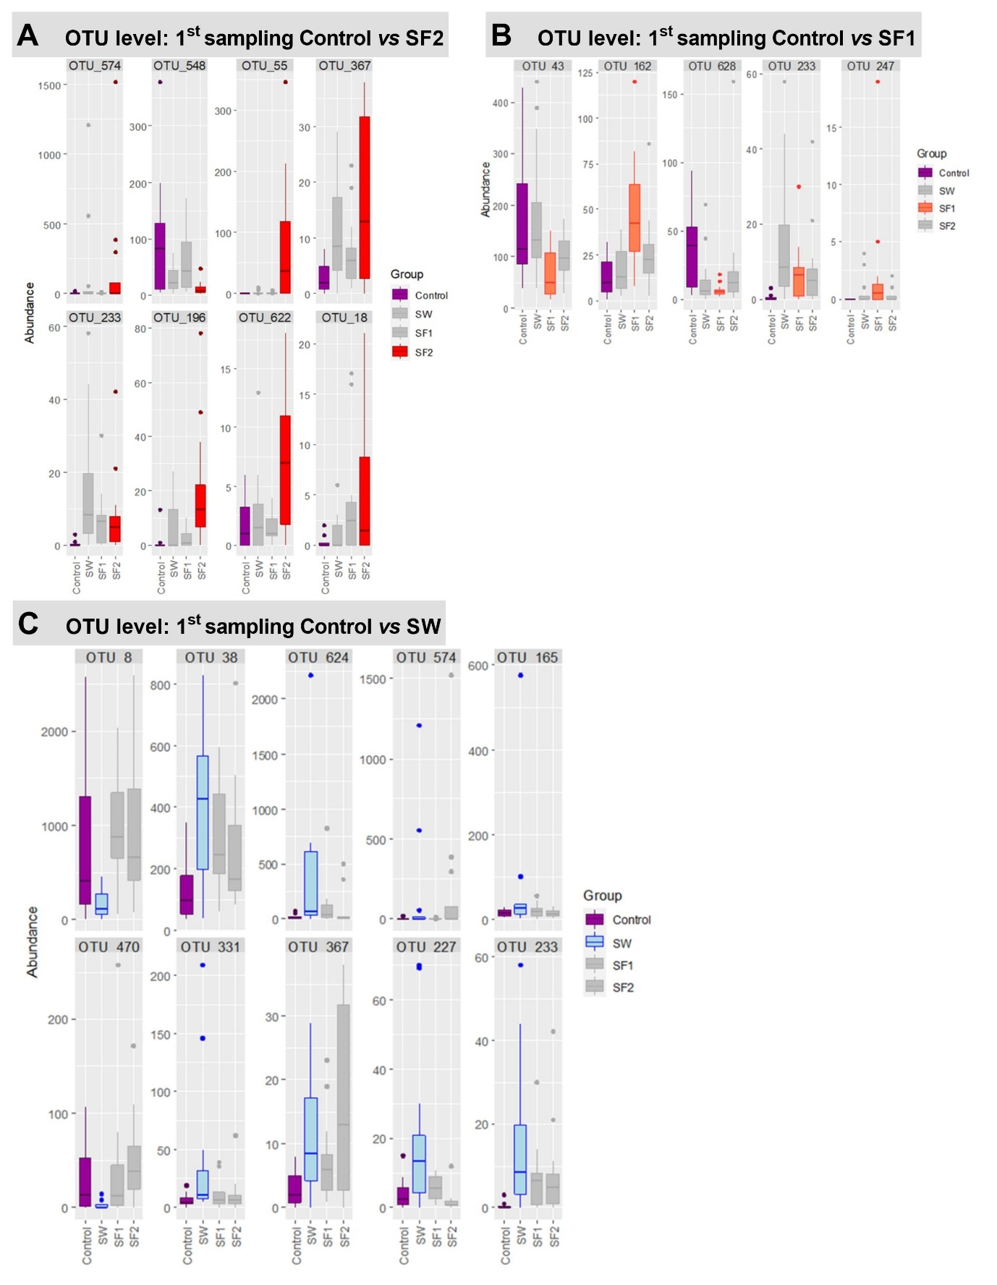
Figure S7. Abundance of cecum microbiota members at OTU level with statistically significant differences in abundance in treatment groups (A) SF2 (spores in feed at concentration 10⁹ spores/kg of feed), (B) SF1 (spores in feed at concentration of 10⁶ spores/kg of feed) and (C) SW (B. subtilis PS-216 spores drinking water at the concentration of 10⁹ spores/L) compared to the untreated control, at first sampling (23 days).

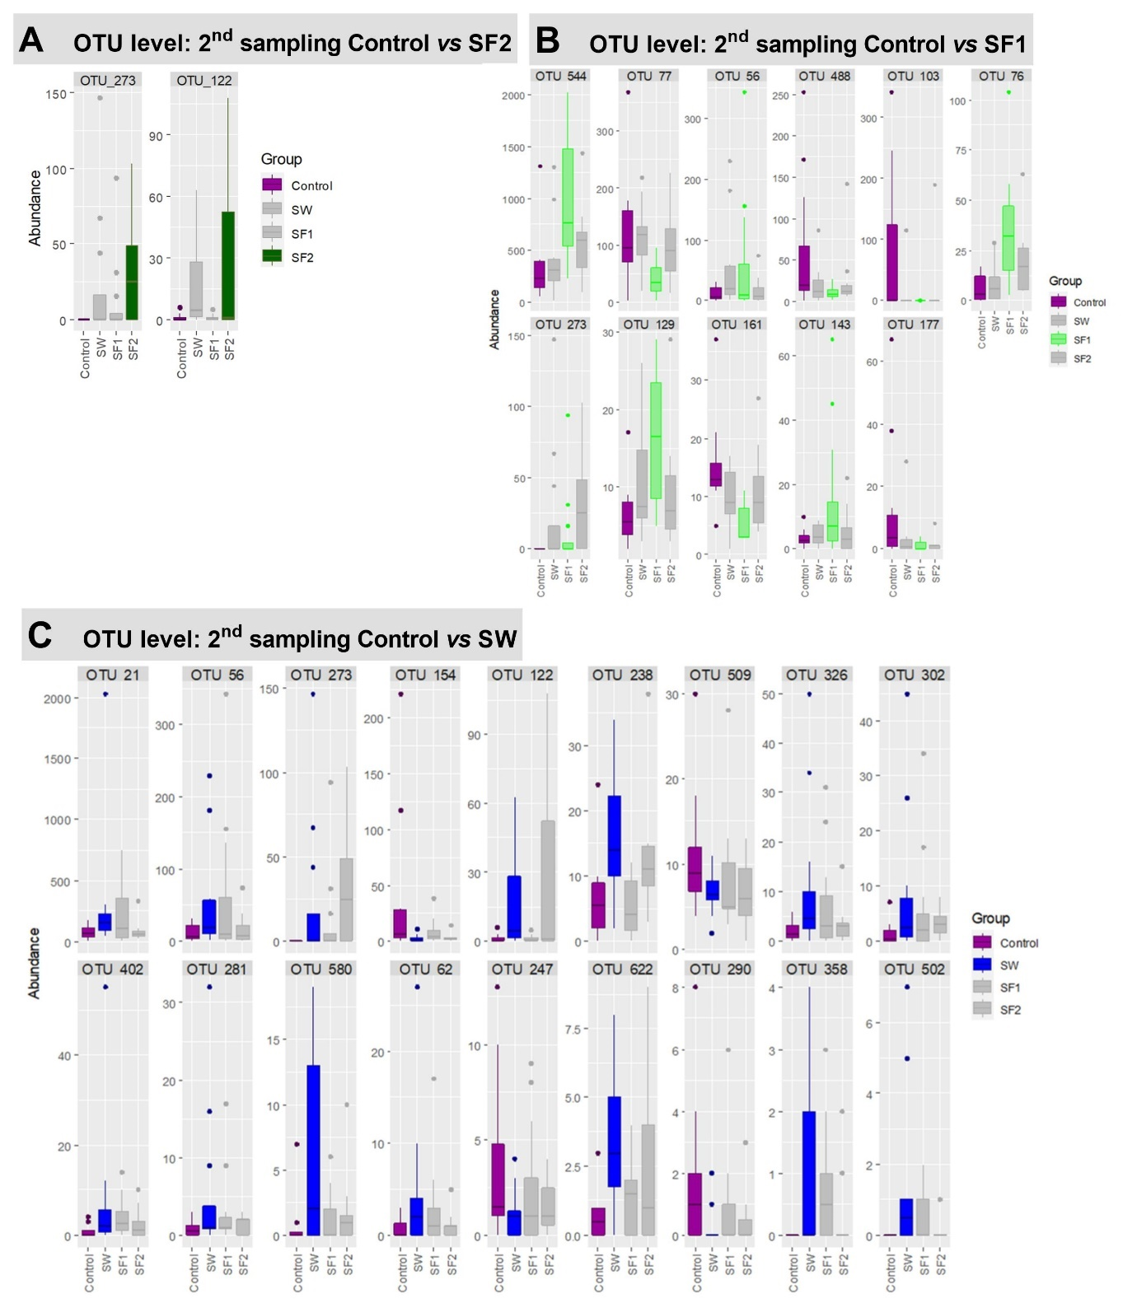
Figure S8. Abundance of cecum microbiota members at OUT level with statistically significant differences in abundance in treatment groups (A) SF2 (spores in feed at concentration 10⁹ spores/kg of feed), (B) SF1 (spores in feed at concentration of 10⁶ spores/kg of feed) and (C) SW (B. subtilis PS-216 spores drinking water at the concentration of 10⁹ spores/L) compared to the untreated control, at second sampling (44 days).

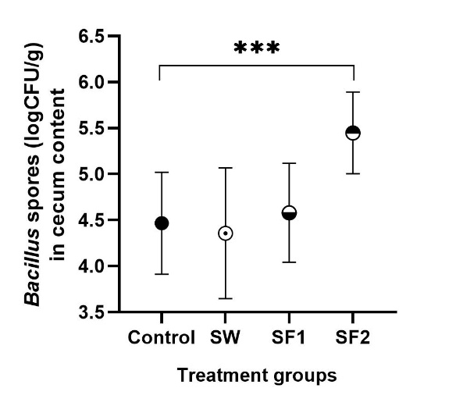
Figure S9. Spore concentration (mean ± standard deviation logCFU/g) in cecum content of broiler chickens untreated control and treated with B. subtilis PS-216 spores in drinking water at the concentration of 10⁹ spores/L (SW), in feed at concentration of 10⁶ spores/kg of feed (SF1), and 10⁹ spores/kg of feed (SF2) at second sampling at 44 days of age. Statistical significance is determined using ANOVA with Dunnett’s multiple comparisons test and presented with ***p<0.001.

