Supplementary material
Table S1.
Gen | Forward | Reverse
il1β | GTCACATTGCCAACCTCATCATCG | GTTGAGCAGGTCCTTGTCCTTGA
tnfα | GCAGCCATCCATTTAGAGGGTGAA | CTAAACGAAGCCTGGCTGTAAACG
cox2 | CAGTGCTCCCAGATGCCAAG | GCGAAGAAGGCGAACATGAG
il10 | ATGAGGCTAATGACGAGCTGGAGA | ATGAGGCTAATGACGAGCTGGAGA
Annexin a1 | ATGGTGAACCAGGAACTTGC | ATAGCCTTTGCCACATCCAC
ef1α | CCCCTCCAGGACGTTTACAAA | CACACGCCCACAGGTACA
Table S1: List of gene primers for qPCR.

Table S2.
 |  |  |  | Bray Curtis | Weighted Unifrac | Unweighted Unifrac
Group 1 | Group 2 | Sample size | Permutations | p value | p value | p value
1A | 1B | 18 | 999 | 0.584 | 0.154 | 0.868
1A | 1C | 18 | 999 | 0.431 | 0.287 | 0.543
1B | 1C | 18 | 999 | 0.955 | 0.474 | 0.731
2A | 2B | 16 | 999 | 0.19 | 0.961 | 0.646
2A | 2C | 15 | 999 | 0.0020** | 0.99 | 0.336
2B | 2C | 15 | 999 | 0.34 | 0.954 | 0.214
3A | 3B | 18 | 999 | 0.581 | 0.746 | 0.881
3A | 3C | 18 | 999 | 0.891 | 0.658 | 0.481
3B | 3C | 18 | 999 | 0.674 | 0.919 | 0.419
4A | 4B | 18 | 999 | 0.050* | 0.0470* | 0.0060**
4A | 4C | 18 | 999 | 0.001** | 0.050* | 0.181
4B | 4C | 18 | 999 | 0.352 | 0.748 | 0.29
5A | 5B | 18 | 999 | 0.384 | 0.44 | 0.82
5A | 5C | 18 | 999 | 0.68 | 0.134 | 0.793
5B | 5C | 18 | 999 | 0.613 | 0.502 | 0.536

Table S2. PERMANOVA Results for Beta Diversity Analysis: Beta diversity was assessed using the Bray–Curtis dissimilarity, as well as the weighted and unweighted UniFrac distance metrics. Statistical significance was evaluated using PERMANOVA, with significance levels indicated as follows: p ≤ 0.05 (), p ≤ 0.01 (), and p ≤ 0.001 ().

Table S3.
Relative abundance family
Group | SP1 | SP2 | SP3 | SP4 | SP5
Corynebacteriaceae
A | 0.156 | 0.199 | 0.387 | 0.264 | 0.507
B | 0.016 | 0.166 | 0.011 | 0.534 | 0.463
C | 0.016 | 0.138 | 0.010 | 0.531 | 0.481
Clostridiaceae_1
A | 0.136 | 0.118 | 0.048 | 0.012 | 0.069
B | 0.325 | 0.107 | 0.208 | 0.046 | 0.083
C | 0.331 | 0.124 | 0.111 | 0.041 | 0.054
Vibrionaceae
A | 0.115 | 0.118 | 0.016 | 0.007 | 0.009
B | 0.002 | 0.274 | 0.001 | 0.033 | 0.018
C | 0.002 | 0.338 | 0.263 | 0.135 | 0.054
Lactobacillaceae
A | 0.268 | 0.278 | 0.127 | 0.041 | 0.174
B | 0.292 | 0.231 | 0.191 | 0.140 | 0.201
C | 0.249 | 0.240 | 0.094 | 0.107 | 0.126
Moraxellaceae
A | 0.112 | 0.032 | 0.050 | 0.108 | 0.017
B | 0.059 | 0.034 | 0.041 | 0.013 | 0.010
C | 0.033 | 0.020 | 0.069 | 0.006 | 0.015
Peptostreptococcaceae
A | 0.060 | 0.065 | 0.043 | 0.033 | 0.071
B | 0.116 | 0.056 | 0.085 | 0.058 | 0.062
C | 0.141 | 0.072 | 0.051 | 0.055 | 0.065
Pseudomonadaceae
A | 0.055 | 0.068 | 0.101 | 0.298 | 0.037
B | 0.070 | 0.056 | 0.166 | 0.026 | 0.033
C | 0.057 | 0.018 | 0.153 | 0.012 | 0.039
Streptococcaceae
A | 0.041 | 0.060 | 0.095 | 0.066 | 0.079
B | 0.037 | 0.032 | 0.126 | 0.107 | 0.069
C | 0.030 | 0.025 | 0.063 | 0.072 | 0.094
Rhodobacteraceae
A | 0.033 | 0.014 | 0.077 | 0.004 | 0.019
B | 0.049 | 0.013 | 0.070 | 0.030 | 0.035
C | 0.101 | 0.014 | 0.088 | 0.035 | 0.040
Enterobacteriaceae
A | 0.023 | 0.048 | 0.057 | 0.167 | 0.018
B | 0.034 | 0.030 | 0.101 | 0.013 | 0.025
C | 0.039 | 0.011 | 0.098 | 0.007 | 0.032
Table S3. Relative abundance of top 10 of most abundant families of intestinal microbiota of Salmo salar during each period.

Table S4.
Relative abundance genus
Group | SP1 | SP2 | SP3 | SP4 | SP5
Lactobacillus
A | 0.280 | 0.264 | 0.124 | 0.039 | 0.162
B | 0.311 | 0.220 | 0.200 | 0.127 | 0.191
C | 0.278 | 0.231 | 0.105 | 0.101 | 0.117
Corynebacterium_1
A | 0.160 | 0.178 | 0.369 | 0.250 | 0.464
B | 0.017 | 0.157 | 0.011 | 0.485 | 0.439
C | 0.018 | 0.132 | 0.011 | 0.496 | 0.448
Clostridium_sensu_stricto_1
A | 0.143 | 0.112 | 0.046 | 0.011 | 0.064
B | 0.343 | 0.102 | 0.221 | 0.042 | 0.079
C | 0.359 | 0.119 | 0.130 | 0.039 | 0.050
Aliivibrio
A | 0.120 | 0.115 | 0.023 | 0.006 | 0.008
B | 0.002 | 0.268 | 0.001 | 0.031 | 0.018
C | 0.003 | 0.326 | 0.278 | 0.130 | 0.050
Pseudomonas
A | 0.078 | 0.062 | 0.119 | 0.327 | 0.034
B | 0.074 | 0.053 | 0.175 | 0.023 | 0.030
C | 0.062 | 0.017 | 0.180 | 0.010 | 0.036
Terrisporobacter
A | 0.062 | 0.061 | 0.042 | 0.031 | 0.065
B | 0.123 | 0.054 | 0.090 | 0.053 | 0.059
C | 0.153 | 0.070 | 0.062 | 0.051 | 0.059
Lactococcus
A | 0.049 | 0.071 | 0.066 | 0.060 | 0.045
B | 0.006 | 0.048 | 0.019 | 0.066 | 0.032
C | 0.005 | 0.025 | 0.011 | 0.053 | 0.066
Romboutsia
A | 0.041 | 0.044 | 0.059 | 0.031 | 0.070
B | 0.049 | 0.039 | 0.050 | 0.066 | 0.064
C | 0.048 | 0.045 | 0.036 | 0.046 | 0.058
Streptococcus
A | 0.040 | 0.051 | 0.088 | 0.063 | 0.072
B | 0.040 | 0.030 | 0.127 | 0.095 | 0.064
C | 0.033 | 0.024 | 0.071 | 0.067 | 0.086
Klebsiella
A | 0.027 | 0.043 | 0.062 | 0.182 | 0.017
B | 0.036 | 0.028 | 0.106 | 0.012 | 0.024
C | 0.042 | 0.010 | 0.116 | 0.006 | 0.029
Table S4. Relative abundance of top 10 of most abundant genera of intestinal microbiota of Salmo salar during each period.

Table S5.
Score | Parameter
Mucosal folds (MF)
1 | Basal length
2 | Some shrinkage and bloating
3 | Diffused shrinkage and onset of tissue disruption
4 | Diffused tissue disruption
5 | Total tissue disruption
Lamina propria (LP)
1 | Normal size LP
2 | Increased size of LP
3 | Medium size LP
4 | Large LP
5 | Largest LP
Supranuclear vacuoles (SNV)
1 | Basal SNV size
2 | Some size reduction
3 | Diffused size reduction
4 | Onset of extinction
5 | No SNV
Granulocytes (GR)
1 | Few in SM basal small quantity
2 | Increased number in SM and some migration into LP
3 | Increased migration into LP
4 | Diffused number in LP and SM
5 | Dense GR in LP and SM
Sub-epithelial mucosa (SM)
1 | Normal SM
2 | Increased size SM
3 | Medium size SM
4 | Large SM
5 | Largest SM
Lymphocytic infiltration
1 | Few in SM basal small quantity
2 | Increased number in SM and some migration into LP
3 | Increased migration into LP
4 | Diffused number in LP and SM
5 | Dense in LP and SM

Table S5. Description of the semi-quantitative scoring system using different parameters to assess the degree of gut inflammation in Atlantic salmon by Urán et al. (2009, 2008).

Figure S1. Rarefactions curves

Figure S2
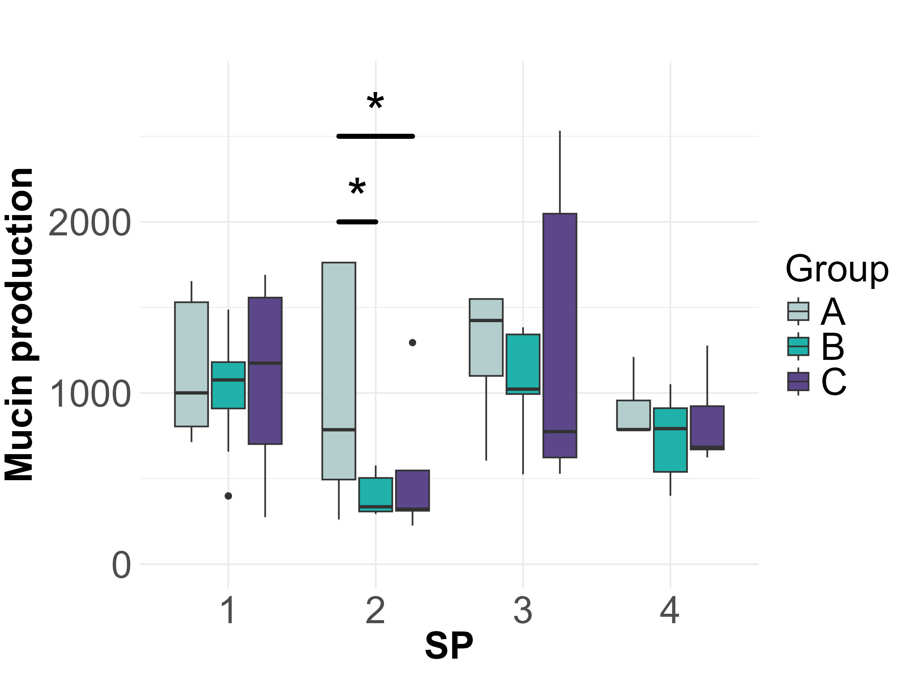
Figure S2. Mucin production in goblet cells of the distal intestine in healthy Atlantic salmon (Salmo salar) fed florfenicol-medicated diets. Significance is indicated as p < 0.05. Experimental groups: (A) Control; (B) Fish fed 15 mg/kg florfenicol; (C) Fish fed 30 mg/kg florfenicol. Sampling periods are indicated by numbers 2 to 4.

