Supplementary Materials

Component (%) | SUCKLING PHASE 1 | SUCKLING PHASE 2 | POST-WEANING PHASE 1 | POST-WEANING PHASE 2
Dry matter | 92.00 | 90.50 | 89.50 | 88.72
Energy (MJ/kg) | 11.88 | 10.86 | 8.77 | 9.44
Crude protein | 19.00 | 17.00 | 16.80 | 17.20
Crude fat | 10.00 | 7.00 | 4.40 | 4.50
Crude fibre | 2.00 | 2.50 | 3.50 | 4.20
Lysine | 1.40 | 1.15 | 1.21 | 1.20
Methionine | 0.45 | 0.98 | 0.46 | 0.42

Table S1. Dietary nutritional composition throughout the course of the experiment.
Suckling phase 1 feed was provided from day 14 to 21. Between days 21 and 28, a 50:50 mixture of suckling phase 1 and 2 was provided. Suckling phase 2 feed alone was provided from day 28 to 35. Post-weaning phase 1 feed was provided from day 35 to 49. Post-weaning phase 2 feed was provided from day 49 onwards.

(Table in separate document with extra references)
Table S2. Primers used for qPCR in the present study.

Day | Restricted |  | Enriched |  | P-Value
Day | Mean BW (kg) | SEM | Mean BW (kg) | SEM | P-Value
0 | 1.34 | 0.03 | 1.40 | 0.03 | 0.211
3 | 1.91 | 0.05 | 1.93 | 0.05 | 0.823
11 | 3.52 | 0.10 | 3.43 | 0.11 | 0.586
18 | 4.94 | 0.16 | 4.75 | 0.16 | 0.425
21 | 5.65 | 0.23 | 5.32 | 0.19 | 0.271
27 | 5.77 | 0.23 | 6.48 | 0.23 | 0.041
42 | 9.72 | 0.37 | 10.30 | 0.38 | 0.282
49 | 11.92 | 0.42 | 12.48 | 0.45 | 0.363
69 | 21.46 | 0.70 | 23.53 | 0.93 | 0.080
90 | 37.68 | 0.79 | 40.71 | 1.26 | 0.044

Table S3. Mean bodyweight (BW) by group from farrowing (day 0) to the endpoint of the experiment (day 90).
Bodyweight is shown as the mean per group ± the standard error of the mean. The Wilcoxon test was performed to calculate the P-value. N = 64.
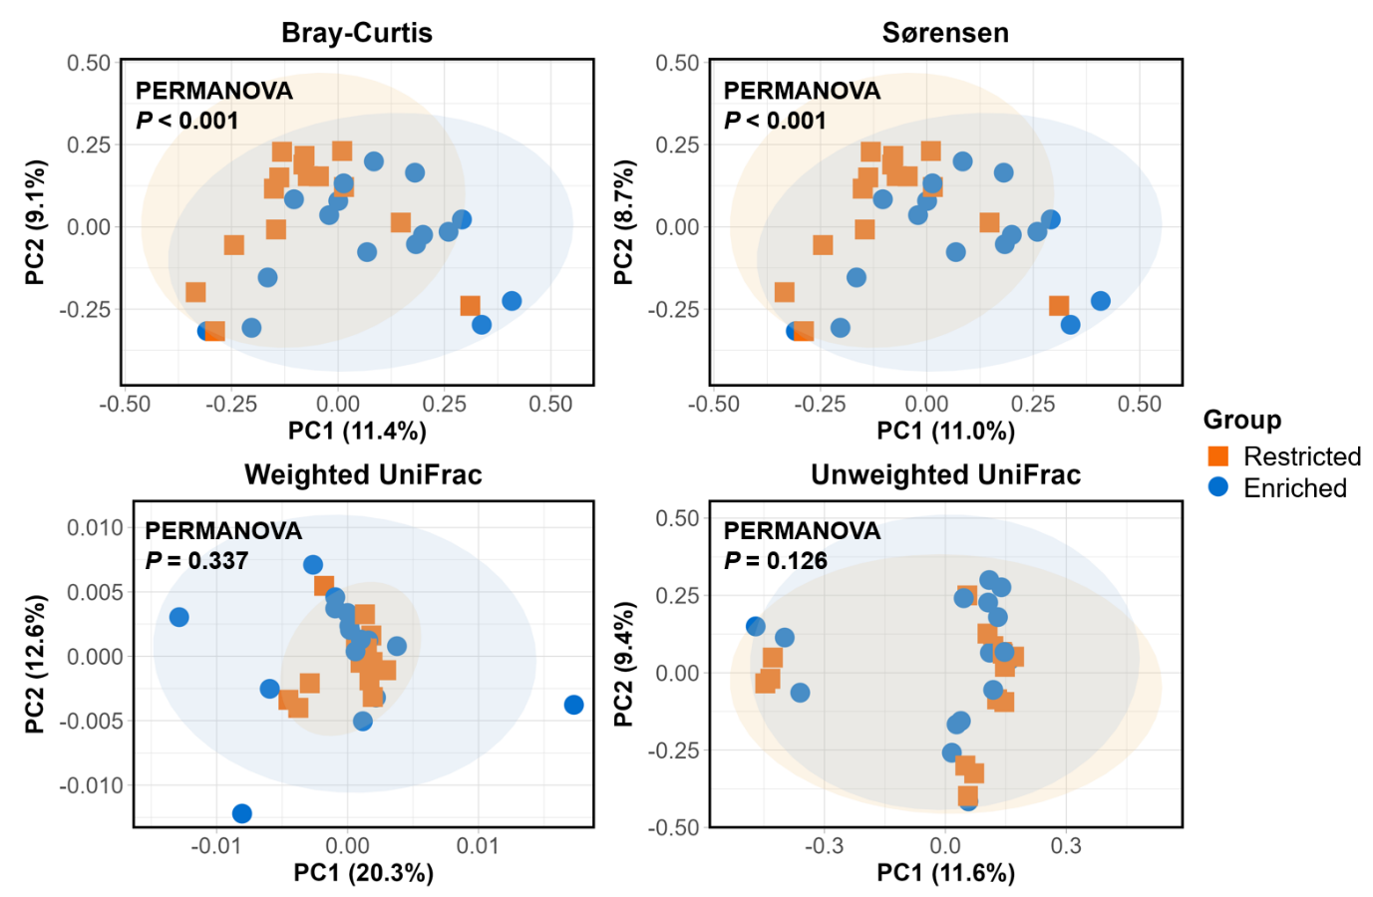

Figure S1. β-diversity of the faecal microbiota on day 42.
The graphs display β-diversity calculated according to Bray-Curtis, Sørensen, and weighted and unweighted UniFrac distances, with PERMANOVA indicating significant differences between groups at both timepoints (P < 0.01).

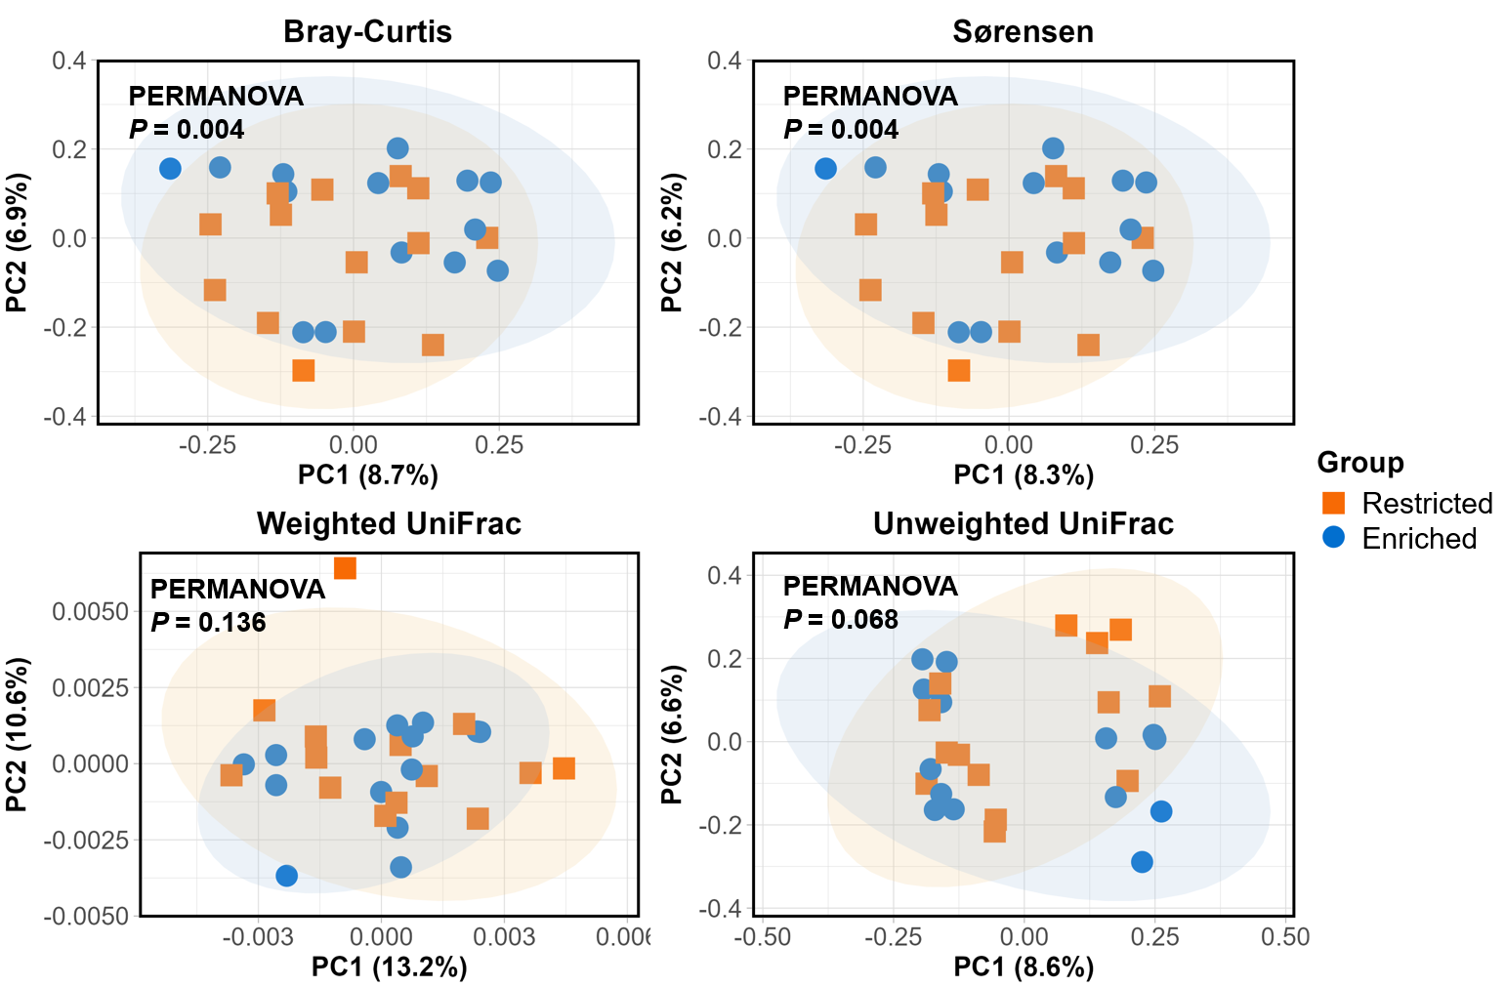

Figure S2. β-diversity of the faecal microbiota on day 90.
The graphs display β-diversity calculated according to Bray-Curtis, Sørensen, and weighted and unweighted UniFrac distances, with PERMANOVA indicating significant differences between groups at both timepoints (P < 0.01).

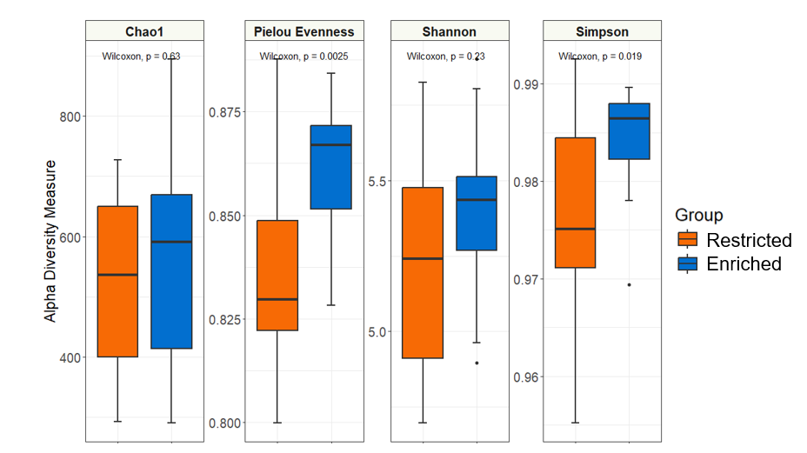
Figure S3. α-diversity of the faecal microbiota on day 90.
α-diversity is shown according to the Chao1, Pielou evenness, Shannon, and Simpson indices. Statistically significant differences were calculated by performing the Wilcoxon test.

Figure S4. Taxonomic abundance at the genus level for faeces day 42, ileum day 90 and faeces day 90
C
C
A
B
Enriched
Enriched
Enriched
Restricted
Restricted
Restricted
Restricted
Enriched
C
B
Graph A shows the faecal microbiota (n = 31) on day 42, with taxa with a mean abundance of < 1.0% grouped together. Graph B shows the ileal microbiota (n = 31) on day 90, with taxa with a mean abundance of < 0.5% grouped together, while graph C shows the faecal microbiota (n = 28) on day 90, with taxa with a mean abundance of < 1.0% grouped together. For each graph, the colour legend is organised in descending order of mean abundance.
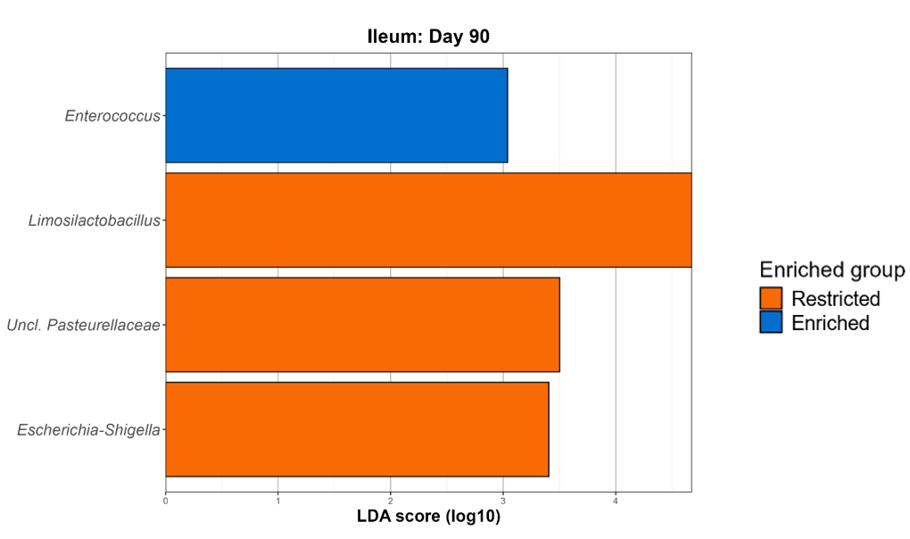

Figure S5. Genera enriched among the restricted and enriched groups on day 90 (ileum) as identified by LEfSe analysis.
For each genus deemed significantly different between the two groups, the LDA score is visualised on the $x$-axis, with a threshold of > 3 chosen for a significant difference.

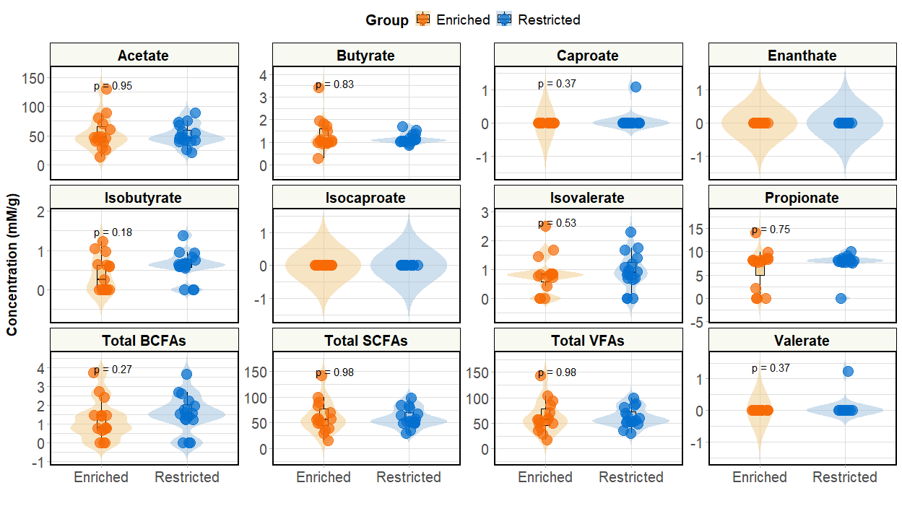

Figure S6. Ileal VFA concentrations on day 90.
The violin plots display VFA concentrations from acetate to enanthate, with total SCFAs, BCFAs, and VFAs also shown. Compromised pigs are represented in orange, and optimal in blue. P-values, as calculated by the Wilcoxon test, are shown.

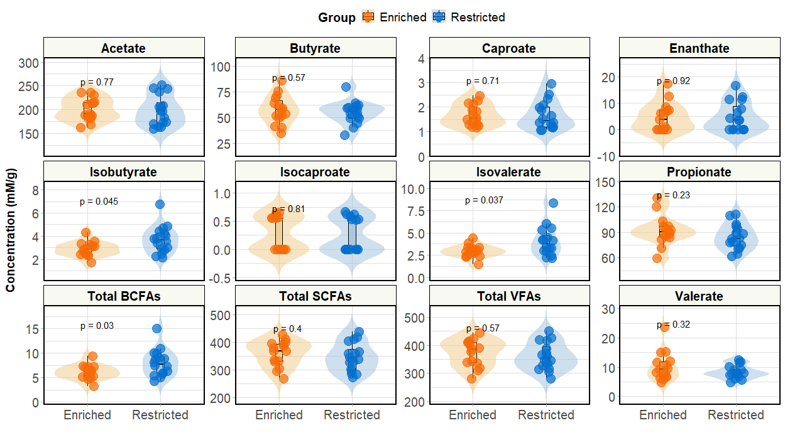

Figure S7. Colonic VFA concentrations on day 90.
The violin plots display VFA concentrations from acetate to enanthate, with total SCFAs, BCFAs, and VFAs also shown. Compromised pigs are represented in orange, and optimal in blue. P-values, as calculated by the Wilcoxon test, are shown.

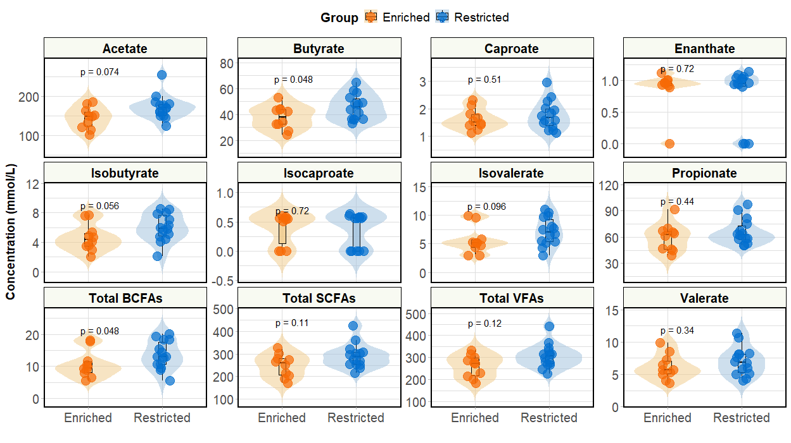

Figure S8. Faecal VFA concentrations on day 90.
The violin plots display VFA concentrations from acetate to enanthate, with total SCFAs, BCFAs, and VFAs also shown. Compromised pigs are represented in orange, and optimal in blue. P-values, as calculated by the Wilcoxon test, are shown.

