Table S1. Royal Canin Mother & Babycat Dry composition.
Nutrient | Composition per kg as fed
Moisture | 5.5%
Protein | 34%
Crude fat | 25%
Crude ash | 7.4%
Crude fibre | 1.9%
Nutritional additives | Vitamin A: 25500 IU; Vitamin D3: 1000 IU; Vitamin E: 600 mg; E1 (Iron): 31.8 mg; E2 (Iodine): 3.2 mg; E4 (Copper): 9.8 mg; E5 (Manganese): 41.4 mg; E6 (Zinc): 118.1 mg; E8 (Selenium): 0.04 mg
Metabolizable energy | 4236 kcal/kg (NRC 2006)
Ingredients | Dehydrated poultry protein, animal fats, maize flour, rice, vegetable protein isolate, hydrolysed animal proteins, yeasts and parts thereof, fish oil, beet pulp, vegetable fibres, soya oil, minerals, fructo-oligo-saccharides (0,35%), hydrolysed yeast (source of manno-oligo-saccharides), yeasts extracts (source of betaglucans), marigold extract (source of lutein)

This composition corresponds to the product fed during this study in 2021 and 2022 and may not correspond exactly to the composition of the commercial product currently available.

Table S2. Royal Canin Kitten Dry composition.
Nutrient | Composition per kg as fed
Moisture | 5.5%
Protein | 36%
Crude fat | 18%
Crude ash | 7.7%
Crude fibre | 2.3%
Nutritional additives | Vitamin A: 21500 IU; Vitamin D3: 800 IU; Vitamin E: 600 mg; E1 (Iron): 32.3 mg; E2 (Iodine): 3.2 mg; E4 (Copper): 9.9 mg; E5 (Manganese): 42 mg; E6 (Zinc): 116.5 mg; E8 (Selenium): 0.05 mg
Metabolizable energy | 3847 kcal/kg (NRC 2006)
Ingredients | Dehydrated poultry protein, rice, vegetable protein isolate, animal fats, maize flour, hydrolysed animal proteins, wheat flour, maize gluten, yeasts and parts thereof, beet pulp, vegetable fibres, fish oil, soya oil, minerals, fructo-oligosaccharides (0,38%), psyllium husks and seeds, hydrolysed yeast (source of manno-oligo-saccharides), yeasts extracts (source of betaglucans), marigold extract (source of lutein)

This composition corresponds to the product fed during this study in 2021 and 2022 and may not correspond exactly to the composition of the commercial product currently available.

Table S3. Royal Canin Mother & Babycat Mousse composition.
Nutrient | Composition per kg as fed
Moisture | 78.7%
Protein | 10.5%
Crude fat | 5.5%
Crude ash | 1.7%
Crude fibre | 0.8%
Nutritional additives | Vitamin D3: 120 IU, Iron (3b103): 5 mg, Iodine (3b202): 0.4 mg, Copper (3b405, 3b406): 3.3 mg, Manganese (3b502, 3b503, 3b504): 1.5 mg, Zinc (3b603, 3b605, 3b606): 15 mg.
Metabolizable energy | 988 kcal/kg (NRC 2006)
Ingredients | Meat and animal derivatives, oils and fats,  cereals, milk and milk derivatives, derivatives of vegetable  origin, minerals, yeasts.

This composition corresponds to the product fed during this study in 2021 and 2022 and may not correspond exactly to the composition of the commercial product currently available.

Table S4. Relative abundance (%) and Spearman correlations of phyla during the trial.
Phylum | PL wk 0 | SB wk 0 |  | PL wk 2 |  | SB wk2 |  | PL wk 4 |  | SB wk 4 |  | PL wk 6 |  | SB wk 6 |  | PL wk 7 |  | SB wk7 | ρ | n | P
Actinobacteria | 2.91±2.27 | 2.02±0.98 | ↓ | 1.66±0.7 |  | 1.72±1.04 |  | 1.56±0.86 |  | 1.43±0.62 |  | 1.47±0.61 |  | 1.21±0.7 |  | 1.59±0.89 |  | 1.57±1.13 | 0.355 | 199 | <0.001
Bacteroidetes | 21.6±6.9 | 22.1±9.8 |  | 23.4±6.68 |  | 23.0±7.18 |  | 26.3±7.52 |  | 20.53±5.99 |  | 21.8±8.11 |  | 18.9±6.28 |  | 20.7±8.68 |  | 16.7±7.12 | 0.695 | 199 | <0.001
Firmicutes | 66.4±11.1 | 66.5±11.4 |  | 66.1±6.71 |  | 67.0±8.52 | ↘ | 60.4±7.51 |  | 66.7±9.02 |  | 63.4±8.49 |  | 62.4±13.1 |  | 54.4±16.14 |  | 55.3±16.9 | -0.154 | 199 | 0.035
Fusobacteria | 1.46±2.94 | 0.57±0.85 |  | 1.19±2.62 |  | 0.46±0.78 |  | 1.26±2 | ↗ | 0.71±0.58 |  | 0.67±0.72 |  | 0.66±0.91 |  | 0.78±1.66 |  | 1.03±2.14 | 0.280 | 188 | <0.001
Proteobacteria | 7.64±6.84 | 8.79±9.74 |  | 7.65±4.79 |  | 7.75±4.36 |  | 10.4±5.76 |  | 10.6±5.18 |  | 12.7±7.8 | ↗ | 16.8±12.8 |  | 22.5±19.4 |  | 25.3±20.2 | -0.287 | 199 | <0.001

Values are mean ± standard deviation. Symbols represent a weekly longitudinal pairwise analysis showing time and treatment effect. For differences in treatment effect between groups in the same week, * indicates P <0.05 and # indicates 0.1> P >0.05. Differences in the effect of time from time x to time x+1 are indicated by the following symbols: “↑” for increase and “↓” for decrease (P <0.05); “↗” for increase and “↘” for decrease (0.1> P >0.05). n is the number of kittens used to perform the Spearman correlation, ρ is Spearman’s rho coefficient. PL, placebo; SB, Saccharomyces cerevisiae var. boulardii CNCM I-1079; wk, week.

Table S5. Relative abundance (%) and Spearman correlations of genera during the trial.
Genus | PL wk 0 | SB wk 0 |  | PL wk2 |  | SB wk 2 |  | PL wk 4 |  | SB wk 4 |  | PL wk6 |  | SB wk6 |  | PL wk 7 |  | SB wk 7 | ρ | n | P
Actinomyces | 0.03±0.08 | 0.07±0.25 |  | 0.14±0.37 |  | 0.01±0.04 |  | 0.19±0.53 |  | 0.04±0.07 |  | 0.12±0.26 |  | 0.08±0.16 |  | 0.23±0.45 | ↑ | 0.25±0.56 | -0.101 | 68 | 0.4116
Alistipes | 0.01±0.02 | 0.02±0.03 |  | 0±0.02 |  | 0.01±0.02 |  | 0.02±0.02 |  | 0±0.02 |  | 0±0 |  | 0.01±0.02 |  | 0.02±0.03 |  | 0±0 | 0.750 | 15 | 0.0013
Anaerobiospirillum | 1.59±2.39 | 0.47±0.73 |  | 0.91±1.15 |  | 0.88±1.91 |  | 1.93±2.25 |  | 0.68±0.99 | ↘ | 1.16±2.7 | * | 1.13±1.51 | ↓ | 0.15±0.23 | ↘ | 0.26±0.36 | 0.260 | 143 | 0.0017
Anaerococcus | 13.1±9.84 | 13.8±9.83 |  | 15.3±7.8 |  | 14.0±9.52 | ↓ | 10.0±7.24 | *↗ | 16.6±8.16 |  | 14.5±10.2 |  | 15.2±8.88 |  | 11.1±9.56 |  | 12.2±7.47 | -0.423 | 198 | 0.0000
Bacteroides | 8.05±4.85 | 8.23±4.2 |  | 8.84±5.93 |  | 8.58±4.95 | ↑ | 12.4±6.87 |  | 10.0±4.69 |  | 10.6±4.94 |  | 10.6±5.18 |  | 12.0±6.9 |  | 9.01±4.95 | 0.189 | 199 | 0.0075
Bacteroides fragilis | 1.61±1.36 | 2.95±2.97 |  | 1.55±1.49 |  | 1.72±2.90 |  | 3.08±3.73 | *↑ | 4.74±4.3 |  | 4.37±4.19 |  | 5.67±3.91 |  | 7.32±7.24 |  | 4.97±3.14 | 0.367 | 156 | 0.0000
Bacteroides plebeius | 0.38±0.75 | 0.25±0.39 |  | 0.39±0.49 |  | 0.16±0.2 |  | 0.47±0.65 |  | 0.25±0.51 |  | 0.32±0.32 |  | 0.15±0.15 |  | 0.19±0.25 |  | 0.09±0.14 | -0.452 | 193 | 0.0000
Bifidobacterium | 0.88±1.34 | 0.36±0.48 | ↘ | 0.29±0.33 |  | 0.45±0.75 |  | 0.19±0.28 | ↓ | 0.09±0.1 |  | 0.08±0.11 |  | 0.08±0.13 |  | 0.14±0.29 |  | 0.09±0.13 | 0.367 | 156 | 0.0000
Bilophila | 0.01±0.02 | 0.05±0.09 |  | 0.02±0.05 |  | 0.01±0.02 |  | 0.03±0.05 | #↑ | 0.03±0.04 |  | 0.06±0.09 |  | 0.03±0.05 |  | 0.07±0.1 |  | 0.03±0.03 | -0.0028 | 84 | 0.9802
Blautia | 5.11±2.41 | 5.8±4.82 |  | 4.81±3.48 |  | 5.74±3.88 |  | 6.32±5.72 | *↓ | 3.05±2.47 |  | 3.08±2.31 |  | 2.41±1.93 |  | 2.3±3.1 |  | 2.27±2.97 | 0.787 | 194 | 0.0000
Bulleidia | 0.02±0.06 | 0.03±0.06 |  | 0.04±0.10 |  | 0.04±0.05 |  | 0.03±0.05 |  | 0.02±0.03 |  | 0.02±0.04 |  | 0.01±0.02 |  | 0.02±0.06 |  | 0.01±0.01 | 0.517 | 59 | 0.0000
Butyricicoccus | 0.27±0.52 | 0.14±0.18 |  | 0.16±0.16 |  | 0.14±0.11 | ↗ | 0.32±0.31 |  | 0.2±0.21 |  | 0.26±0.21 |  | 0.22±0.2 | ↓ | 0.12±0.13 |  | 0.17±0.24 | 0.228 | 164 | 0.0032
Campylobacter | 2.67±4.44 | 1.08±2.54 |  | 3.02±2.87 |  | 2.02±1.93 |  | 2.76±2.75 |  | 1.76±2.33 |  | 4.85±7.41 | ↗ | 3.58±3.29 | ↓ | 0.86±1.12 | ↘ | 2.43±5.03 | 0.096 | 190 | 0.1870
Catenibacterium | 0.18±0.24 | 0.13±0.14 |  | 0.1±0.06 | * | 0.23±0.15 |  | 0.15±0.19 | *↓ | 0.08±0.09 |  | 0.09±0.11 |  | 0.06±0.1 |  | 0.1±0.22 |  | 0.09±0.14 | 0.524 | 137 | 0.0000
Clostridium | 2.83±1.96 | 2.74±2.17 |  | 2.68±1.33 |  | 3.43±1.92 |  | 3.26±2 | *↓ | 2.19±1.15 |  | 2.78±2.2 |  | 1.72±1.34 | ↓ | 1.24±1.15 | # | 1.66±1.63 | 0.777 | 199 | 0.0000
Clostridium hiranonis | 2.68±1.97 | 2.67±2.15 |  | 2.6±1.32 |  | 3.32±1.87 |  | 3.16±1.99 | *↓ | 2.11±1.11 |  | 2.29±1.68 |  | 1.65±1.23 | ↓ | 1.18±1.12 | # | 1.55±1.55 | 0.769 | 198 | 0.0000
Clostridiales un | 0.36±0.55 | 0.17±0.24 |  | 0.34±0.33 |  | 0.43±0.53 |  | 0.43±0.58 |  | 0.12±0.14 |  | 0.15±0.17 | # | 0.13±0.18 |  | 0.11±0.22 | ↘ | 0.03±0.06 | 0.602 | 135 | 0.0000
Clostridium (Lachno) | 0.27±0.34 | 0.48±0.54 |  | 0.19±0.19 |  | 0.3±0.39 |  | 0.27±0.4 |  | 0.54±0.47 |  | 0.45±0.58 | * | 0.36±0.54 |  | 0.38±0.51 |  | 0.3±0.32 | -0.154 | 146 | 0.0642
Collinsella | 1.61±1.21 | 1.15±0.87 | ↓ | 0.77±0.55 |  | 0.86±0.67 |  | 0.75±0.62 | #↗ | 0.52±0.52 |  | 0.59±0.44 |  | 0.38±0.32 |  | 0.5±0.59 |  | 0.44±0.32 | 0.667 | 196 | 0.0000
Corynebacterium | 0.33±0.42 | 0.37±0.52 |  | 0.41±0.31 |  | 0.36±0.31 |  | 0.38±0.33 | *↑ | 0.72±0.41 |  | 0.6±0.56 |  | 0.62±0.52 |  | 0.65±0.6 |  | 0.73±0.66 | -0.213 | 165 | 0.0061
Coprococcus | 0.52±0.52 | 0.48±0.44 |  | 0.64±0.79 |  | 0.49±0.47 |  | 0.82±1 | ↓ | 0.26±0.26 |  | 0.43±0.49 |  | 0.2±0.15 | ↘ | 0.24±0.35 | ↘ | 0.1±0.13↓ | 0.649 | 174 | 0.0000
Desulfovibrio | 0.1±0.27 | 0.17±0.28 |  | 0.16±0.3 |  | 0.11±0.17 |  | 0.11±0.24 |  | 0.19±0.38 |  | 0.11±0.19 |  | 0.18±0.36 |  | 0.08±0.18 |  | 0.12±0.28 | 0.152 | 81 | 0.1763
Dialister | 0.08±0.06 | 0.07±0.07 | ↓ | 0.03±0.03 |  | 0.07±0.05 |  | 0.04±0.04 |  | 0.06±0.05 |  | 0.04±0.07 | ↘ | 0.02±0.03 |  | 0.03±0.05 |  | 0.03±0.03 | 0.326 | 120 | 0.0003
Dorea | 1.42±1.69 | 1.06±1.56 |  | 1.93±2.34 |  | 1.16±1.32 |  | 0.76±0.68 | ↓ | 0.4±0.51 |  | 0.37±0.29 |  | 0.47±0.87 |  | 1.09±2.99 |  | 0.86±1.44 | 0.532 | 174 | 0.0000
Enterobacteriaceae un | 1.72±1.46 | 2.54±2.9 |  | 1.59±1.76 |  | 1.19±1.37 |  | 1.2±1.31 | *↑ | 3.39±2.87 | ↑ | 2.7±1.86 |  | 3.31±1.98 |  | 3.77±3.55 |  | 3.68±2.3 | -0.326 | 195 | 0.0000
Enterococcus | 2.46±3.54 | 1.93±3.22 | ↓ | 0.61±0.91 | ↓ | 0.6±0.85 | ↘ | 0.39±0.6 | *↗ | 0.72±0.77 |  | 0.7±1.9 |  | 0.86±0.94 |  | 0.81±0.86 |  | 1.09±1.4 | -0.2064 | 172 | 0.0066
Eubacterium | 0.16±0.14 | 0.17±0.17 | ↘ | 0.1±0.1 |  | 0.14±0.13 |  | 0.12±0.11 |  | 0.16±0.15 |  | 0.08±0.06 | ↘ | 0.09±0.08 |  | 0.09±0.14 |  | 0.11±0.13 | 0.461 | 171 | 0.0000
Faecalibacterium | 0.31±0.59 | 0.42±0.86 | ↑ | 0.96±0.94 |  | 1.41±3.08 |  | 1.03±1.35 |  | 0.64±0.71 |  | 0.71±1.21 |  | 0.51±0.67 |  | 0.33±0.55 |  | 0.24±0.28 | 0.613 | 155 | 0.0000
Finegoldia | 6.28±5.85 | 5.55±6.04 |  | 7.87±5.1 |  | 5.91±5.0 |  | 6.11±4.65 | * | 7.17±4.75 |  | 8.07±5.24 |  | 7.59±5.84 |  | 7.37±5.09 |  | 6.17±4.69 | -0.446 | 193 | 0.0000
Fusobacteriaceae un | 0.3±1.24 | 0.03±0.11 |  | 0.61±2.32 |  | 0.2±0.77 |  | 0.45±1.54 |  | 0.12±0.32 |  | 0.09±0.37 |  | 0.31±0.83 | ↗ | 0.48±1.63 | ↗ | 0.79±2.1 | 0.014 | 33 | 0.9397
Fusobacterium | 1.16±2.79 | 0.54±0.86 |  | 0.57±0.83 |  | 0.26±0.19 | ↗ | 0.8±1.1 | ↗ | 0.59±0.58 |  | 0.57±0.69 |  | 0.35±0.21 | ↓ | 0.29±0.6 | ↓ | 0.23±0.14 | 0.296 | 182 | 0.0001
Gemmiger | 0.11±0.29 | 0.39±1.03 |  | 0.26±0.42 |  | 0.48±0.71 |  | 0.11±0.35 | ↓ | 0.16±0.35 |  | 0.18±0.39 |  | 0.09±0.23 |  | 0.16±0.24 |  | 0.11±0.21 | 0.316 | 80 | 0.0043
Helcococcus | 0.27±0.86 | 0.14±0.48 |  | 0.38±0.65 |  | 0.38±1.07 |  | 0.2±0.39 |  | 0.26±0.59 |  | 0.27±0.35 |  | 0.23±0.71 |  | 0.33±0.78 |  | 0.05±0.12 | -0.286 | 75 | 0.0128
Helicobacteraceae un | 0.04±0.13 | 1.33±5.72 |  | 0.1±0.3 |  | 0±0.01 |  | 0.53±1.95 | ↗ | 0.51±2.07 |  | 0±0 |  | 0±0.02 |  | 0±0 |  | 0±0 | 0.295 | 20 | 0.2071
Helicobacter | 0.44±1.07 | 2.29±8.81 |  | 0.95±2.08 |  | 2.39±3.9 |  | 2.8±5.81 |  | 3.31±4.52 |  | 3.02±5.32 |  | 7.96±13.6 | ↑ | 17.0±20.7 | ↗ | 18.2±21.4 | -0.371 | 127 | 0.0000
Lachnospiraceae un | 0.32±0.35 | 0.25±0.25 |  | 0.22±0.22 |  | 0.25±0.23 |  | 0.28±0.24 | *↓ | 0.1±0.12 |  | 0.14±0.2 | # | 0.12±0.18 |  | 0.14±0.24 | ↘ | 0.03±0.07 | 0.633 | 134 | 0.0000
Lachnospiraceae uk | 1.61±0.93 | 1.58±1.19 |  | 1.63±1.66 |  | 1.64±0.99 | ↑ | 2.15±1.85 | ↓ | 1.04±0.93 |  | 1.43±1.79 |  | 0.79±0.7 |  | 1.02±1.41 |  | 0.63±0.49 | 0.726 | 193 | 0.0000
Lachnospira | 0.01±0.04 | 0.01±0.02 |  | 0.04±0.08 |  | 0.02±0.05 |  | 0.07±0.16 |  | 0.001±0.02 | ↘ | 0.01±0.02 |  | 0±0 |  | 0.01±0.03 |  | 0.01±0.01 | 0.350 | 30 | 0.0583
Lactobacillus | 0.02±0.04 | 0.01±0.03 |  | 0.04±0.06 |  | 0.02±0.05 |  | 0.04±0.08 |  | 0.02±0.04 | ↑ | 1.8±2.83 | ↑ | 1.09±2.99 | ↘ | 0.5±0.83 | ↘ | 0.5±1.39 | 0.217 | 86 | 0.0446
Megamonas | 4.1±5.65 | 2.14±2.27 |  | 1.55±0.9 | * | 3.09±2.48 |  | 1.63±1.74 | *↓ | 1.29±1.13 |  | 1.25±1.46 |  | 1±1.28 |  | 0.86±1.03 |  | 1.22±1.51 | 0.614 | 195 | 0.0000
Megasphaera | 3.81±3.83 | 4.69±4.21 |  | 2.11±1.48 |  | 4.23±4.27 |  | 1.97±2.25 |  | 2.18±2.26 |  | 1.63±1.67 |  | 1.02±0.75 |  | 1.77±2.72 |  | 1.17±0.96 | 0.549 | 190 | 0.0000
Mogibacteriaceae un | 0.43±0.58 | 0.5±0.61 |  | 0.54±0.51 |  | 0.45±0.41 |  | 0.6±0.64 |  | 0.65±0.69 | ↘ | 0.34±0.32 | ↘ | 0.5±0.7 |  | 0.32±0.41 |  | 0.37±0.46 | 0.320 | 176 | 0.0000
Odoribacter | 0.15±0.24 | 0.13±0.4 |  | 0.26±0.48 |  | 0.18±0.42 |  | 0.32±0.47 |  | 0.08±0.1 | ↘ | 0.14±0.16 |  | 0.09±0.14 | ↘ | 0.07±0.17 | ↘ | 0.05±0.1 | 0.396 | 114 | 0.0000
Oscillospira | 0.28±0.27 | 0.42±0.4 |  | 0.37±0.3 | # | 0.28±0.25 |  | 0.37±0.33 | ↓ | 0.2±0.18 |  | 0.22±0.19 | ↘ | 0.15±0.19 |  | 0.24±0.37 |  | 0.07±0.08 | 0.534 | 178 | 0.0000
Parabacteroides | 0.54±0.66 | 0.73±0.68 | ↑ | 1.11±1.55 | * | 0.6±0.95 |  | 0.9±1.56 |  | 0.38±0.4 |  | 0.35±0.38 |  | 0.23±0.21 |  | 0.22±0.22 | ↓ | 0.09±0.12 | 0.403 | 183 | 0.000
Pediococcus | 0.69±1.18 | 0.6±1.1 |  | 0.37±0.68 |  | 0.32±0.45 |  | 0.32±0.44 | ↑ | 0.98±1.18 |  | 0.54±0.49 | * | 0.81±1.62 |  | 0.49±0.67 |  | 1.13±2.09 | -0.074 | 137 | 0.3881
Peptococcus | 0.33±0.16 | 0.32±0.27 |  | 0.34±0.28 |  | 0.3±0.22 |  | 0.41±0.36 |  | 0.23±0.19 | ↘ | 0.21±0.17 | ↘ | 0.15±0.16 |  | 0.13±0.15 |  | 0.09±0.08 | 0.713 | 180 | 0.0000
Peptoniphilus | 6.77±6.12 | 5.95±6.54 |  | 8.79±4.07 |  | 8.57±6.81 |  | 6.85±4.91 |  | 9.15±5.45 |  | 7.57±4.13 |  | 8.27±5.6 |  | 7.78±5.83 |  | 7.18±6.35 | -0.412 | 191 | 0.0000
Peptostreptococcus | 0.51±0.6 | 0.76±0.93 |  | 0.38±0.56 | ↓ | 0.19±0.37 | ↘ | 0.12±0.19 | * | 0.33±0.4 | ↑ | 0.5±0.92 | * | 0.35±0.57 |  | 0.26±0.55 | ↓ | 0.18±0.28 | -0.085 | 119 | 0.3605
Phascolarctobacterium | 2.74±1.77 | 2.84±2.3 |  | 2.01±1.44 |  | 2.77±1.77 |  | 2.39±1.81 | ↓ | 1.62±1.21 |  | 1.76±1.85 |  | 1.44±1.33 |  | 1.1±1.34 |  | 1.34±1.58 | 0.749 | 195 | 0.0000
Porphyromonas | 2.4±5.47 | 1.82±3.26 | ↑ | 6.13±5.78 | ↑ | 4.59±5.62 |  | 4.9±5.64 |  | 4.37±4.36 |  | 4.42±4.05 |  | 3.02±3.85 |  | 4.45±5.57 |  | 2.32±3.19 | -0.055 | 161 | 0.485
Prevotella | 7.39±8.59 | 7.63±9.78 |  | 5.36±5.1 |  | 7.3±6.2 |  | 5.41±6.89 |  | 4.05±4.58 |  | 4.69±6.01 |  | 3.29±4.21 |  | 3.14±4.56 |  | 4.33±6.17 | 0.586 | 184 | 0.000
[Prevotella] | 2.88±2.9 | 3.48±3.34 | ↘ | 1.64±2.18 | ↘ | 1.72±1.35 |  | 2.31±3.11 |  | 1.6±1.96 |  | 1.58±1.61 |  | 1.65±1.81 | ↘ | 0.79±0.98 | ↓ | 0.91±1.22 | 0.597 | 177 | 0.000
Propionibacterium | 0.01±0.01 | 0.01±0.01 |  | 0.01±0.01 |  | 0.01±0.01 |  | 0.01±0.01 |  | 0.01±0.01 |  | 0.01±0.01 | # | 0±0 |  | 0±0 | # | 0.01±0.01 | -0.033 | 25 | 0.8753
Roseburia | 1.39±2.14 | 1.21±1.24 |  | 1.61±1.89 |  | 1.38±1.26 |  | 2.17±3.26 |  | 2.45±2.35 |  | 3.2±5.92 |  | 2.92±3.06 |  | 2.32±2.81 |  | 3.46±3.64 | -0.123 | 192 | 0.0881
Ruminococcaceae uk | 0.54±0.35 | 0.76±0.69 |  | 0.74±0.67 |  | 0.73±0.5 |  | 0.91±0.73 | #↓ | 0.42±0.49 | ↘ | 0.48±0.47 | # | 0.32±0.27 |  | 0.44±0.6 | ↓ | 0.14±0.12 | 0.772 | 187 | 0.0000
Ruminococcus | 0.15±0.11 | 0.15±0.12 |  | 0.24±0.24 |  | 0.16±0.25 |  | 0.22±0.2 |  | 0.13±0.09 |  | 0.2±0.15 | *↑ | 0.2±0.13 |  | 0.27±0.17 |  | 0.19±0.07 | 0.013 | 189 | 0.8620
Ruminococcus (Lachno) | 3.04±2.42 | 2.76±2.33 |  | 2.53±1.46 |  | 2.18±1.52 |  | 3.92±3.03 |  | 2.67±1.73 |  | 3.15±2.4 |  | 2.25±1.35 |  | 2.04±1.63 |  | 1.9±1.3 | 0.210 | 199 | 0.0029
Ruminococcus gnavus | 1.32±2.09 | 0.56±0.45 |  | 0.62±0.74 |  | 0.55±0.68 |  | 0.68±0.5 |  | 0.51±0.37 |  | 0.76±0.67 |  | 0.52±0.42 |  | 0.49±0.51 |  | 0.56±0.57 | 0.335 | 188 | 0.0000
Slackia | 0.04±0.06 | 0.04±0.05 |  | 0.02±0.03 |  | 0.01±0.02 |  | 0.03±0.03 | *↑ | 0.04±0.03 |  | 0.06±0.05 | * | 0.02±0.04 |  | 0.04±0.06 | # | 0.03±0.04 | -0.083 | 102 | 0.4045
Staphylococcus | 0.12±0.43 | 0.3±0.51 |  | 0.31±1.01 |  | 0.15±0.29 |  | 0.18±0.74 | ↑ | 0.51±0.73 |  | 0.17±0.31 |  | 0.65±1.06 | ↗ | 0.93±2.87 |  | 0.93±1.48 | -0.227 | 95 | 0.0269
Streptococcus | 3.96±3.34 | 6.09±7.47 |  | 3.98±3.41 |  | 3.39±3.23 |  | 3.98±3.47 | *↑ | 7.7±4.28 |  | 4.96±3.06 |  | 8.07±4.55 |  | 6.14±4.87 |  | 7.05±4.48 | -0.338 | 199 | 0.0000
Streptococcus equi | 2.9±3.24 | 3.54±7 |  | 3.23±3.55 |  | 2.4±2.62 |  | 2.56±2.75 | *↑ | 5.89±3.69 | ↑ | 3.72±2.38 |  | 6.45±4.58 |  | 5.14±4.47 |  | 5.89±4.12 | -0.377 | 192 | 0.0000
Succinivibrionaceae un | 0.22±0.31 | 0.24±0.54 |  | 0.09±0.1 |  | 0.21±0.27 |  | 0.12±0.12 |  | 0.11±0.15 |  | 0.14±0.22 |  | 0.11±0.17 |  | 0.06±0.11 |  | 0.13±0.19 | 0.478 | 113 | 0.0000
Sutterella | 0.77±0.85 | 0.58±0.49 |  | 0.73±0.76 |  | 0.87±0.58 |  | 0.85±0.74 | # | 0.59±0.42 |  | 0.59±0.56 |  | 0.43±0.3 |  | 0.48±0.61 |  | 0.42±0.4 | 0.701 | 196 | 0.0000
Veillonella | 1.54±2.54 | 0.93±1.92 |  | 1.54±2.59 |  | 1.21±2.44 |  | 0.94±1.43 | *↑ | 1.78±2.14 |  | 1.23±1.25 |  | 1.55±1.74 |  | 1.5±2.02 |  | 1.69±2.12 | -0.191 | 160 | 0.0155

Values are mean ± standard deviation. Symbols represent a weekly longitudinal pairwise analysis showing time and treatment effect. For differences in treatment effect between groups in the same week, * indicates P <0.05 and # indicates 0.1> P >0.05. Differences in the effect of time from time x to time x+1 are indicated by the following symbols: ”↑“ for increase (dark green shading) and ” ↓” for decrease (P <0.05); ”↗” for increase and ”↘” for decrease (0.1> P >0.05) These arrows are positioned to the left of the time corresponding to x+1 in the comparison. n is the number of kittens used to perform the Spearman correlation, ρ is Spearman’s rho coefficient. PL, placebo; SB, Saccharomyces cerevisiae var. boulardii CNCM I-1079; wk, week.

Figure S1. Alpha rarefaction plots of observed operating taxonomic units (OTUs) (A) and good coverage per sequence depth of each sample (B).
A
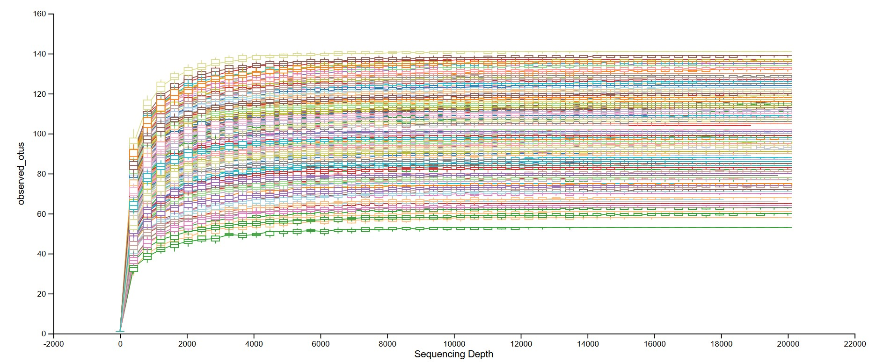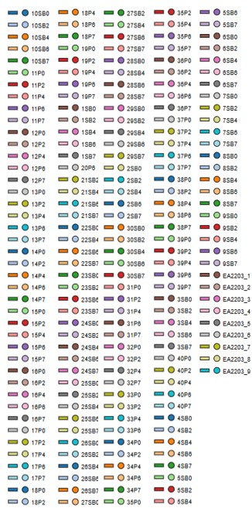
B
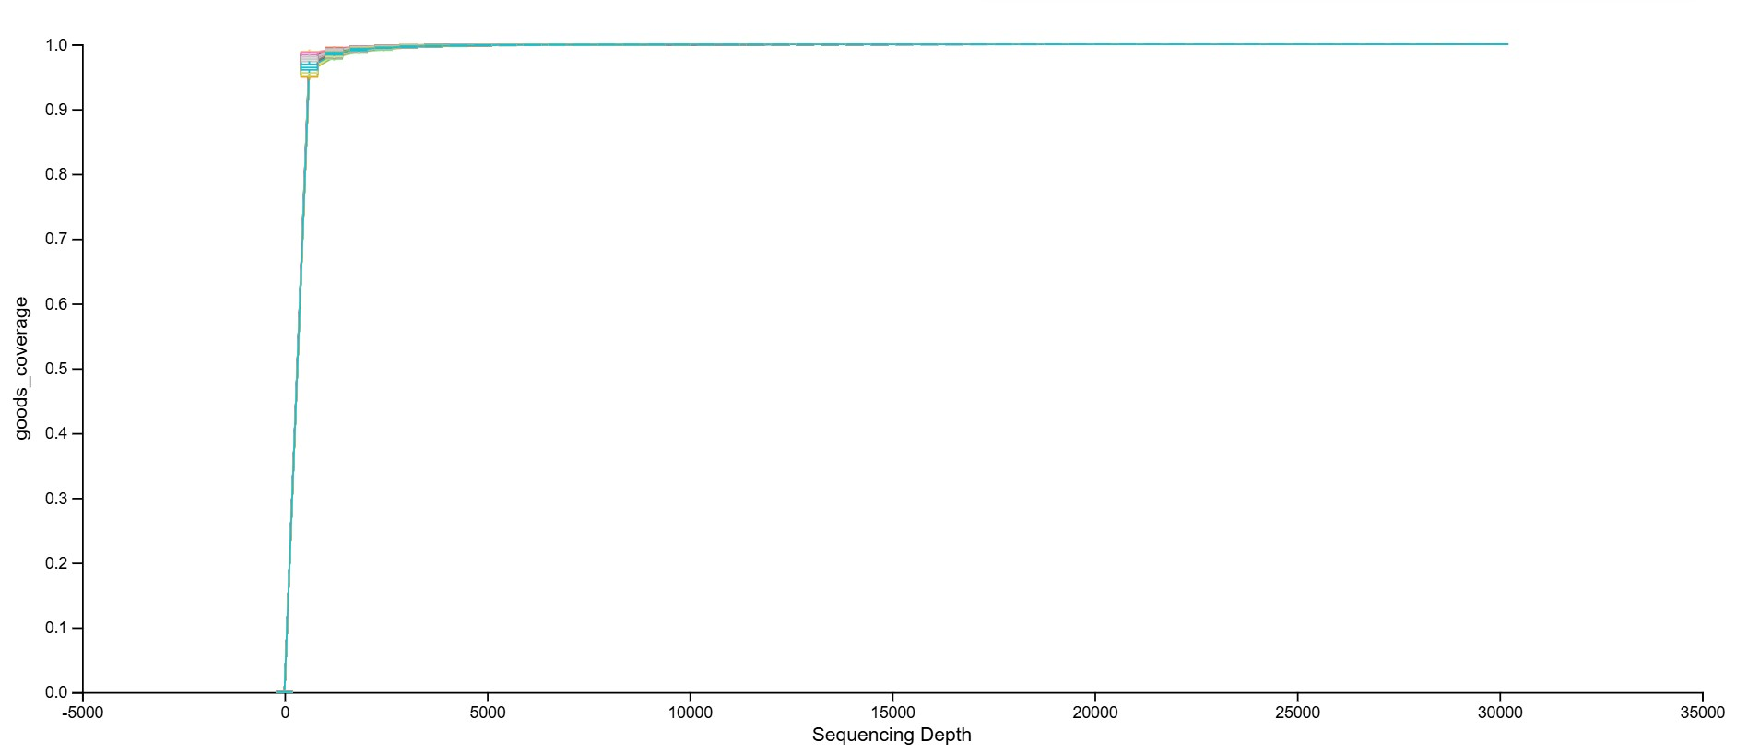

Figure S2. Principal coordinate analysis of the significant weighted Unifrac distances of beta diversity at Week 4 with ellipses at 1.5 SD (P=0.017) (A) and significant distance of the weighted Unifrac distances from Week 6 to Week 7 (P =0.008) (B). SB, Saccharomyces cerevisiae variant boulardii CNCM I-1079; SD, standard deviation; w, week.
A B
