Skin bacteriome linked to disease defense in neotropical frogs
Laura K. Schuck¹*, Julia R. Ernetti^{2,3}, Shannon M. Buttimer¹, Ananda B. de Assis^{4,5}, Renato A. Martins⁴, Mariana Pontes^{2,3}, Ana C. Z. Silva⁶, Maria B. Tosta², Luis Felipe Toledo^{2,3}, C. Guilherme Becker^{1,7}
Supplementary material

Supplementary methods:
Frog transport, housing and acclimation
After swabbing, we housed individual frogs in sterile plastic bags (Whirl-Pak®) with local leaf-litter that was in direct contact with the frog at the time of capture (contact leaf-litter). We also added autoclaved Sphagnum moss moistened with sterile distilled water to each plastic bag. We placed the bags housing our focal animals in a cooler to maintain stable temperatures at the capture site until we transferred the frogs to a climate-controlled laboratory at Universidade Estadual de Campinas (Unicamp, São Paulo, Brazil).
In the lab, we housed frogs individually in terraria (40×30×13 cm; 11 L), with autoclaved Sphagnum and contact leaf-litter moistened with sterile distilled water. The animal room in which frogs were kept had a 12/12 h light/dark cycle and a stable temperature of 20.5°C. We fed frogs every four days with crickets ad libitum. We kept individual frogs in their terrariums without any intervention for three days to allow them to acclimate before the onset of the experimental manipulation.

Treatment details
For the antibiotic treatment, we used a cocktail of Enroflaxacin (60 ug/mL), Cephalexin (24 ug/mL), Streptomycin (100 ug/mL), and Penicillin (100 UI/mL) solution. Our solution differs from the one used in Holden et al. ¹ by not using Trimethoprim and Sulfadiazine, due to the known impact of those substances on Bd in vitro ². We dissolved the antibiotics in sterile artificial pond water (Provosoli ³) to ensure no osmotic stress in frogs while in the bath. Following the treatment, we placed the frogs into new, clean terraria of the same dimensions containing only autoclaved Sphagnum moistened with sterile distilled water, in the same room and feeding conditions described above.
We used a Bd-Asia-1-Brazil/Bd-GPL hybrid genotype isolated from a ranarium in São Paulo, Brazil (CLFT 278) for all Bd inoculations. We flooded 80 seven-day old Bd culture plates with 3 mL of artificial pond water for 40 minutes to stimulate zoospore release by the zoosporangia. We transferred the liquid containing free-swimming zoospores from plates to a sterile beaker. We followed the same plate flooding protocols using Bd-free, sterile tryptone 1% agar plates to obtain a Bd-free sham inoculum. For the Bd exposure, we exposed individual frogs to 3 mL of either Bd zoospore solution or Bd-free control solution. Each frog in the Bd+ treatment was exposed to a concentration of approximately 4.2×10⁶ Bd zoospores/mL, totaling 1×10⁷ zoospores in each bath. We kept each individual frog in contact with Bd or control solutions in sterile plastic containers for 45 minutes and then returned them to their terraria. The solution was transferred to their terraria as well.

Lysozyme step on extraction
The lysozyme buffer was prepared by dissolving 3.15 g of Tris-HCl, 0.744 g of EDTA, and 12 mL of Triton X-100 in 1 L of distilled water, followed by autoclaving. We then added 3.6 mg of lysozyme powder to 150 µL of this buffer, filter-sterilized the mixture using a 0.22 µm syringe filter and added it to each sample. Samples were vortexed and incubated at 37ºC for 30 minutes.

Bioinformatics
Prior to analyzing sequence data, we used seqkit2 ⁴ to filter out reads of QV lower than 30, and Cutadapt ⁵ to trim away the full length F27-R1492 16S primers of the reads. We then imported the filtered reads to QIIME2 ⁶ and clustered sequences into ASVs using DADA2 ⁷. We used QIIME2 to generate amplicon sequence variant (ASV) tables and calculated metrics of alpha and beta diversity for bacteriomes. We used the Greengenes2 classifier to assign taxonomy to ASVs at 99% sequence similarity. We filtered out chloroplast and mitochondrial sequences then rarefied the ASV table to 5620 reads based on the leveling of rarefaction curves (Fig. S2), rarefaction cutoff a total of 30 samples of the 343 sequenced samples.

Bacterial isolate culturing and sequencing
We thawed glycerol preserved swabs at room temperature (21°C) until no ice was observable in tubes. After thawing and homogenizing with a pipette, we inoculated 20 uL of the solution into each of two Petri dishes: one containing R2A agar and the second containing 1% tryptone (T1%) agar, both with 100 mg/L of diluted Nystatin to prevent fungal growth. The plates were then incubated at 21°C and 60% humidity from two to seven days, until microbial growth was observed. After growth, we identified colonies with unique morphotypes between the sample duplicates with the aid of a dissecting microscope. We picked one colony of each morphotype and streaked them multiple times on non-overlapping sections of T1% agar plate to thin out the number of bacterial cells until colonies were separate and likely growing from one unique cell. The new plates grew for 24 to 48 hours, or until growth was observed. The streaking was repeated multiple times as needed until no other microorganisms were observed growing in the plates and colonies were growing isolated from one another. We isolated bacterial from the glycerol swabs to axenic culture using standard microbiological techniques ⁸ (see Supplementary Methods). We then transferred pure isolates T1% broth where at 22°C and 60% humidity until growth of visible colonies was observed. Once grown, the pure isolates were centrifuged to form cell pellets. The supernatant media containing the isolate metabolites (extract) was carefully harvested and cells were removed by filtering the supernatant through a 0.22 uM membrane filter. Using those extracts, we conducted challenge assays, adapting the standardized method from Bell et al.⁹ (see Methods). Isolates were considered Bd-inhibitory when the average Bd growth in their extract experimental wells were equal or smaller than 50% of the growth observed in the positive control (Bd in T1%) in the respective assay plate.
We selected Bd isolate CLFT (BAF) 041 for our challenge assays, a Global Panzootic Lineage (GPL) genotype cultured from the same region in Brazil where our study animals were collected. The isolate was cryopreserved in 1% tryptone, 10% DMSO medium. We revived cryopreserved cultures using the standard method of Prostak & Fritz-Laylin ¹⁰. We rested the cultures for one week to allow cells to recover activity and started subculturing when multiple zoospores per field of view were observed. Subcultures were started in 1% tryptone agar plates and were allowed to grow for seven days after inoculation. After growing, plates were flooded with 3 mL sterile T1% broth to create a suspension of zoospores. The suspension was collected and filtered through a sterile 20 μm nylon filter to remove sporangia. Filtered zoospores were counted on a Neubauer improved chamber and resuspended in sterile T1% to a concentration of 2×10⁶ mL⁻¹. All Bd cultures were maintained at 21°C, and 60% humidity; conditions in which we observed optimum growth.
We performed sequencing of the 16S rRNA gene of each isolate using a dual index method, employing 16S rRNA universal primers 8F and 1492R. To extract DNA, we treated pellets of the isolates with 100 µL of a 5% Chelex solution and incubated at 99°C for 20 minutes. To mitigate potential PCR inhibition, the extracted DNA was diluted at a ratio of 1:10 with deionized water. We then amplified the samples in duplicate using Phire Hot Start II DNA Polymerase (Finnzyme, Espoo, Finland), including negative controls in each 96-well plate to ensure no contamination. The success of amplification and the integrity of the DNA bands were confirmed by visualizing the amplicons on a 1% agarose gel. The purified DNA was later sequenced using Sanger sequencing on an ABI 3730XL station. We used the isoQC function of the “isolateR" package in R to quality control isolate sequences, and sequences were cut keeping the base pairs with a phred score higher than 20 and a minimum total length of 200 base-pairs. We created a comprehensive database containing sequences from all our cultured isolates, including both Bd-inhibitory and non-Bd-inhibitory taxa. We used QIIME2 and vsearch to match our full pacbio library to the isolate libraries with 100% similarity in sequences. We then calculated the richness of Bd-inhibitory ASVs per sample and the ratio of inhibitory reads over total cultured reads (proportion of Bd-inhibitory reads).

Challenge assays
We conducted challenge assays in 96-well microplates, adapting the standardized method from Bell et al.⁹. Experimental wells contained 50 μL of Bd zoospores at a concentration of 2×10⁶ mL⁻¹ and 50 μL of a bacterial cell-free extract. The positive control wells contained 50 μL Bd and 50 μL T1% medium. We included two types of negative controls: a (medium-only) control, which consisted of wells containing 100 μL replicates of T1% alone, and a heat-killed control of 50 μL of heat-killed Bd zoospores (80°C for 30 min) at a concentration of 2×10⁶ mL⁻¹ in 50 μL of T1%. We added nutrient depleted controls containing 50 μL of Bd zoospores at a concentration of 2×10⁶ mL⁻¹ and 50 μL of artificial pond water instead of T1%. Each plate contained 16 bacterial supernatant samples in triplicate (experimental wells), and three wells of each control type. We incubated assay plates at 21°C and recorded optical density of each well at 492 nM on days 0, 3, 5 and 8 using a Thermoscientific Varioskan Lux microplate reader, which was sufficient time for the growth curve to reach a plateau ^{11,12}. To calculate Bd growth in each well we followed the established protocol described by Bell et al ⁹.

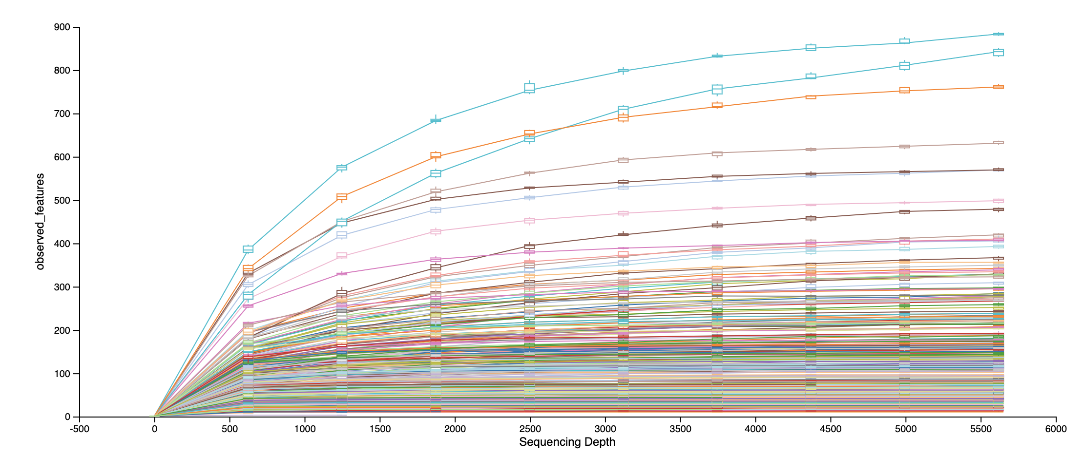
Figure S1: Rarefaction curves for each sample, plotted in QIIME2.

Figure S2: Representativity of Bd-inhibitory and non-inhibitory isolates across cultured taxa.

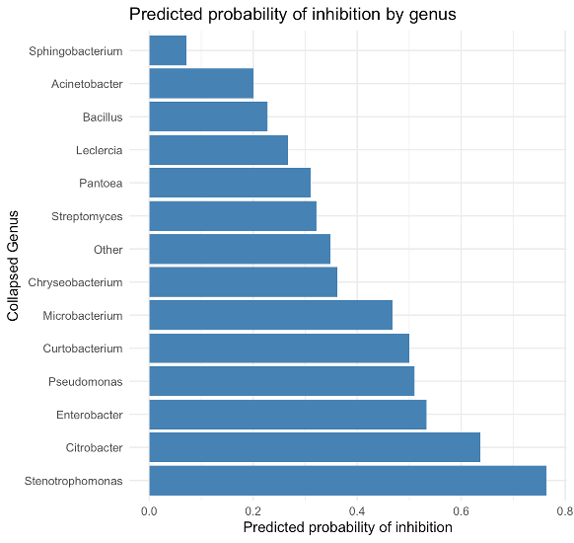
Figure S3: Predicted probability of Batrachochytrium dendrobatidis (Bd) inhibition by bacterial genera isolated from
frog skin. Genera with fewer than 10 isolates were grouped as Other; Probabilities are from a logistic regression
model. Significant genera (e.g., Stenotrophomonas) show higher Bd-inhibitory potential (p < 0.05).

Supplementary References:
1. Holden, W. M. et al. Skin bacteria provide early protection for newly metamorphosed southern leopard frogs (Rana sphenocephala) against the frog-killing fungus, Batrachochytrium dendrobatidis. Biological Conservation 187, 91–102 (2015).
2. Muijsers, M. et al. Antibacterial therapeutics for the treatment of chytrid infection in amphibians: Columbus’s egg? BMC Vet Res 8, 175 (2012).
3. Wyngaard, G. & Chinnappa, C. C. General Biology and Cytology of Cyclopoids. https://works.bepress.com/grace_wyngaard/41/ (1982).
4. Shen, W., Sipos, B. & Zhao, L. SeqKit2: A Swiss army knife for sequence and alignment processing. iMeta 3, e191 (2024).
5. Martin, M. Cutadapt removes adapter sequences from high-throughput sequencing reads. EMBnet j. 17, 10 (2011).
6. Bolyen, E. et al. Reproducible, interactive, scalable and extensible microbiome data science using QIIME 2. Nat Biotechnol 37, 852–857 (2019).
7. Callahan, B. J. et al. DADA2: High-resolution sample inference from Illumina amplicon data. Nat Methods 13, 581–583 (2016).
8. Salle, A. J. Fundamental Principles Of Bacteriology. (McGraw Hill Book Company Inc., 1943).
9. Bell, S. C., Alford, R. A., Garland, S., Padilla, G. & Thomas, A. D. Screening bacterial metabolites for inhibitory effects against Batrachochytrium dendrobatidis using a spectrophotometric assay. Dis Aquat Organ 103, 77–85 (2013).
10. Prostak, S. M. & Fritz-Laylin, L. K. Laboratory Maintenance of the Chytrid Fungus Batrachochytrium dendrobatidis. Curr Protoc 1, e309 (2021).
11. McMahon, T. A., Romansic, J. M. & Rohr, J. R. Nonmonotonic and Monotonic Effects of Pesticides on the Pathogenic Fungus Batrachochytrium dendrobatidis in Culture and on Tadpoles. Environ. Sci. Technol. 47, 7958–7964 (2013).
12. Siomko, S. A. et al. Selection of an anti-pathogen skin microbiome following prophylaxis treatment in an amphibian model system. Philosophical Transactions of the Royal Society B: Biological Sciences 378, 20220126 (2023).

