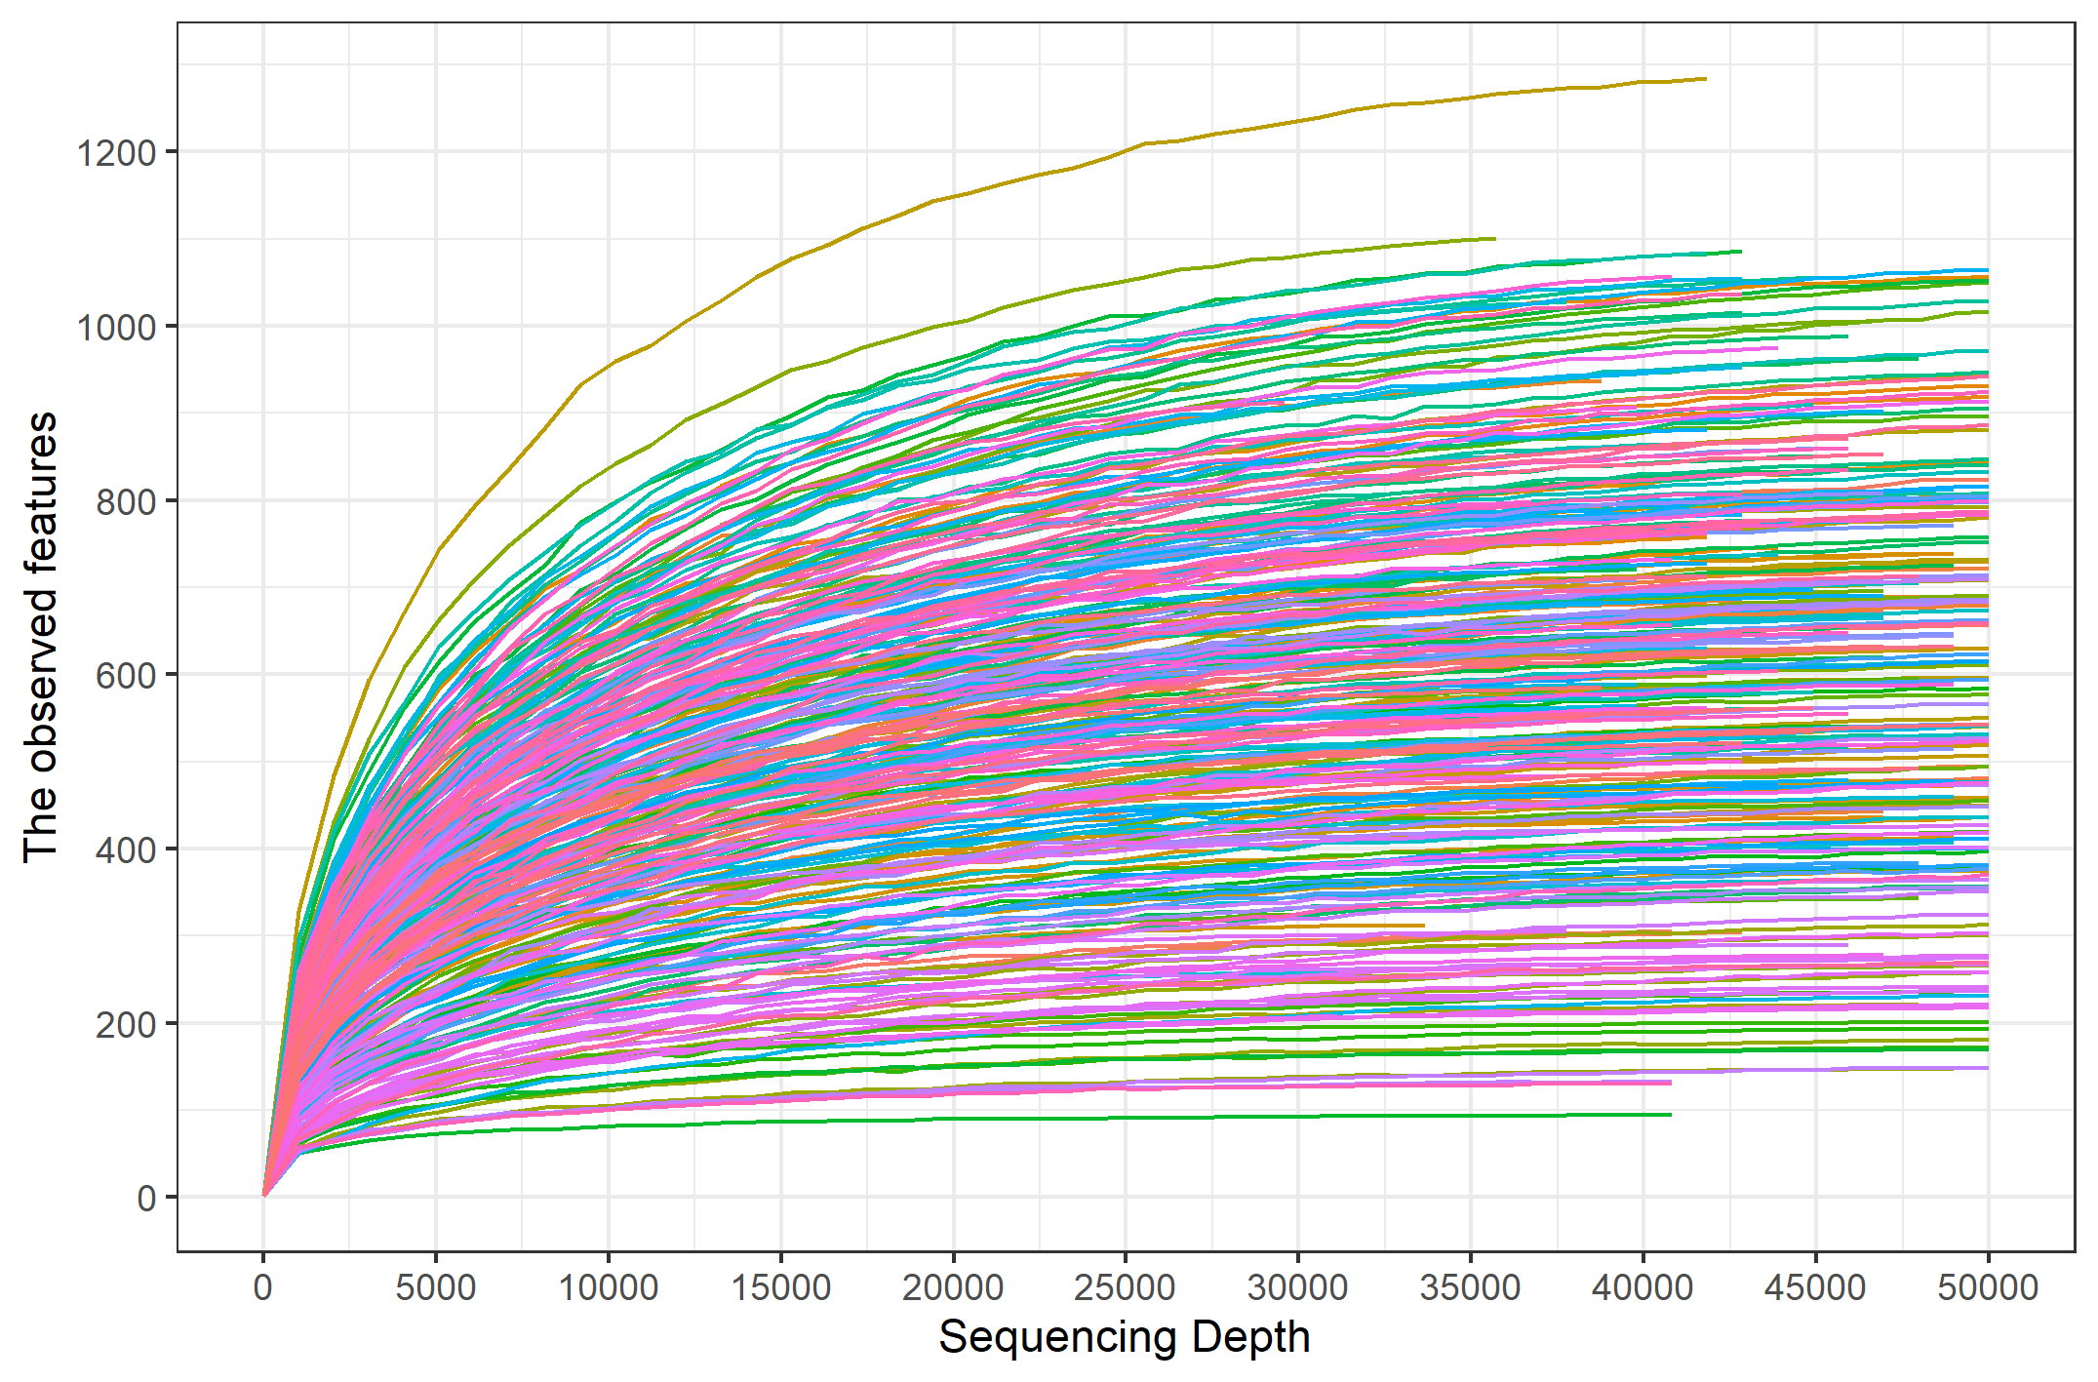
Supplementary Figure S1. Rarefaction curves of the number of observed features among different sequencing depth.

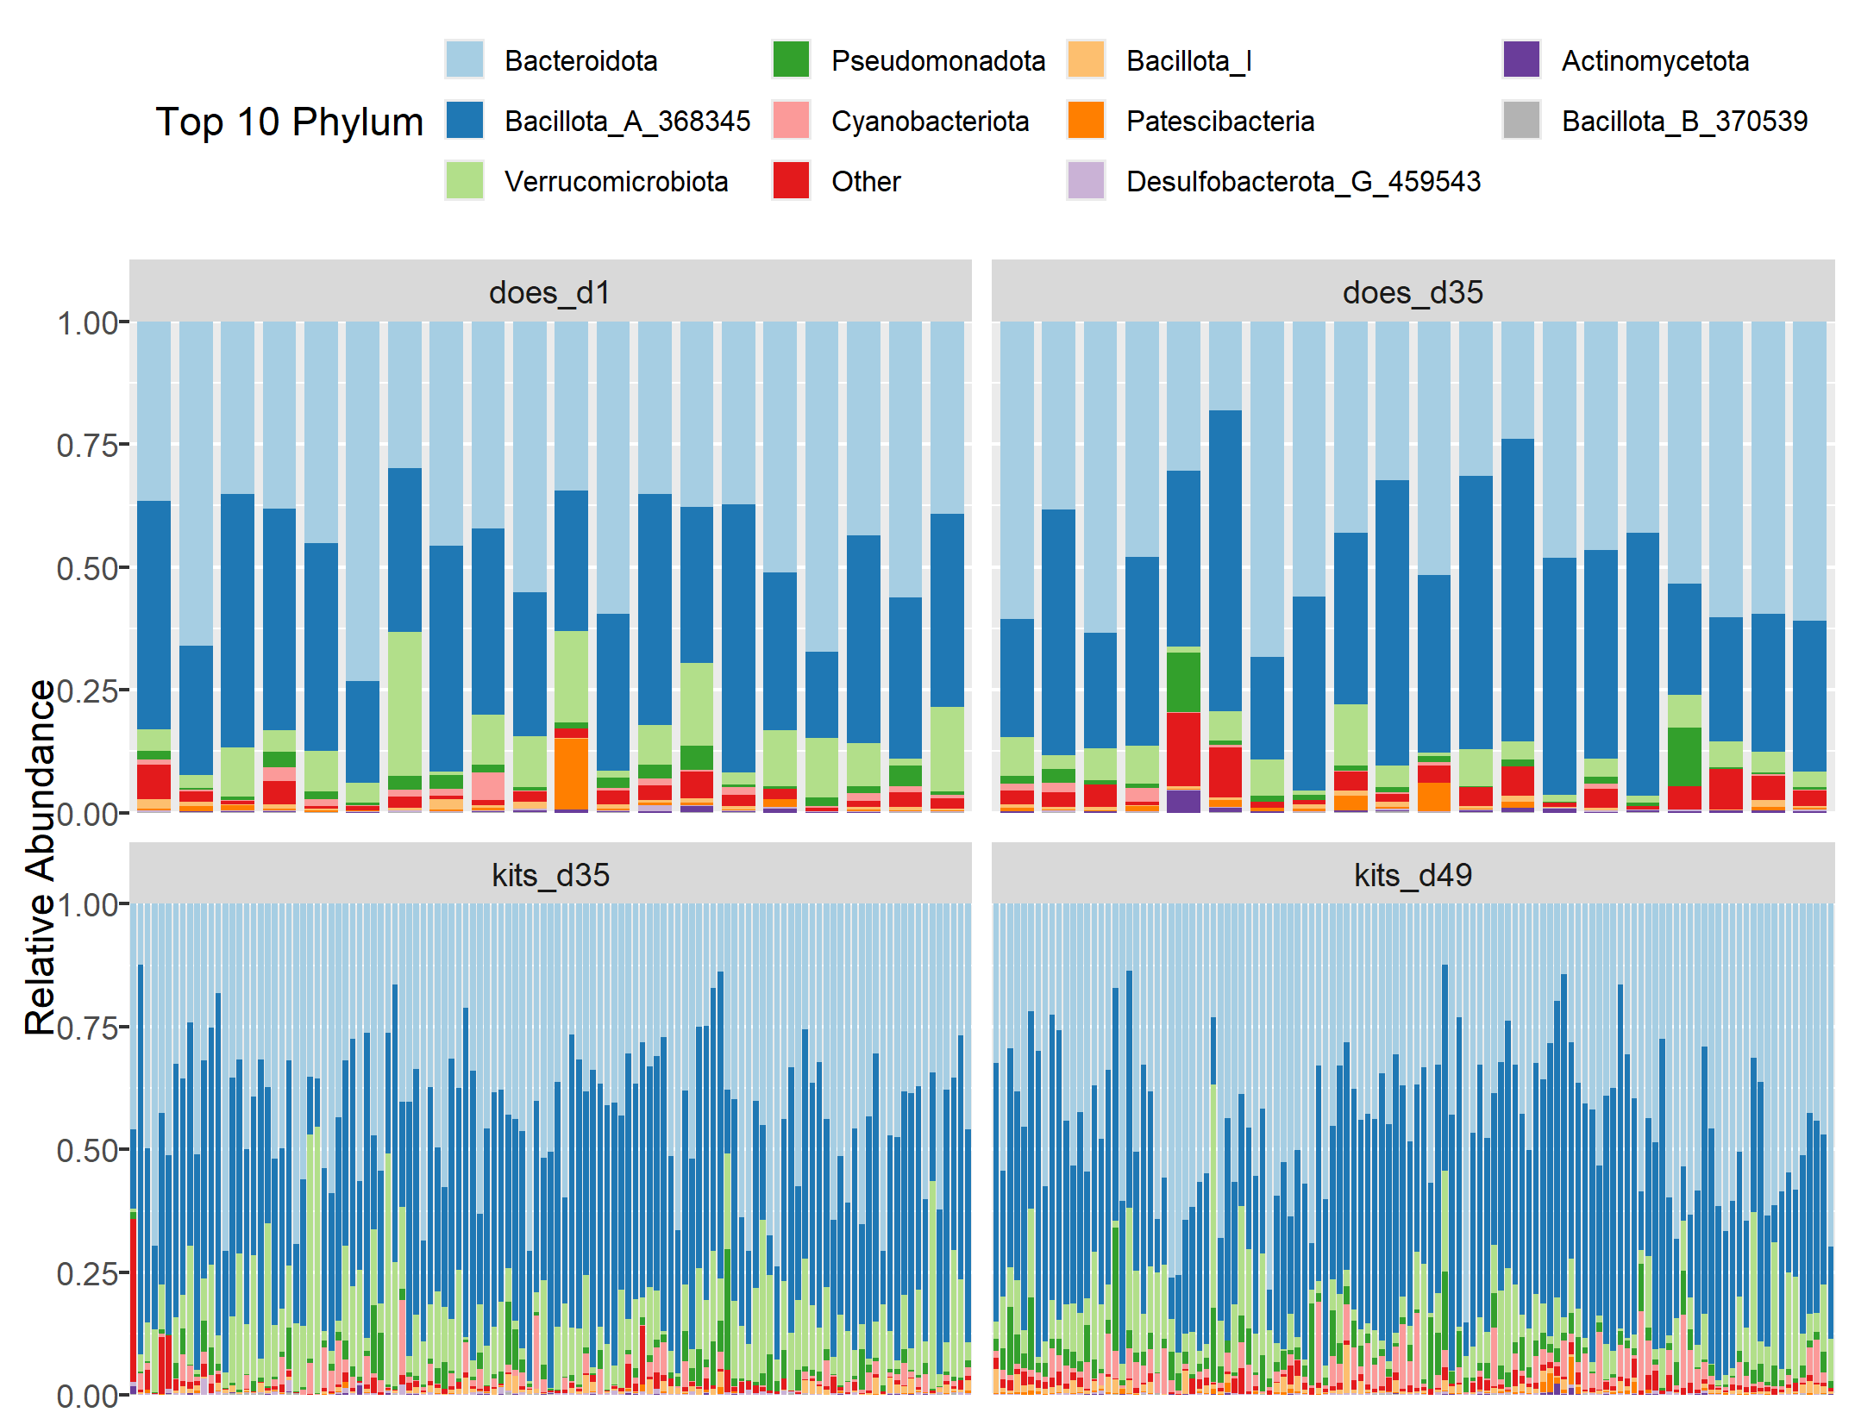
Supplementary Figure S2. Taxonomical compositions at the phylum level for both does and kits at the three ages.

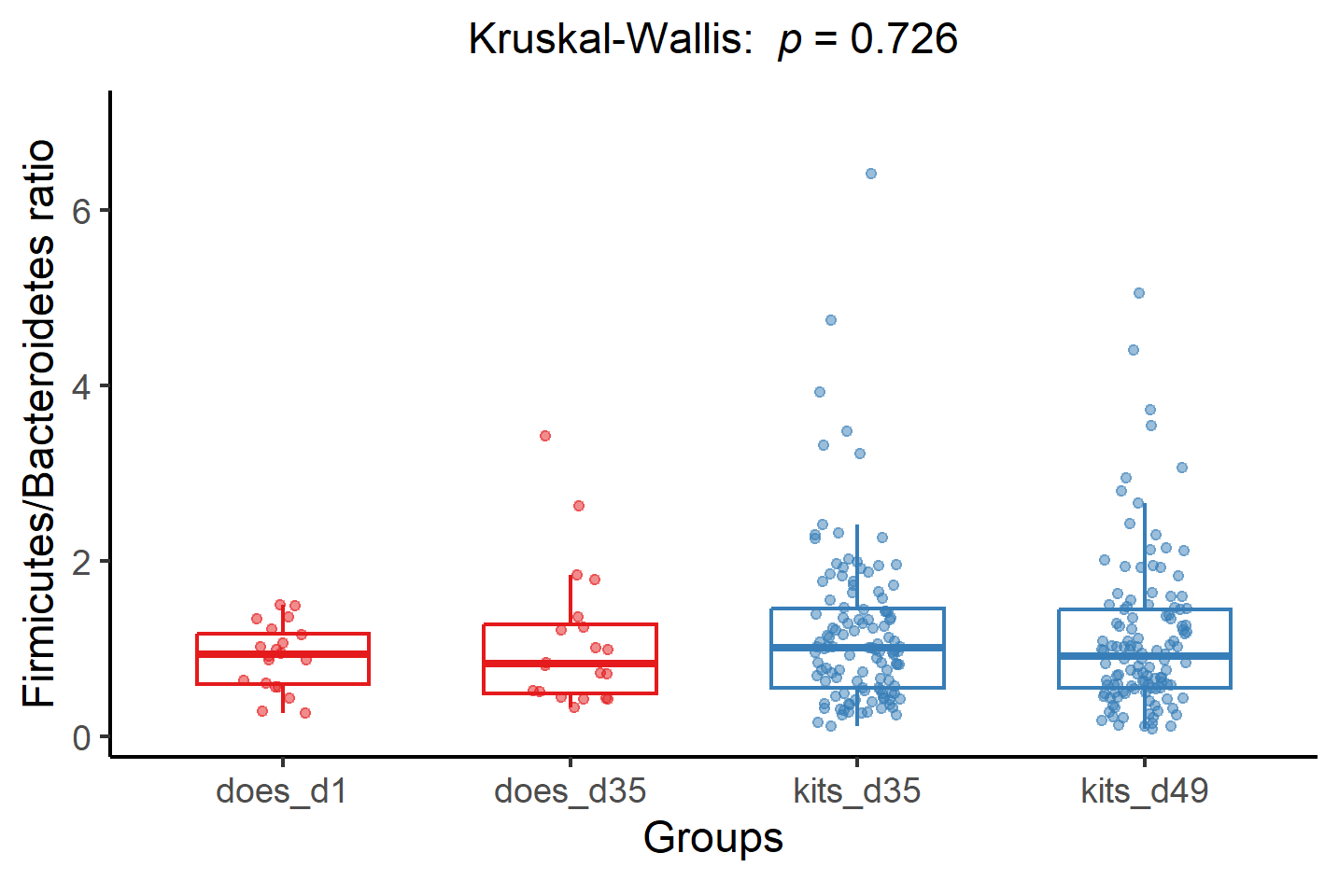
Supplementary Figure S3. Statistical comparisons of Firmicutes/Bacteroidetes ratio among the four groups of both does and kits at three age stages. The p values of Kruskal-Wallis tests are shown to the top of boxplots.

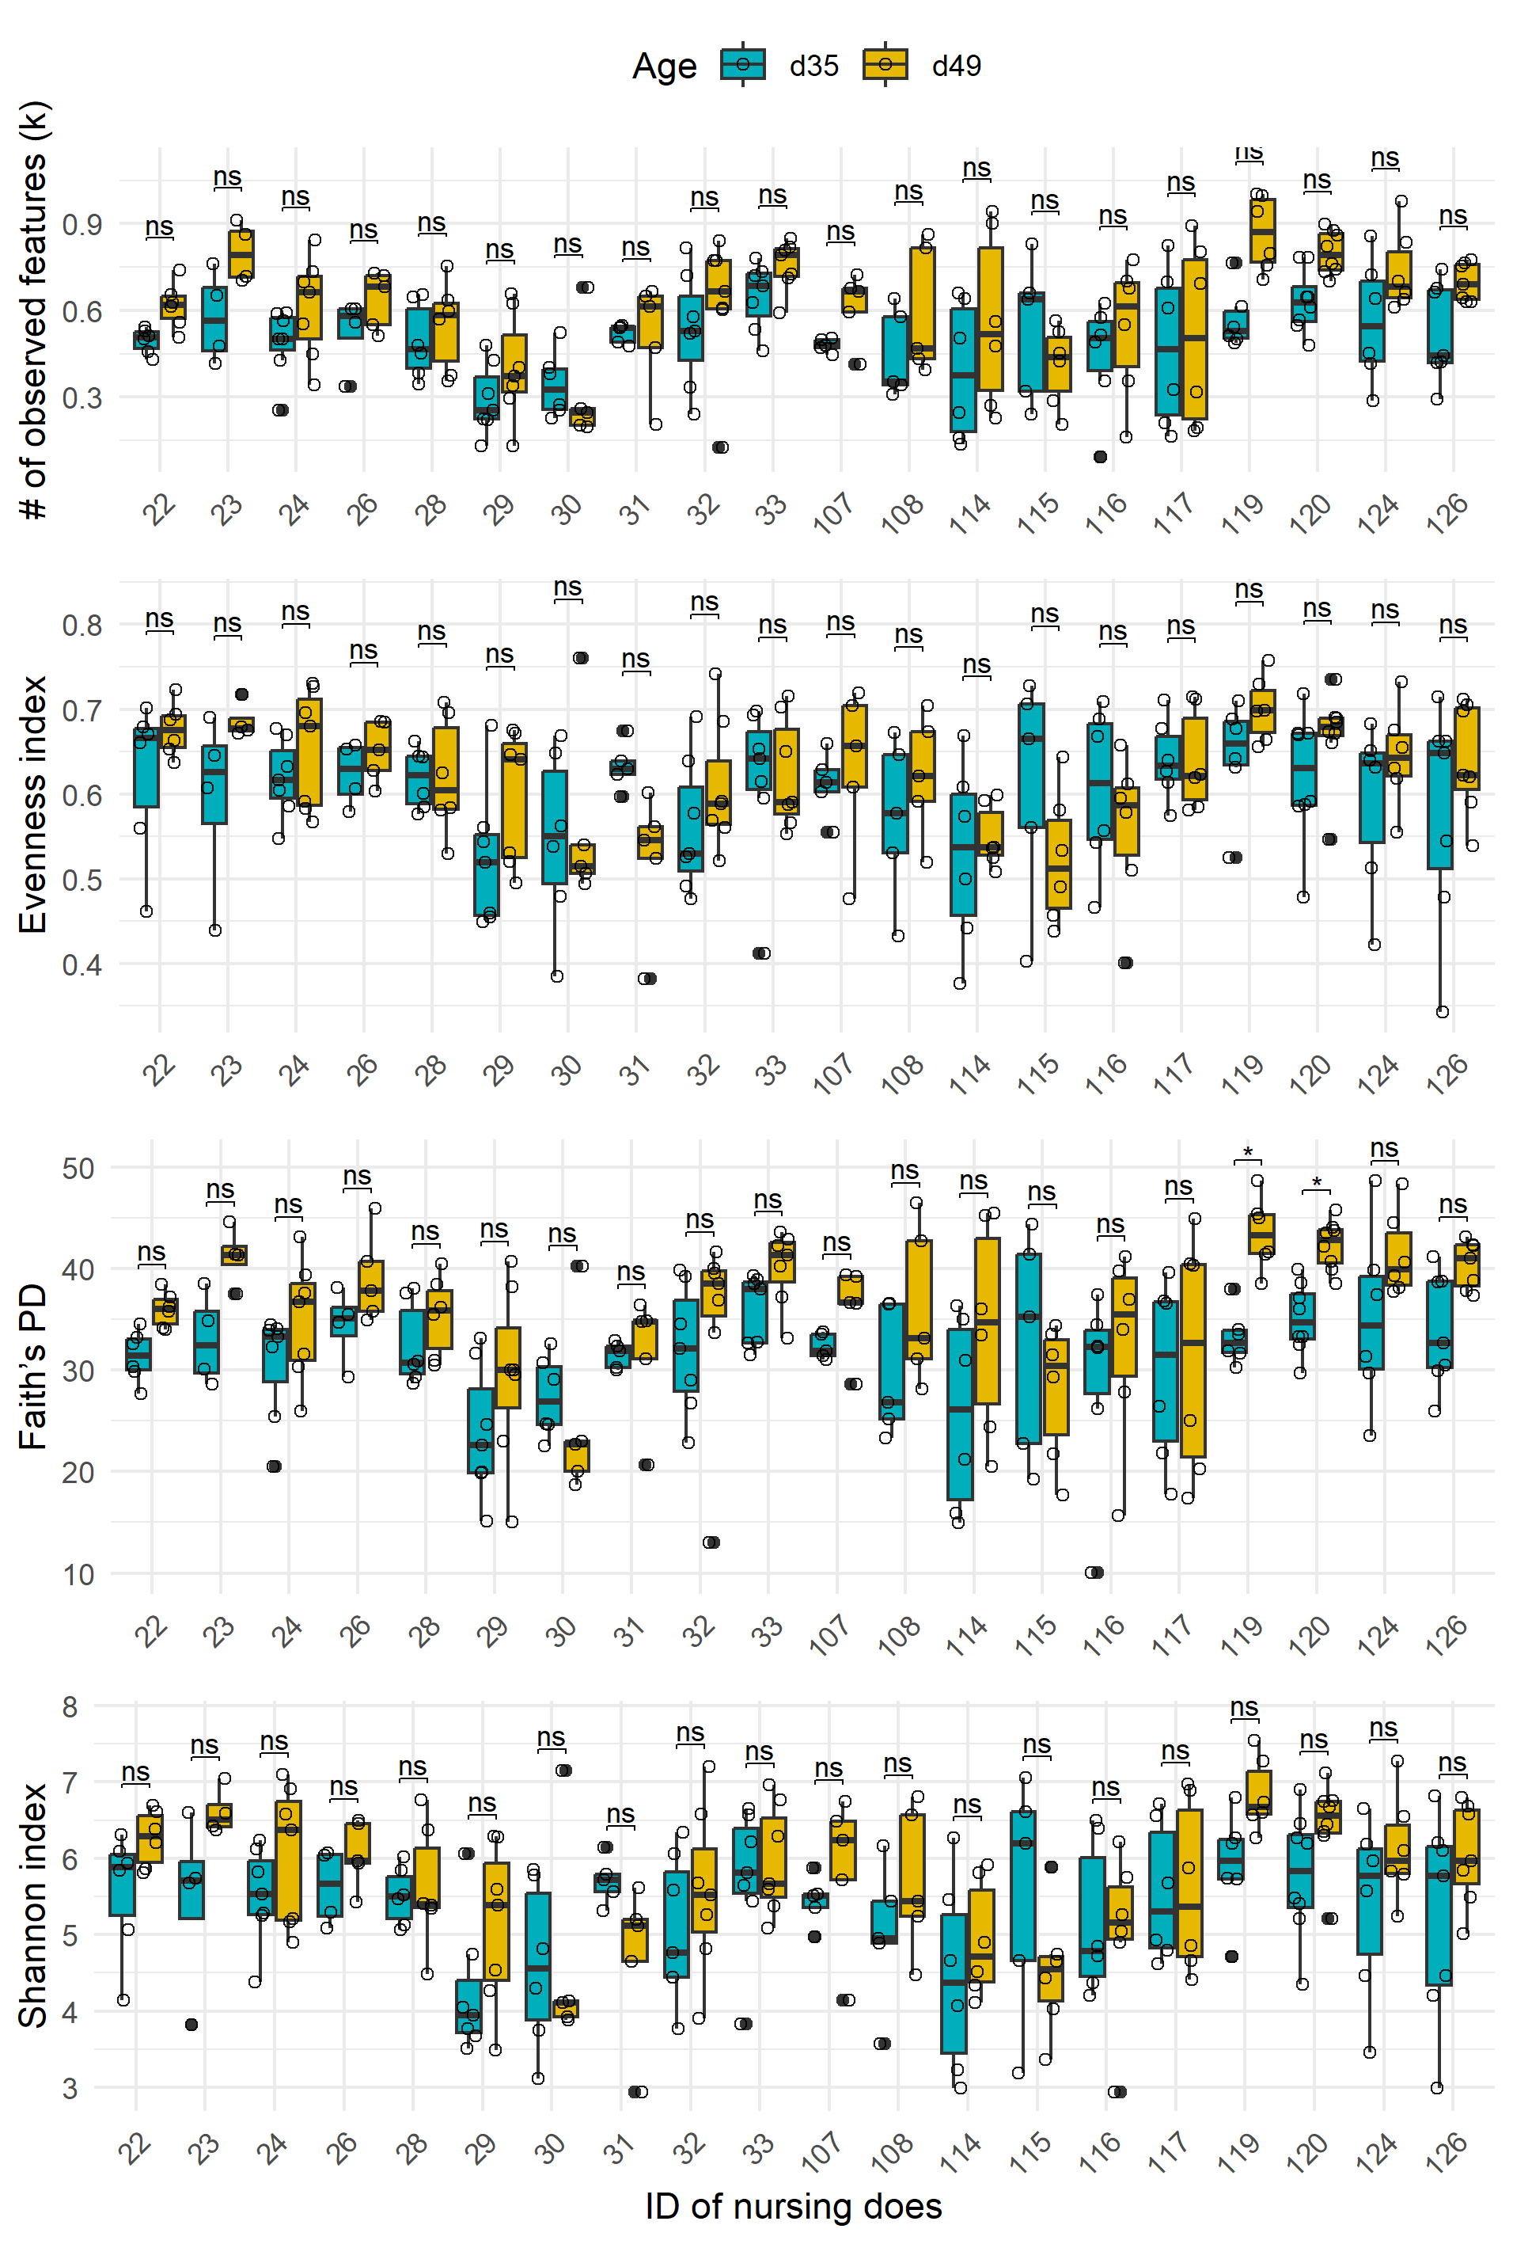
Supplementary Figure S4. Comparisons of individual alpha diversity of kits between 35 d and 49 d of age within every nursing doe. Faith’s PD: Faith’s phylogenetic diversity. The Kruskal-Wallis test is applied (ns: p > 0.05, *: p < 0.05).

