Additional File 1 (supplementary figures)

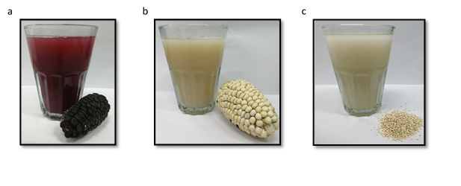
Additional Figure A. Chicha made from different cereals in Peru: a) Chicha made from purple corn (Zea mays L.) b) Chicha made from white corn (Zea mays L.) c) Chicha made from quinoa (Chenopodium quinoa).

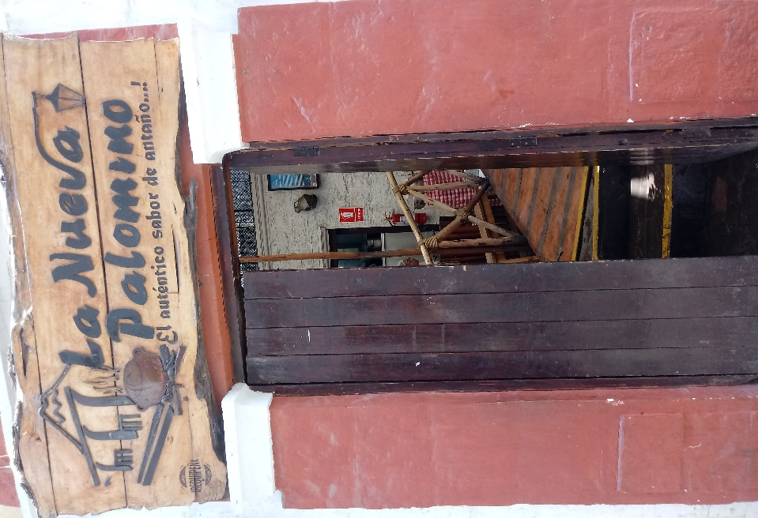
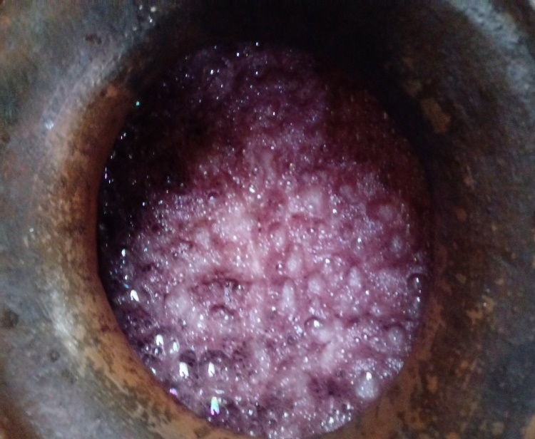
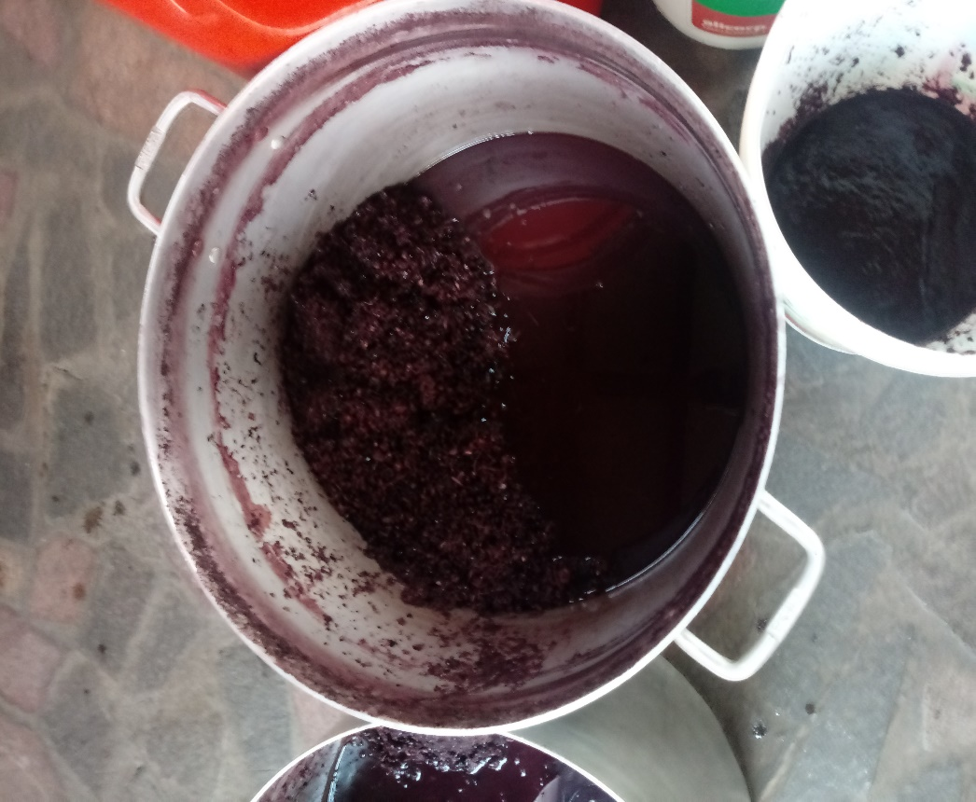
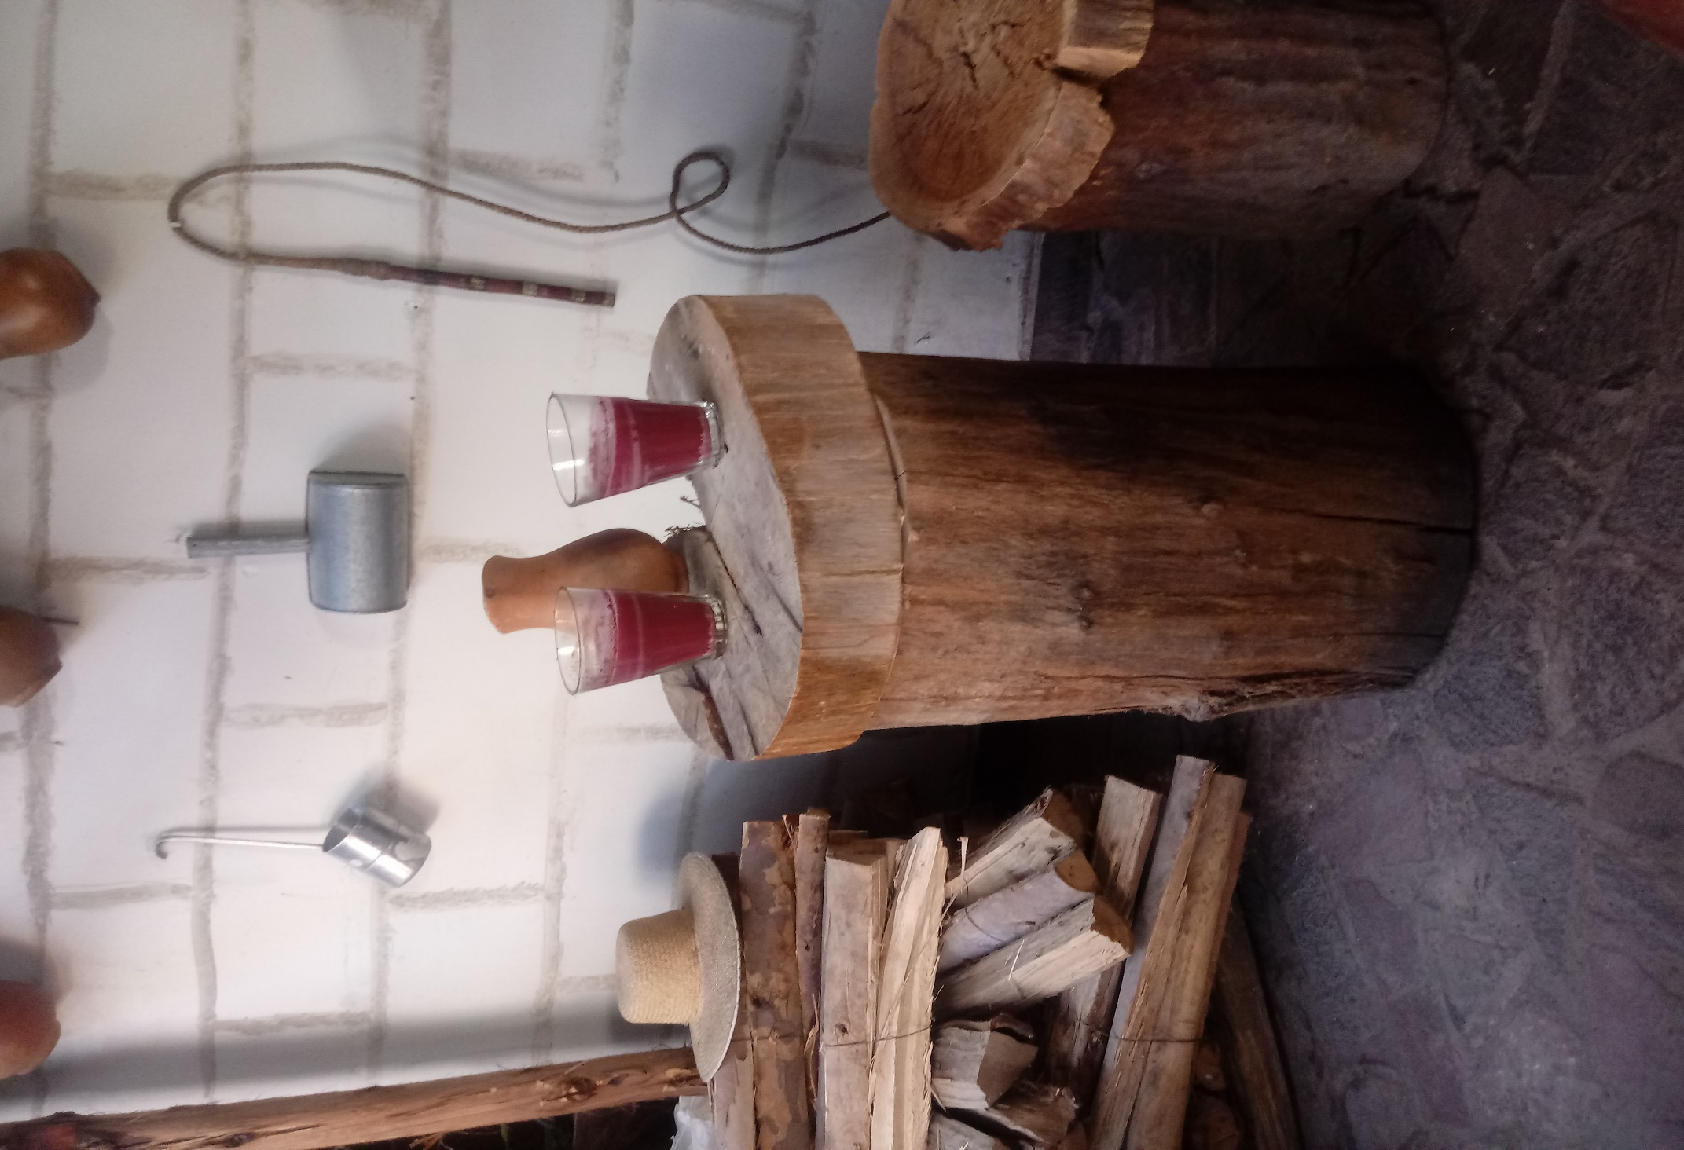
a)
b)
c)
d)

Additional Figure B. Picanteria of Zone 1 (Arequipa). a) Front entrance of Picanteria “La nueva Palomino”. b) Residues of the boiling step. c) Foam produced during the fermentation of boiled and filtered Chicha. d) Final product: Chicha de Güiñapo

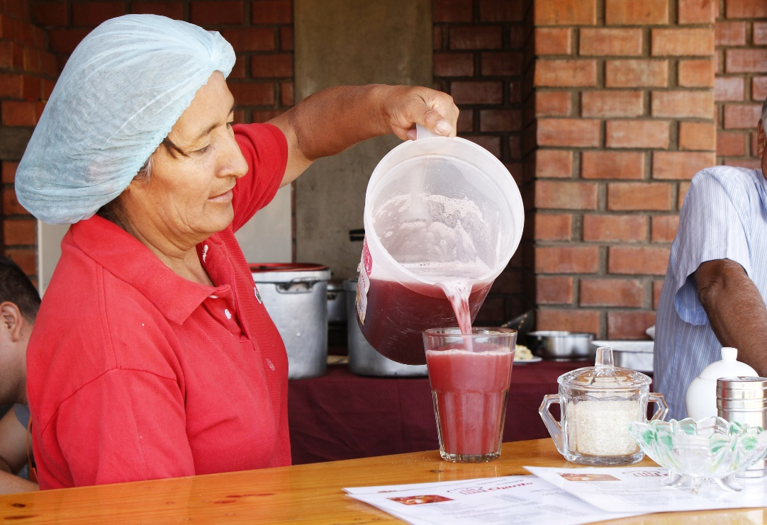
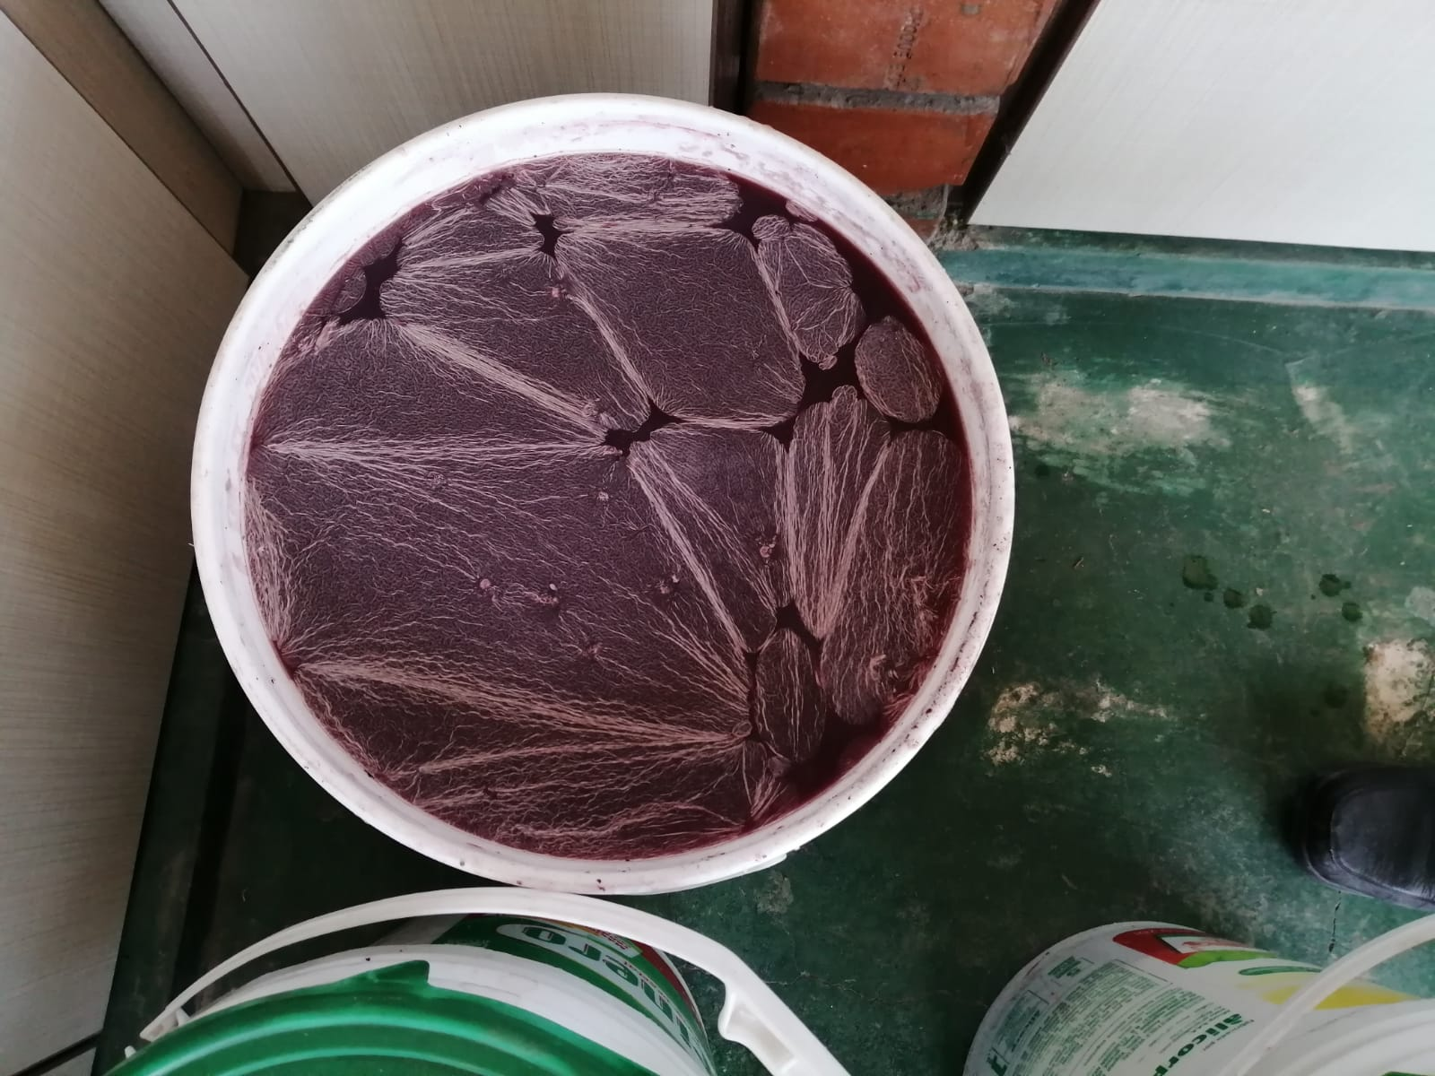
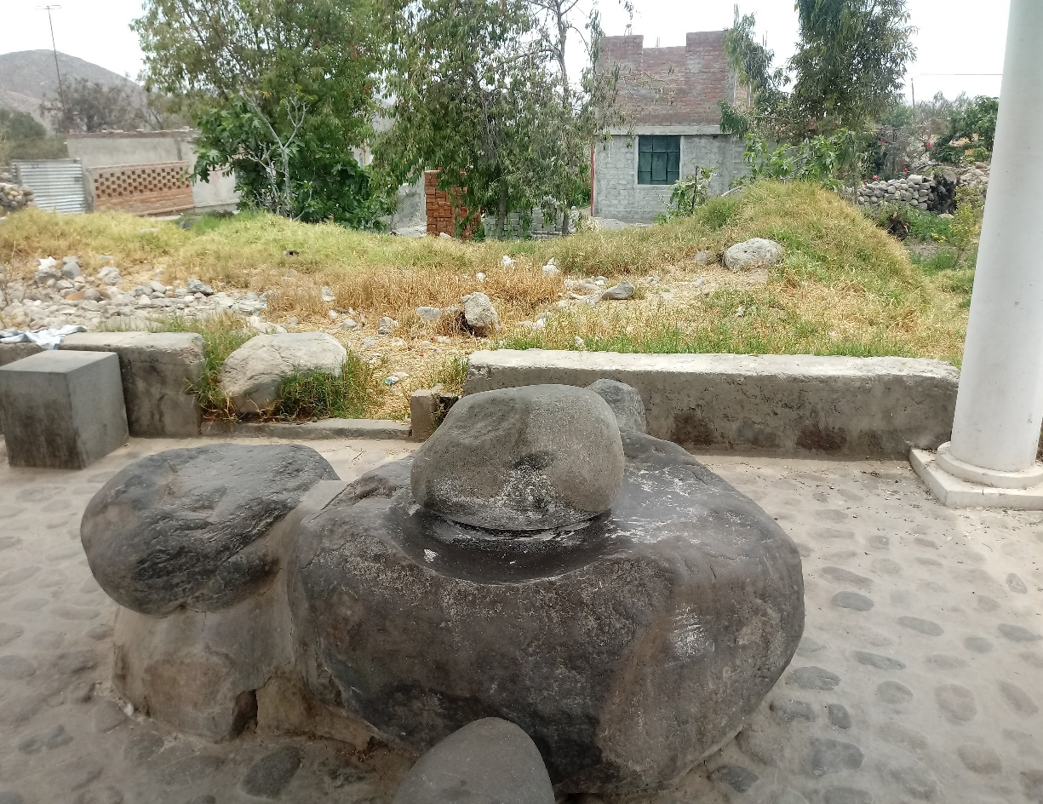
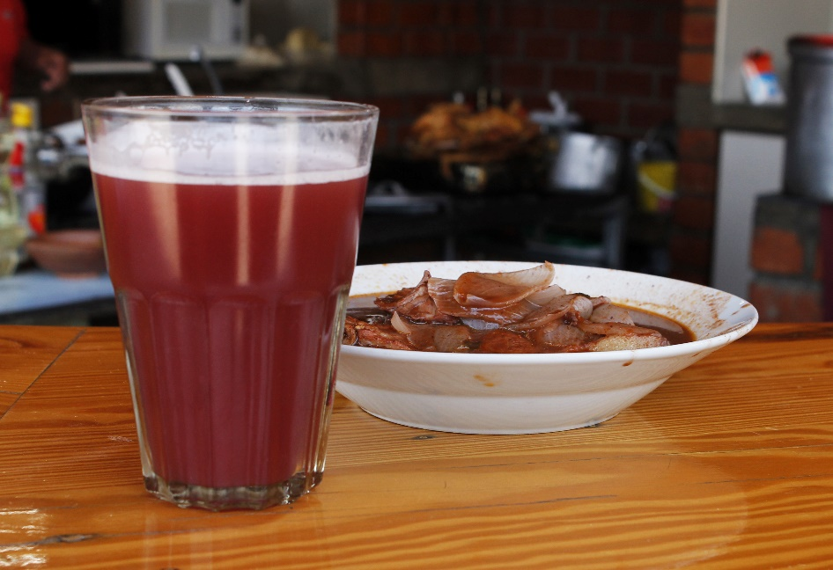
a)
b)
c)
d)

Additional Figure C. Picanteria of Zone 2 (Characato). a) Traditional stone tool called “batán” used to mill the germinated corn kernels into flour. b) Modern style of fermentation of Chicha in plastic containers. c) Chicha de Güiñapo served in a traditional glass called “Caporal”. d) Chicha de Güiñapo served alongside a traditional pork-based dish called “Adobo”, also prepared with Chicha.

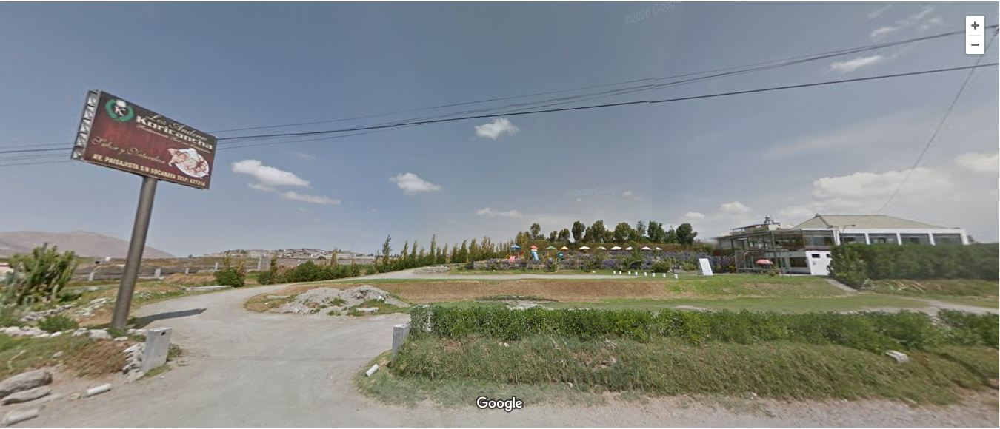

Additional Figure D. Picanteria of Zone 3 (Socabaya). Front entrance of Picanteria “Andenes del Koricancha”. Obtained from Google Maps (1).

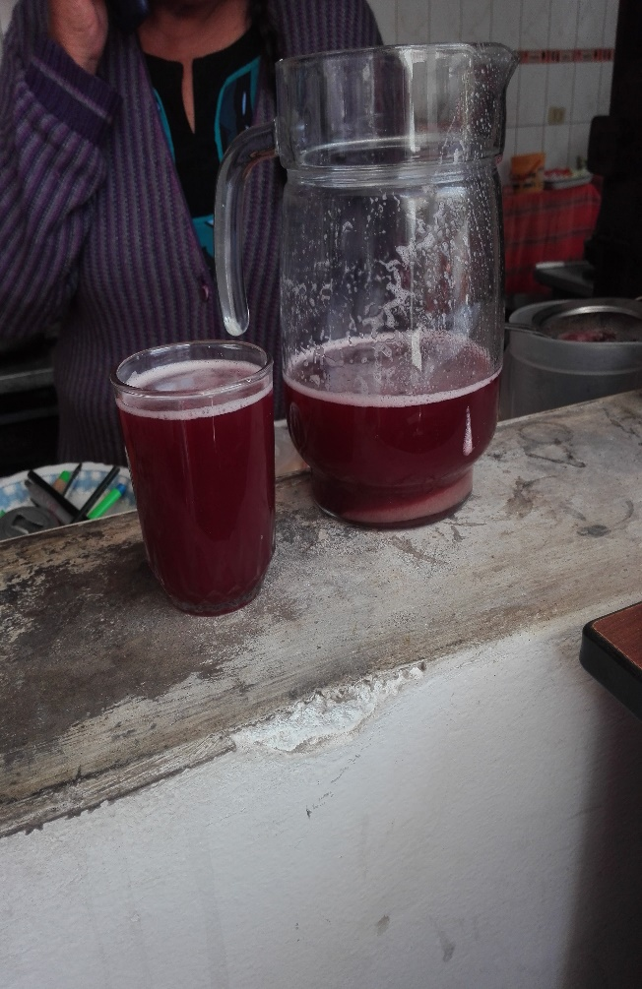
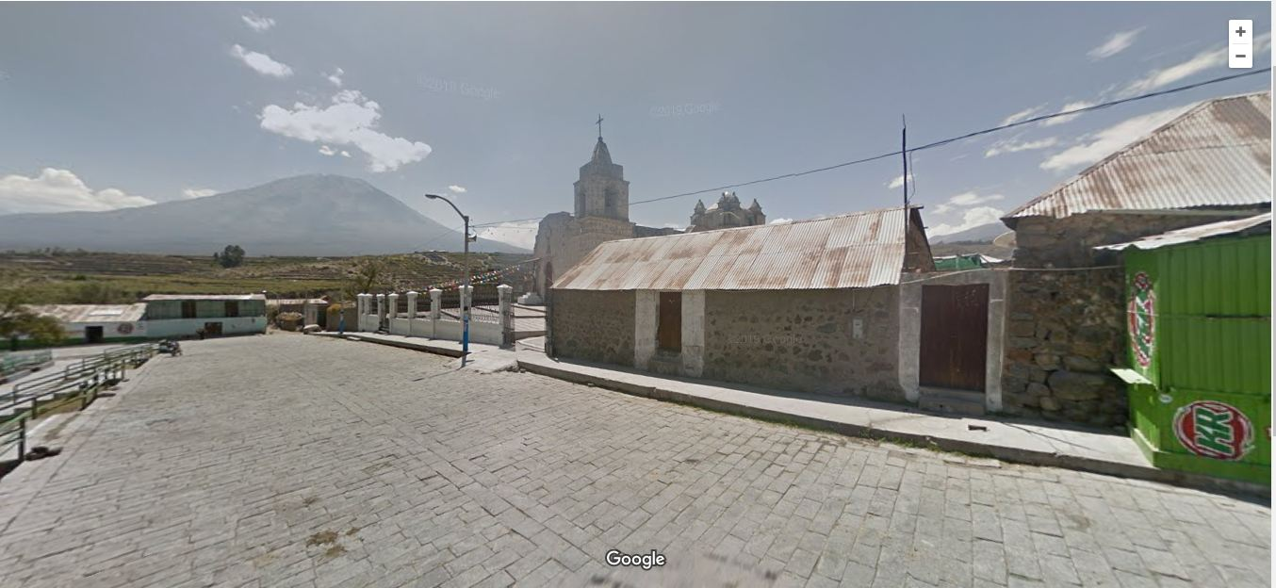
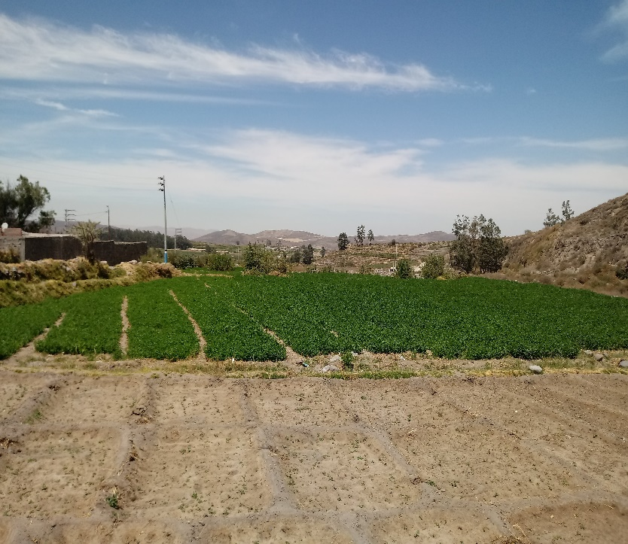
a)
b)
c)

Additional Figure E. Picanteria of Zone 4 (Chiguata). a) Front entrance (to the right) of Picanteria “Doña Leo” (2). b) Plots used to grow maize and alfalfa. c) Modern presentation of Chicha in common glasses, not fermented in “chombas” but in metal cooking pots.

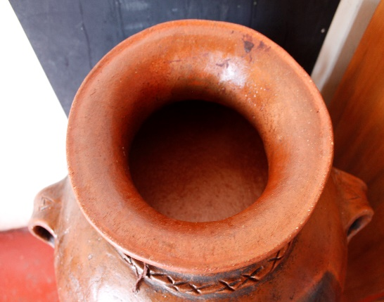
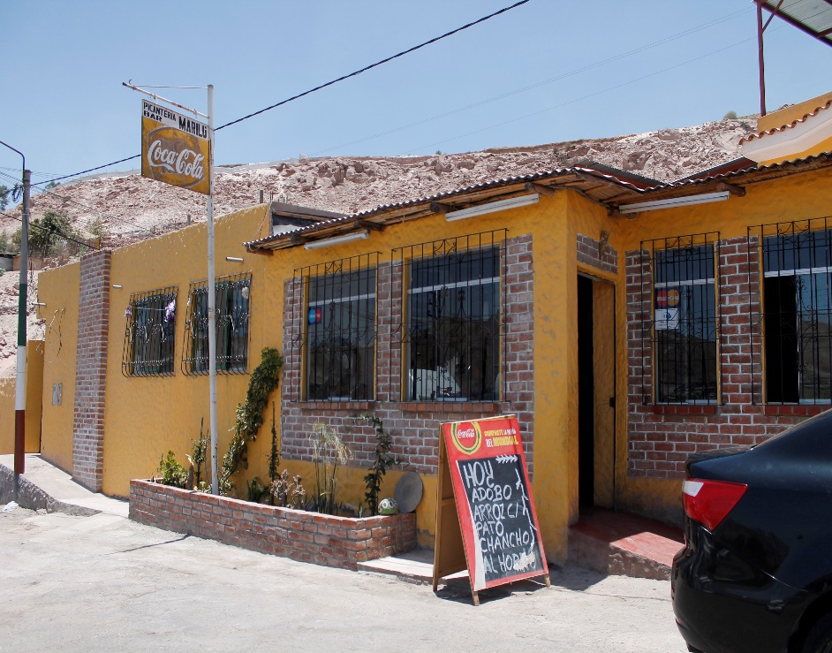
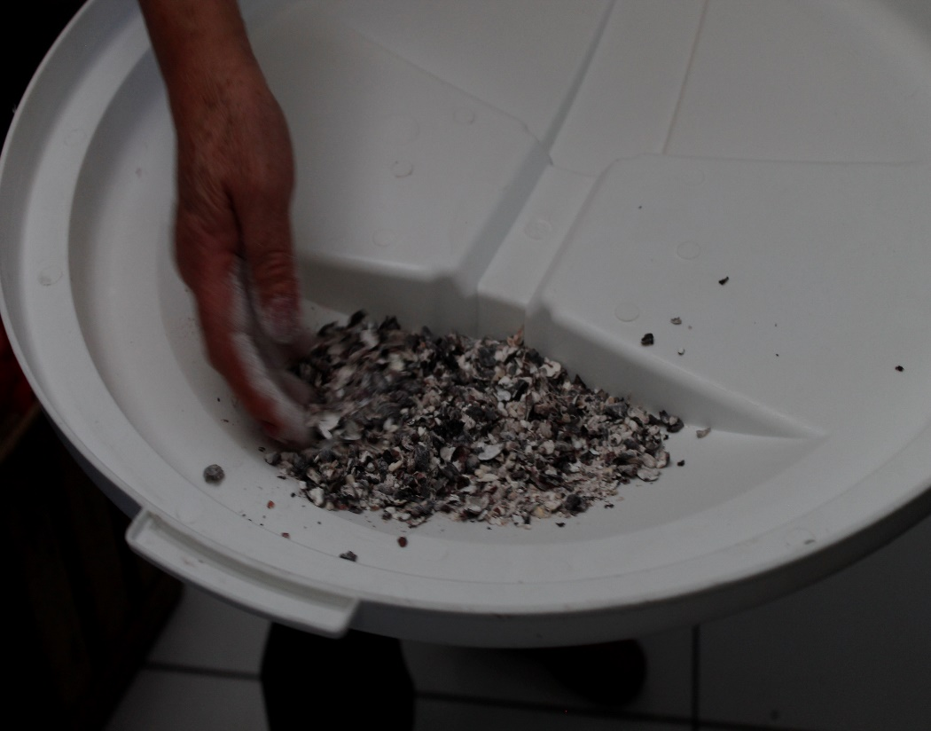
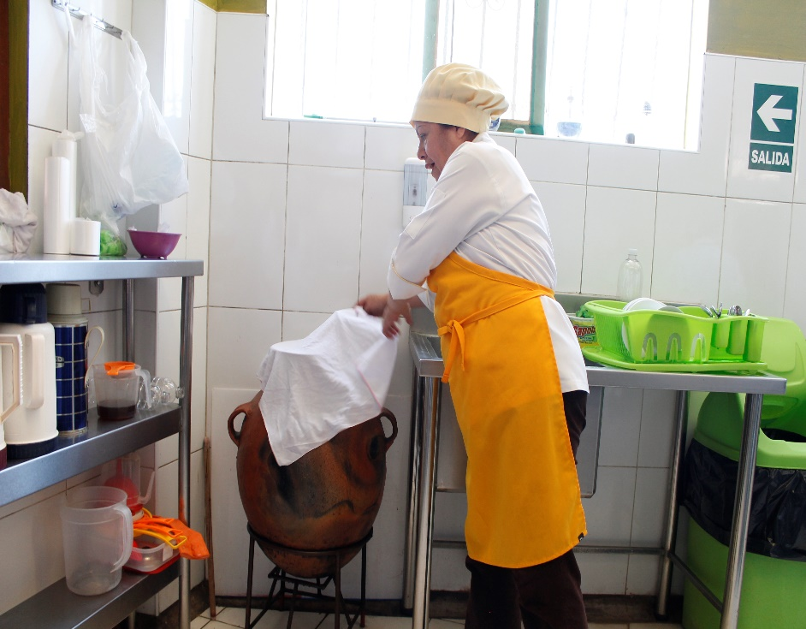
a)
b)
c)
d)

Additional Figure F. Picanteria of Zone 5 (Uchumayo). a) Front entrance of Picantería “Picanteria-Bar Marilú”. b) Milled corn kernels used to produce Chicha. c) Traditional ceramic vessels called “chombas” used for the fermentation of Chicha. d) Fermentation of Chicha in chombas, almost ready to be served.

References

1. Picanteria “Andenes del Koricancha” [Map on the Internet]. Arequipa: Google Maps; c2020 [cited 2020 May 25]. Available from: https://www.google.com/maps/@-16.4575114,-71.5438751,3a,75y,314.7h,100.62t/data=!3m6!1e1!3m4!1swjPT3gVttwb0NZC7csjIag!2e0!7i13312!8i6656
2. Picanteria “Doña Leo” [Map on the Internet]. Arequipa: Google Maps; c2020 [cited 2020 May 25]. Available from: https://www.google.com/maps/@-16.402666,-71.3916408,3a,75y,33.25h,90.34t/data=!3m6!1e1!3m4!1sKN8ySrcwAWpNXnLYrY_7Yw!2e0!7i13312!8i6656

