No | Name of Dishes | Figures | Sources
1 | Ketupat | 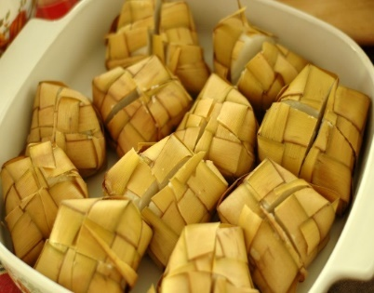 | https://www.freeimages.com/photo/ketupat-1325785
2 | Opor Ayam | 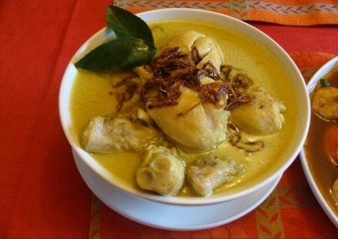 | https://alchetron.com/Opor-ayam
3 | Lontong | 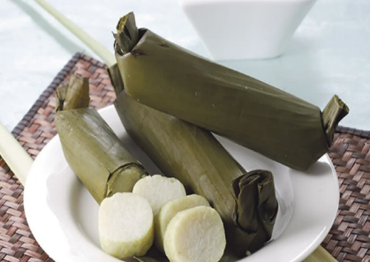 | https://wordpressmu-1122769-3933803.cloudwaysapps.com/7-langkah-membuat-lontong-enak-dan-empuk/
4 | Sambal Kentang | 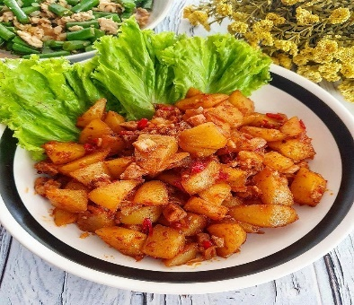 | https://www.briliofood.net/resep/13-resep-sambal-goreng-kentang-rumahan-mudah-dibuat-dan-bikin-nagih-220109m.html
5 | Kaastengel | 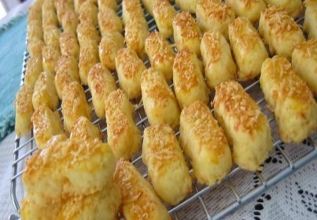 | https://www.pinterest.com/pin/362610207471747798/visualsearch/?x=16&y=16&  w=532&h=271&cropSource=6&surfaceType=flashlight
6 | Nastar | 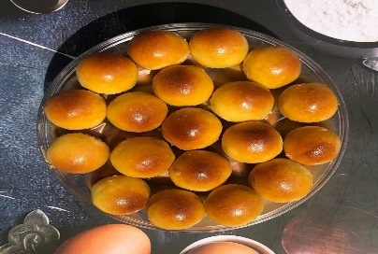 | https://sweetrip.id/kuliner/resep-nastar-premium/
7 | Putri Salju | 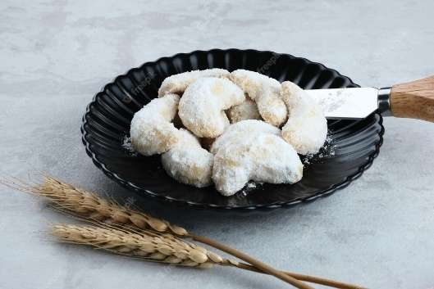 | https://www.freepik.com/premium-photo/kue-putri-salju-snow-white-cookies-with-crescent-shaped-made-from-flour-sugar-butter_24247980.htm
8 | Kue Semprit | 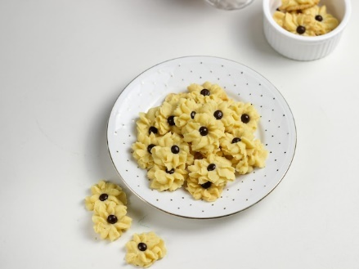 | https://www.freepik.com/premium-photo/kue-semprit-indonesian-traditional-cookies-served-celebrate-lebaran-idul-fitri-ied-mubarak_29514162.htm
9 | Kue Kacang |  | https://www.tokopedia.com/blog/resep-cara-membuat-kue-kacang/
10 | Kacang Bawang | 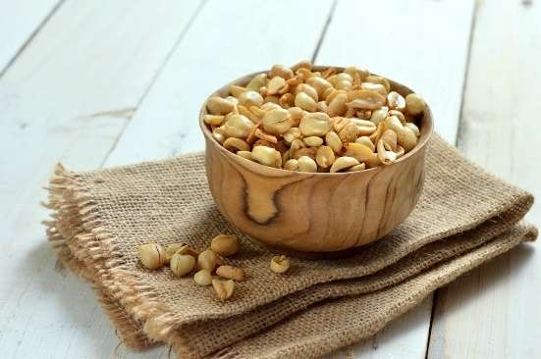 | https://www.masakapahariini.com/resep/resep-kacang-bawang-renyah/
11 | Kacang Mete | 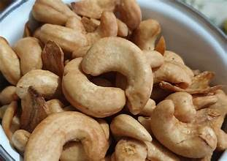 | https://cookpad.com/id/resep/12520714-kacang-mete-goreng-original-4
12 | Kue Sagu | 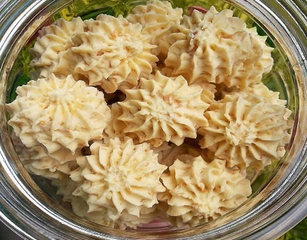 | https://www.pinterest.com/pin/744360644641684001/
13 | Kue Bolen | 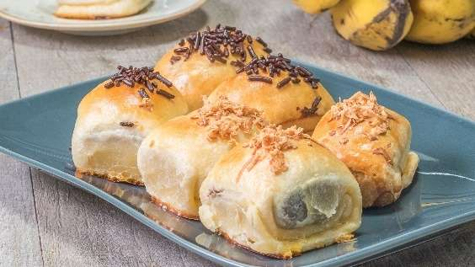 | https://prinsipbisnis.com/cara-membuat-bolen-coklat/
14 | Kue Lidah Kucing | 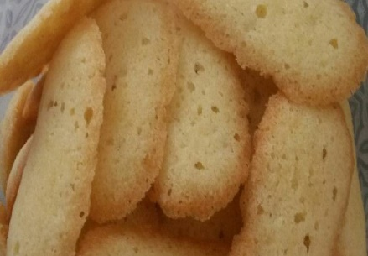 | https://cookpad.com/id/resep/8357387-kue-lidah-kucing-no-oven-tanpa-cetakan
15 | Kue Kuping Gajah | 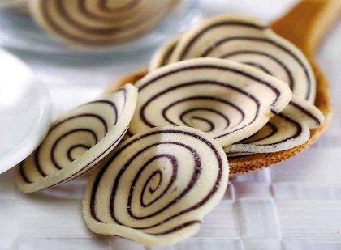 | https://www.pinterest.com/pin/804174077195942779/
16 | Soes Kering | 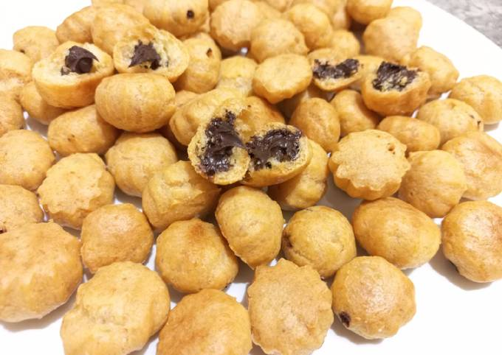 | https://cookpad.com/id/resep/16283697-soes-kering-isi-coklat
17 | Sumpia Ebi | 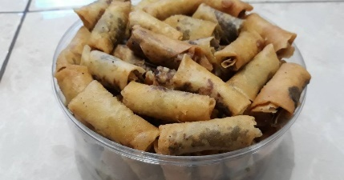 | https://cookpad.com/id/resep/4479569-sumpia-ebi-abon-simpel-3-bahan
18 | Brownies | 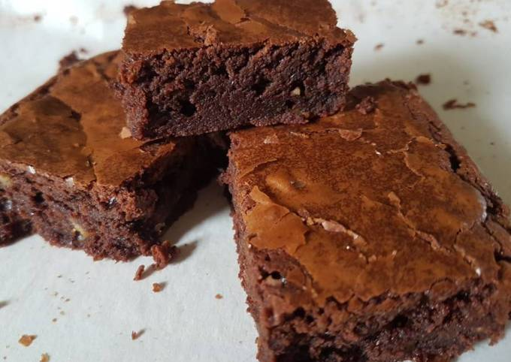 | https://cookpad.com/in/recipes/2942753-moist-brownie
19 | Bolu Pandan | 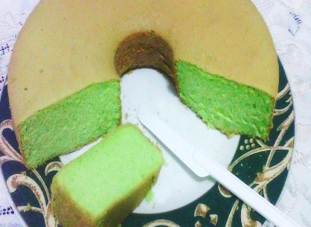 | https://cookpad.com/id/resep/177387-bolu-pandan
20 | Lapis Legit | 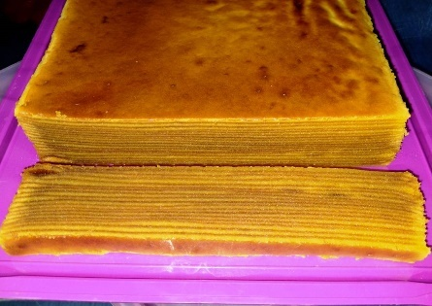 | https://cookpad.com/id/resep/11541834-lapis-legit-simple
21 | Tepe Ketan | 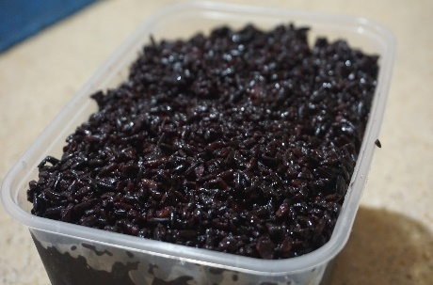 | https://www.rumahmesin.com/cara-membuat-tape-ketan/
22 | Perkedel | 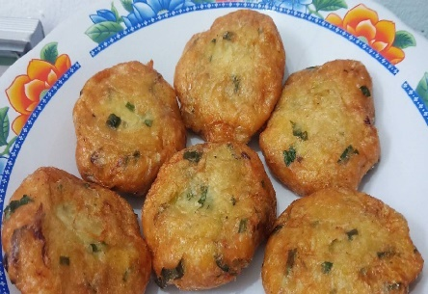 | https://cookpad.com/id/resep/15707243-perkedel
23 | Kroket | 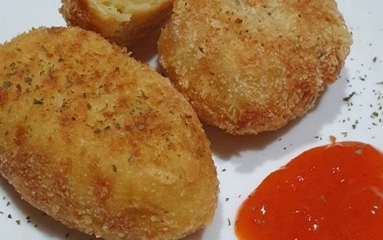 | https://cookpad.com/id/resep/12195702-kroket-kentang
24 | Bakso | 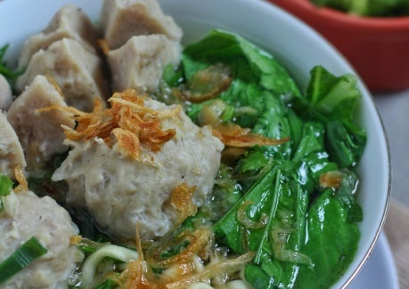 | https://cookpad.com/id/resep/12561973-bakso-kuah
25 | Mie Goreng | 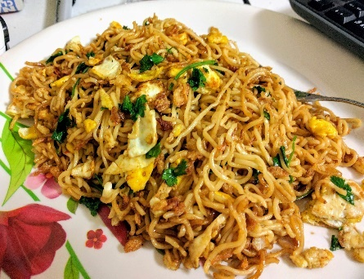 | https://imgur.com/mie-goreng-homemade-OYYIncT
26 | Es Buah | 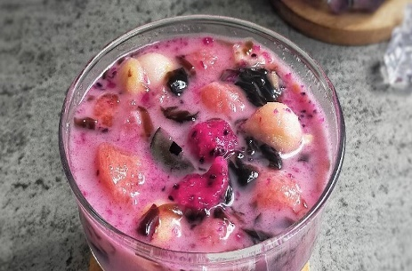 | https://cookpad.com/id/cari/es%20buah%20sederhana
27 | Es Sirup |  | https://cookpad.com/id/resep/177103-es-sirup-segar
28 | Es Timun | 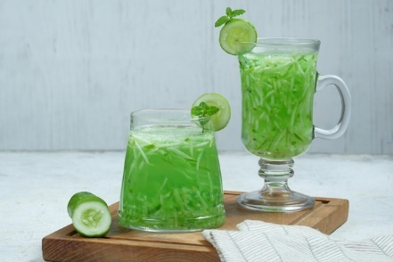 | https://www.freepik.com/premium-photo/es-timun-serut-indonesian-fresh-drink-made-from-cucumber-basil-seed_25326790.htm
29 | Es Blewah | 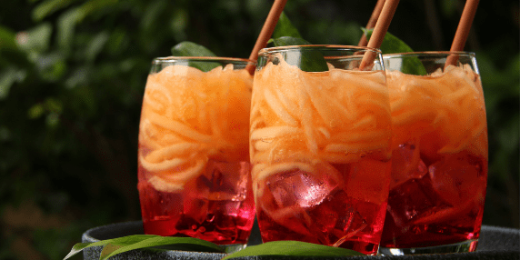 | https://blog.tokowahab.com/resep-es-blewah-yang-segar-untuk-buka-puasa/
30 | Es Cendol | 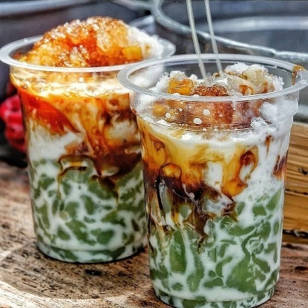 | https://sweetrip.id/kuliner/resep-es-cendol/
31 | Es Kopyor | 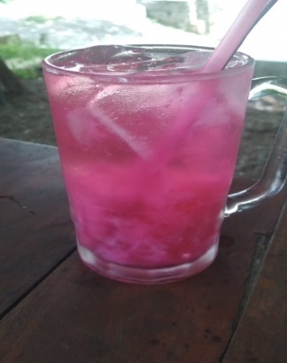 | https://linkumkm.id/ecommerce/detail/18938/es-kopyor
32 | Es Kolang-Kaling | 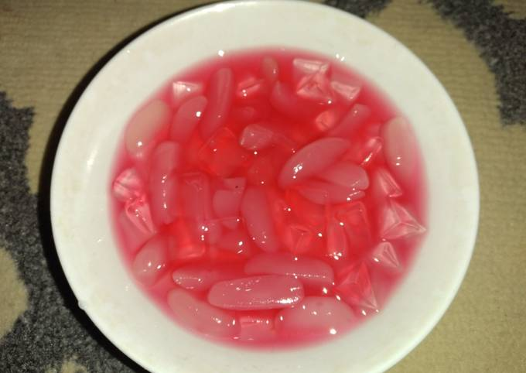 | https://cookpad.com/id/resep/12297465-es-kolang-kaling
33 | Bebek Gulai Kurma | 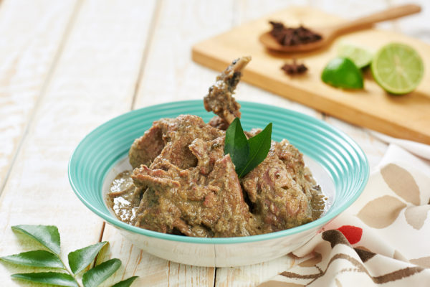 | https://www.idntimes.com/food/recipe/reza-iqbal/resep-dan-cara-membuat-bebek-gulai-kurma-khas-aceh
34 | Kuah Labu | 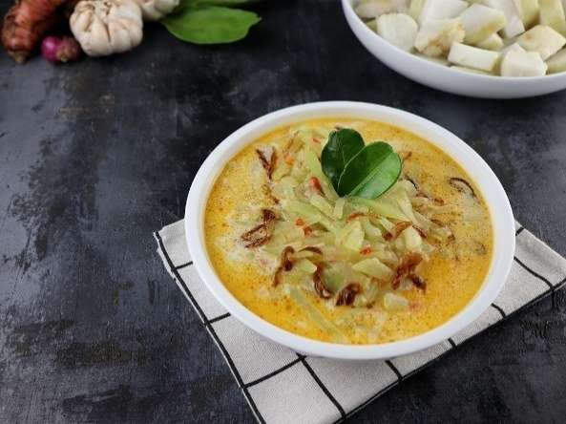 | https://www.masakapahariini.com/resep/resep-sayur-labu-siam-kuah-santan/amp/
35 | Timphan Pisang | 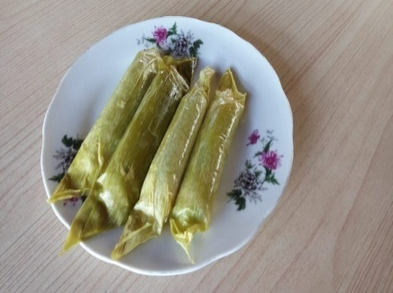 | https://notula.news/4277/timphan-aceh-kelezatan-dalam-sehelai-daun-pisang-yang-membawa-makna-mendalam-dari-warisan-budaya/
36 | Sie Reuboh | 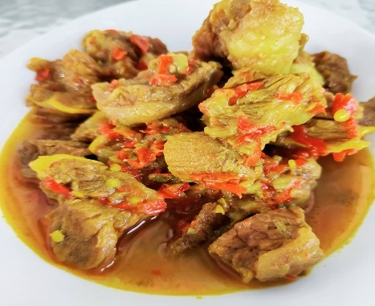 | https://sweetrip.id/kuliner/resep-sie-reuboh/
37 | Kari Ayam Aceh | 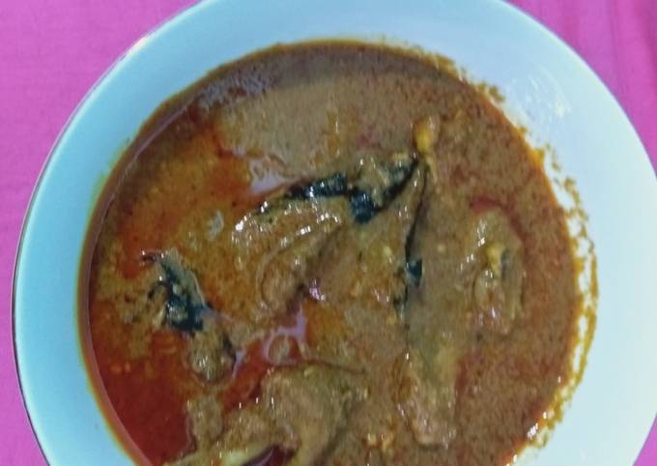 | https://cookpad.com/id/resep/10958998-ayam-kari-aceh
38 | Gulai Nangka | 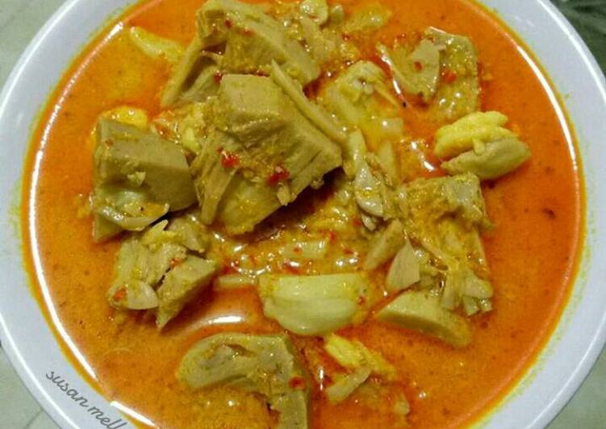 | https://cookpad.com/id/resep/2487782-gulai-nangka-padang-pr_recookmasakanpedas
39 | Mie Gomak | 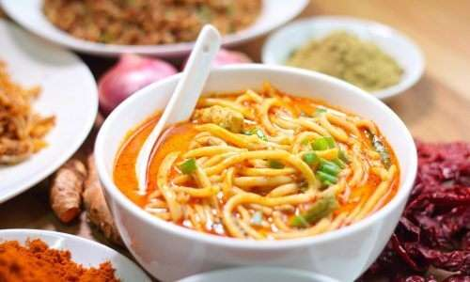 | https://www.masakapahariini.com/resep/resep-mie-gomak/
40 | Lontong Medan | 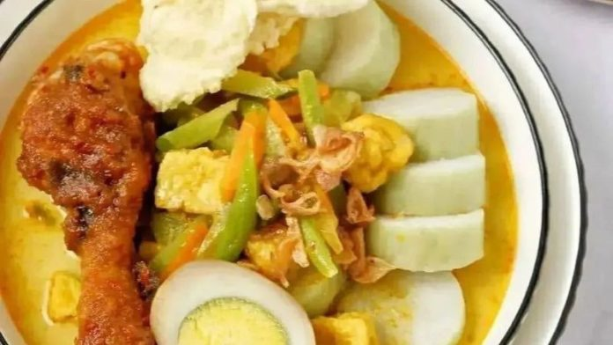 | https://meramuda.com/food-travel/lontong-medan/
41 | Satai Memeng | 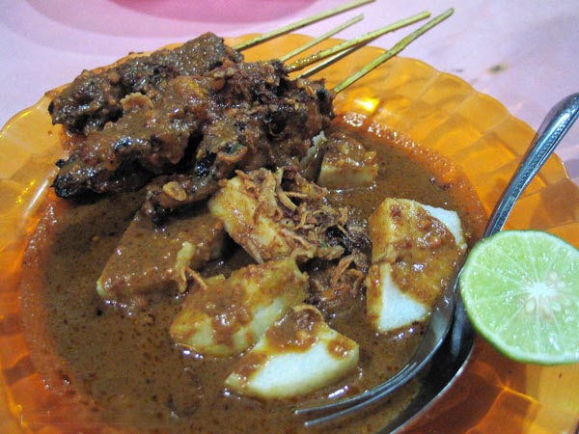 | https://liputan-medan.blogspot.com/2012/10/sate-memeng.html
42 | Lemang/Lomang | 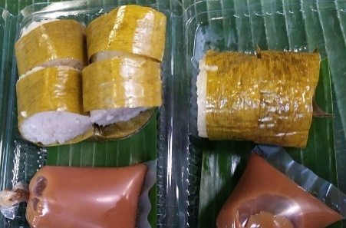 | https://travel.okezone.com/read/2021/04/19/301/2396913/lomang-makanan-khas-mandailing-paling-laris-manis-saat-ramadan
43 | Lontong Sayur | 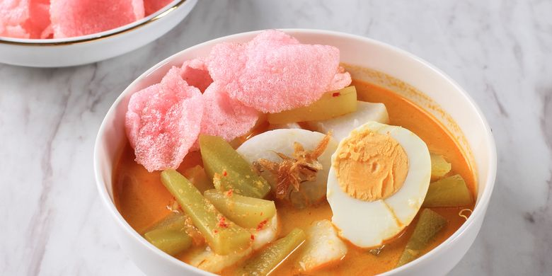 | https://www.kompas.com/food/read/2021/06/22/100400575/resep-lontong-sayur-betawi-hidangan-berkuah-santan-untuk-sarapan
44 | Dendeng Balado | 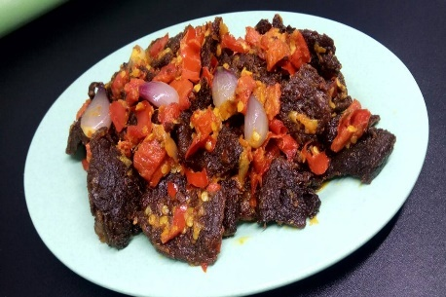 | https://cookpad.com/id/resep/5720602-dendeng-kering-balado
45 | Rendang | 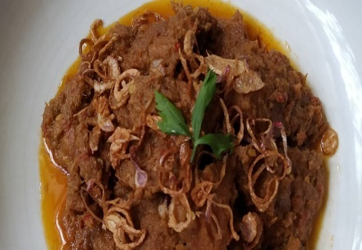 | https://cookpad.com/id/resep/12238934-rendang
46 | Lemang Tapai | 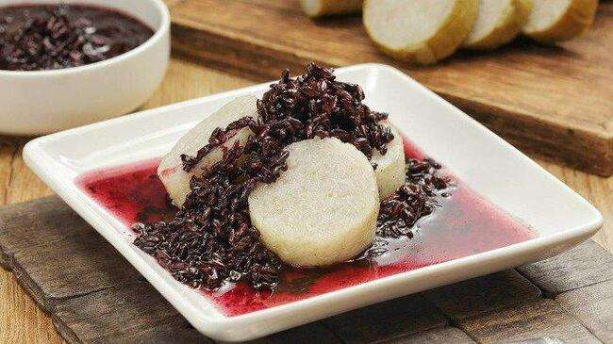 | https://www.jalanwisata.id/15-makanan-khas-bengkulu-dari-ikan-dan-durian-yang-nikmat-jalan-wisata-1771.html
47 | Gulai Cubadak | 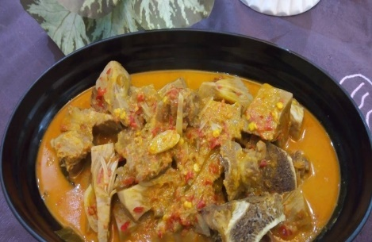 | https://cookpad.com/id/resep/16450178-gulai-cubadak-nangka-khas-minang
48 | Asam Padeh | 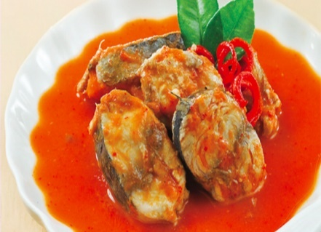 | https://lifestyle.okezone.com/read/2015/04/07/298/1129994/resep-ikan-tongkol-asam-padeh
49 | Ketupat Ketan | 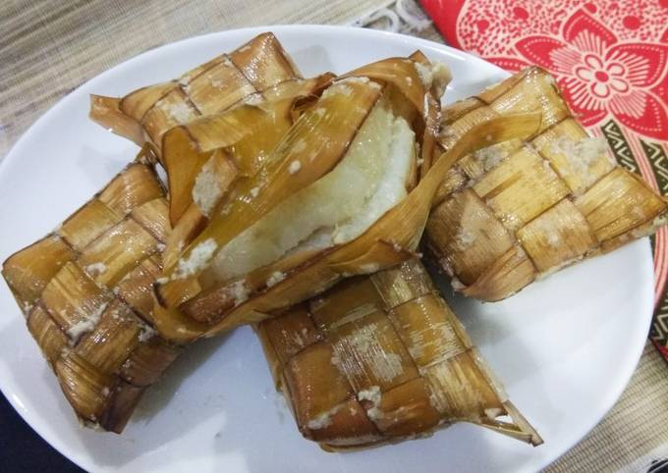 | https://cookpad.com/id/resep/7542852-ketupat-ketan
50 | Kue Sapik | 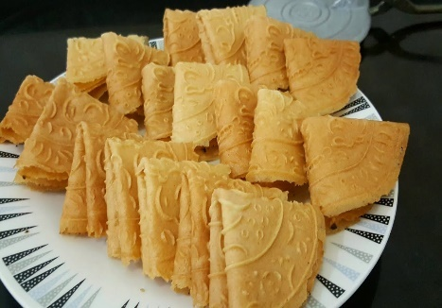 | https://news.halonusa.id/berita/84205/5-rekomendasi-oleholeh-khas-padang-yang-wajib-dibawa-pulang/halaman/2
51 | Kue Makmur | 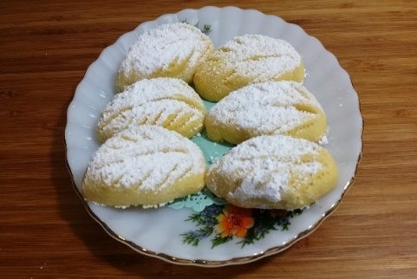 | https://dapurkotasinga.blogspot.com/2015/11/kuih-makmur.html
52 | Kari Ayam Melayu | 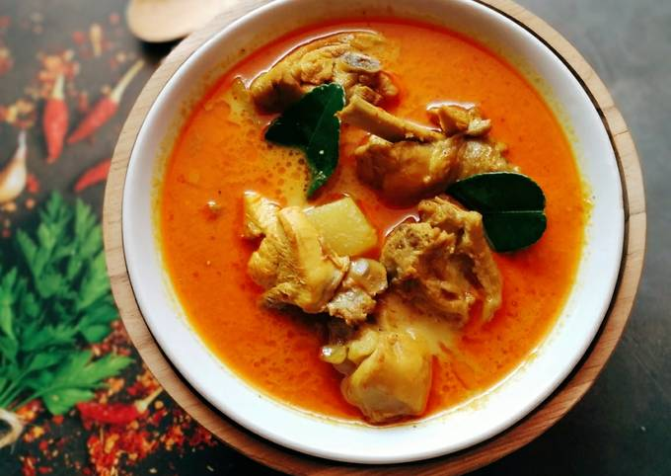 | https://cookpad.com/id/resep/15263608-kari-ayam-khas-melayu-riau
53 | Gulai Patin | 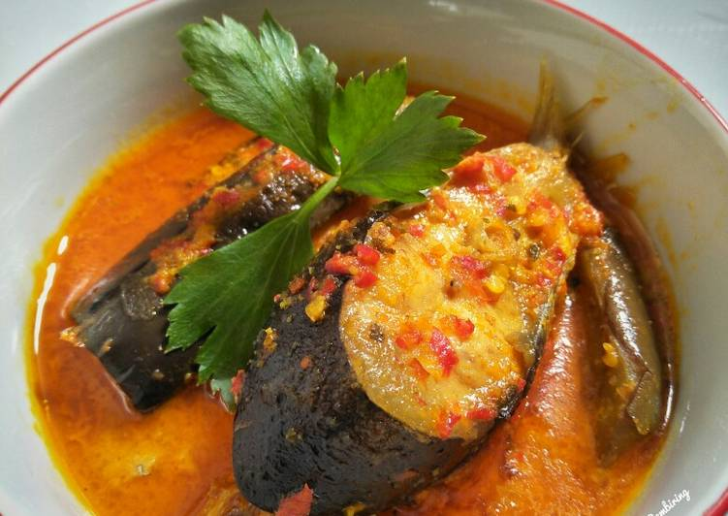 | https://cookpad.com/id/resep/10710148-gulai-ikan-patin
54 | Kue Bangkit | 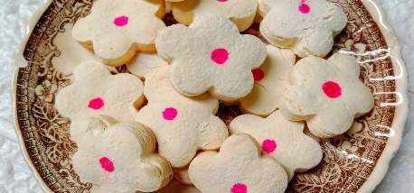 | https://cookpad.com/id/resep/14946057-kue-bangkit-jadul
55 | Kacang Pukul | 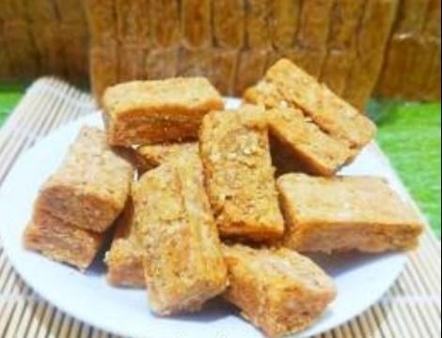 | https://www.melayupedia.com/berita/1484/gurihnya-kue-kacang-pukul-wajib-dicoba
56 | Lempuk | 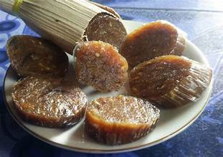 | https://cookpad.com/id/resep/4775714-lempuk-durian
57 | Tempoyak | 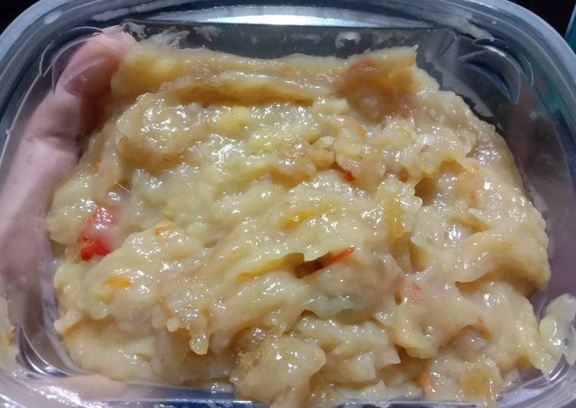 | https://dapuremakkita.blogspot.com/2019/10/cara-mudah-menyiapkan-tempoyak-durian.html
58 | Sup Tulang | 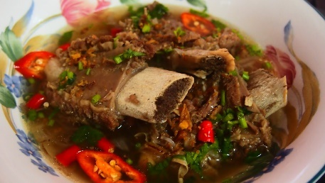 | https://mamamiasanasini.blogspot.com/2015/10/sup-tulang-rusuk.html
59 | Ayam Bumbu Anam | 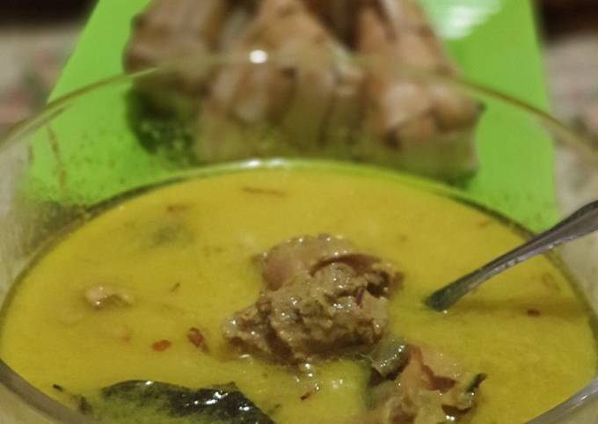 | https://cookpad.com/id/resep/9118049-ayam-masak-anam
60 | Pempek | 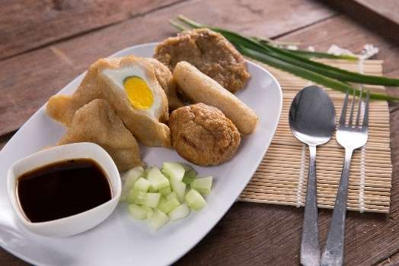 | https://www.generasimaju.co.id/artikel/5-tahun/resep/resep-pempek-palembang?ref=jakartanotebook.com
61 | Kue Maksuba | 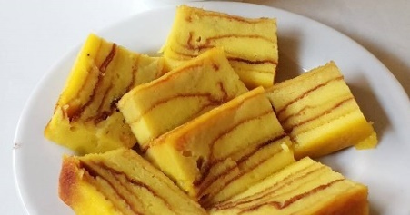 | https://cookpad.com/id/cari/kue%20maksuba
62 | Kue Delapan Jam | 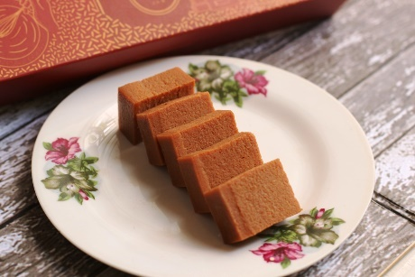 | https://itikkecil.com/2020/02/05/oleh-oleh-khas-palembang-kue-maksuba-dan-kue-delapan-jam-palembang-harum/
63 | Malbi | 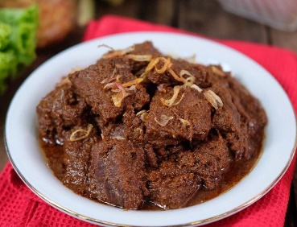 | https://doyanresep.com/resep-malbi-daging-sapi/
64 | Kue Tat | 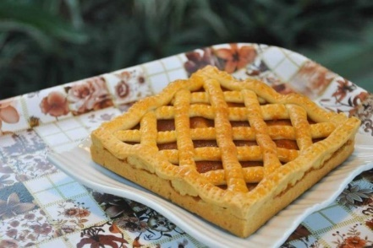 | https://www.idntimes.com/food/recipe/sha-kookie/resep-bay-tat-khas-bengkulu-c1c2
65 | Gulai Kemba'ang | 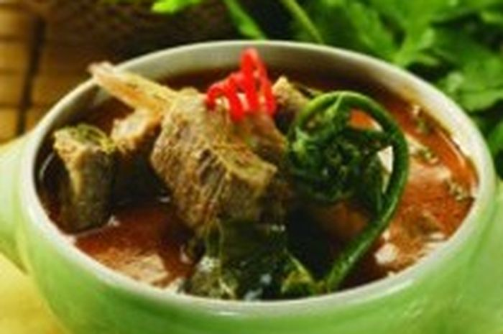 | https://sajiansedap.grid.id/read/10723740/gulai-kembaang
66 | Kue Lepek Binti | 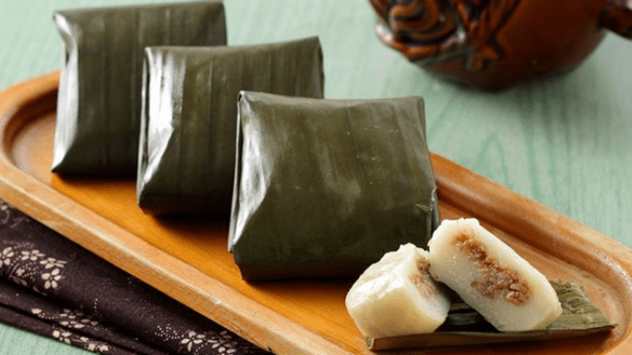 | https://correcto.id/beranda/read/25182/1
67 | Bongkol | 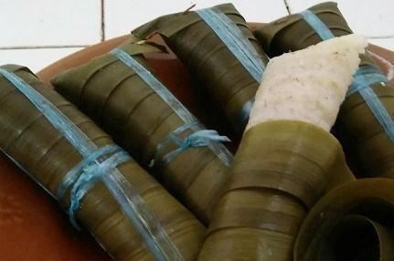 | https://radarmukomuko.disway.id/read/672814/bongkol-ketan-makanan-khas-bangka-yang-menggunakan-daun-kelapa-muda-sebagai-pembungkus
68 | Mi Ikan | 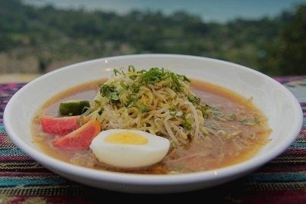 | https://www.idntimes.com/food/recipe/fina-wahibatun-nisa-1/resep-mi-kuah-ikan-khas-bangka
69 | Getas | 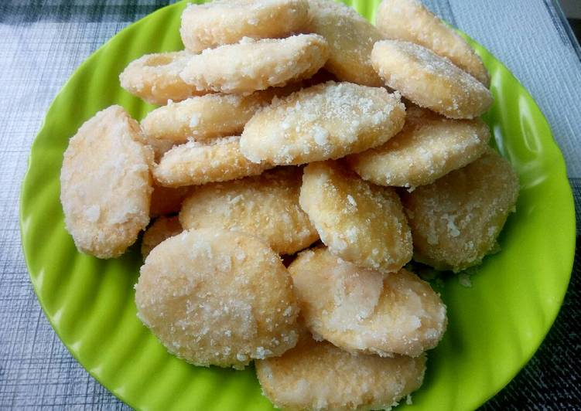 | https://cookpad.com/id/resep/4036839-getas-kemplang-ketan
70 | Tumis Rebung | 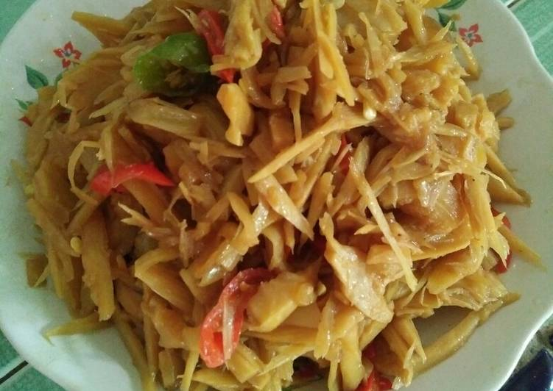 | https://qapawutima.blogspot.com/2019/06/resep-tumis-rebung.html
71 | Tumis Keladi | 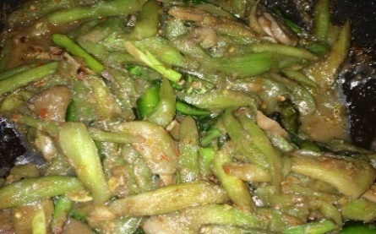 | https://cookpad.com/id/resep/7450518-tumis-keladi-belacan-bangka
72 | Lempah Kuning | 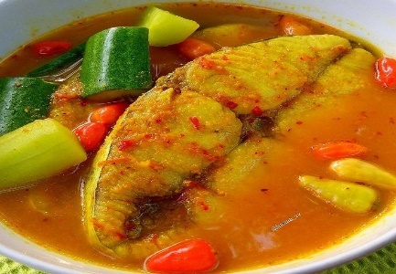 | https://food.detik.com/foto-kuliner/d-4165273/asam-gurih-sedap-ikan-lempah-kuning-khas-bangka
73 | Ikan Jebung Bakar | 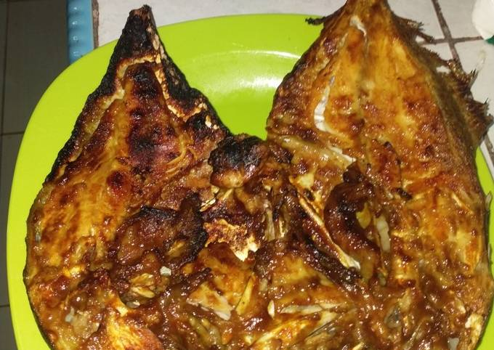 | https://cookpad.com/id/resep/16668398-ikan-bakar-bumbu-kuning
74 | Lempah Kulat Pelawan | 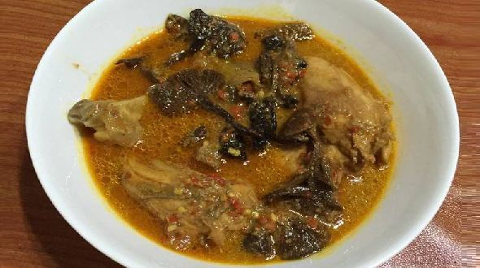 | https://zonabangkabelitung.blogspot.com/2015/11/resep-lempah-kulat-khas-bangka-belitung-spesial.html
75 | Sambal Belacan | 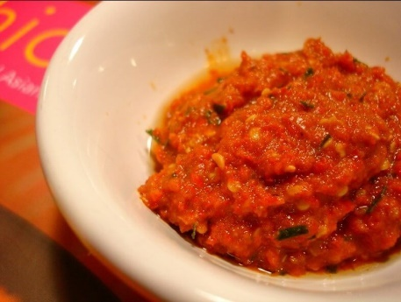 | https://budaya-indonesia.org/Belacan-Bangka
76 | Kue Engkak |  | https://www.fimela.com/food/read/4519136/resep-kue-engkak-ketan-khas-sumatera-selatan
77 | Keripik Pisang | 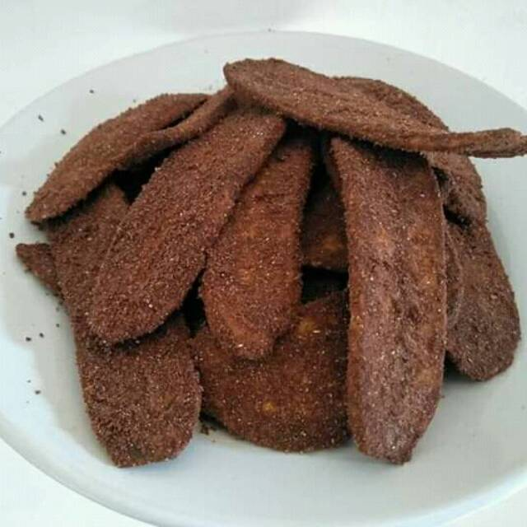 | https://lovelylampung.com/keripik-pisang-makanan-khas-lampung-yang-legendaris/
78 | Gulai Taboh | 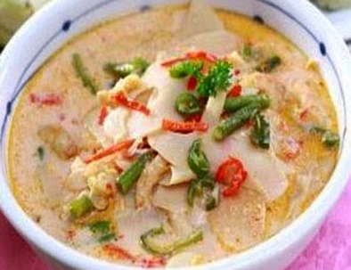 | https://carabuatresep.blogspot.com/2016/04/cara-membuat-gulai-taboh-dalom-khas-lampung.  html
79 | Peros Masin Iwa | 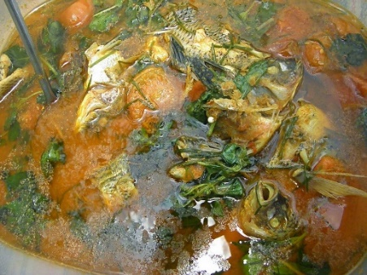 | https://www.dapurkita.my.id/2017/01/resep-dan-cara-membuat-peros-masin-khas.html
80 | Rabeg | 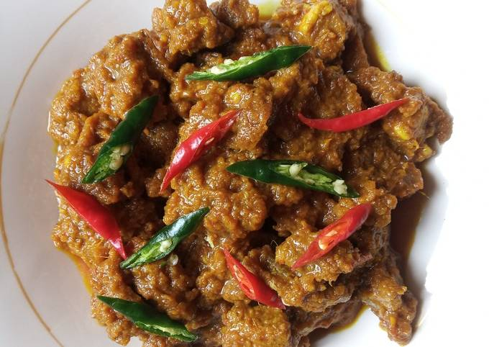 | https://cookpad.com/id/resep/14449640-rabeg-sapi-khas-banten
81 | Pindang Bandeng | 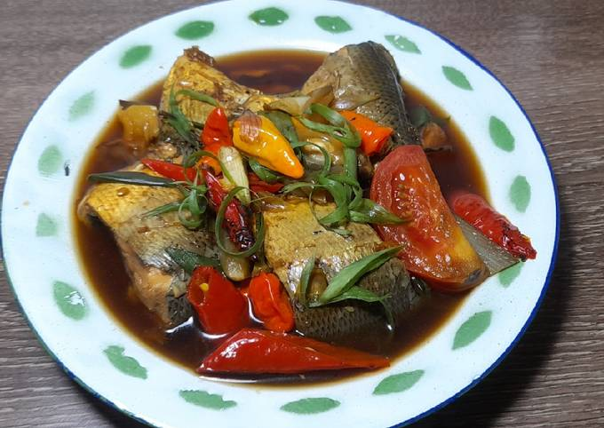 | https://cookpad.com/id/resep/15872072-pindang-bandeng-betawi
82 | Semur Daging | 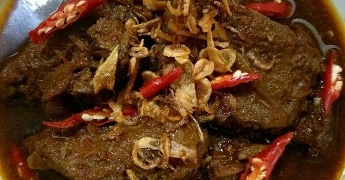 | https://cookpad.com/id/cari/semur%20daging
83 | Ketupat Betawi | 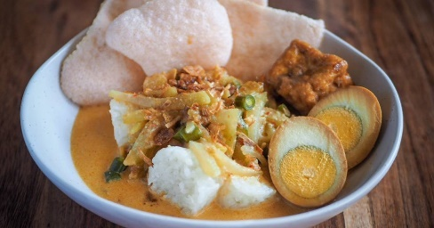 | https://cookpad.com/id/cari/sayur%20ketupat%20betawi
84 | Dodol Betawi | 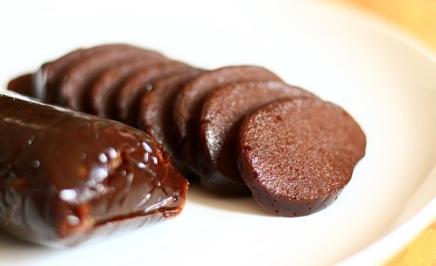 | https://www.istockphoto.com/id/foto/dodol-betawi-gm1396438287-451191149
85 | Tape Uli | 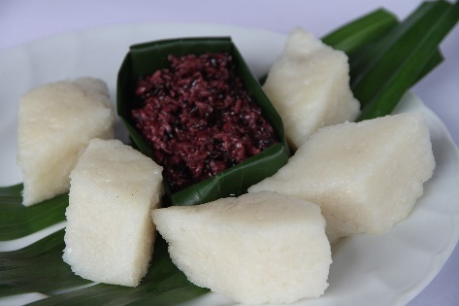 | https://www.pinterest.com/pin/395542779743303927/
86 | Kue Satu | 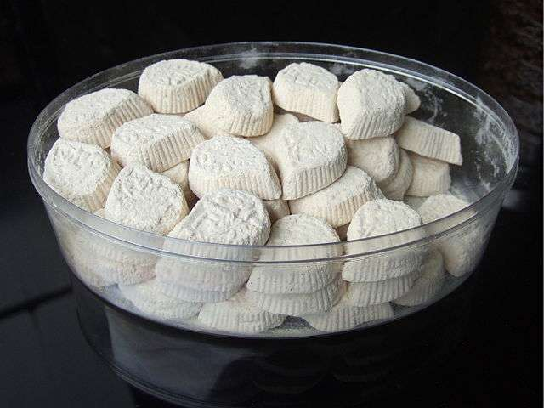 | https://resepjuna.blogspot.com/2016/06/resep-kue-satu.html
87 | Serundeng Daging | 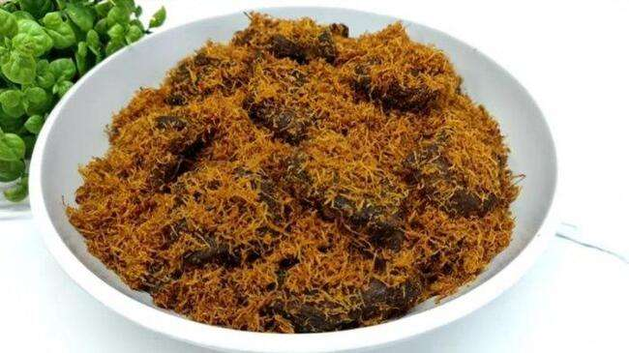 | https://jateng.tribunnews.com/2021/08/24/resep-serundeng-daging-cocok-jadi-stok-lauk
88 | Kue Biji Ketapang | 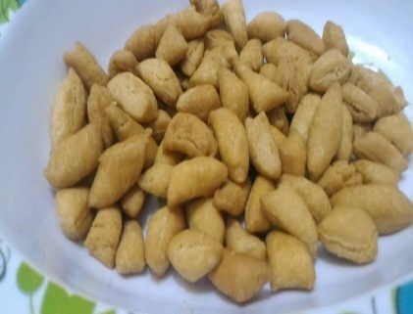 | https://cookpad.com/id/resep/2506031-kue-biji-ketapang
89 | Kue Kembang Goyang | 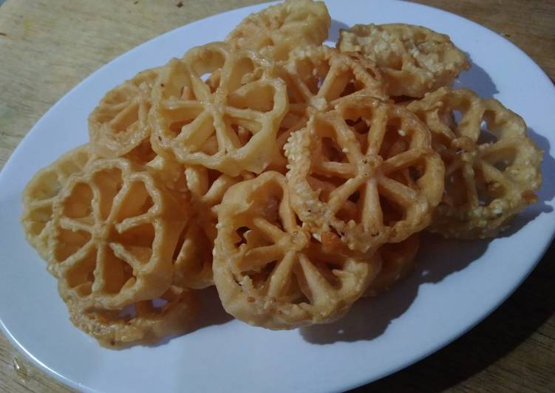 | https://cookpad.com/id/resep/2946982-kue-kembang-goyang-wijen-renyah-anti-gagal
90 | Kue Akar Kelapa | 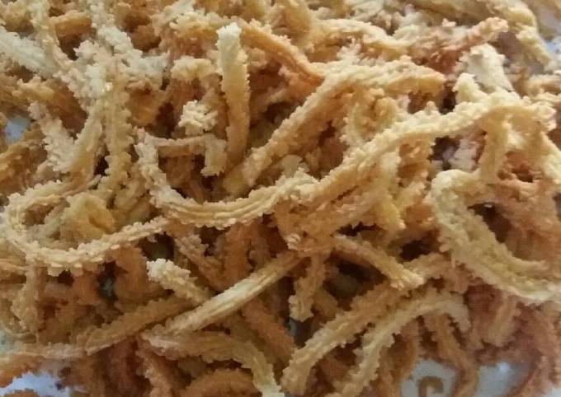 | https://cookpad.com/id/resep/810474-kue-akar-kelapa-wijen
91 | Kue Geplak | 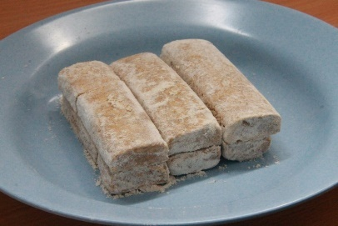 | https://indonesiakaya.com/pustaka-indonesia/kue-geplak-kue-khas-betawi-yang-mulai-langka-keberadaannya/
92 | Nasi Tutug Oncom | 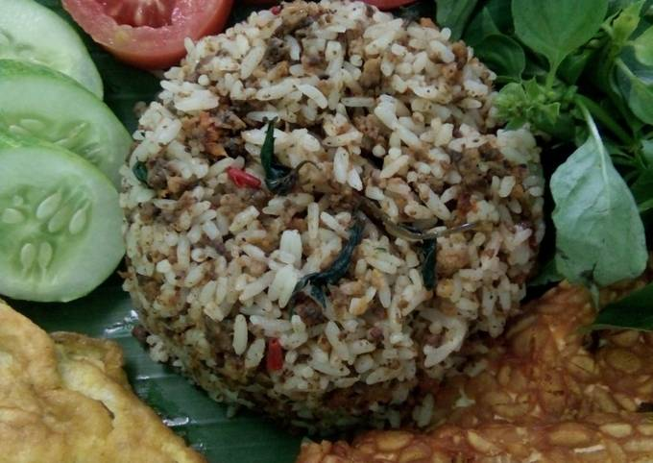 | https://cookpad.com/id/resep/10042063-nasi-tutug-oncom-khas-sunda
93 | Rujak Cuka | 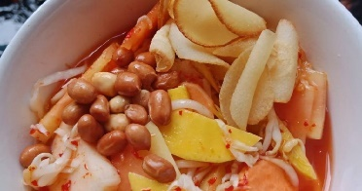 | https://cookpad.com/id/resep/5972258-rujak-cuka-rujak-donggala-khas-cirebon
94 | Sayur Lengko | 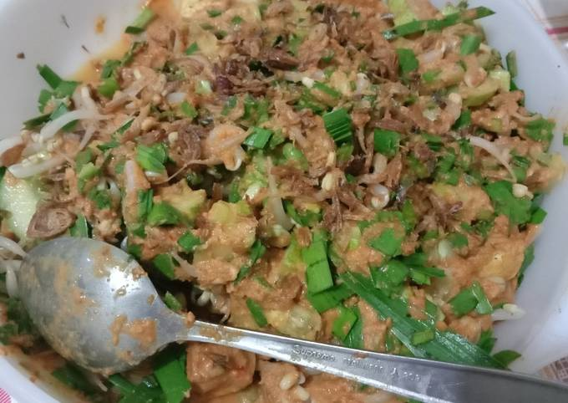 | https://cookpad.com/id/resep/13425063-02-sayur-lengko-bumbu-kacang
95 | Rengginang | 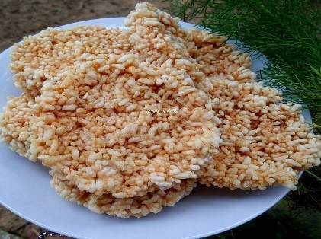 | https://www.briliofood.net/resep/6-cara-membuat-rengginang-enak-gurih-dan-renyah-191029y.html
96 | Kentang Mustofa | 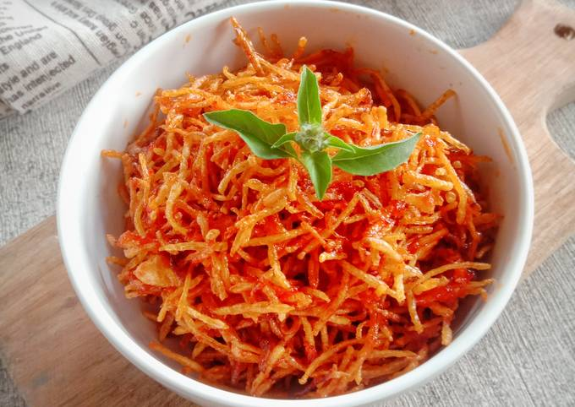 | https://cookpad.com/id/resep/12835413-mustofa-kentang-kentang-mustofa
97 | Kupat Tahu Bandung | 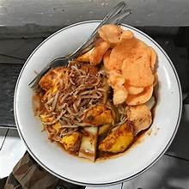 | https://travelingyuk.com/kupat-tahu-di-bandung/274073/
98 | Kue Gapit | 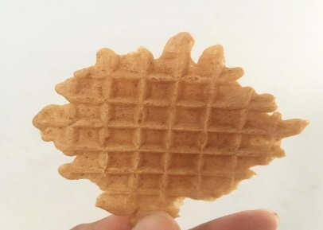 | https://worldfood.guide/dish/kue_gapit/
99 | Getuk Lindri | 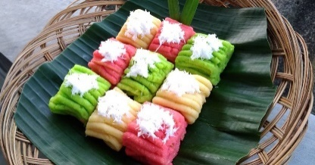 | https://cookpad.com/id/resep/13245989-getuk-lindri
100 | Kue Clorot | 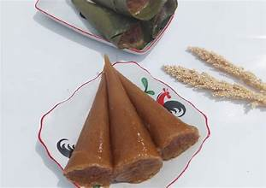 | https://cookpad.com/id/resep/16633794-kue-clorot
101 | Lepet | 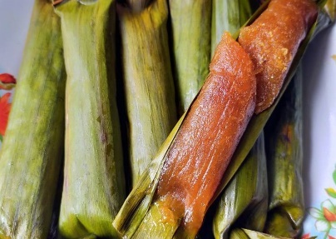 | https://www.briliofood.net/resep/7-resep-lepet-berbagai-bahan-enak-lezat-dan-menggugah-selera-200903e.html
102 | Lemper | 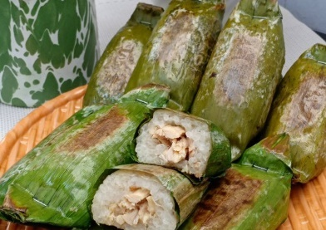 | https://cookpad.com/id/resep/13323488-lemper-ayam
103 | Arem-Arem | 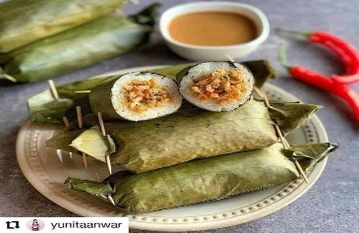 | https://www.resepkekinian.com/recipe/kelezatan-arem-arem-ayam-kudapan-lezat-di-akhir-minggu/#google_vignette
104 | Sambal Goreng Ati | 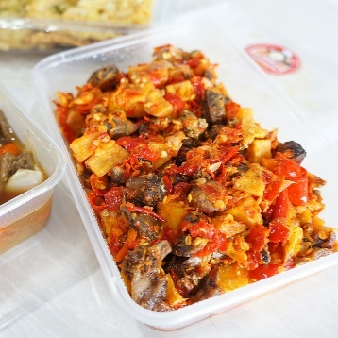 | https://www.briliofood.net/resep/25-resep-sambal-goreng-ati-spesial-dan-praktis-190513z.html
105 | Lodeh Terong | 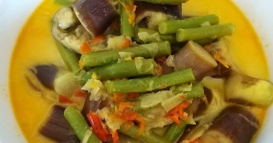 | https://cookpad.com/id/resep/11273337-lodeh-terong-kacang-panjang
106 | Pindang Kudus | 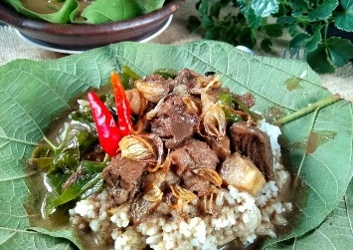 | https://cookpad.com/id/resep/9314435-nasi-pindang-khas-kudus
107 | Sayur Jipang | 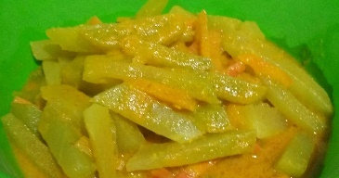 | https://cookpad.com/id/cari/sayur%20jipang%20bumbu%20kuning
108 | Kue Ganjel Rel | 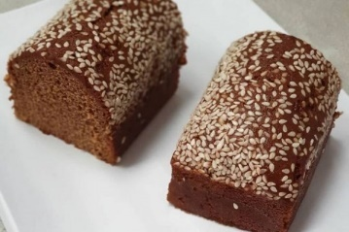 | https://www.idntimes.com/food/recipe/09-gilang-khuatul-akhmal/resep-roti-ganjel-rel-khas-semarang-c1c2
109 | Bistik Solo | 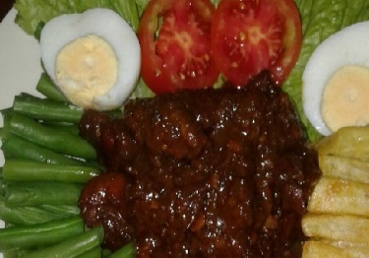 | https://cookpad.com/id/cari/bistik%20jawa%20asli%20solo
110 | Selat Solo | 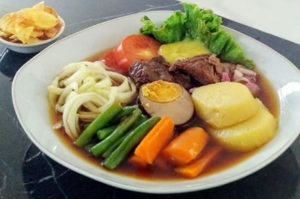 | https://www.idntimes.com/food/dining-guide/maria-liana/nikmatnya-selat-solo-exp-c1c2
111 | Sambal Goreng Krecek | 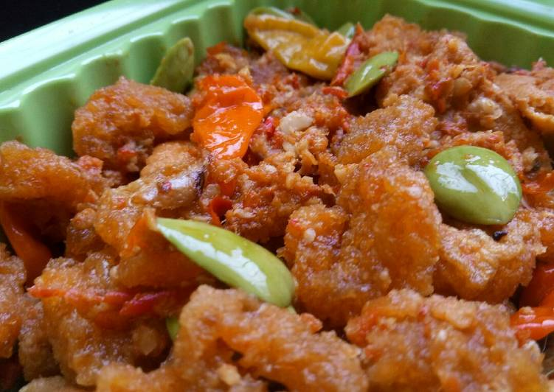 | https://cookpad.com/id/resep/8317472-sambal-goreng-krecek
112 | Lapis Surabaya | 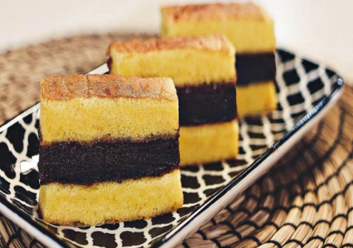 | https://www.sidechef.com/recipes/8692/Lapis_Surabaya
113 | Daging Sapi Bumbu Age | 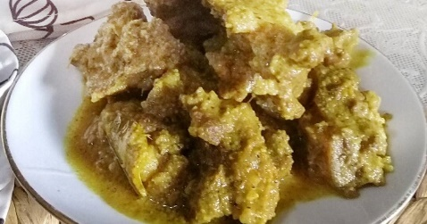 | https://cookpad.com/id/resep/16997976-daging-sapi-bumbu-age-khas-jember
114 | Telur Petis | 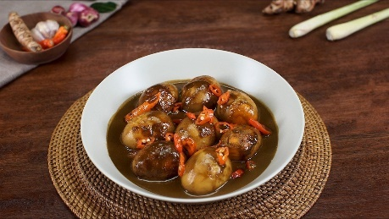 | https://www.masakapahariini.com/resep/resep-telur-petis-madura-khas-pesisir/amp/
115 | Rawon | 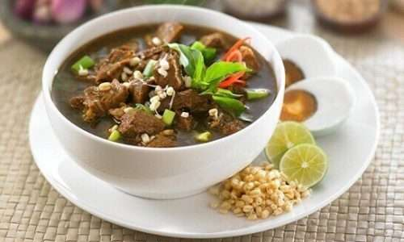 | https://www.suara.com/lifestyle/2023/08/01/125000/resep-rawon-jawa-timur-ala-chef-devina-hermawan-mudah-dibuat-di-rumah
116 | Kella Pate | 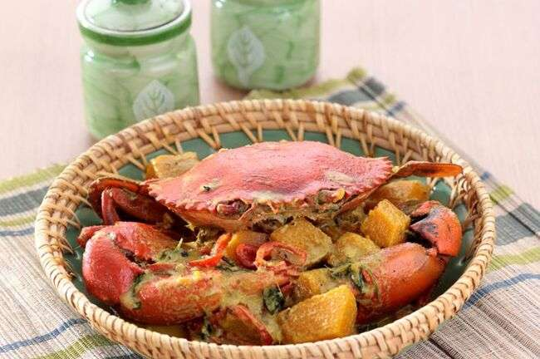 | https://sajiansedap.grid.id/read/10755689/kella-pate-kopeteng-olahan-kepiting-sedap-khas-sumenep
117 | Topak Ladeh | 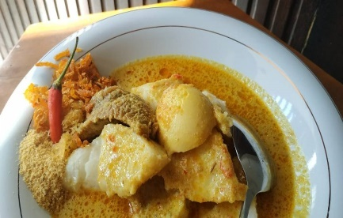 | https://cookpad.com/id/resep/12714546-topak-ladeh
118 | Bandeng Kawak | 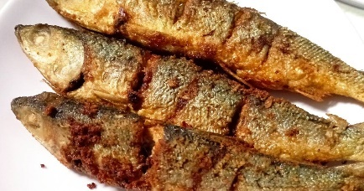 | https://cookpad.com/id/resep/16377408-ikan-bandeng-goreng
119 | Madu Mongso | 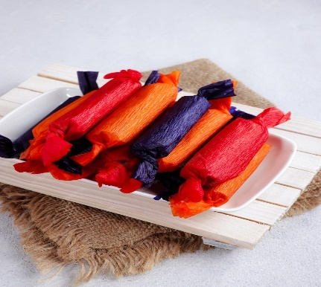 | https://www.freepik.com/premium-photo/madu-mongso-indonesian-traditional-snack-made-from-fermented-black-sticky-rice-coconut-milk_24862269.htm
120 | Lemang Lau | 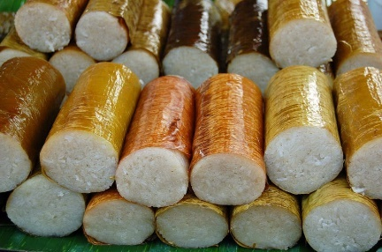 | https://correcto.id/beranda/read/46985/resep-cara-membuat-lemang-lepat-lau-makanan-khas-pontianak-bisa-disantap-saat-lebaran
121 | Pacri Nanas | 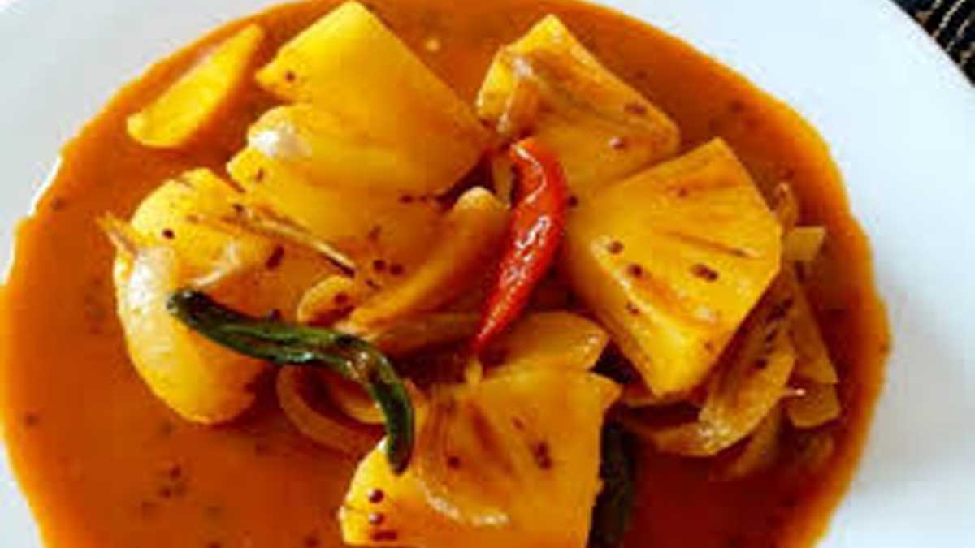 | https://gencil.news/kuliner/cara-membuat-pacri-nanas/
122 | Kerupuk Basah | 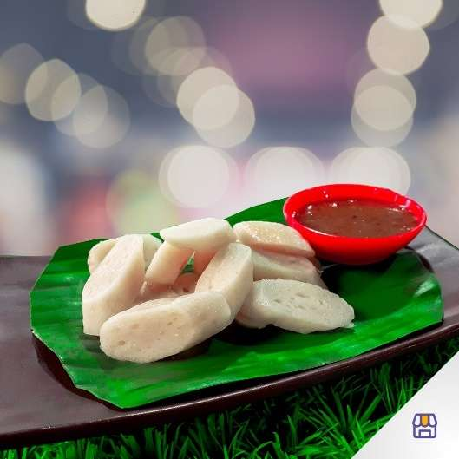 | https://paxelmarket.co/product/kerupuk-basah-khas-kalimantan-barat/
123 | Ketupat Colet | 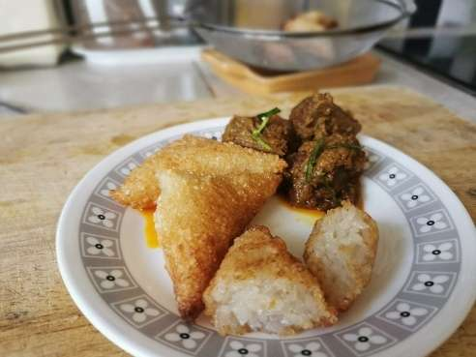 | https://www.goodnewsfromindonesia.id/2022/05/01/ketupat-colet-hidangan-lebaran-unik-dari-kalimantan
124 | Tapai Benoan | 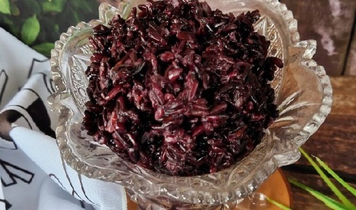 | https://insidepontianak.com/gaya-hidup/28668/mengenal-tapai-menaon-khas-pontianak-kuliner-wajib-saat-lebaran-dan-moment-budaya-melayu
125 | Botong Buloh | 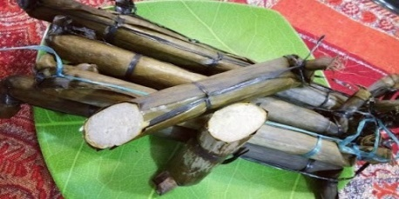 | https://correcto.id/beranda/read/27005/bontong-buloh-kuliner-andalan-kalbar-saat-idulfitri-ini-4-lainnya
126 | Sotong Pangkong | 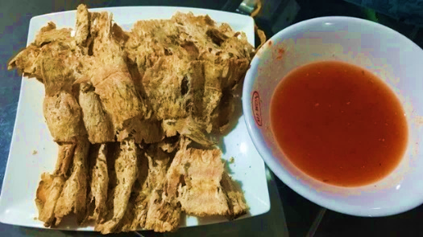 | https://www.libur.co/kulinery/makanan-khas-kalimantan-barat
127 | Kue Lapis Sambas | 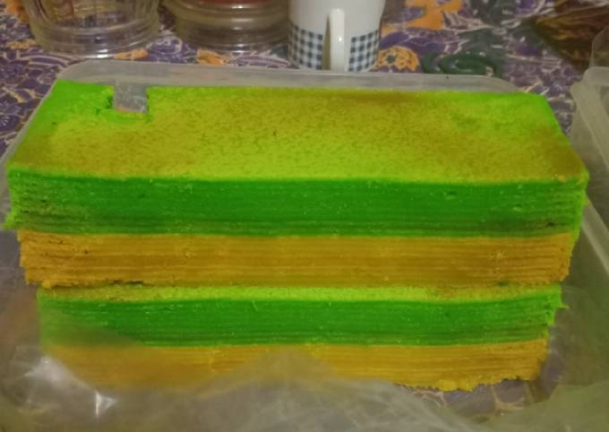 | https://cookpad.com/id/resep/15002003-10-lapis-pulut-khas-sambas
128 | Nasi Sungkui | 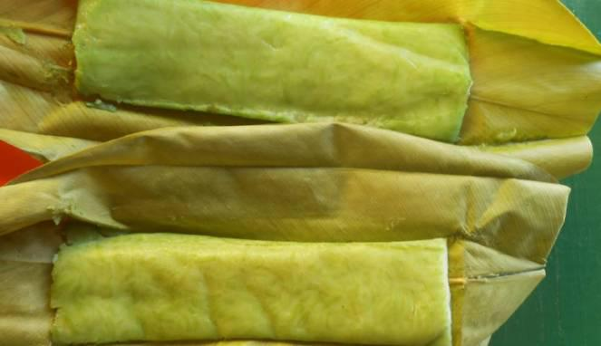 | https://budaya-indonesia.org/Nasi-Sungkui
129 | Soto Banjar | 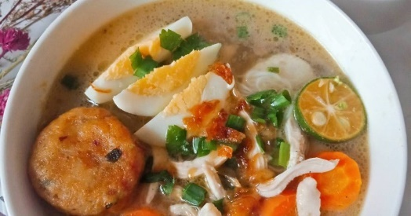 | https://cookpad.com/id/cari/soto%20banjar
130 | Ketupat Kandangan | 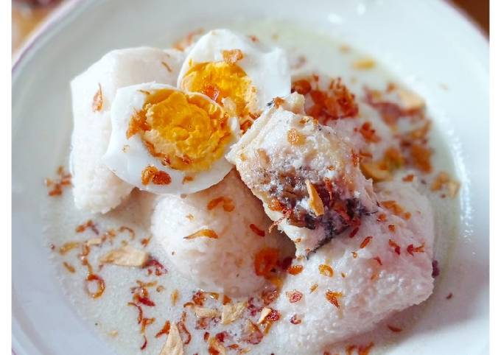 | https://cookpad.com/id/resep/14679053-ketupat-kandangan-khas-kalimantan-selatan
131 | Panggang Haruan | 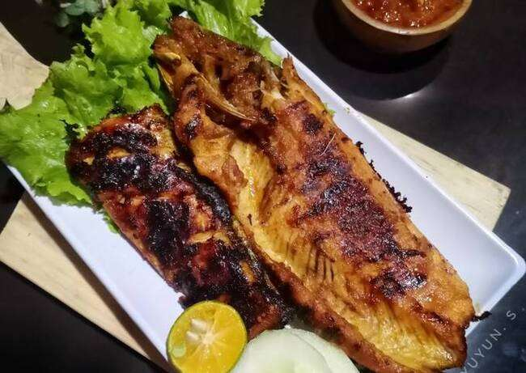 | https://cookpad.com/id/resep/13557601-haruan-panggang-ikan-gabus-bakar
132 | Daging Masak Habang | 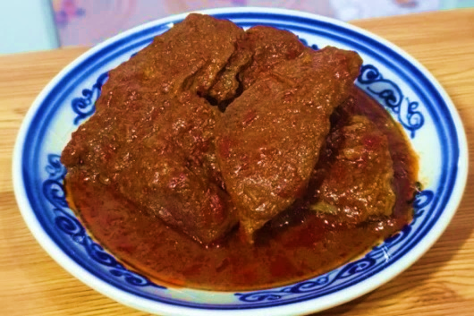 | https://www.idntimes.com/food/recipe/fina-wahibatun-nisa-1/resep-daging-masak-habang
133 | Rabuk Haruan | 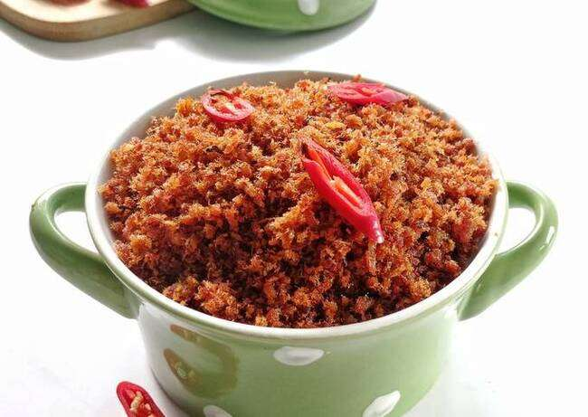 | https://www.dapurawit.id/resep-rabuk-haruan-khas-banjar/
134 | Kue Apam | 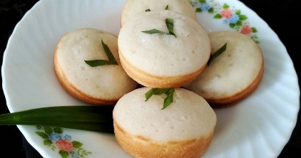 | https://cookpad.com/id/cari/kue%20apem%20jawa
135 | Ayam Cincane | 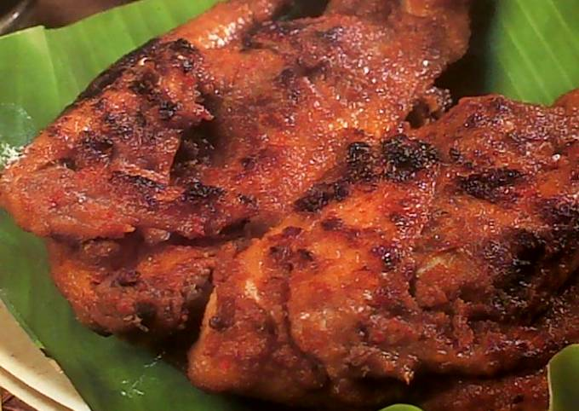 | https://cookpad.com/id/resep/484009-ayam-cincane-bakar
136 | Burasa | 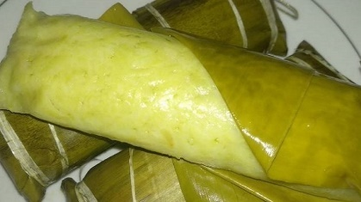 | https://sulsel.suara.com/read/2021/05/29/143227/burasa-makanan-khas-bugis-yang-nikmat-dan-gurih
137 | Tumbu | 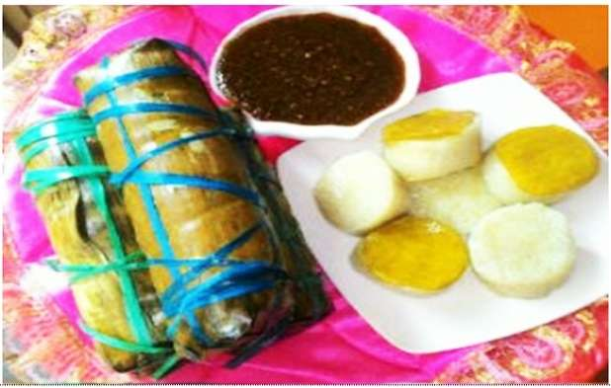 | https://mc.tanahbumbukab.go.id/sokko-tumbu-makanan-khas-bugis-untuk-lebaran/
138 | Nusu' Likku | 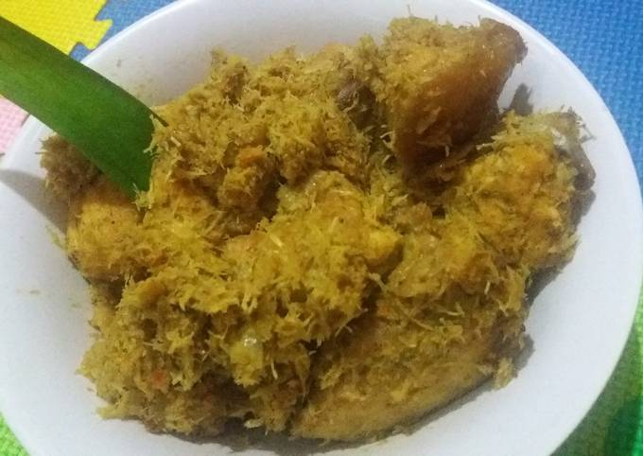 | https://cookpad.com/id/resep/4868314-nasu-likku
139 | Nusu' Palekko | 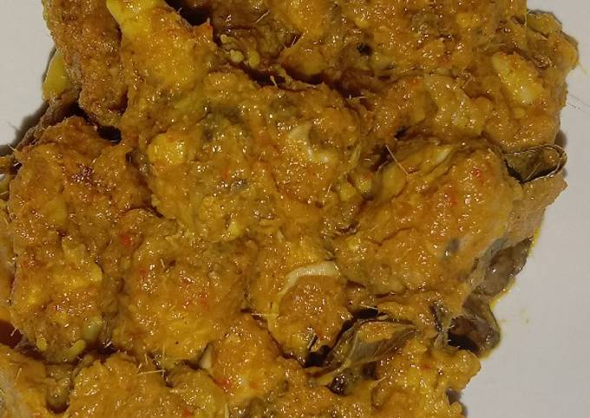 | https://cookpad.com/id/resep/15749383-ayam-nasu-palekko-dangkot
140 | Bajabu | 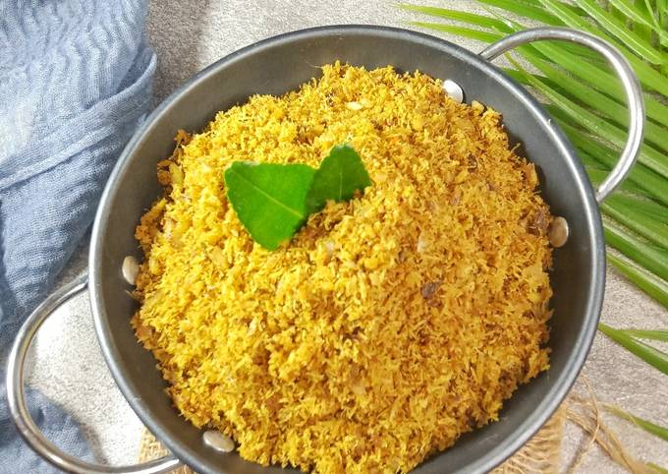 | https://cookpad.com/id/resep/16127217-bajabu-khas-bugis-pinrang
141 | Ayam Gegape | 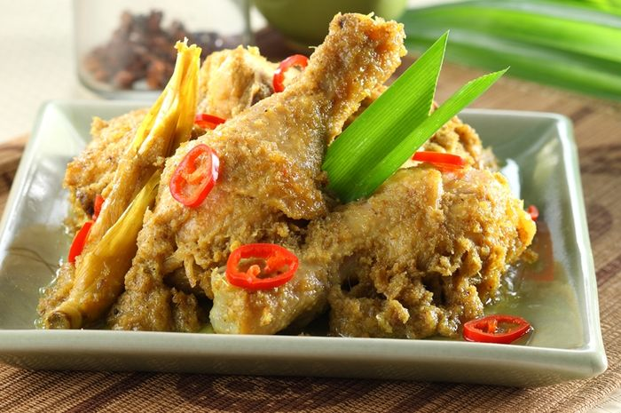 | https://sajiansedap.grid.id/read/10761139/ayam-gagape-khas-makassar-olahan-ayam-berkuah-dengan-cita-rasa-nendang
142 | Leppe'-Leppe' | 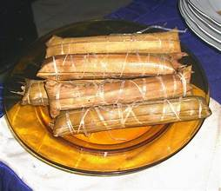 | https://soppengcreative.blogspot.com/2015/03/leppe-leppe-to-soppeng.html
143 | Gogoso | 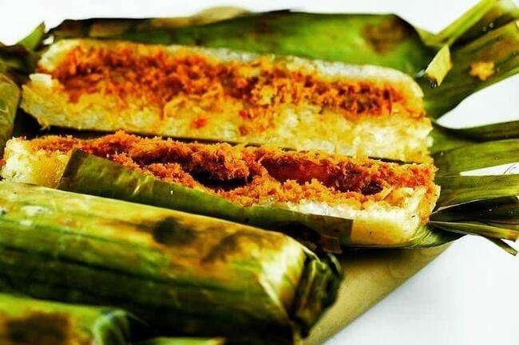 | https://www.tribunnewswiki.com/2021/05/25/gogoso
144 | Coto Makassar | 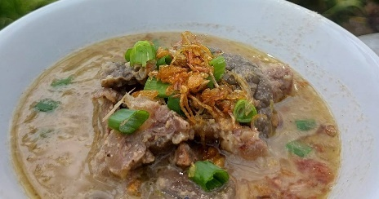 | https://cookpad.com/id/resep/16074865-coto-makassar
145 | Kacipo | 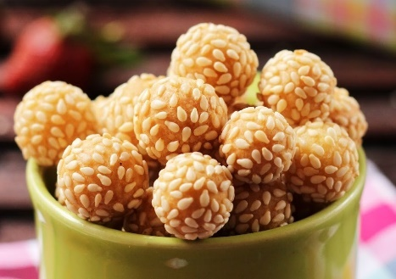 | https://menuresepkue.blogspot.com/2015/07/resep-kue-keciput-keju-wijen.html
146 | Barongko | 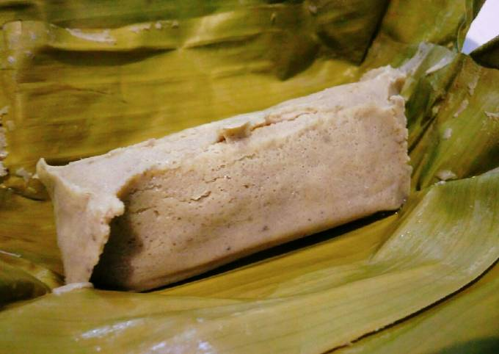 | https://cookpad.com/id/resep/5383321-barongko-bugis-makassar
147 | Uvempoi | 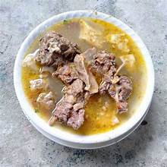 | https://mamaokkitchen.com/traveling/kuliner-khas-lebaran-di-indonesia-mulai-dari-opor-ayam-sampai-uvempoi/
148 | Mandura | 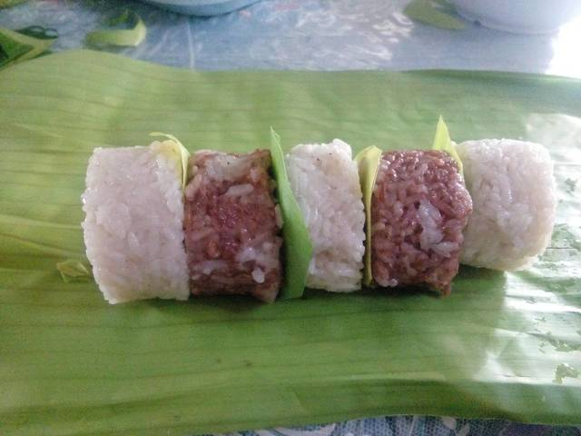 | https://infoutama.github.io/studyhelp/post/mandura/
149 | Nasi Jaha | 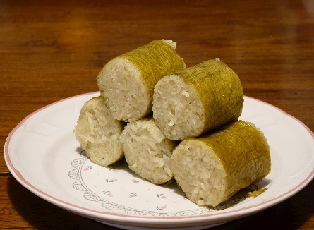 | https://www.tasteatlas.com/nasi-jaha
150 | Ayam Woku | 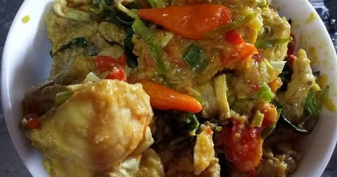 | https://cookpad.com/id/cari/ayam%20woku
151 | Asida | 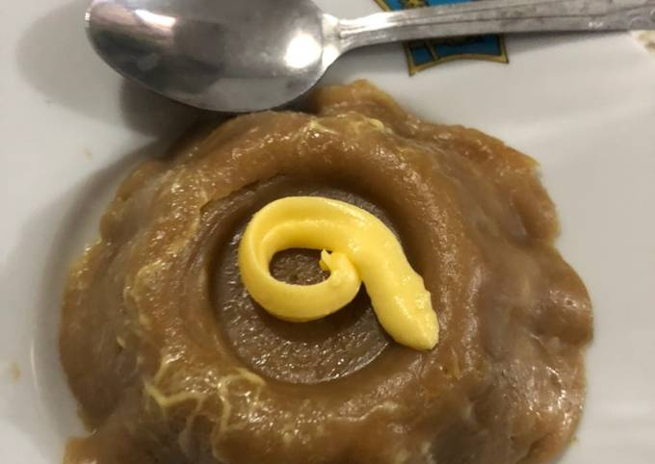 | https://cookpad.com/id/resep/12457605-asida-simpel-khas-maluku-ala-amah
152 | Ikan Kuah Kuning | 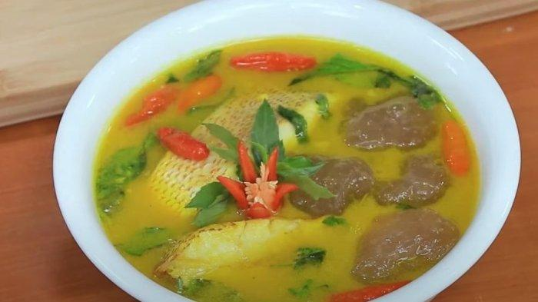 | https://medan.tribunnews.com/2022/12/08/resep-papeda-dan-ikan-kuah-kuning-dan-cara-membuatnya-makanan-khas-maluku
153 | Papeda | 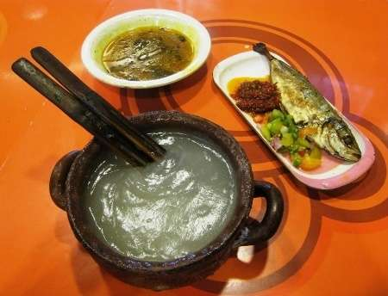 | https://makanan-indonesia.weebly.com/home/papeda
154 | Ikan Kuah Pala Banda | 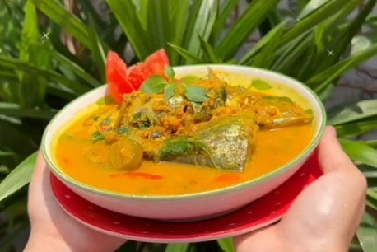 | https://sulsel.idntimes.com/food/recipe/ria-1688113138-bqp/resep-ikan-kuah-pala-banda-c1c2
155 | Rwbia | 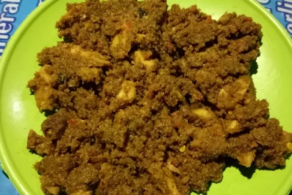 | https://travelingyuk.com/kuliner-khas-ambon-istimewa/268273/
156 | Opor Manis Pedas Bali | 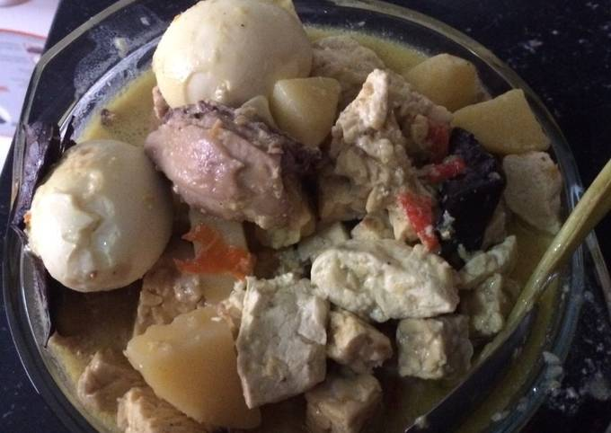 | https://cookpad.com/id/resep/723308-opor-ayam-bumbu-khas-klungkung-bali
157 | Poteng Jeje' Tujak | 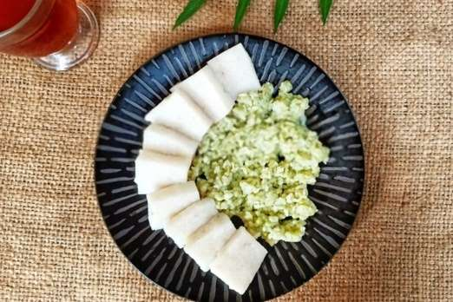 | https://www.kooliner.com/blog/poteng-jaje-tujak-kuliner-tape-asli-lombok/
158 | Cerorot | 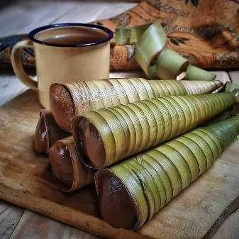 | https://gomandalika.com/menikmati-cerorot-jajanan-unik-khas-pulau-lombok/
159 | Temerodok | 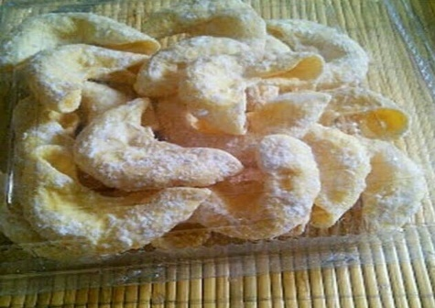 | https://travelingyuk.com/jajanan-khas-nusa-tenggara-barat/315017/#google_vignette
160 | Kerake | 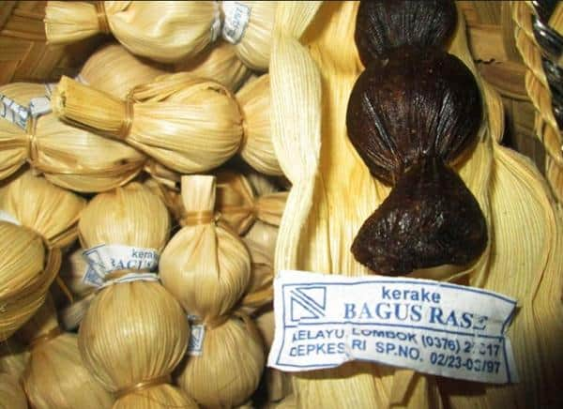 | https://lombokpost.jawapos.com/lapsus/1502791896/kerake-bagus-rase-jajanan-khas-kelayu-yang-melegenda-di-lombok-timur
161 | Manjareal | 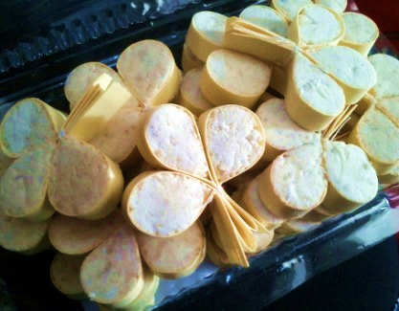 | https://www.gotravelly.com/blog/11-oleh-oleh-khas-sumbawa-yang-penuh-rasa/
162 | Timbu-Dahi | 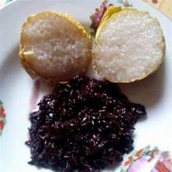 | https://www.gotravelly.com/blog/11-oleh-oleh-khas-sumbawa-yang-penuh-rasa/#google_vignette
163 | Bebalung | 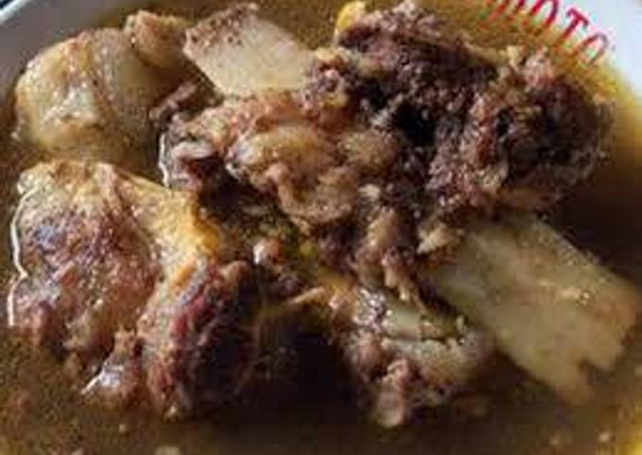 | https://cookpad.com/id/resep/2389574-bebalung-sapi-khas-lombok
164 | Kaleso | 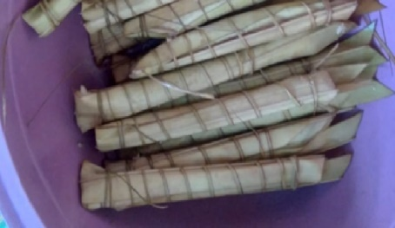 | https://katongntt.com/mirip-ketupat-lebaran-kaleso-atau-lepa-jadi-tradisi-masyarakat-ntt/#google_vignette
165 | Manuk Beikut | 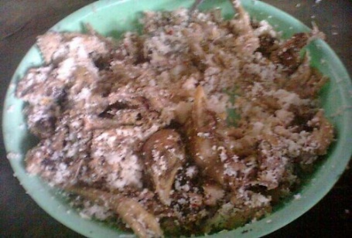 | https://makassar.terkini.id/manuk-beikut-memiliki-sejuta-cita-rasa-lidah-orang-lamaholot/

