Supplementary Information for

Aluminum tanning of hide powder and skin pieces under microwave irradiation

Yue Liu^{a,b}, Bin Song^{a,b}, Jinwei Zhang^{a,b}, Carmen Gaidau^{c}, Haibin Gu^{a,b,*}

ªKey Laboratory of Leather Chemistry and Engineering of Ministry of Education, Sichuan University, Chengdu 610065, China. E-mail: guhaibinkong@126.com (H. Gu)
^{b}National Engineering Laboratory for Clean Technology of Leather Manufacture, Sichuan University, Chengdu 610065, China.
^{c}The Research and Development National Institute for Textiles and Leather-Division Leather and Footwear Research Institute, Leather Research Department, 93, Ion Minulescu Str, Bucharest, 3, Romania.

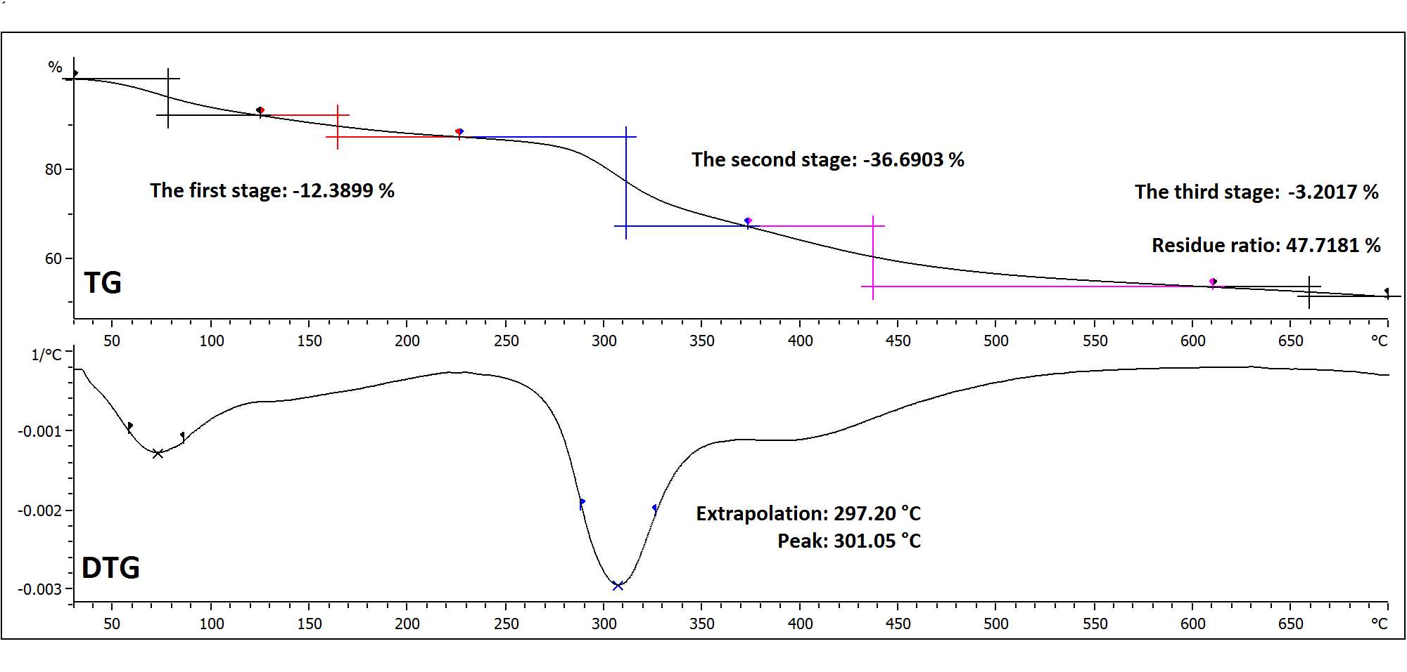
Fig. S1 TG/DTG curves of tanned hide powder with WBH at 30 ºC.

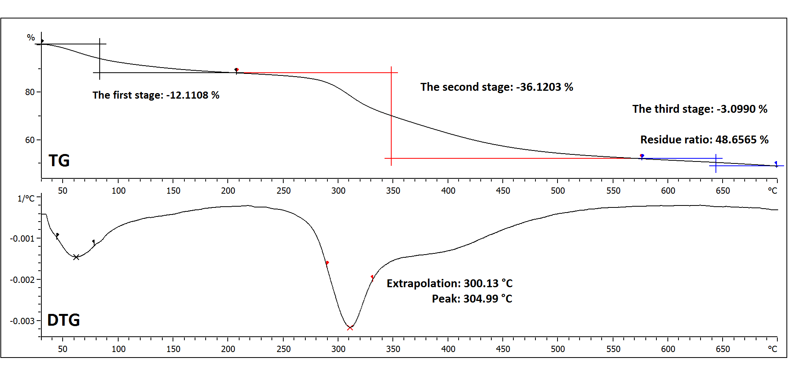
Fig. S2 TG/DTG curves of tanned hide powder with MWH at 30 ºC.
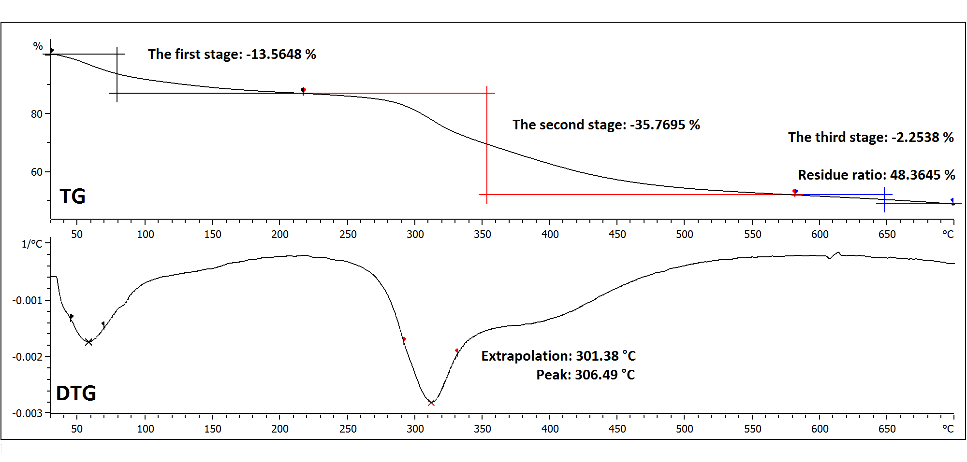
Fig. S3 TG/DTG curves of tanned hide powder with WBH at 40 ºC.

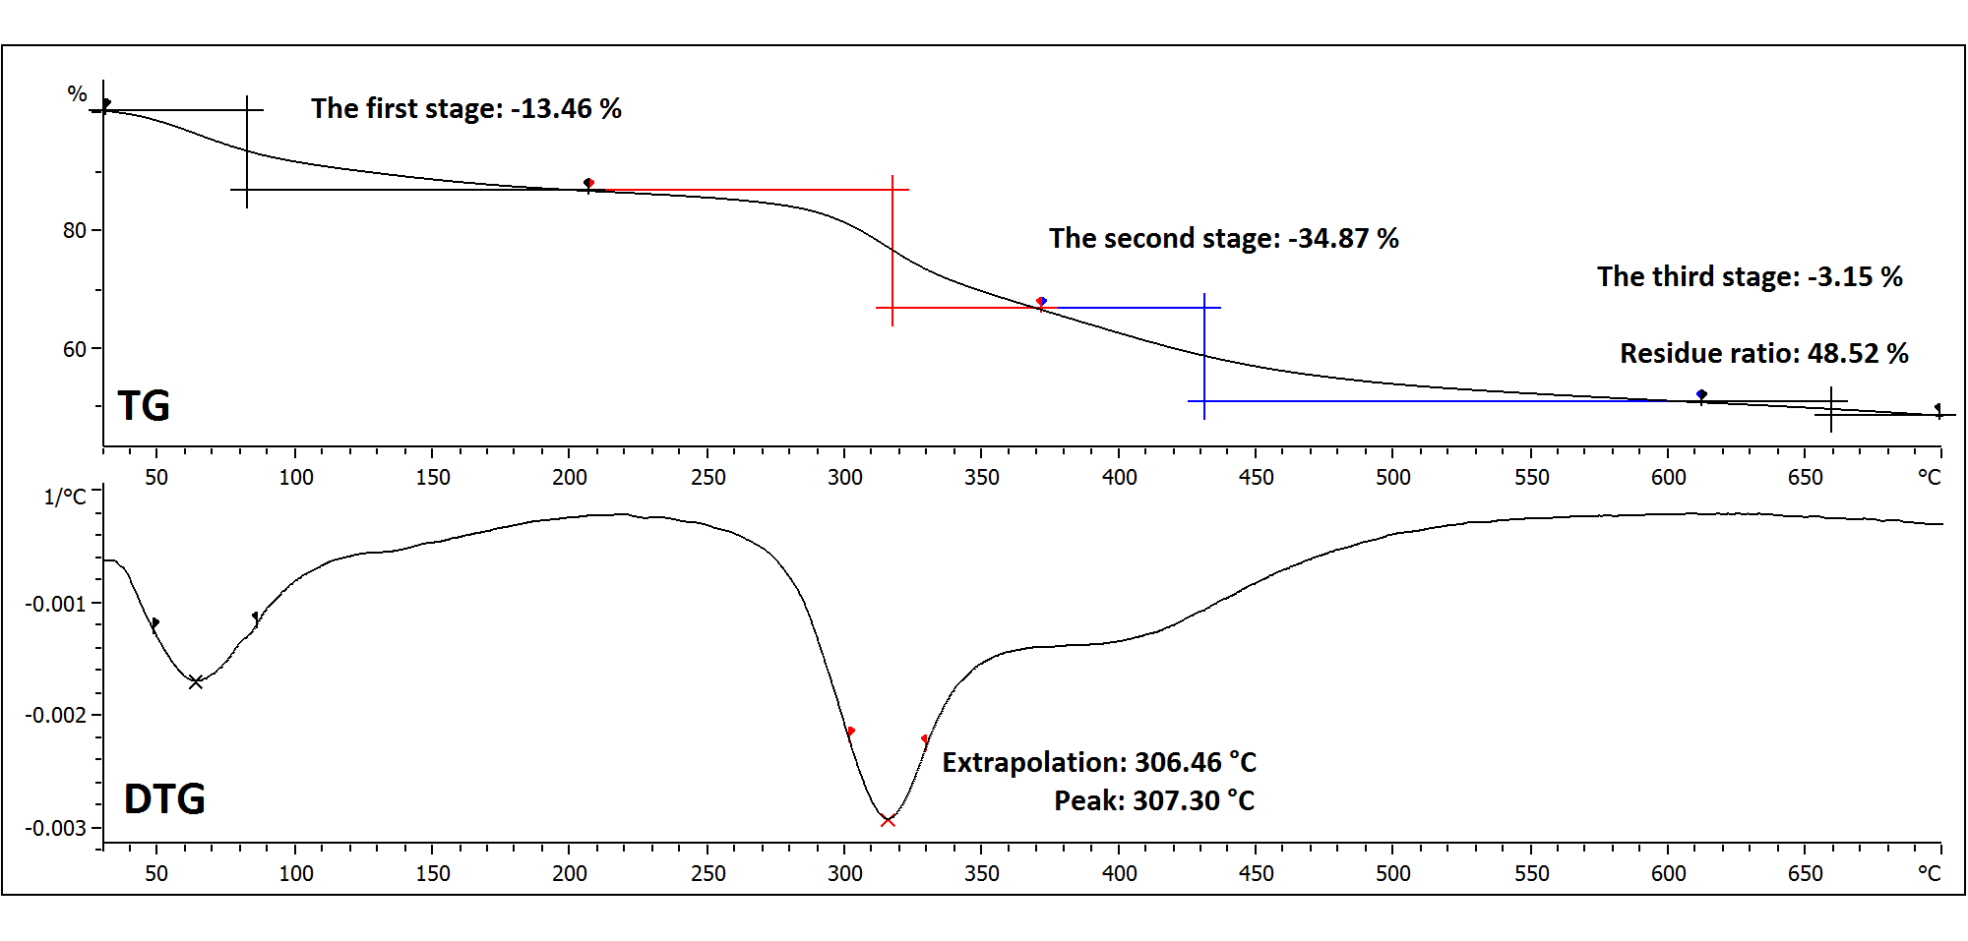
Fig. S4 TG/DTG curves of tanned hide powder with MWH at 40 ºC.

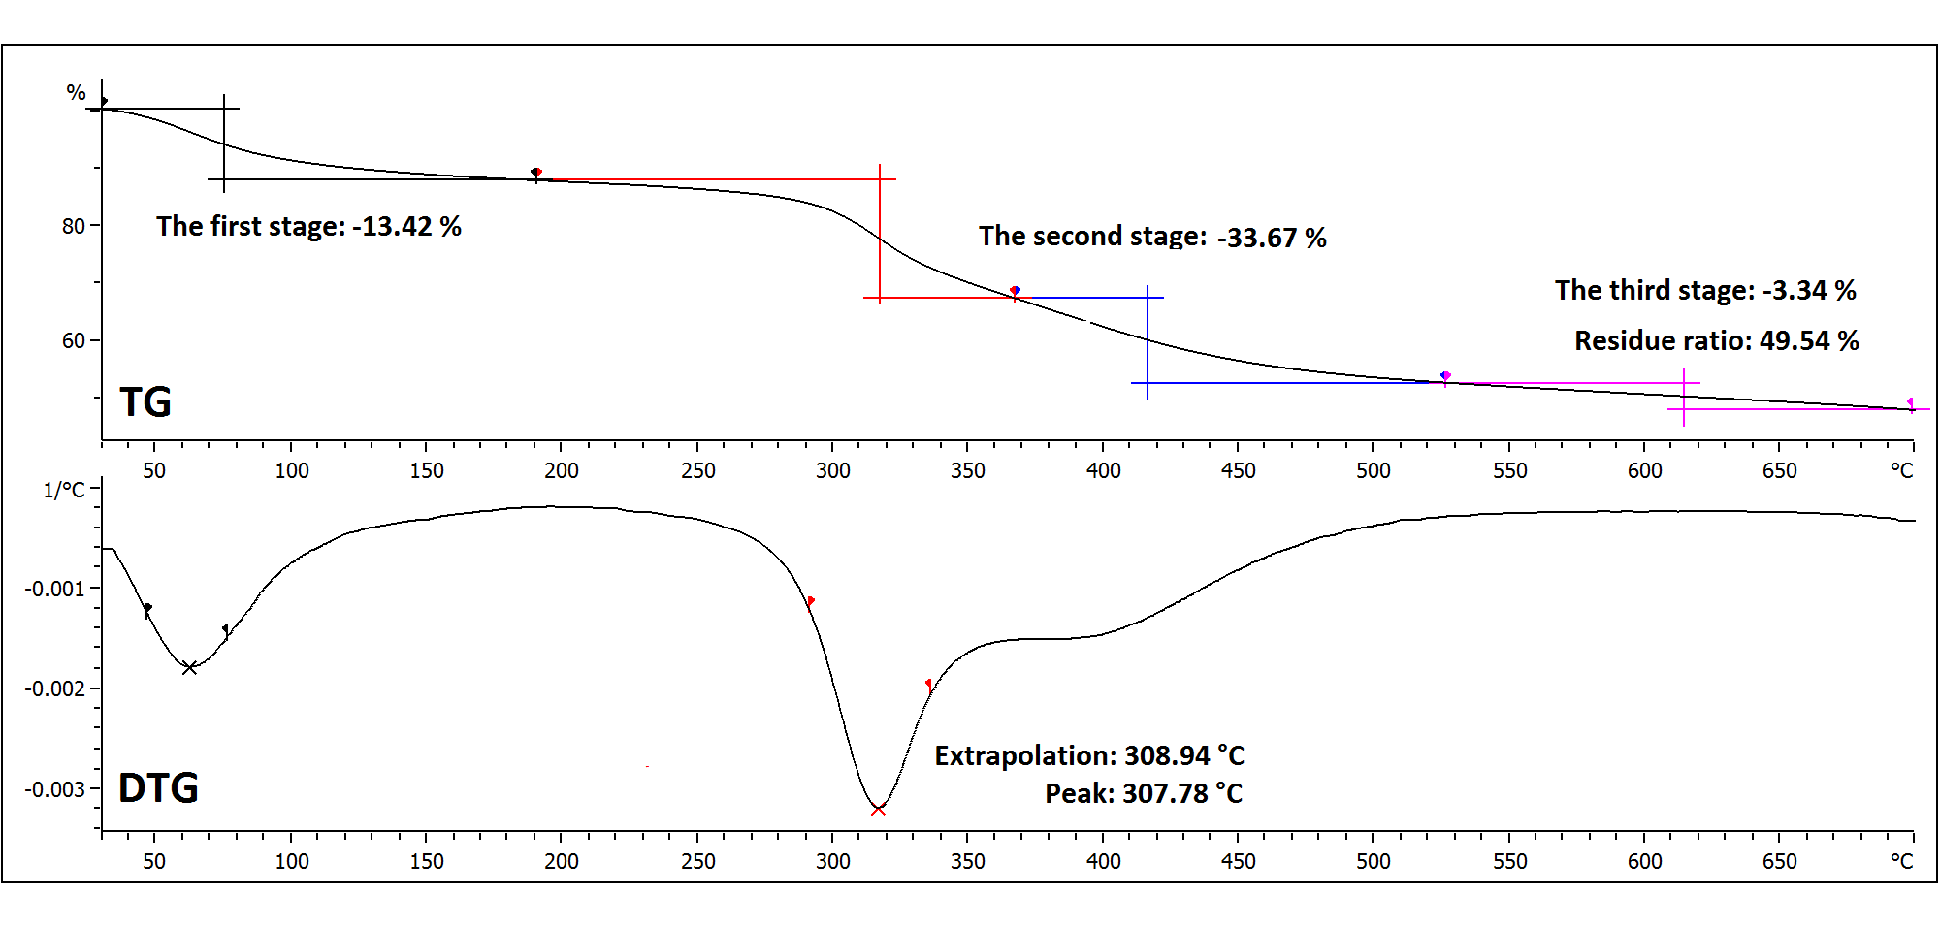
Fig. S5 TG/DTG curves of tanned hide powder with WBH at 50 ºC.

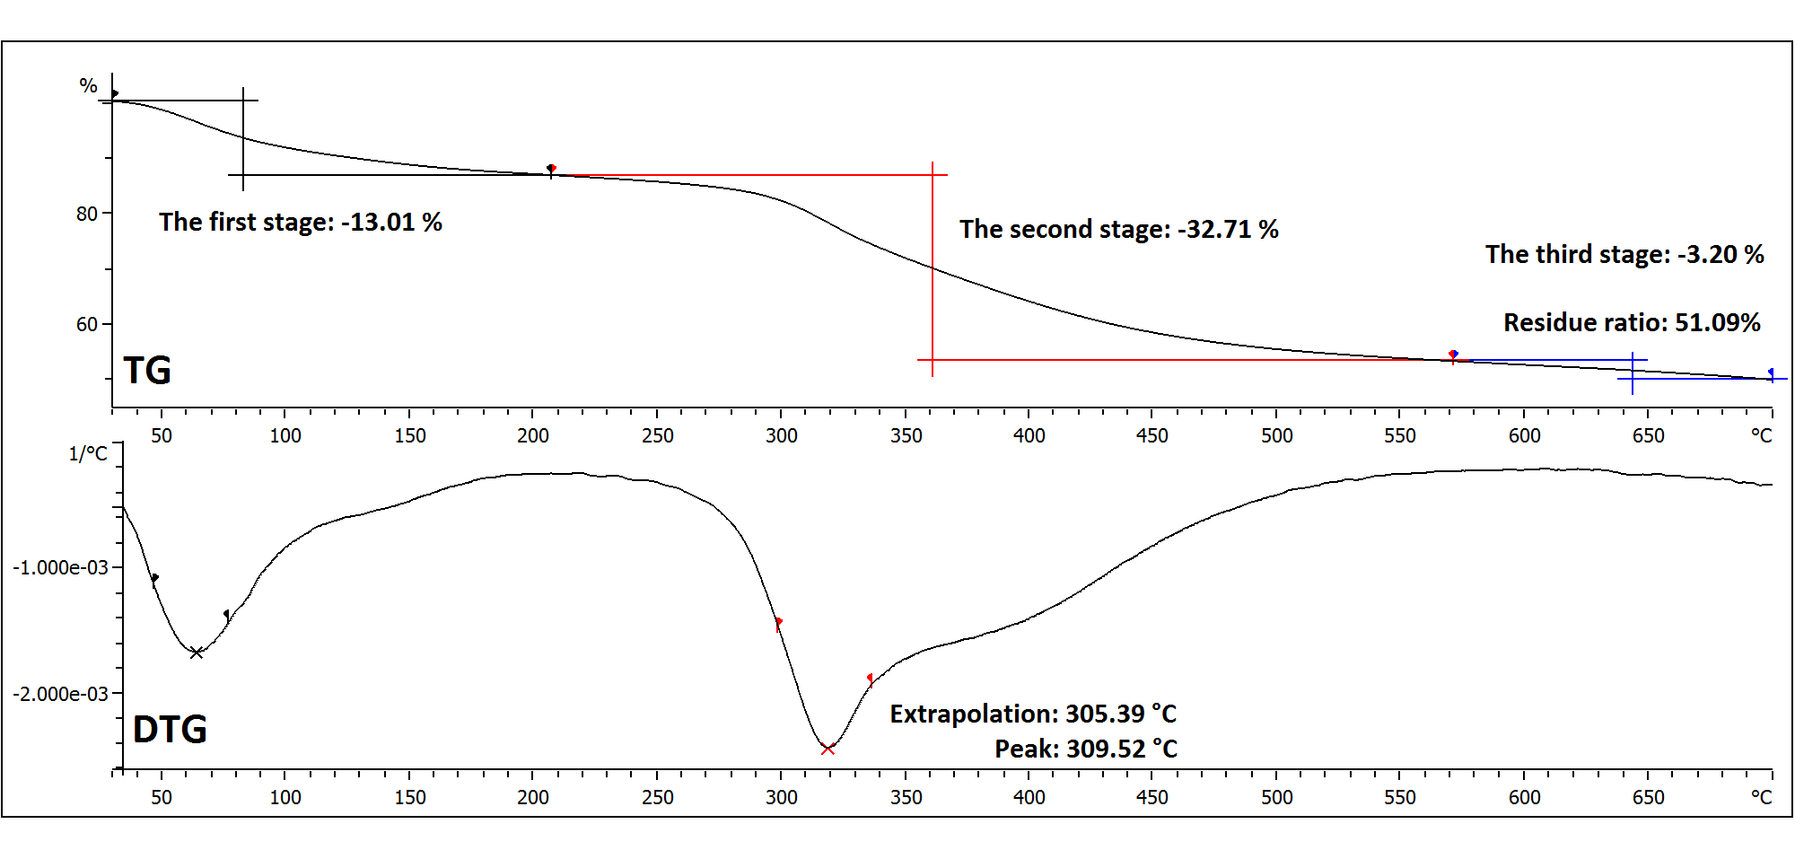
Fig. S6 TG/DTG curves of tanned hide powder with MWH at 50 ºC.

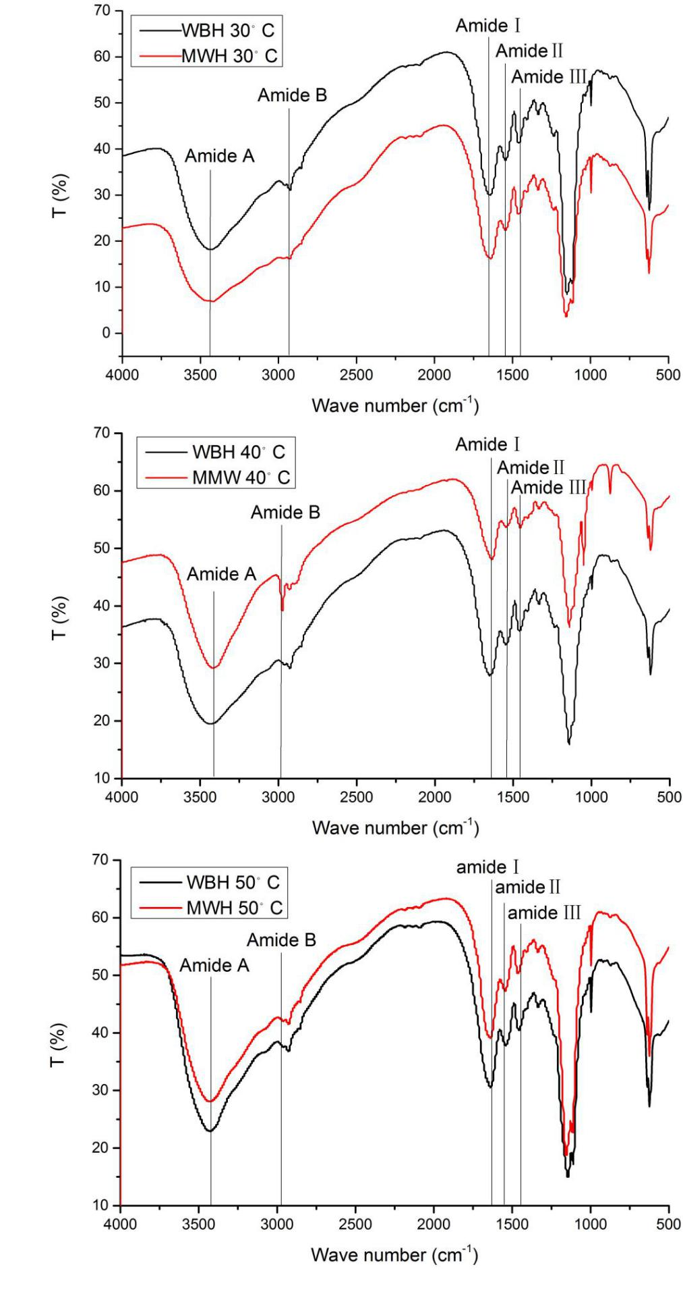
Fig. S7 FT-IR spectra of aluminum tanned hide powder at 30 ºC, 40 ºC and 50 ºC with different heating methods.

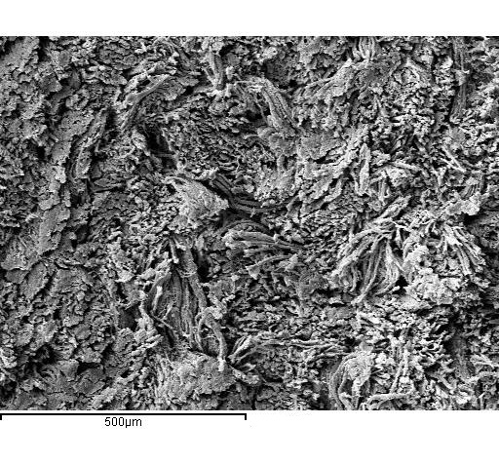
Fig. S8 SEM image for EDX analysis for the cross-section of aluminum tanned skin pieces of WBH. The magnification of mapping is ×100.
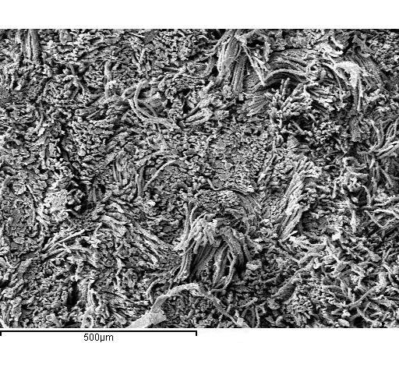
Fig. S9 SEM image for EDX analysis for the cross-section of aluminum tanned skin pieces of MWH. The magnification of mapping is ×100
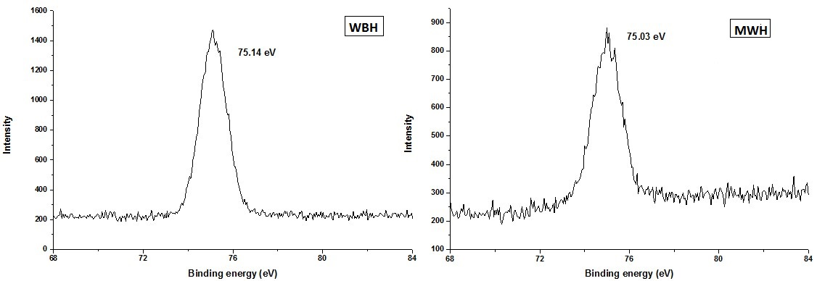
Fig. S10 XPS-Al images of tanned skin pieces with different heating methods.

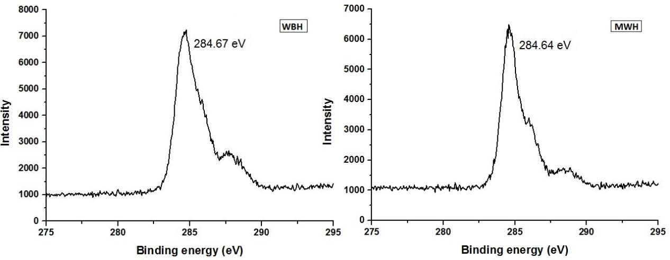
Fig. S11 XPS-C images of tanned skin pieces with different heating methods.

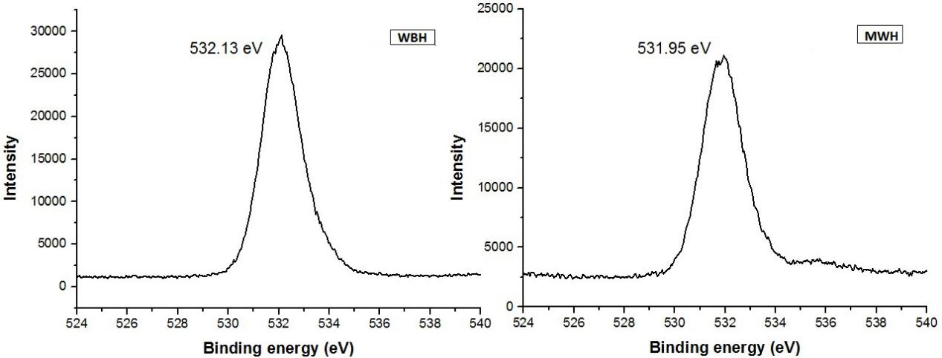
Fig. S12 XPS-O images of tanned skin pieces with different heating methods.

