Supporting Information
Collagen fiber membrane-derived chemically and mechanically durable superhydrophobic membrane for high-performance emulsion separation
Huifang Li ª, Wan Zheng ª, Hanzhong Xiao ª, Baicun Hao ª, Yujia Wang ª, Xin Huang ^{a*}, Bi Shi ^{a*}
ª National Engineering Research Center of Clean Technology in Leather Industry, Sichuan University, Chengdu 610065, P.R. China.
*E-mail addresses of the corresponding authors: xhuangscu@163.com (X. Huang), shibi@scu.edu.cn (B. Shi).

Table S1. Ingredients of NE1, NE2, NE3, NE4, ME1 and ME2.
Emulsion | Surfactant | Surfactant content | Oil content | Water content
NE1 | Span 80/SDBS | 0.12 g/0.06 g | Dodecane (300 mL) | 3.0 mL
NE2 | Span 80/CTAB | 0.12 g/0.06 g | Dodecane (300 mL) | 3.0 mL
NE3 | Tween 80/SDBS | 0.12 g/0.06 g | N-octane (300 mL) | 3.0 mL
NE4 | Tween 80/SDS | 0.12 g/0.06 g | N-heptane (300 mL) | 3.0 mL
ME1 | Span 80/SDS | 0.12 g/0.06 g | Dodecane (300 mL) | 30 mL
ME2 | Span 80/CTAB | 0.12 g/0.06 g | Dodecane (300 mL) | 30 mL

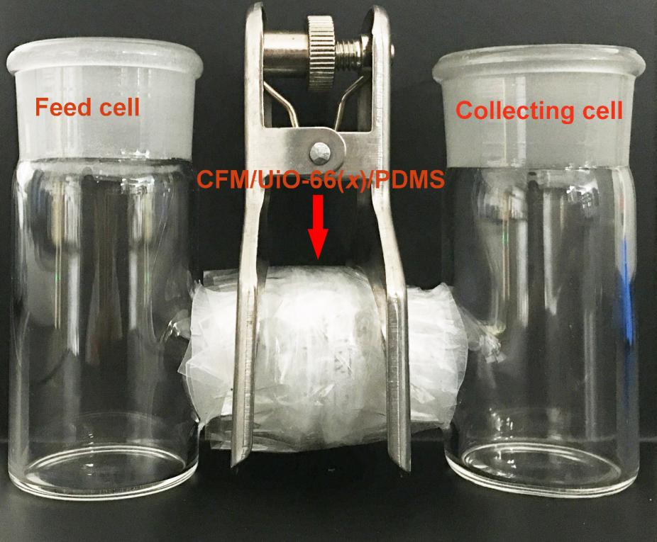
Figure S1. Digital photograph showing the H-shape separation device.

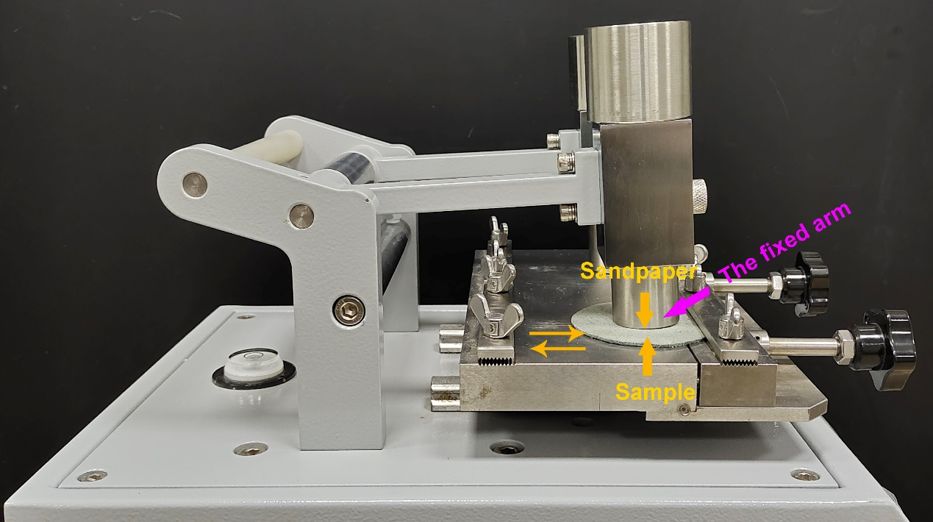
Figure S2. Digital photograph of rub fastness tester.

Figure S3. FESEM-EDS mapping images of the CFM/UiO-66(12)/PDMS membrane (a-d).

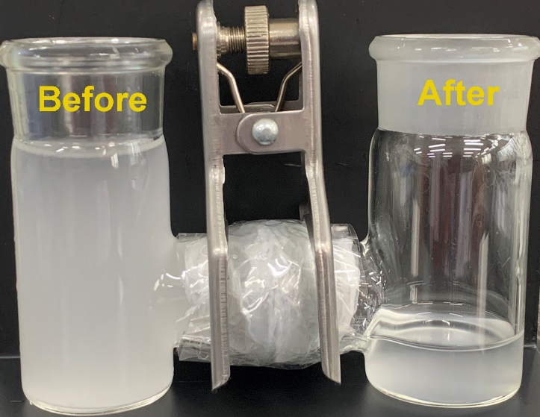
Figure S4. The digital photo of the H-shaped separation device for NE1 separation by the single-layer CFM/PDMS membrane.

Figure S5. DLS curves of NE1 after the separation by the single-layer CFM/UiO-66(x)/PDMS membranes that were prepared by seeding growth of UiO-66NPs for: 3.0 h (a), 6.0 h (b), 9.0 h (c), 12 h (d), 15 h (e) and 18 h (f).

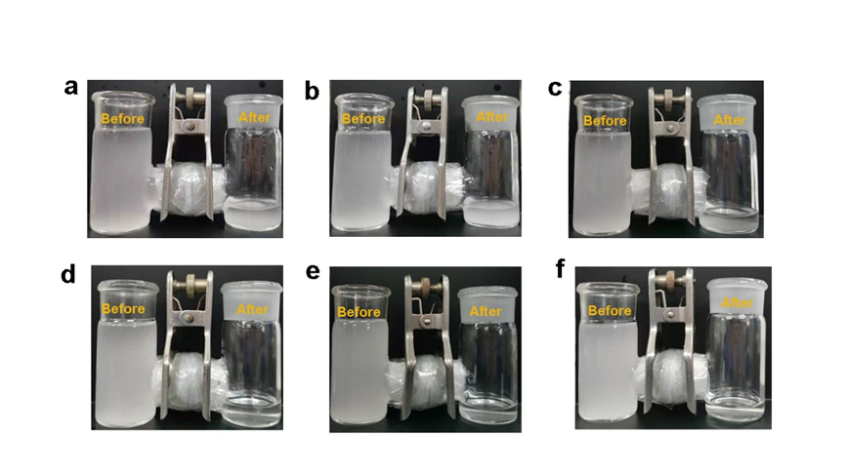
Figure S6. Digital photos of NE1 before and after the separation by the single-layer CFM/UiO-66(x)/PDMS membranes that were prepared by seeding growth of UiO-66NPs for: 3.0 h (a), 6.0 h (b), 9.0 h (c), 12 h (d), 15 h (e) and 18 h (f).

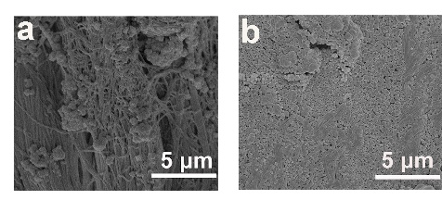
Figure S7. FESEM images of the CFM/UiO-66(3) membrane (a) and the CFM/UiO-66(18) membrane (b).

Figure S8. DLS curves of NE3 and NE4 before (a-b) and after (c-d) the separation by the double-layer CFM/UiO-66(12)/PDMS membranes.

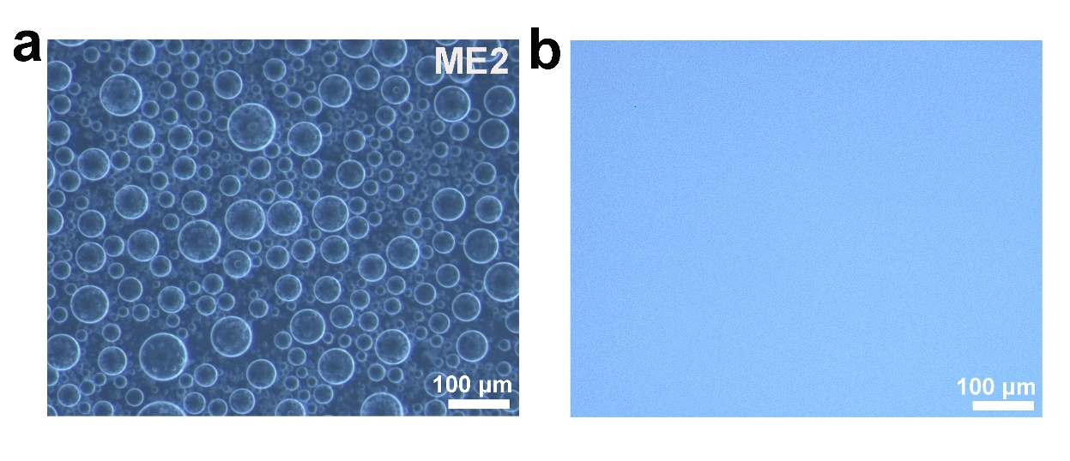
Figure S9. Optical microscopy images of ME2 before (a) and after (b) the separation by the double-layer CFM/UiO-66(12)/PDMS membranes.

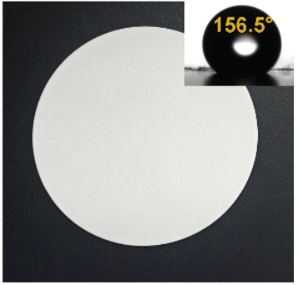
Figure S10. Digital photograph of commercial polytetrafluoro ethylene membrane (inset: the corresponding water contact angle).

Figure S11. DLS curves of NE1 after the separation by the double-layer CFM/UiO-66(12)/PDMS membranes that were assembled by the CFM/UiO-66(12)/PDMS membranes immersed in the solutions at pH2 (for 2.0 h) (a) and pH12 (for 2.0 h) (b), respectively, fluxes of NE1 separated by the double-layer CFM/UiO-66(12)/PDMS membranes that were assembled by the CFM/UiO-66(12)/PDMS membranes immersed in the solutions at pH2 (for 2.0 h) and pH12 (for 2.0 h), respectively (c) and the corresponding water contents in the filtrate and separation efficiency (d).

