Additional file 1
Efficient and ecological leather processing: replacement of lime and sulphide with dispase assisted by 1-allyl-3-methylimidazolium chloride
Hui Liu ^{a, b}, Keyong Tang ^{a *}, Xiumin Li ª, Jie Liu ª, Xuejing Zheng ª, Ying Pei ª
ª School of Materials Science and Engineering, Zhengzhou University, Zhengzhou 450001, P. R. China
^{b} Department of Packaging Engineering, Henan University of Science and Technology, Luoyang 471023, P. R. China
* Corresponding author
E-mail: Kytangzzu@hotmail.com (K. Tang);
Tel: +86 371 67739012;
Fax: +86 371 67781593.

1 Materials
Wet salted bovine hides were from Henan Prosper Skins & Leather Enterprise Co. Ltd, China. Na₂S·9H₂O (ACS pure) and AgNO₃ (analytical reagent, AR) were purchased from Aladdin Reagent Co. Ltd, China. NaOH (AR), Ca(OH)₂ (AR), tannic acid (AR), phenol (AR), fluorescein isothiocyanate (FITC, a mixture of 5- and 6- isomers, 97% biochemical reagent), potassium chloride (KCl, AR) and dispase (50 U/mg，biological reagent) were provided by Macklin Inc., Shanghai, China. China. H₂SO₄ (AR) and Na₂CO₃ (AR) were produced by Tianjin No. 1 Chemical Reagent Factory, Tianjin, China. An enhanced BCA protein assay reagent kit was from Beyotime Institute of Biotechnology, China. Optimal cutting temperature compound (OCT) was from Sakura Finetek USA, Inc., Torrance, CA 90501 USA.
2 De-salting of bovine hide
Salted wet bovine hides were added into a drum of tanning machine (DJD∅350, Xishan, Beitang Leather Machinery Factory, Jiangsu, China) with 500 wt% water (based on salted wet bovine hide in weight) by at room temperature for desalting. The water was changed every hour to completely remove the NaCl in bovine hides, which was verified by dropping in a little silver nitrate solution (0.02 mol/L) with no white precipitation appeared. After desalting, the bovine hides were washed with distilled water and stored at 4 ℃ for subsequent use.
3 Conventional unhairing (liming), reliming, deliming and bating
A piece of de-salted bovine hides (15 g) was carried out using Na2S/Ca(OH)2, Ca(OH)2, NH4Cl and dispase for unhairing(liming), reliming, deliming and bating respectively, and their detailed experimental procedure was referred to the previous work (Liu et al., 2021).
4 Tanning
The bovine hides samples from the KCl/dispase, [AMIm]Cl-dispase and conventional processes were pickled in 300 wt% sulfuric acid solution (pH = 4) at 27 ℃ for 30 min with vibrations (100 r/min). After being tanned in 10 wt%, 15 wt% and 20 wt% tannic acid solution with the ratio of solid-to-liquid (w/w) of 1∶3 at 27 ℃ for 24 h with vibrations (50 r/min) respectively, the samples were soaked in the same liquor at 27 ℃ for another 24 h. After being washed with 200 wt% water at 27 ℃ for 12 h (the water was changed every 3 h), the samples were air-dried at 30 ℃ for two days, and then stored in a desiccator for subsequent use.
5 Activity of dispase in wastewater
The activity of the dispase in wastewater from the processes of dispase, [AMIm]Cl/dispase and KCl/dispase during cycle unhairing and one-pot beamhouse was measured using universal protease activity with casein as the substrate. The detailed procedure was as follows: 1 mL of the dispase wastewater was diluted 10 times using a phosphate buffer solution (pH = 7.2). 1 mL of dilute dispase wastewater was transferred to 10 mL test tube and incubated at 40 ℃ for 5 min, and then added with 1mL casein solution for reaction at 40 ℃ for 10 min. 2 mL of trichloroacetic acid (TDA) (0.4 mol/L) was immediately added to terminate the reaction at 40 ℃ for 15 min. Whereafter, the solution was filtered using the qualitative filter paper (medium speed, type 102), and 1 mL of the filtered liquor, 5 mL sodium carbonate solution (0.4 mol/L) and 1 mL Folin-Phenol reagent were added into the 10 mL test tube successively, and the mixture was incubated at 40 ℃ for 20 min, followed by the analysis at 680 nm with an ultraviolet spectrometer (TU-1950, PERSEE, China).
6 Carbohydrate, protein and hydroxyproline (HYP) content in wastewater
The contents of protein in wastewater from the cycle unhairing and one-pot beamhouse were determined using a method of bicinchoninic acid [1] (BCA) by enzyme-labeled instrument (1510, Thermo Fisher Scientific, USA) at 562 nm. The contents of carbohydrate in wastewater were measured by a method of phenylhydrate-sulfuric acid [2], colorimetric analysis at 490 nm by the ultraviolet spectrometer (TU-1950, PERSEE, China). The contents of HYP in wastewater were measured by oxidation and color mechanism with hydroxyproline assay kit, colorimetric analysis at 550 nm by the ultraviolet spectrometer (TU-1950, PERSEE, China).
7 Verhoeff's Van Gieson (EVG) staining
The samples of bovine hide from KCl/dispase, [AMIm]Cl/dispase and conventional processes after formalin fixation were respectively dehydrated using 15% (v/v) and 30% (v/v) sucrose solution at 4 ℃. The samples were embedded with opti-mum cutting temperature compound (OCT), and then cut into slices with a thickness of 8 ~ 10 μm by a freezing microtome (CRYOSTAR NX50, Thermo Fisher Scientific, USA). Then the slices were stained with EVG as described in the reported work[3]. The stained slices were observed by digital slice scanning system (DSSS) (Pannoramic 250/MIDI, Hungary).
8 Morphological analyses
The samples of tanned leather were cut into pieces sized 5×4×1 mm, which were fixed on the sample platform by conductive tapes and gold-sprayed under vacuum conditions for 30 seconds. The opening effect of collagen fiber-bundles and grain morphology of tanned leather were observed by scanning electron microscopy (SEM) (FEI inspect F50, USA) at 10 kV and 20 kV.
9 Physical properties and shrinkage temperature
The tanned leathers from the processes of [AMIm]Cl/dispase, KCl/dispase and convention were cut into the shape of dumbbell by the dumbbell cutter ((4×75) GB/T-528 II, Kunshan Creator Testing Instrument Co. Ltd., China), which were then air-conditioned in a closed container at 60±5% humidity for one week. The physical properties of the tanned leather samples were tested by texture analyzer (TA.XT Plus, UK). The hydrothermal stability of the samples (soaked in distilled water at room temperature for 24 h) was determined using the digital leather thermal shrinkage temperature tester (MSW-YD4, Sunshine Electronic Research Institute of Shaanxi University of Science & Technology, China).
10 Pollutant content in wastewater
The wastewater here was from the both methods of KCl/dispase and [AMIm]Cl/dispase one-pot beamhouse, while that of conventional process was the mixture from unhairing, liming, deliming and bating. The concentrations of chemical oxygen demand (COD), ammonia nitrogen (NH₃-N), total nitrogen (TN) and total solids (TS) in wastewater were analyzed according to standard methods[4]. Effluent wastewater samples were collected and tested for COD, NH₃-N, TN and TS by equation (1) [5]:
$$\text{Pollutant load }\left({\text{kg}}/{\text{t}}\right)\text{=}\frac{\text{C}\text{×}\text{V}}{\text{W}} (1)$$
where C represents the concentration of pollutant (COD, NH₃-N, TN and TS), kg/m³, V represents the volume of effluent, m³, while W represents de-salted raw bovine hide in the process, ton. Each pollutant index was measured three times, with the average reported here.

Fig. S1 Effects of each cycle unhairing with dispase, KCl/dispase and [AMIm]Cl/dispase processes.
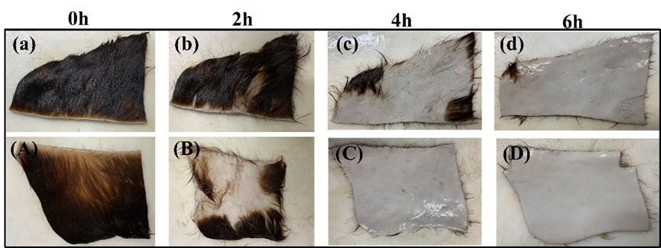
Fig. S2 Digital photos of unhairing by KCl/dispase (a, b, c, d) and [AMIm]Cl/dispase (A, B, C, D) processes.
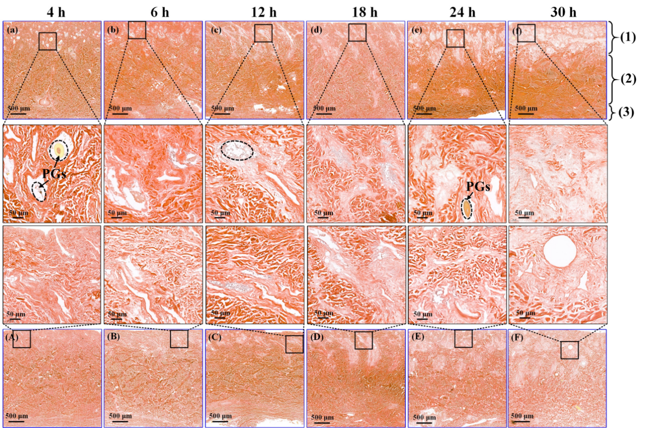
Fig. S3 Digital scan images of EVG staining of cross-section of bovine hides ((1) grain layer; (2) reticular layer; (3) subcutis) during one-pot beamhouse by KCl/dispase (a, b, c, d, e, f) and [AMIm]Cl/dispase (A, B, C, D, E, F) processes.
Fig. S4 The effect of KCl and [AMIm]Cl concentrations on the Zerta potential dispase solution.
Fig. S5 (A) Contact angles of dispase, KCl/dispase and [AMIm]Cl/dispase solutions on the surface of bovine hides; (B) Contact angle digital photos of dispase, KCl/dispase and [AMIm]Cl/dispase solutions on the surface of bovine hides at different time.
Fig. S6 SEM images of the cross-section of the tanned leather: (A) conventional process; (B) KCl-dispase process: (C) [AMIm]Cl-dispase process.

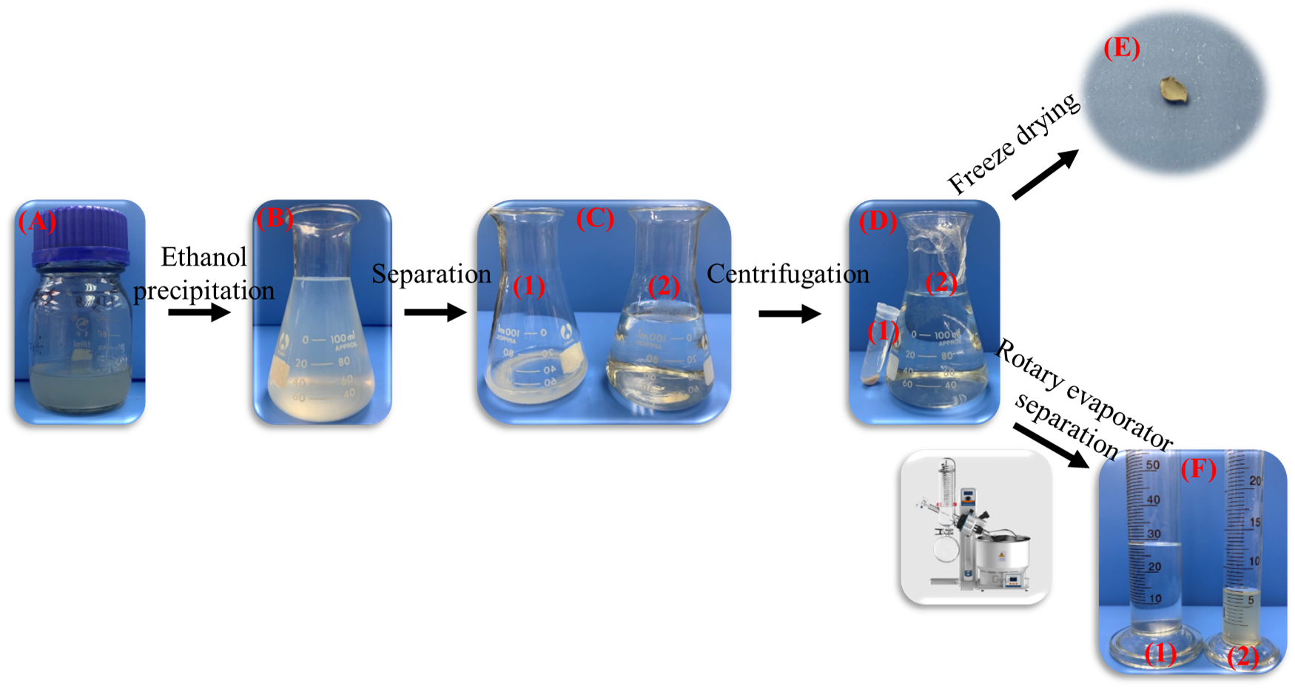
Fig. S7 Extraction of organic matter in wastewater: (A) Wastewater after one-pot beamhouse; (B) Mixture of wastewater and absolute ethanol; (C) Separation of sediment and solution; (D) Separation of sediment (1) and solution (2); (E) Wastewater extract; (F) Ethanol (1) and containing [AMIm]Cl of water solution (2) after separation.
Fig. S8 Infrared spectra of wastewater extract, sodium hyaluronate and pure bovine hide collagen.
Fig. S9 Planting Epipremnum aureum using the water (1) and the wastewater from KCl-dispase process (2) and [AMIm]Cl-dispase process (3): (A) 0 d; (B) 210 d; (C) 246 d; (D) 371 d; (E) 432 d.
Reference
[1]L.C. Davis, G.A. Radke, Measurement of protein using flow injection analysis with bicinchoninic acid, Anal. Biochem. 1987; 161: 152-56.
[2]M. Dubois, K.A. Gilles, J.K. Hamilton, P.A. Rebers, F. Smith, Colorimetric Method for Determination of Sugars and Related Substances, Anal. Chem. 1956; 28: 350-56.
[3]H. Liu, Z. Yin, Q. Zhang, X. Li, K. Tang, J. Liu, Y. Pei, X. Zheng, C.E. Ferah, Mathematical modeling of bovine hides swelling behavior by response surface methodology for minimization of sulfide pollution in leather manufacture, J. Clean. Prod. 2019; 237: 117800. 10.1016/j.jclepro.2019.117800.
[4]Federation W E, Standard methods for the examination of water and wastewater, American Public Health Association 2005.
[5]S. Pandurangan, I. Meganathan, S. Ragavan, K.N. Ramudu, E. Shanmugam, G. Shanmugam, A. Niraikulam, Engineering of a skin-fiber-opening enzyme for sulfide-free leather beam house operation through xenobiology, Green Chem. 2019; 21: 2070-81. 10.1039/c8gc03479f.

