Supplementary materials
The improvement of dispersity, thermal stability and mechanical properties of collagen fibers by silane modification: An exploration for developing new leather making technology
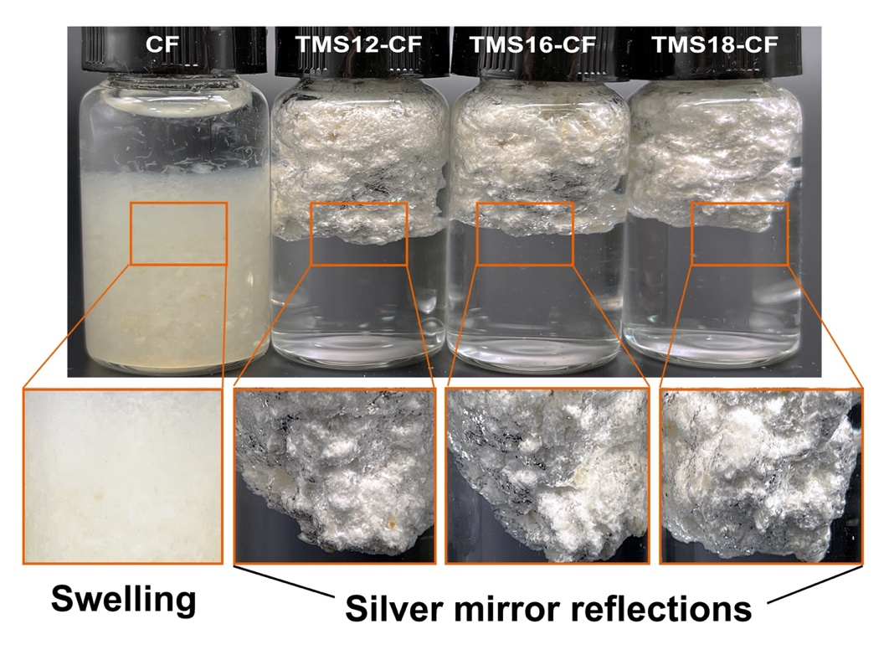
Figure S1 CF, TMS12-CF, TMS16-CF and TMS18-CF were immersed in water

Figure S2 TMS16-CF (a) and TMS18-CF (b) were immersed in solution with different pH.
Figure S3 DSC curve of CF.

