Sustainable Metal-Free Leather Manufacture via Synergistic Effects of Triazine Derivative and Vegetable Tannins
Yuanhang Xiao ¹, Jiajing Zhou ^{1,2}, Chunhua Wang ¹, Jinwei Zhang ¹, Vera D. Radnaeva ³,
Wei Lin ^{1,4*}
- Department of Biomass and Leather Engineering, Key Laboratory of Leather Chemistry and Engineering of Ministry of Education, Sichuan University, Chengdu 610065, China
- Department of NanoEngineering, University of California San Diego, 9500 Gilman Drive, La Jolla, CA 92093, United States
- Department of Leather and Fur Technology · Water Resources and Commodity Research, East Siberia State University of Technology and Management, Ulan-Ude, Buryatia 670013, Russia
- National Engineering Research Center of Clean Technology in Leather Industry, Sichuan University, Chengdu 610065, China

* Corresponding Author: Email: wlin@scu.edu.cn (W.L.)

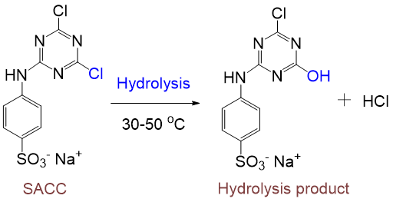
Fig. S1 Schematic diagram of structure and hydrolysis of SACC.

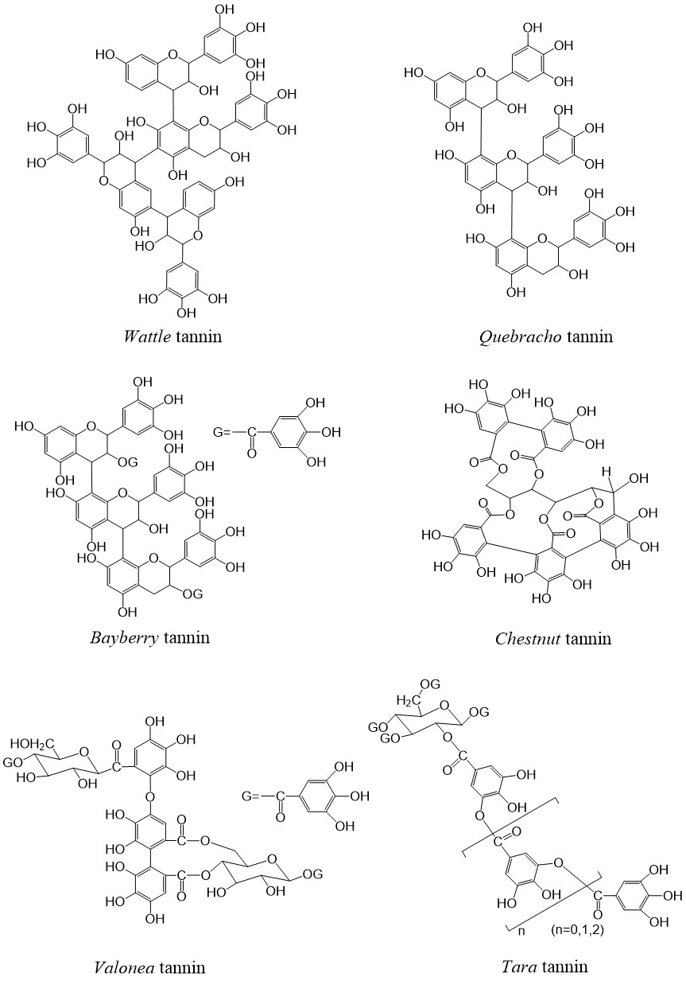
Fig. S2 Structural representation of condensed tannins (a: wattle, b: quebracho, c: bayberry) and hydrolysable tannins (d: chestnut, e: valonea, f: tara).
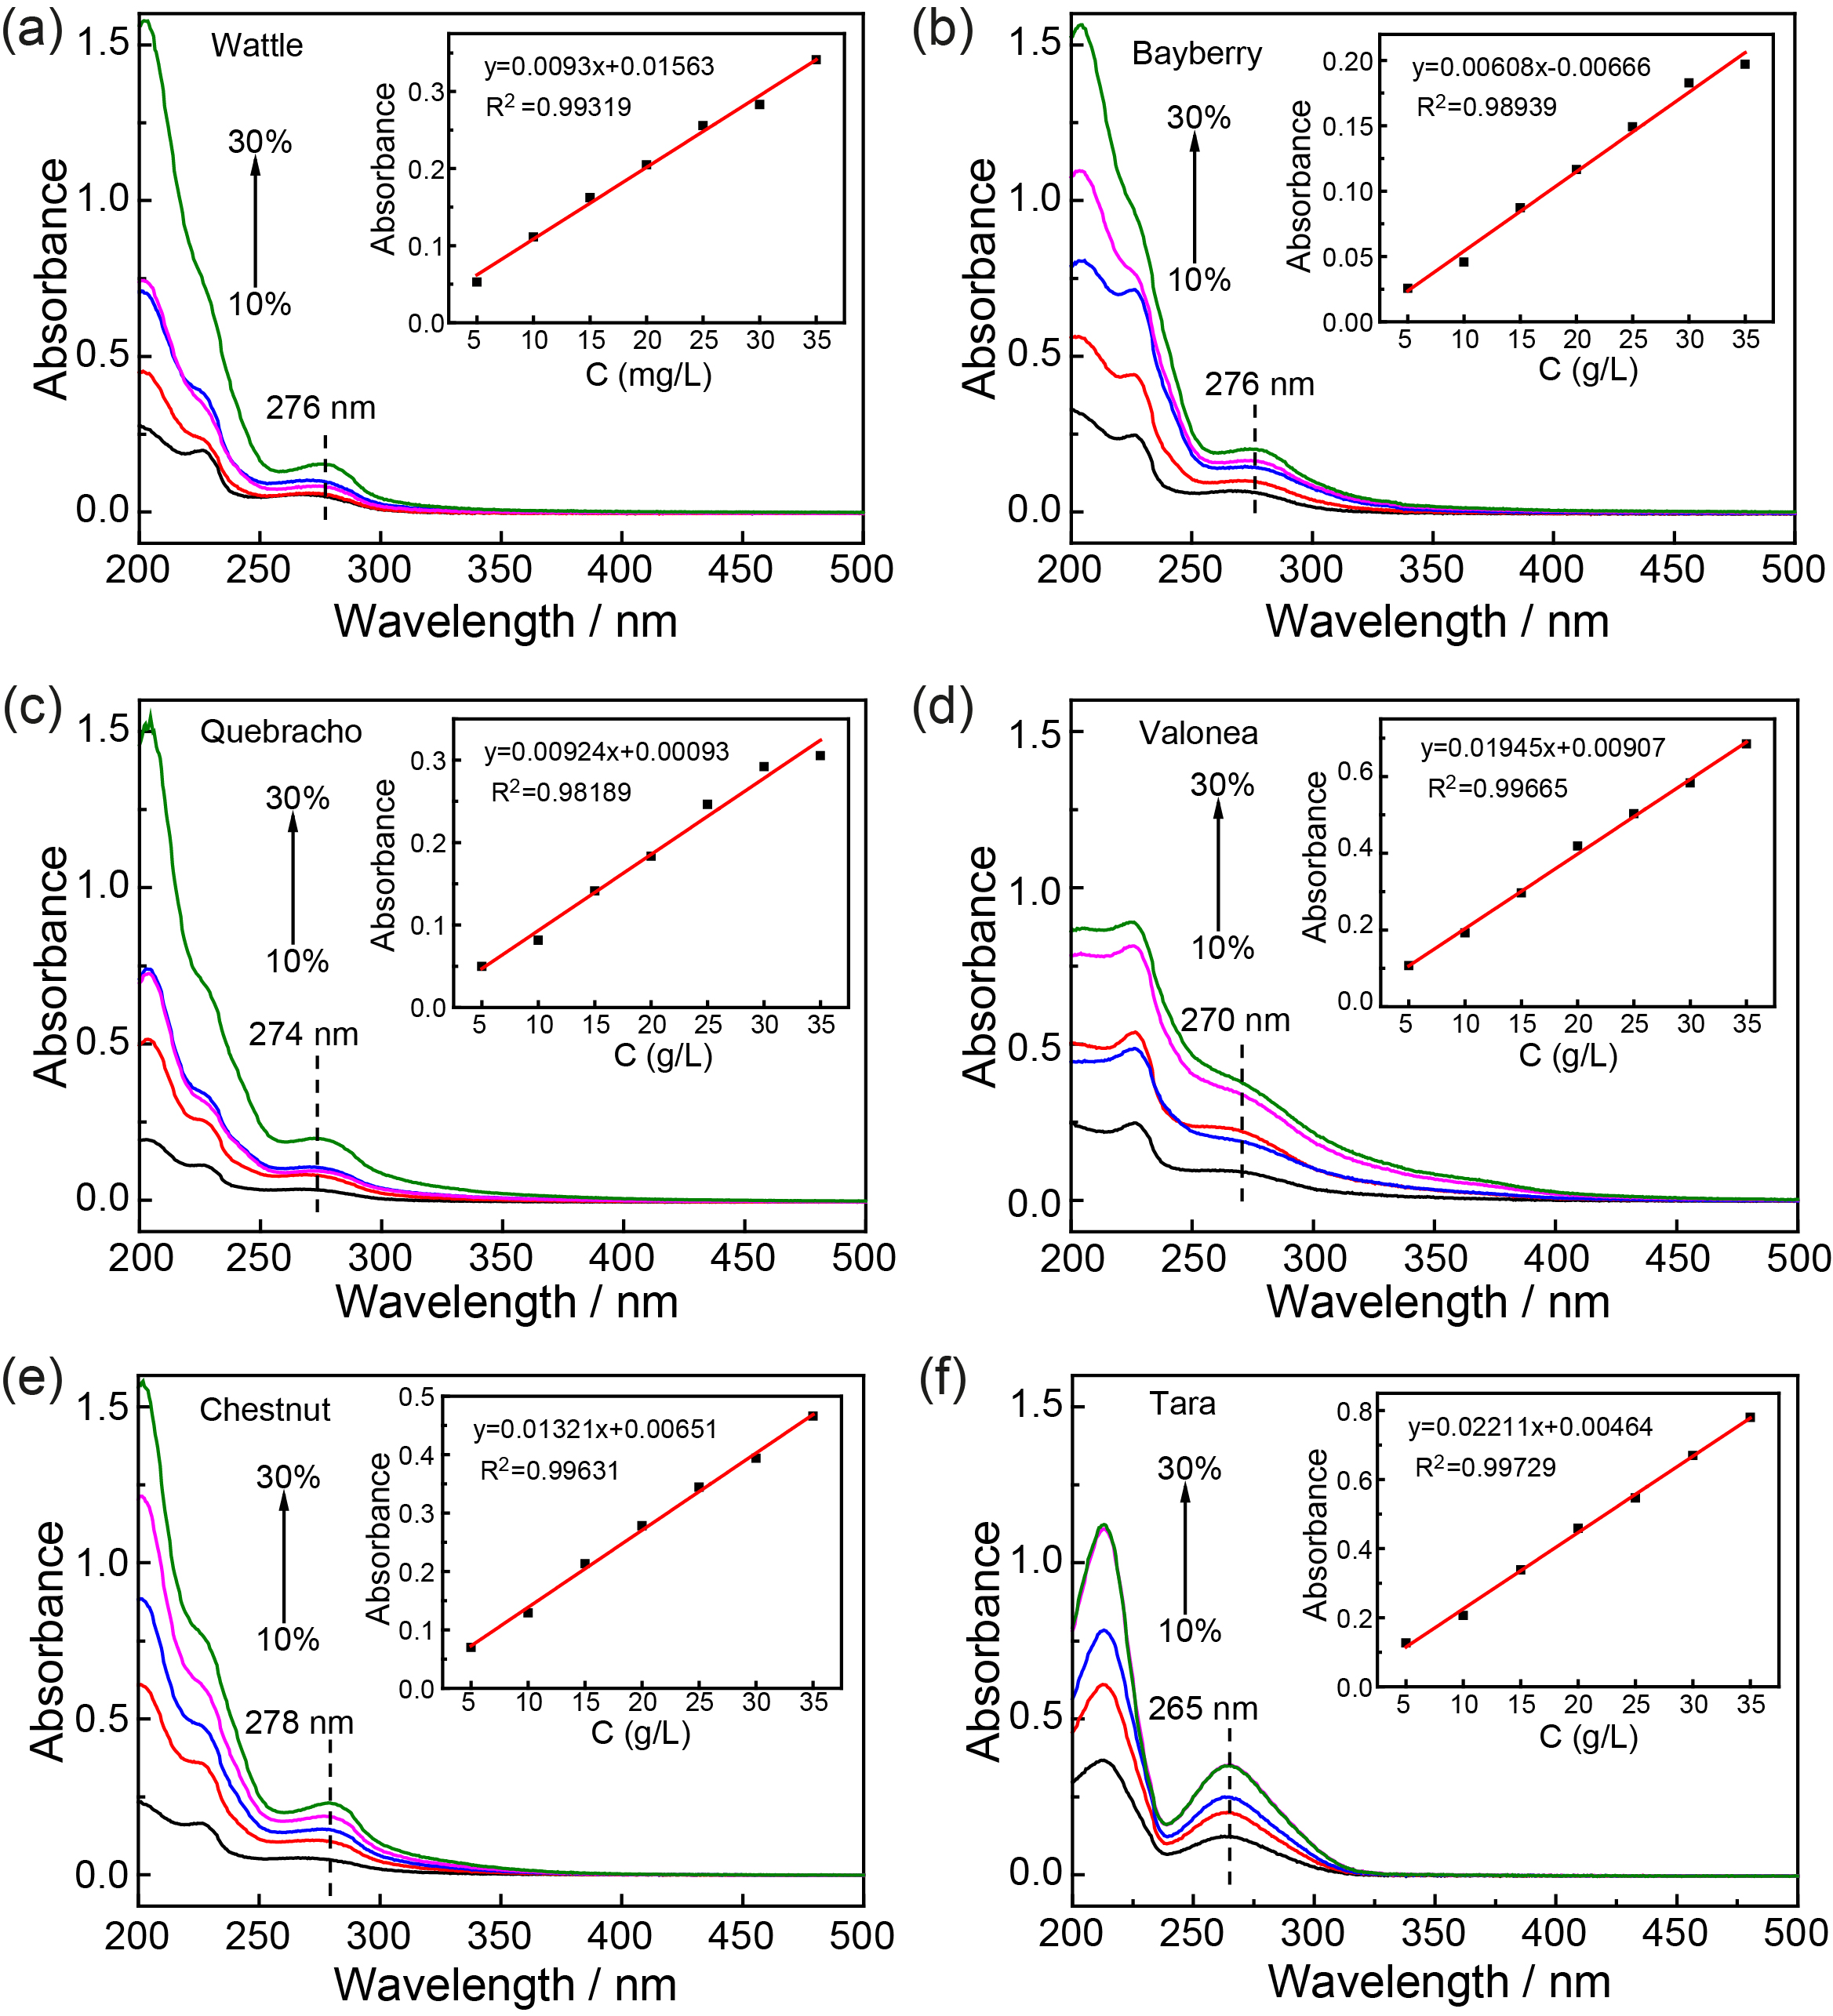
Fig. S3 The UV spectra of different tanning spent liquors and standard curves of six tannin extracts (a: wattle, b: bayberry, c: quebracho, d: valonea, e: chestnut, f: tara). The insets show the standard curves of six tannin extracts.

Table S1. The combination tanning process of SACC and tannins
Process | Chemicals | Dosage / % | T / ℃ | Time / min | Remarks
SACC tanning | Water | 70 | 25 |  | pH ~7.8
 | SACC | 10 |  | 120
 | Hot water | 50 | 40 | 120
 | Hot water | 50 | 45 | 240 | pH ~5.0
 | Washed, piled overnight; shaved, weighed (baseline of material dosage)
Rewetting | Water | 150 | 40
 | oxalic acid | 0.5
 | disodium EDTA | 0.3
 | Degreasing agent | 0.1
 | Wetting agent | 0.2 |  | 60 | pH ~3.5
Neutralization | Water | 150 | 35
 | Neutralize tannin | 2 |  | 20
 | Sodium bicarbonate | 0.5 |  | 60 | pH 4.5−4.7
Vegetable tanning | Water | 80 | 35
 | tannins | 10−30 |  | 180
 | Formic acid | 0.5 |  | 30 | pH ~3.5
 | Washed and piled for 24 h

Table S2. The post-tanning process of tanned leathers
Process | Chemicals | Dosage / % | T / ℃ | Time / min | Remarks
Retanning | Water | 80 | 35
 | DESOATEN NHK | 1
 | DESOPON LQ-5 | 5 |  | 10
 | DOWELLTAN RV | 2
 | LEUROTAN 8090 | 2
 | LEUKOTAN 970 | 1 |  | 30
 | RETINGAN R6 | 4
 | RETINGAN R7 | 2
 | LEVOTAN X-BIOMER R | 2
 | TANIGAN OS | 1 |  | 30
 | TANIGAN AN | 4
 | TANIGAN VR | 3
 | TANIGAN OS | 1 |  | 30
 | HCOOH | 0.6 |  | 30 | pH ~4.5
Dyeing | Water | 80 | 50
 | NH₃·H₂O | 0.5 |  | 10
 | Dye | 3 |  | 60
Fatiliquoring | DESOPON DPF | 2 | 50
 | TRUPON K1 | 2
 | TRUPON LNC | 1
 | TRUPON SWS | 1
 | DESOPON PM-S | 1 |  | 40
 | Formic acid | 2 |  | 15*3+30 | pH ~3.5
 | Washed and piled overnight
Note: DESOATEN NHK, DESOPON LQ-5, DESOPON DPF and DESOPON PM-S from Sichuan Decision New Material Technology Co., Ltd. DOWELLTAN RV form Sichuan Dowell. LEUROTAN 8090 and LEUKOTAN 970 from Rohm and Haas. RETINGAN R6, RETINGAN R7, LEVOTAN X-BIOMER R, TANIGAN OS, TANIGAN AN and TANIGAN VR from Lanxess. TRUPON K1, TRUPON LNC and DESOPON PM-S from Trumpler.
Table S3. The solo tanning process of the vegetable tannins
Process | Chemicals | Dosage / % | T / ℃ | Time / min | Remarks
Depickling | Water | 100 | 25
 | NaCl | 8 |  | 30
 | Sodium bicarbonate | 1 |  | 60 | pH 4.5−5.0
Vegetable tanning | Tannins | 25 | 25 | 240 | 180
 | Formic acid | 0.5 |  | 30 | pH ~3.5
 | Washed and piled for 24 h

