Supplementary Material
1. FT-IR and XPS spectra of the Col, Col/Dp, and Col/Dp-LA/VOP films

1.1 Experimental method

1.1.1 Fourier transform infrared (FT-IR) spectroscopy
FT-IR analysis of the films was carried out on a Middle and attenuated total reflection (ATR) mode in the wavenumber range from 4000 to 650 cm−1 at room temperature. For each spectrum, 16 scans at a resolution of 2 cm−1 were obtained.

1.1.2 X-ray photoelectron spectra
X-ray photoelectron spectra of the films were determined by AXIS Ultra DLD (Kratos) X-ray photoelectron spectrometer.

1.2 Results and discussion

1.2.1 FT-IR analysis
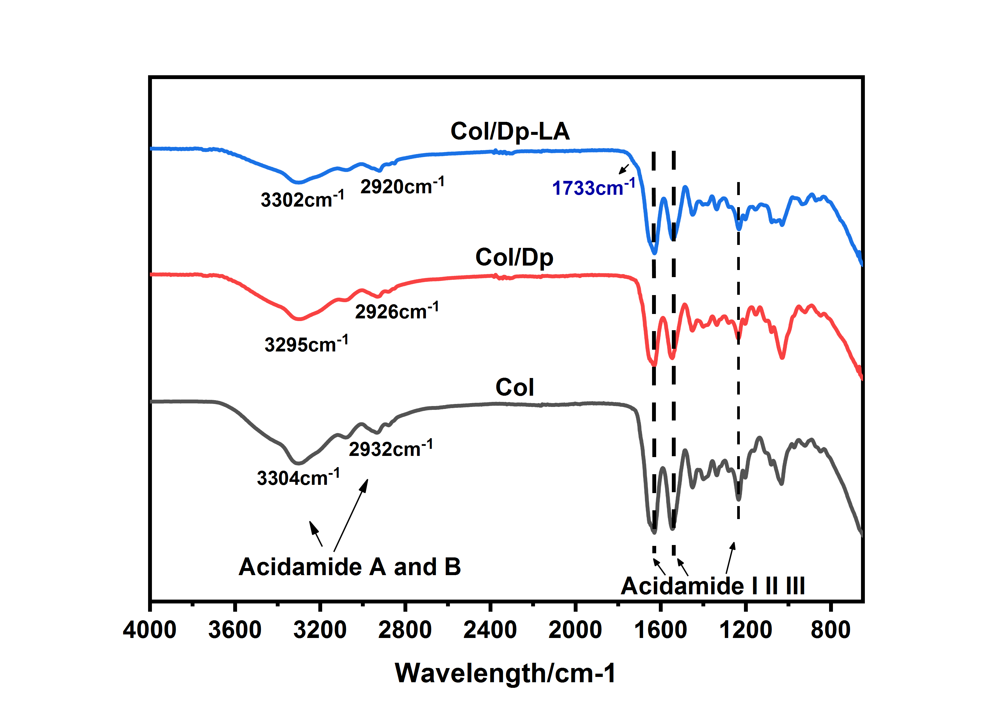
Fig. S1. FT-IR spectra of the Col film, Col/Dp film, and Col/Dp-LA film.
The FT-IR image revealed that the Col/Dp-LA film showed a new characteristic peak in its FT-IR curve at 1733cm⁻¹ which was attributed to the C=O stretching vibration[1]. This finding indicated that the polyphenols had been oxidized by laccase to form quinone groups.

1.2.2 XPS spectra analysis
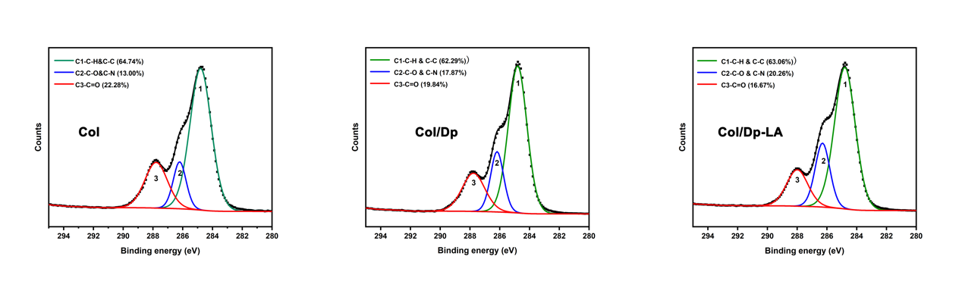
Fig. S2. High-resolution C1s XPS spectra of the Col film, Col/Dp film, and Col/Dp-LA film.
The high-resolution C 1s XPS spectra are shown in the Fig.S2. Three peaks at about 284.8, 286.2, and 287.7 eV were observed, which corresponded to three different chemical bonds (C1: C–H & C–C, C2: C–O & C– N, C3: C–O) of carbon in all collagen films. It should be noted that the content of C3 (C=O) in the cross-linked films decreased from 22.28% to 16.67% after the addition of Dp and LA in order. A possible reason was the Schiff base reaction between the –NH2 of collagen molecules and quinones disrupted the C=O bonds. The content of C2 (C–O & C–N) showed an upward trend from 13.00% to 20.26%, higher than that of the native collagen film (13.00%), which might be mainly due to the Schiff bases between the –NH2 of collagen molecules and quinones[2].

2. Physical and chemical properties of the Col/Dp-LA/VOP film

2.1 Properties testing of the Col/Dp-LA/VOP

2.1.1 Differential scanning calorimetry (DSC)
The thermostabilities of the films were evaluated by DSC-204F01 (NETZSCH Co, Germany) in the temperature range 20 °C - 100 °C at a heating rate of 10°C/min and a nitrogen flow rate of 40 mL/min.

2.1.2 Thickness
The thickness of the films were measured according to the Chen et al with a minor modified[3]. To accurately measure the thickness of the films, five sites of each film were randomly selected, and the cross-section thickness of the films was specially measured by using lectronic digital micrometer (model 211-101F, Guangxi, China).

2.1.3 Mechanical property
Each film sample was cut into 45 mm × 5 mm strips to test the dry tensile strength, wet tensile strength, dry elongation at break, and wet elongation at break by a universal testing machine (UTM2102, New Sansi, Shenzhen, China). The dry strength and elongation at break were tested by stretching mode in the vertical direction at a constant speed of 10 mm/min. The wet strength and elongation at break measurements were used in the same mode after pre-immersing the films in distilled water for 2 min.
The tensile strength was calculated using the Equation (1):
$\text{Tensile strength }\left(\text{MPa}\right)\text{=}\frac{\text{F}}{\text{d×W}}$ (1)
Where F is the maximum tension when the film breaks (N), d is the thinness of the film (mm), W is the wideness of the film (mm).
The Elongation at break was calculated using the Equation (2):
$\text{Elongation at break (\%)=}\frac{\text{L-}{\text{L}}_{\text{0}}}{{\text{L}}_{\text{0}}}\text{×100\%}$ (2)
Where L is the line distance when the film breaks (mm), L0 is the line distance of the original film (mm).

2.1.4 Water vapor permeability (WVP)
WVP values of the three samples were measured according to the method of Liu et al[4]. A 75% relative humidity circumstance was established in the desiccator with saturated sodium chloride (NaCl) aqueous solution. Each film sample was covered on the top of the beaker that contained anhydrous calcium chloride (0% relative humidity) and then placed in the test chamber at 25 °C and 75% relative humidity. The WVP value was measured by weighing beakers at an interval of 2 h within 5 d and WVP (g·mm−2·s−1·Pa−1) was calculated by equation (3).
$\text{WVP = }\frac{\text{W × d}}{\text{∆t × A × ∆P}}$ (3)
In this equation, W/Δt is the weight gain over time (g·s⁻¹), d is the average thickness of the film (mm), A is the bottle top area (mm²) and ΔP (Pa) is the vapor pressure difference across the film.

2.1.5 Water solubility
The water solubilities of the films were experienced using the method of Choo et al. with minor modifications [5]. Each film sample was cut into 2 cm × 2 cm pieces. The pieces were dried at 105 °C for 4h and were then weighted to obtain the initial weight (W₀). The dried films were then placed in distilled water at 25˚C for 24 h and filtered through Whatman No. 1 filter paper. The residue collected on the filter paper was again dried at 105˚C for 24h and was then weight (recorded as W₁). Water solubility (%) was calculated by equation (4)
$\text{Water solubility }\left(\text{\%}\right)\text{ = }\frac{{\text{W}}_{\text{1 }}\text{-}{\text{ W}}_{\text{0}}}{{\text{W}}_{\text{0}}}\text{ × 100\%}$ (4)

2.1.6 Optical property
The optical properties of the films were evaluated by measuring the transmittance of the films in the range of 200 - 800 nm on a UV–vis spectrophotometer (UV-2600, Shimadzu, Japan). The light transmittance of the films was then calculated by the following equation (5) based on their OD.
$\text{Light transmittance }\left(\text{\%}\right)\text{ = }\frac{\text{1}}{{\text{10}}^{\text{OD}}}\text{ × 100\%}$ (5)
Where OD is the absorbance of the films at different wavelengths.

2.1.7 Antioxidant activity
The antioxidant properties of the films were evaluated using DPPH and ABTS scavenging activity according to the method of Tang et al. with minor modification[6]. Briefly, each film (4 mg) was immersed in 4 mL ABTS and DPPH free radical working solutions for 30 min in the dark, respectively. After the reaction, the ABTS scavenging rate was obtained by the equation as follows:
$\text{ABTS scavenging activity }\left(\text{\%}\right)\text{ = }\left[\frac{{\text{A}}_{\text{0}} \text{-}{\text{ A}}_{\text{s}}}{{\text{A}}_{\text{0}}}\right]\text{ × 100\%}$ (6)
Where A₀ is the absorbance of the ABTS radicals working solution at 734 nm, and A_{s} is the absorbance of the ABTS radicals working solution at 734 nm after treatment with the film.
The DPPH scavenging activity was calculated by the following equation:
$\text{DPPH scavenging activity (\%) = }\left[\frac{{\text{A}}_{\text{1}} \text{-}{\text{ A}}_{\text{2}}}{{\text{A}}_{\text{1}}}\right]\text{ × 100\%}$ (7)
Where A₁ is the absorbance of the DPPH radicals working solution at 517 nm, and A₂ is the absorbance of the DPPH radicals working solution at 517 nm after treatment with the film.

2.2 Results and discussion

2.2.1 Thermal stability and mechanical strength of the Col/Dp-LA/VOP film
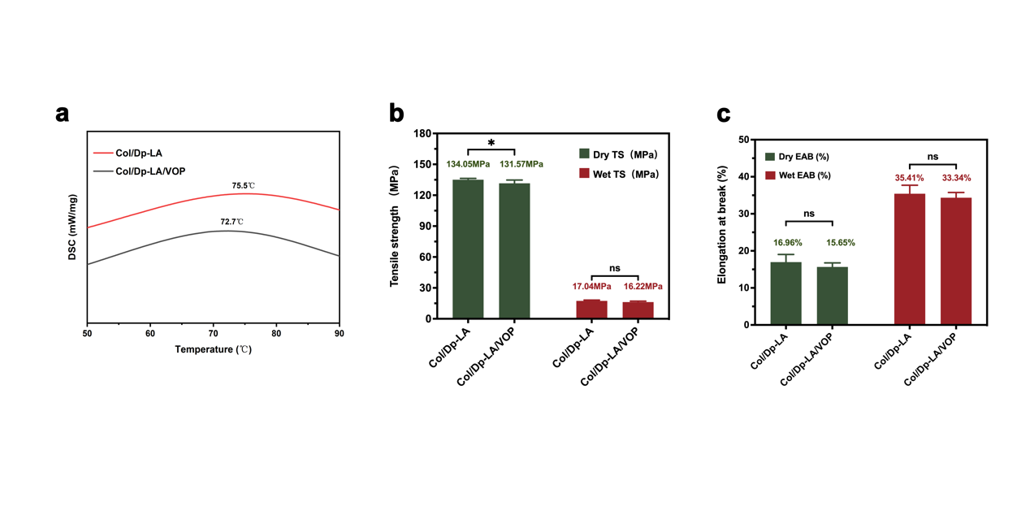
Fig. S3. DSC(a), dry and wet tensile strength (b), dry and wet elongation at break (c) curves of the Col/Dp-LA film and the Col/Dp-LA/VOP film.
As shown in Fig.S3., the thermal stability and mechanical strength of the Col/Dp-LA/VOP film decreased slightly after the addition of Dp. This result might be explained by the reason that the excess VOP filled in the interior of the film and disrupted the connections between collagen and Dp, and between collagen molecules.

2.2.2 Water-resistance property of the Col/Dp-LA/VOP film
Table S1. Thickness, Water vapor permeability (WVP), and water solubility of the Col/Dp-LA film and Col/Dp-LA/VOP film.
Film | Thickness  (𝛍m) | WVP  (×10⁻¹³gmm⁻¹s⁻¹Pa⁻¹) | Water solubility  （%）
Col/Dp-LA | 39.8 ± 1.8 | 1.04 ± 0.05 | 13.29 ± 1.79
Col/Dp-LA/VOP | 42.4 ± 1.9^{ns} | 1.01 ± 0.03^{ns} | 27.70 ± 2.32****
Values are presented as mean ± standard deviation (n=3). All significance analyses were based on “Col/Dp-LA”. The number of asterisks in the same column indicates the significance of the difference, ^{ns}P>0.05, *p<0.05, **P<0.01, ***P<0.001, ****p<0.0001.
As shown in Table S1, after the addition of VOP, the WVP value of the Col/Dp-LA/VOP film has not significantly changed, and the water solubility increased from 13.29% to 27.70%. The reason was that when the Col/Dp-LA/VOP film was exposed to water, the competition of water molecules led to the dissociation of the hydrogen bond between VOP and collagen and resulted in the dissolution of VOP into water. A similar trend was found in Azlim et al. who added dragon fruit skin extract to the gelatin substrate led to the water solubility of the gelatin/ dragon fruit skin extract composite film increased[7].

2.2.3 Light barrier property of the Col/Dp-LA/VOP film
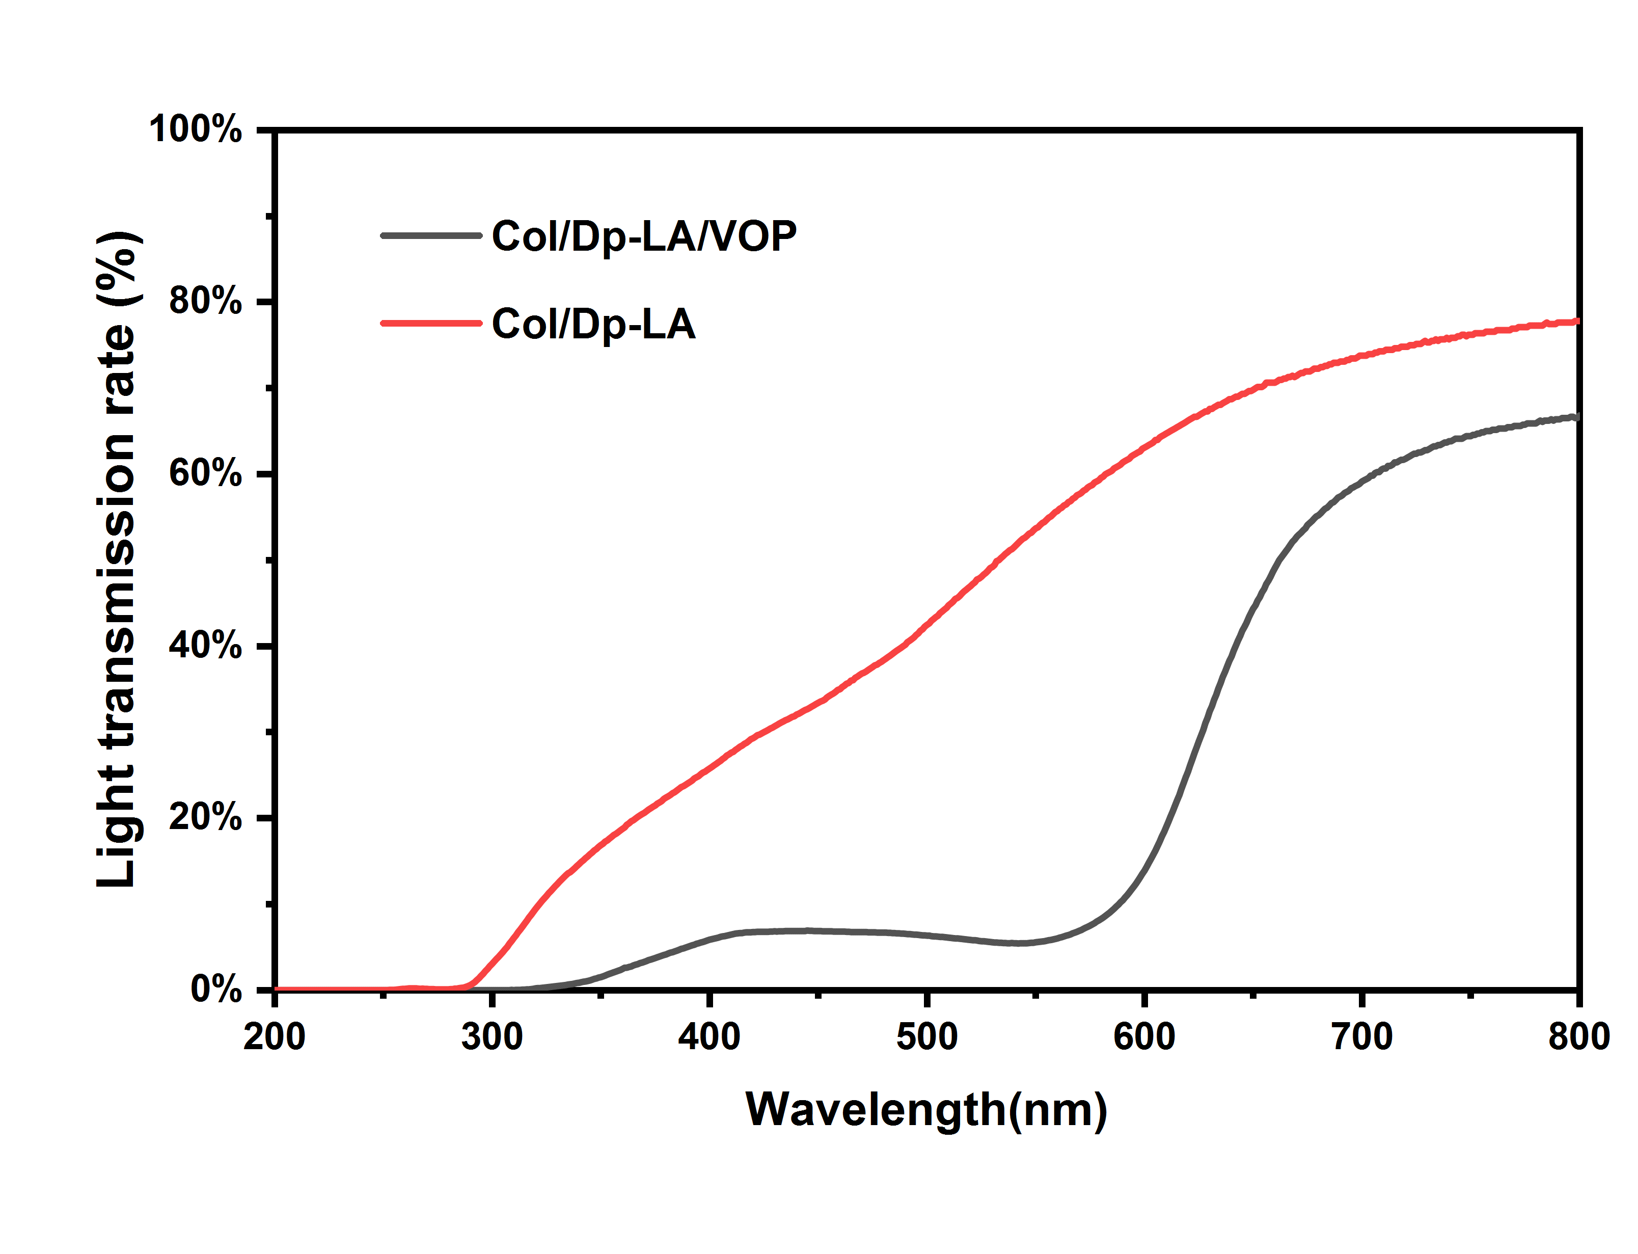

Fig. S4. Light barrier property of the Col/Dp-LA film and the Col/Dp-LA/VOP film.
As shown in Fig.S4., the Col/Dp-LA/VOP has a higher light barrier efficiency than that of the Col/Dp-LA film, especially in UV region (200 nm -400 nm). The reason was that a large number of benzene rings in the structure of VOP can absorb light and UV rays. This is a beneficial property for active packaging.

2.2.4 Antioxidant activity of the Col/Dp-LA/VOP film

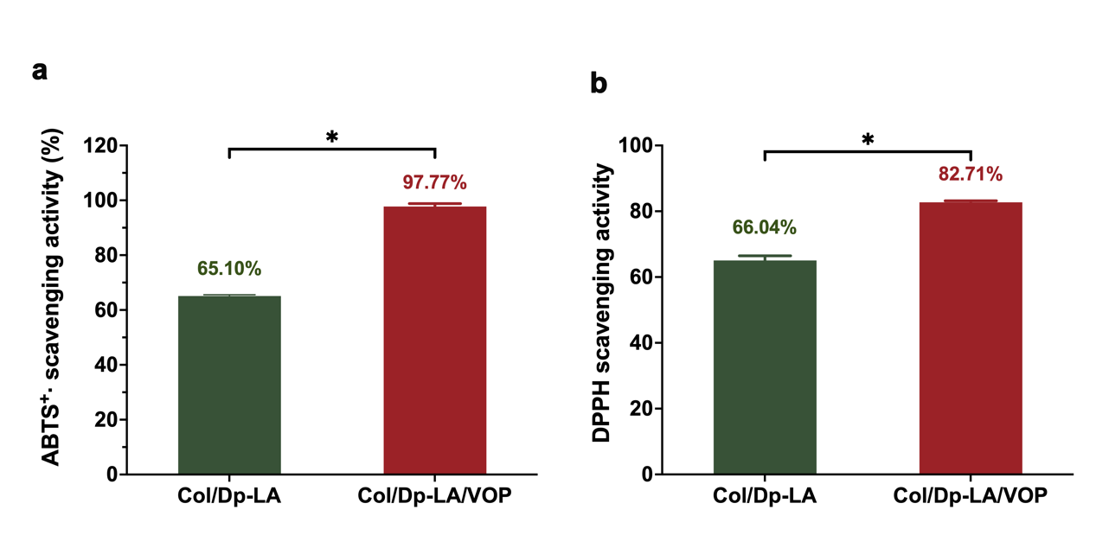
Fig. S5. ABTS(a), DPPH(b) free radical scavenging rates of the Col/Dp-LA film and the Col/Dp-LA/VOP film.
As shown in Fig.S5., the antioxidant activity of the Col/Dp-LA/VOP film was significantly increased after the addition of VOP, presumably due to the large number of phenolic hydroxyl groups contained in VOP. Meanwhile, VOP could produce synergistic effects with Dp to further enhance the antioxidant activity of the film. It is an absolutely advantageous property for antioxidant packaging.

References
1. Liao C, Xiao Y, Chen K, Li P, Wu Y, Li X and Zuo Y: Synergistic modification of polylactic acid by oxidized straw fibers and degradable elastomers: A green composite with good strength and toughness. Int J Biol Macromol 2022; 221: 773-83. http://10.1016/j.ijbiomac.2022.09.023
2. Huang S, Tu Z, Sha X, Hu Y, Chen N and Wang H: Fabrication and performance evaluation of pectin-fish gelatin-resveratrol preservative films. Food Chem 2021; 361: 129832. http://10.1016/j.foodchem.2021.129832
3. Chen J, Luo LC, Cen CN, Liu YA, Li H and Wang YB: The nano antibacterial composite film carboxymethyl chitosan/gelatin/ nano ZnO improves the mechanical strength of food packaging. International Journal of Biological Macromolecules 2022; 220: 462-71. 10.1016/j.ijbiomac.2022.08.005
4. Liu J, Wang H, Wang P, Guo M, Jiang S, Li X and Jiang S: Films based on κ-carrageenan incorporated with curcumin for freshness monitoring. Food Hydrocolloids 2018; 83(OCT.): 134-42
5. Choo KW, Lin M and Mustapha A: Chitosan/acetylated starch composite films incorporated with essential oils: Physiochemical and antimicrobial properties. Food Bioscience 2021;(43-): 43
6. Tang P, Zheng T, Yang C and Li G: Enhanced physicochemical and functional properties of collagen films cross-linked with laccase oxidized phenolic acids for active edible food packaging. Food Chem 2022; 393: 133353. http://10.1016/j.foodchem.2022.133353
7. Azlim NA, Mohammadi Nafchi A, Oladzadabbasabadi N, Ariffin F, Ghalambor P, Jafarzadeh S and Al-Hassan AA: Fabrication and characterization of a pH-sensitive intelligent film incorporating dragon fruit skin extract. Food Sci Nutr 2022; 10(2): 597-608. http://10.1002/fsn3.2680

