Supporting Information

Wearable synthetic leather-based high-performance X-ray shielding materials enabled by the plant polyphenol- and hierarchical structure-facilitated dispersion
Linping Yan,¹ Jibo Zhou,¹ Hao Li,¹ Rui Zhong,³ Junxin Zhuang,⁴ Xiaohui Xu,⁵ Yaping Wang,^{1,2,}* Xuepin Liao,^{1,2} Bi Shi^{1,2}

1 College of Biomass Science and Engineering, Sichuan University, Chengdu 610065, P. R. China
2 National Engineering Research Center of Clean Technology in Leather Industry, Sichuan University, Chengdu 610065, P. R. China
3 Key Laboratory of Radiation Physics and Technology, Ministry of Education Institute of Nuclear Science and Technology, Sichuan University, Chengdu 610064, P. R. China
4 Mingxin Automotive Leather Co., Ltd., Jiaxing 314006, P. R. China
5 Department of Chemistry, Materials Innovation Factory, University of Liverpool, Liverpool L7 3NY, UK

* E-mail: ypwang@scu.edu.cn (Y. Wang).

Table of Contents

Section 1: Synergistic effect of bis-high-Z elements on X-ray shielding

Section 2: Supplementary Figures

Section 3: Supplementary Tables

Section 4: References

Section 1: Synergistic effect of bis-high-Z elements on X-ray shielding
When X-ray energies are no less than the binding energies of the high-Z elements, X-ray photons can transfer their energy to the electrons completely through the photoelectric effect to dissipate the X-rays [1]. The probability of the photoelectric effect between X-rays and electrons of high-Z elements increases dramatically when the incident photon energy equals to or slightly surpasses the binding energy (dashed lines in Fig. S1a, b), resulting in the uprush of mass attenuation coefficients (MACs) and the formation of the absorption edge [2]. However, the single high-Z element displayed a distinct weak absorption region (e.g., region I in Fig. S1a, b could be attributed to the weak absorption regions of Ce and Er, respectively) because X-ray with slightly lower energy than the absorption edge was incapable of interacting with electrons via the photoelectric effect [3]. To address this issue, we selected Ba or Bi as the second high-Z element to compensate for the weak absorption regions of Ce and Er. By utilizing the synergistic effects of their strong absorption regions at different energies, high X-ray shielding performance was achieved in the entire energy regions in our measurement.

Fig. S1 Synergistic effect of bis-high-Z elements on X-ray shielding performance. (a) MACs of Ce and Bi in the National Institute of Standards and Technology of USA (NIST) database. (b) MACs of Er and Ba in the NIST database. (c) Comparison of attenuation efficiency of Ce_{3.67}-MFM and Z_{0.84}Ce_{3.67}-MFM. (d) Comparison of attenuation efficiency of Er_{3.65}-MFM and Z_{y}Er_{3.65}-MFM.

Commonly, the X-ray attenuation efficiency displayed an overall decreasing trend, however, attenuation efficiencies of Ce_{3.67}-MFM and Er_{3.65}-MFM exhibited obvious fluctuations near the absorption edges of Ce and Er, respectively (Fig. S1c, d). Since the K absorption edge of Ce is 40.45 keV, X-ray photons with an incident energy of 33 keV are unable to induce the photoelectric effect with the K-shell electrons of Ce. Thus, the attenuation efficiency of Ce_{3.67}-MFM was only 61 % at 33 keV, even 6 % lower than that at 48 keV (Fig. S1c). Similarly, the attenuation efficiency of Er_{3.65}-MFM was also affected by the K absorption edge of Er (57.50 keV), resulting in a lower X-ray attenuation efficiency at 48 keV than at 65 keV (Fig. S1d). Based on the above analyses, we introduced Ba or Bi to compensate for the weak absorption region of Ce and Er to bring significant enhancement to X-ray attenuation efficiency in the weak absorption regions of Ce and Er. Considering Bi_{0.84}Ce_{3.67}-MFM as an example, the composite showed an excellent attenuation efficiency of 90 % at 33 keV, which was 29 % higher than that of Ce_{3.67}-MFM. Since X-ray photon energy was lower than the K absorption edge of Ce, falling in both the K weak absorption region of Ce and the L strong absorption region of Bi, the incident X-rays predominately interacted with Bi via the photoelectric effect and were further attenuated and absorbed by Ce, demonstrating that Bi considerably complemented the weak absorption region of Ce (Fig. S1a, region I). As the X-ray energy increased to 48, 65, and 83 keV, falling in the region between K absorption edges of Ce and Bi (40.45 and 90.50 keV, respectively), the attenuation of the X-ray energy was primarily achieved by Ce due to the weak absorption region of the Bi, while Bi acted as a supplementation to further attenuate and absorb X-ray energy (Fig. S1a, region II). With the X-ray energy rising to 100 keV and 118 keV which already exceeded the K absorption edge of Bi, the interaction probability between K-shell electrons of Bi and X-ray photons through the photoelectric effect increased remarkably, thus making up for the weak absorption region of Ce in this X-ray energy range (Fig. S1a, region III). As compared to Ce_{3.67}-MFM, the Bi coating of Bi_{0.84}Ce_{3.67}-MFM led to a 12 % enhancement in attenuation efficiency at 118 keV (Fig. S1c). According to our estimation, the introduction of 0.84 mmol cm^{–3} Bi gave rise to a more significant increase in attenuation efficiency than the addition of 2.70 mmol cm^{–3} Ce, providing solid evidence for the synergistic effect of Bi and Ce in X-ray shielding. Likewise, both Ba and Bi could be utilized to complement the weak absorption region of Er since the K absorption edges of Ba and Bi were distinct from Er, as a result, Ba_{0.79}Er_{3.65}-MFM and Bi_{0.81}Er_{3.65}-MFM illustrated no obvious shielding defects in the whole range of 16–118 keV as well (Fig. S1d). Contrary to the aforementioned composites, in Ba_{0.84}Ce_{3.67}-MFM, because the K absorption edges of Ba and Ce were almost the same (37.44 and 40.45 keV, respectively), the highly overlapped weak absorption regions were unable to be compensated by the synergistic effect of bis-high-Z elements, causing the difference in attenuation efficiency between 33 and 48 keV which increased from 11 % to 17 % (Fig. S1c). In short, through a delicate selection of two high-Z elements with distinct absorption edges, we utilized the synergistic effect to complement the weak absorption region of single high-Z elements and to attenuate and absorb the X-ray energy effectively. In this way, the resultant composites possessed excellent X-ray shielding performance in the entire energy range.

Section 2: Supplementary Figures
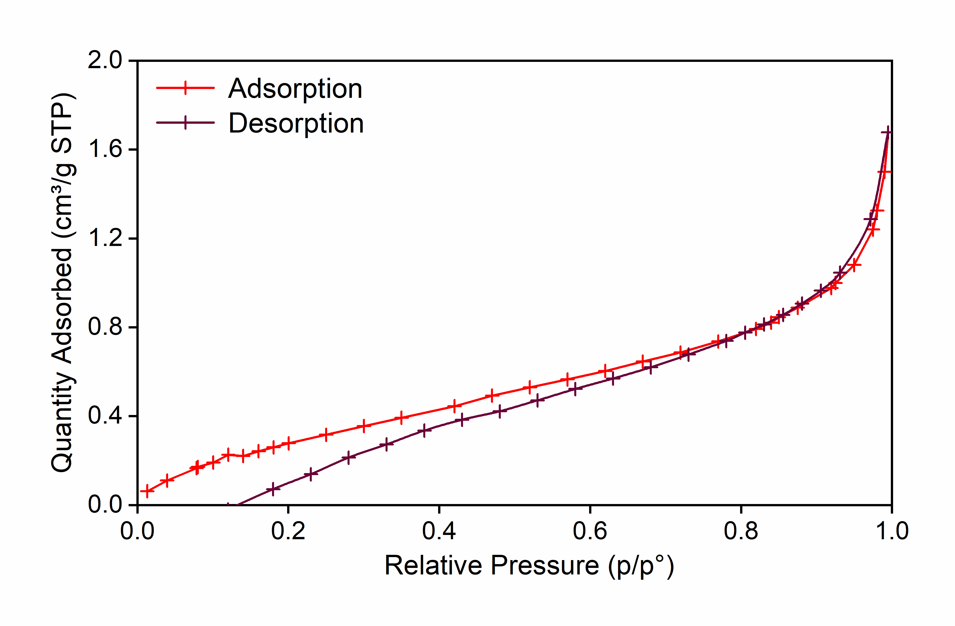
Fig. S2 Nitrogen adsorption-desorption isotherms of PETM.
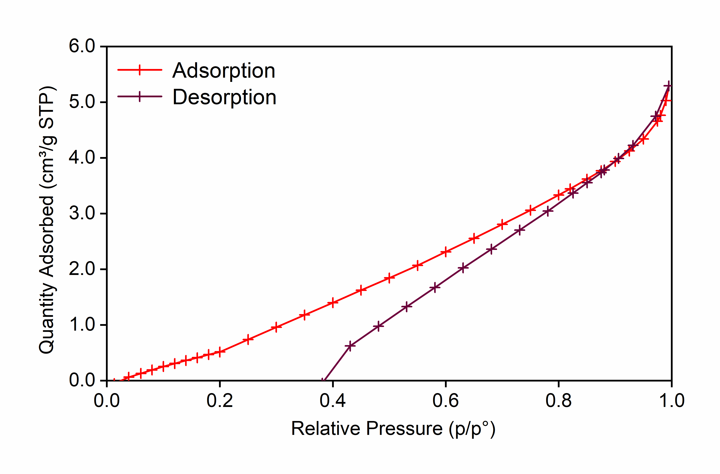
Fig. S3 Nitrogen adsorption-desorption isotherms of MFM.

Fig. S4 High-resolution XPS O 1s scan spectra of Er-MPN.

Fig. S5 XPS survey spectrum of BaCe-MFM and BiCe-MFM.

Fig. S6 XPS survey spectrum of BaEr-MFM and BiEr-MFM.

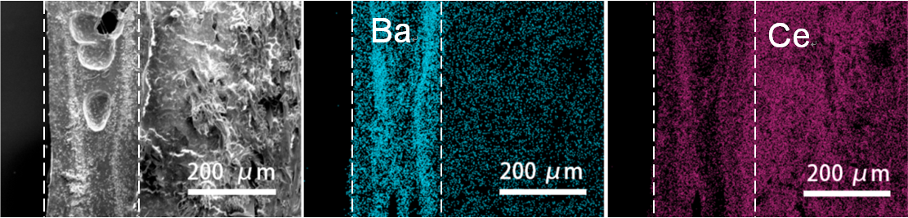

Fig. S7 SEM morphology and elemental mappings of BaCe-MFM.
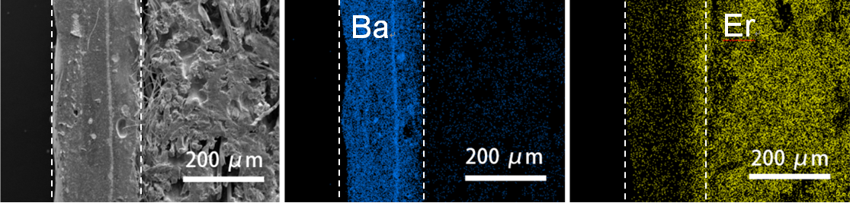

Fig. S8 SEM morphology and elemental mappings of BaEr-MFM.
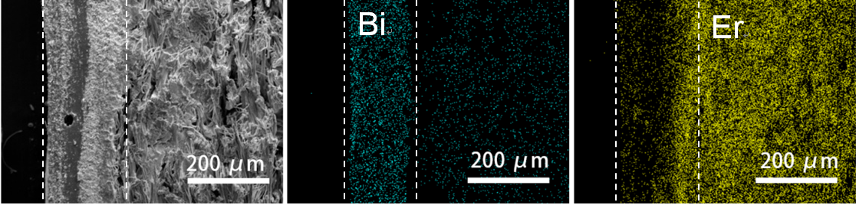

Fig. S9 SEM morphology and elemental mappings of BiEr-MFM.

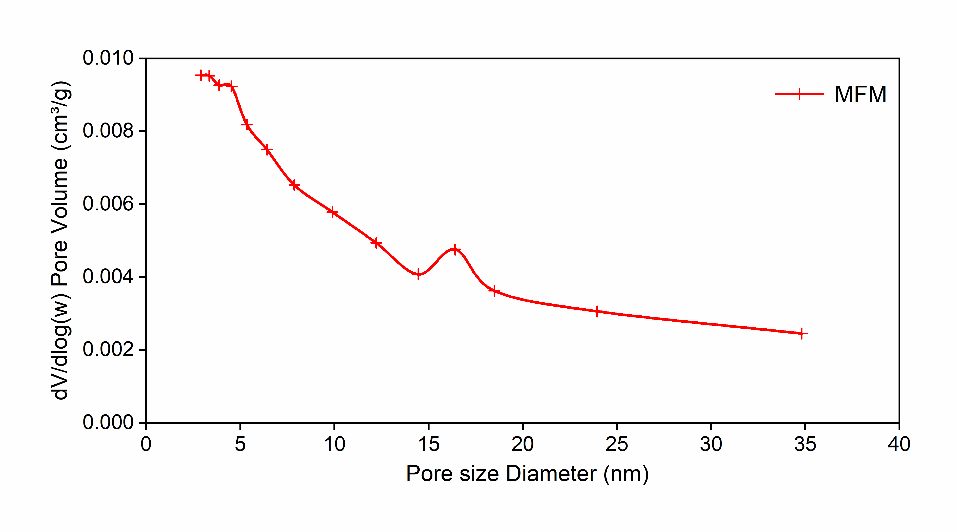
Fig.S10 Mesopore size distribution of MFM.
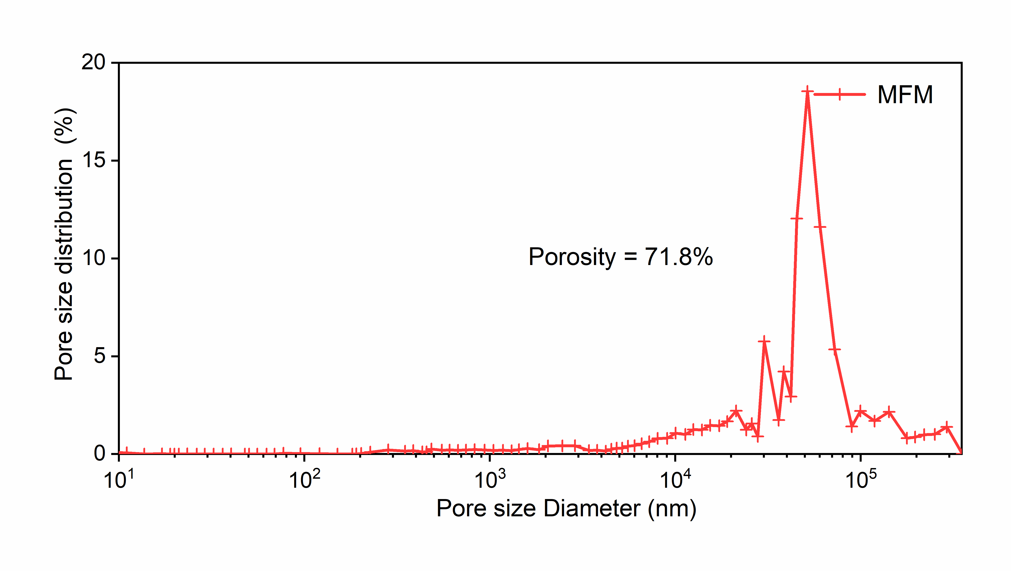
Fig.S11 Macropore size distribution of MFM.

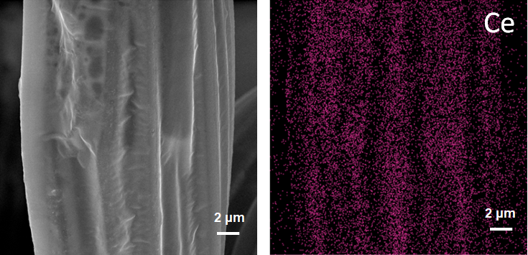
Fig. S12 SEM morphology and elemental mapping of the microfiber of Ce-MFM.

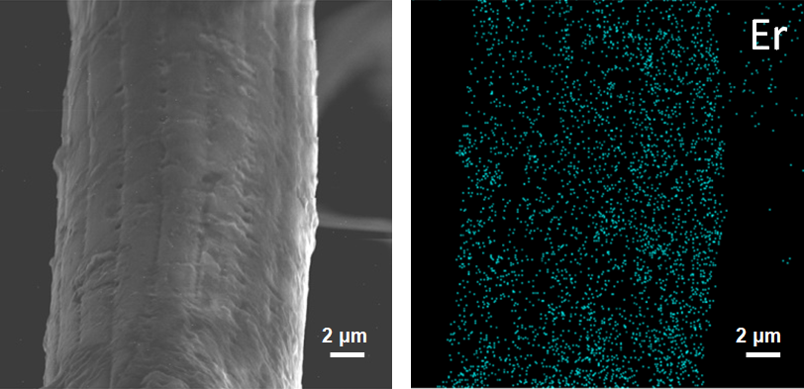
Fig. S13 SEM morphology and elemental mapping of the microfiber of Er-MFM.
Fig. S14 SEM image of PETM.
Fig. S15 SEM morphology and elemental mapping of the microfiber of RE-MFM.
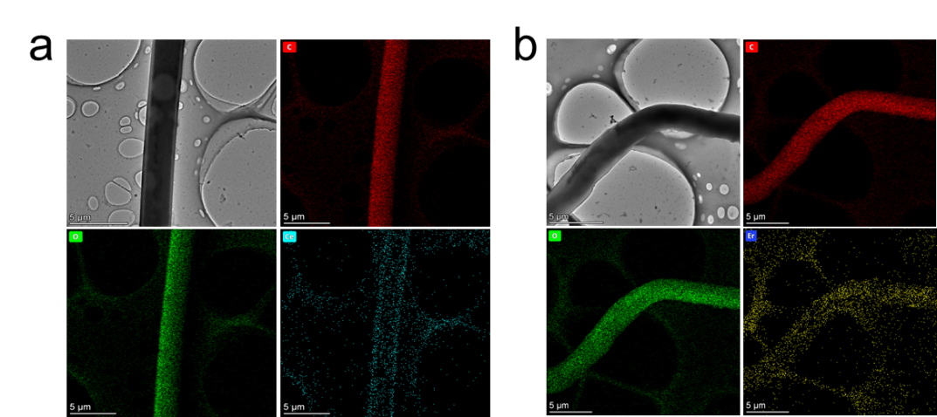
Fig. S16 Elemental mapping of singe fiber of (a) Ce-MFM and (b) Er-MFM.
Fig. S17 SEM morphology and elemental mapping of the microfiber of Ce-PETM.

Fig. S18 X-ray attenuation efficiency of Ba_{0.79}Er_{x}-MFM with different Er loadings.

Fig. S19 X-ray attenuation efficiency of Bi_{0.81}Er_{x}-MFM with different Er loadings.

Fig. S20 X-ray attenuation efficiency of Ba_{0.79}Er_{3.65}-MFM with different thicknesses.

Fig. S21 X-ray attenuation efficiency of Bi_{0.81}Er_{3.65}-MFM with different thicknesses.

Fig. S22 The fitted curves of linear attenuation coefficients for Ba_{0.79}Er_{3.65}-MFM at different energies.

Fig. S23 The fitted curves of linear attenuation coefficients for Bi_{0.81}Er_{3.65}-MFM at different energies.

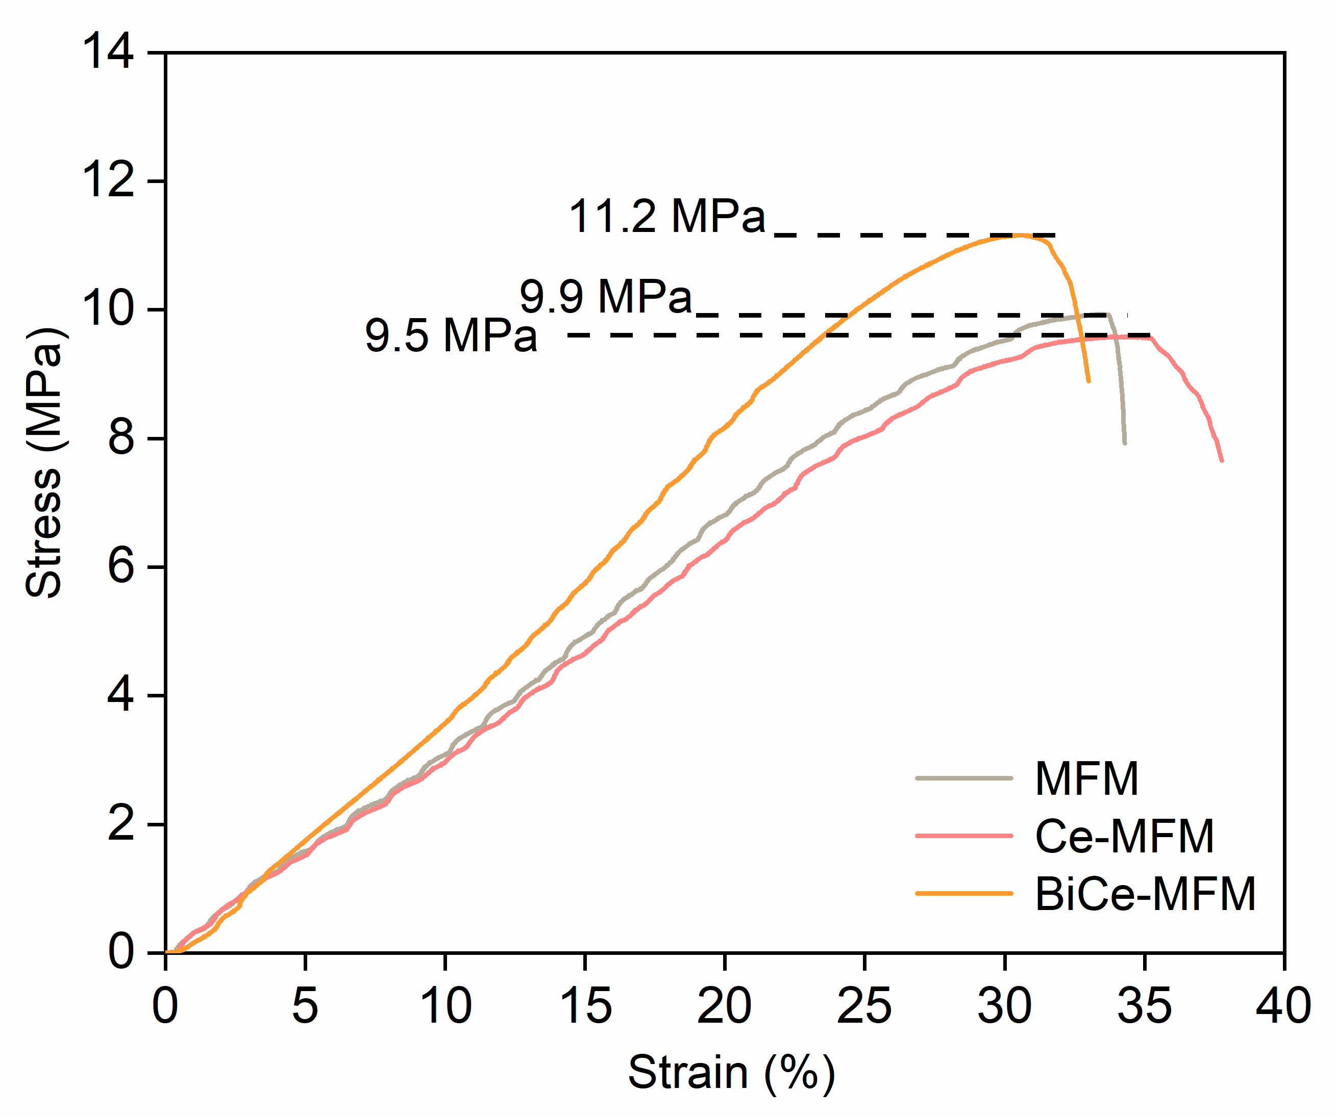
Fig. S24 The stress-strain curves of MFM, Ce-MFM and BiCe-MFM.
Fig. S25 The load–extension curves of MFM, Ce-MFM and BiCe-MFM.

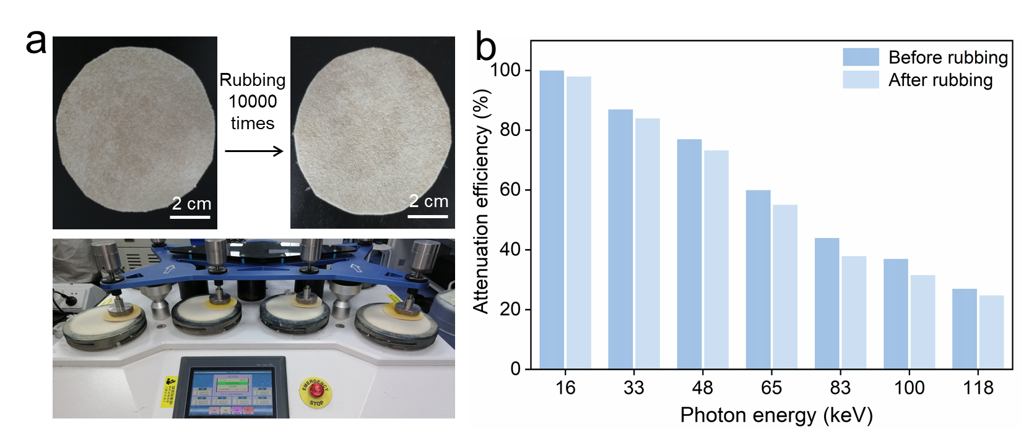
Fig. S26 (a) The rubbing process and (b) attenuation efficiency of Bi_{0.84}Ce_{3.67}-MFM after rubbing 10,000 times.

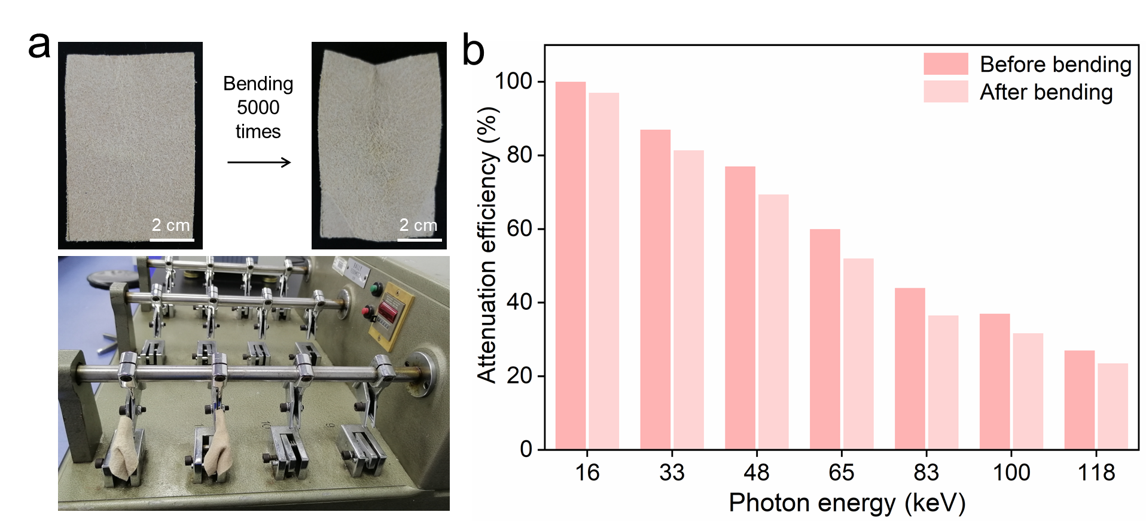

Fig. S27 (a) The bending process and (b) attenuation efficiency of Bi_{0.84}Ce_{3.67}-MFM after bending 5,000 times.

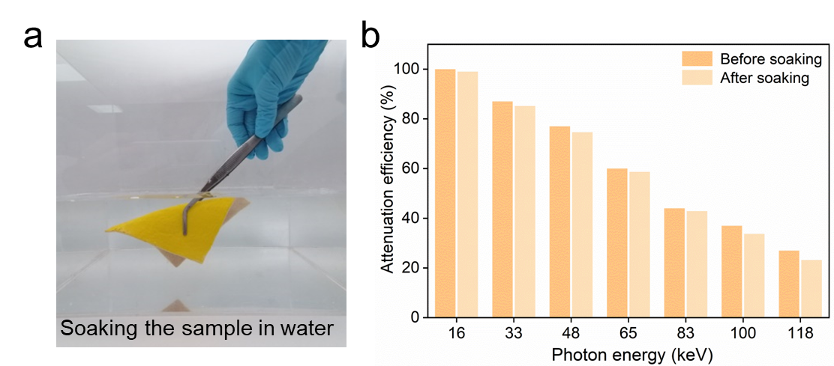
Fig. S28 (a) The soaking process and (b) attenuation efficiency of Bi_{0.84}Ce_{3.67}-MFM after soaking.

Section 3: Supplementary Tables
Table S1 The high-Z element coating amounts, RE element loading amounts and loading efficiencies of the as-prepared samples.
Sample notation | Coating amount of high-Z element (mmol cm^{–3}) |  | Coating efficiency | Loading amount of RE element (mmol cm^{–3}) | Loading efficiency
RE_{x}-MFM:
Ce_{3.67}-MFM | — |  | — | 3.672 | 91.8%
Er_{3.65}-MFM | — |  | — | 3.648 | 91.2%
Z_{y}RE_{x}-MFM:
Ba_{0.84}Ce_{0.91}-MFM | 0.841 |  | 84.1% | 0.913 | 91.3%
Ba_{0.84}Ce_{1.81}-MFM | 0.841 |  | 84.1% | 1.812 | 90.6%
Ba_{0.84}Ce_{2.70}-MFM | 0.841 |  | 84.1% | 2.697 | 89.9%
Ba_{0.84}Ce_{3.67}-MFM | 0.841 |  | 84.1% | 3.672 | 91.8%
Bi_{0.84}Ce_{0.91}-MFM | 0.838 |  | 83.8% | 0.913 | 91.3%
Bi_{0.84}Ce_{1.81}-MFM | 0.838 |  | 83.8% | 1.812 | 90.6%
Bi_{0.84}Ce_{2.70}-MFM | 0.838 |  | 83.8% | 2.697 | 89.9%
Bi_{0.84}Ce_{3.67}-MFM | 0.838 |  | 83.8% | 3.672 | 91.8%
Ba_{0.79}Er_{0.93}-MFM | 0.785 |  | 78.5% | 0.934 | 93.4%
Ba_{0.79}Er_{1.83}-MFM | 0.785 |  | 78.5% | 1.834 | 91.7%
Ba_{0.79}Er_{2.72}-MFM | 0.785 |  | 78.5% | 2.724 | 90.8%
Ba_{0.79}Er_{3.65}-MFM | 0.785 |  | 78.5% | 3.648 | 91.2%
Bi_{0.81}Er_{0.93}-MFM | 0.809 |  | 80.9% | 0.934 | 93.4%
Bi_{0.81}Er_{1.83}-MFM | 0.809 |  | 80.9% | 1.834 | 91.7%
Bi_{0.81}Er_{2.72}-MFM | 0.809 |  | 80.9% | 2.724 | 90.8%
Bi_{0.81}Er_{3.65}-MFM | 0.809 |  | 80.9% | 3.648 | 91.2%
Ba_{0.84}Ce_{3.67}-MFM₀ |  | 0.841 | 84.1% | 3.672 | 91.8%
Ba_{0.84}Ce_{3.67}-PETM |  | 0.841 | 84.1% | 3.672 | 91.8%
Bi_{0.84}Ce_{3.67}-MFM₀ |  | 0.838 | 83.8% | 3.672 | 91.8%
Bi_{0.84}Ce_{3.67}-PETM |  | 0.838 | 83.8% | 3.672 | 91.8%
Ba_{0.79}Er_{3.65}-PETM |  | 0.785 | 78.5% | 3.648 | 91.2%
Bi_{0.81}Er_{3.65}-PETM |  | 0.809 | 80.9% | 3.648 | 91.2%

Section 4: Supplementary References
[1] Yu SB, Watson AD. Metal-based X-ray contrast media. Chem Rev. 1999; 99(9): 2353–2378. https://doi.org/10.1021/cr980441p.
[2] McCaffrey JP, Shen H, Downton B, Mainegra-Hing E. Radiation attenuation by lead and nonlead materials used in radiation shielding garments: Radiation attenuation by radiation shielding garments. Med Phys. 2007; 34(2): 530–537. https://doi.org/10.1118/1.2426404.
[3] General administration of quality supervision, inspection and quarantine of the people’s republic of China, X and Gamma radiation dose equivalent (rate) meters and monitors used in radiation protection, 2003.

