Supporting information
Combination tanning mechanism inspired environmentally benign catalyst for efficient degradation of tetracycline
Meng Xiao ª, Shuangmei Liu ª, Wenqian Qi ª, Yu Peng ^{b}, Qingyu Yan ^{c}, Hui Mao^{*a}
ª College of Chemical Engineering, Sichuan University, Chengdu 610065, PR China.
^{b} College of Chemistry and Materials Science, Sichuan Normal University, Chengdu 610066, PR China.
^{c} School of Materials Science and Engineering, Nanyang Technological University, Singapore, 639798, Singapore.
* To whom correspondence should be addressed.
E-mail: rejoice222@163.com (Hui Mao)
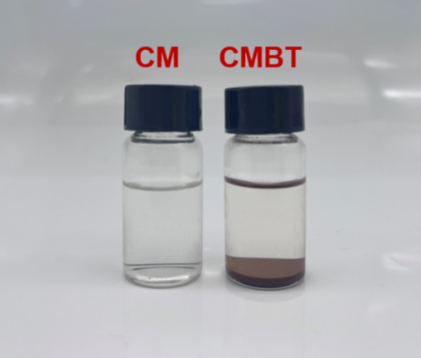
Fig. S1. Photographs of CM and CMBT after immersion in 0.2 mol/L HCl for 24 h.
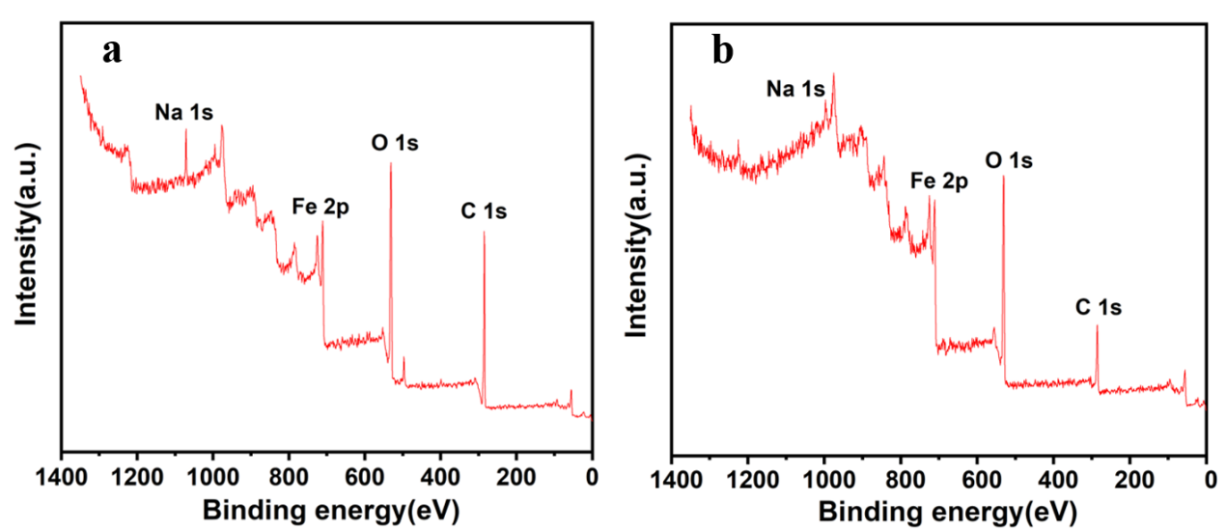
Fig. S2. XPS survey scan spectra of CMBT-Fe⁰ before (a) and after (b) the degradation of TC.
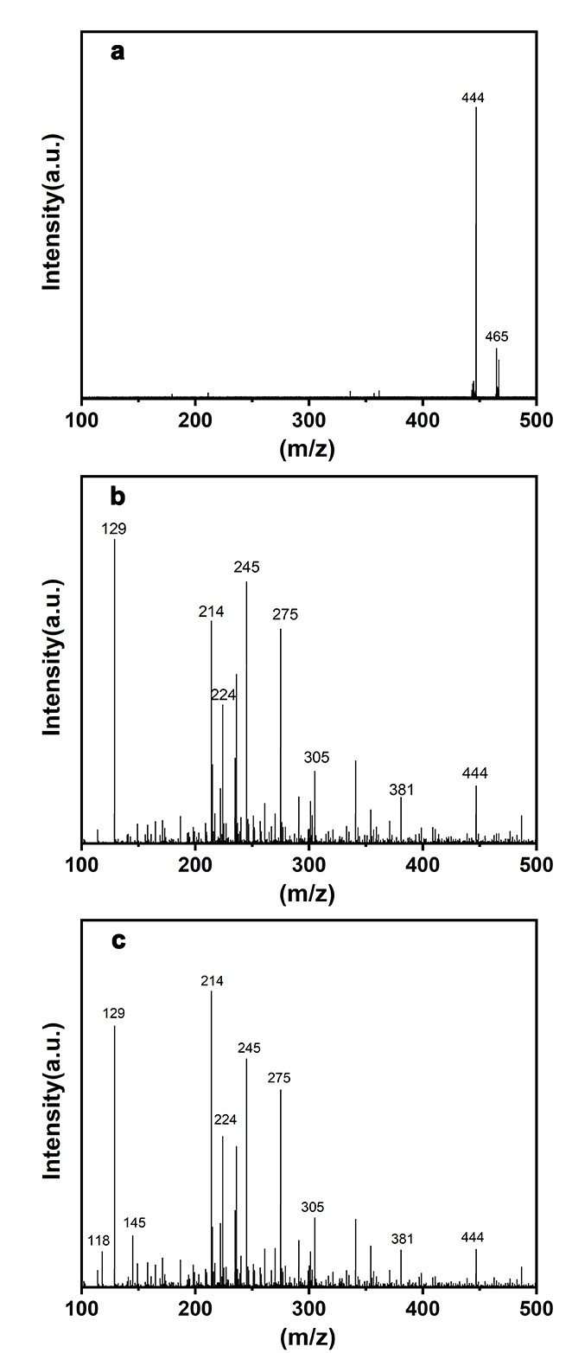
Fig. S3. Mass spectrum of TC (a), mass spectra of TC degraded by CMBT-Fe⁰ for 30 min (b) and 90 min (c), respectively.

