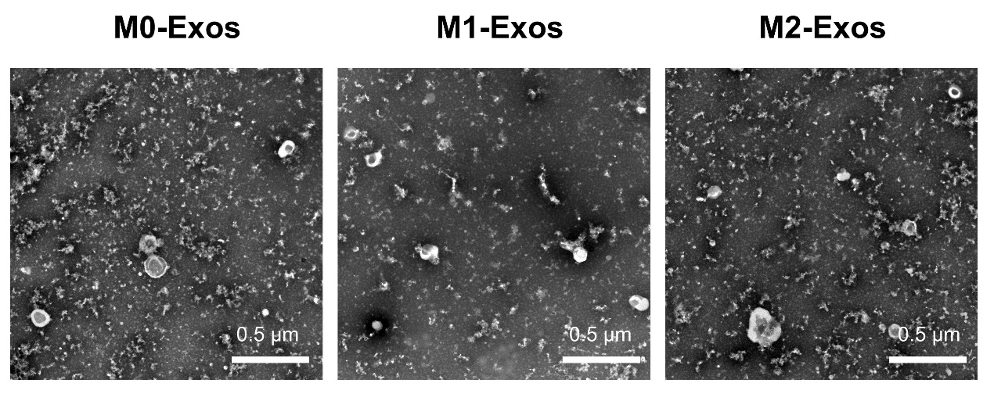
Fig. S1 TEM of MΦ Exos images with low magnification and large field

Fig. S2 CCK-8 results of HUVECs treated with PBS, M0-Exos, M1-Exos, or M2-Exos on day 3 and 7 (n = 6)

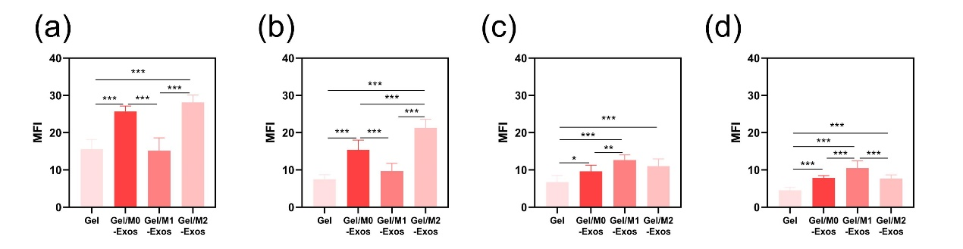
Fig. S3 The MFI of (a,c) CD31 and (b,d) α-SMA on (a,b) day 7 and (c,d) day 14

