Supplementary Information
Effect of transglutaminase cross-linking on the in vivo digestion and absorption characteristics of collagen gel
Yapeng Lu ª, Yugang Liu ª, Haotian Zhang ª, Yunke Yang ª, Liang Ma ^{a, c}, Hongjie Dai ª, Xin Feng ª, Yuhao Zhang ^{a, b}
ª College of Food Science, Southwest University, Chongqing, 400715, China
^{b} Chongqing Academy of Agricultural Sciences, Chongqing, 401329, China
^{c} Chongqing Key Laboratory of Speciality Food Co-Built by Sichuan and Chongqing, Chongqing 400715, China
*Corresponding author: Yuhao Zhang
Present/permanent address: Southwest University, No.2 Tiansheng Road, Beibei District, Chongqing City, China
E-mail address: zhy1203@163.com

Scheme 1 Total ion chromatogram of peptide profile analysis. (a) Stomach; (b) Small intestine; (c) Cecum; (d) Serum.

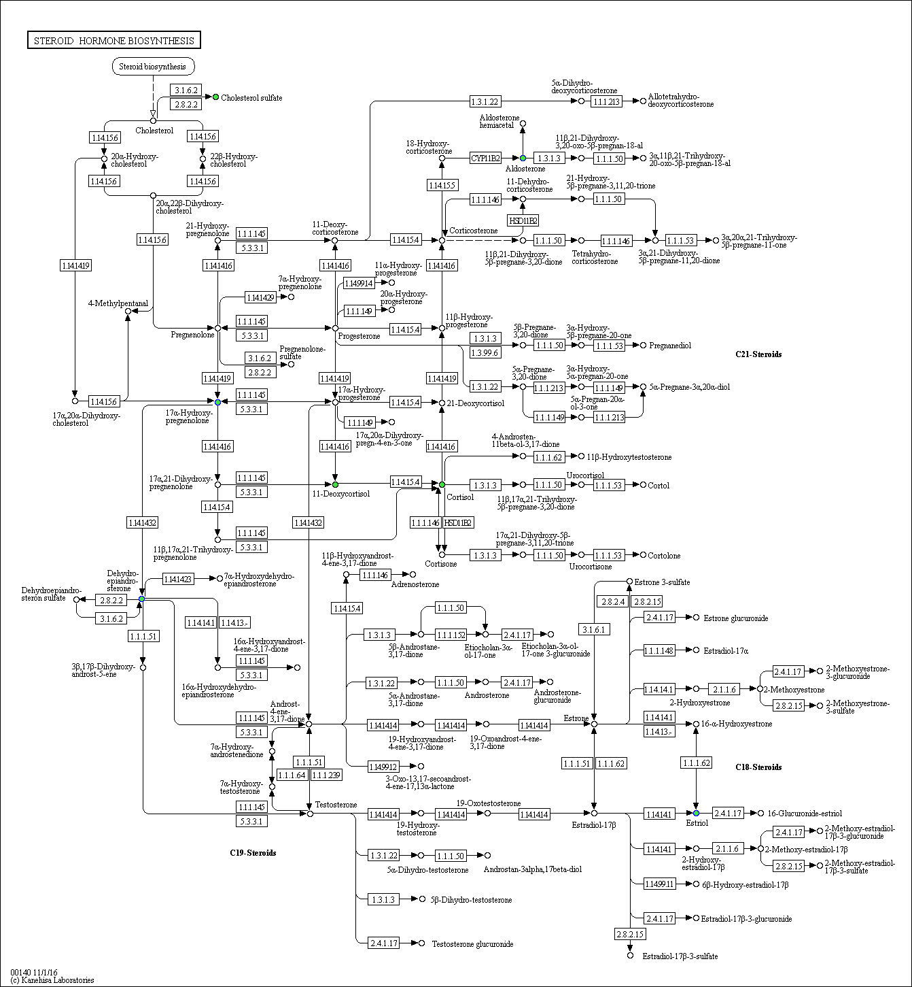
(a) Con vs CGL neg Steroid hormone biosynthesis

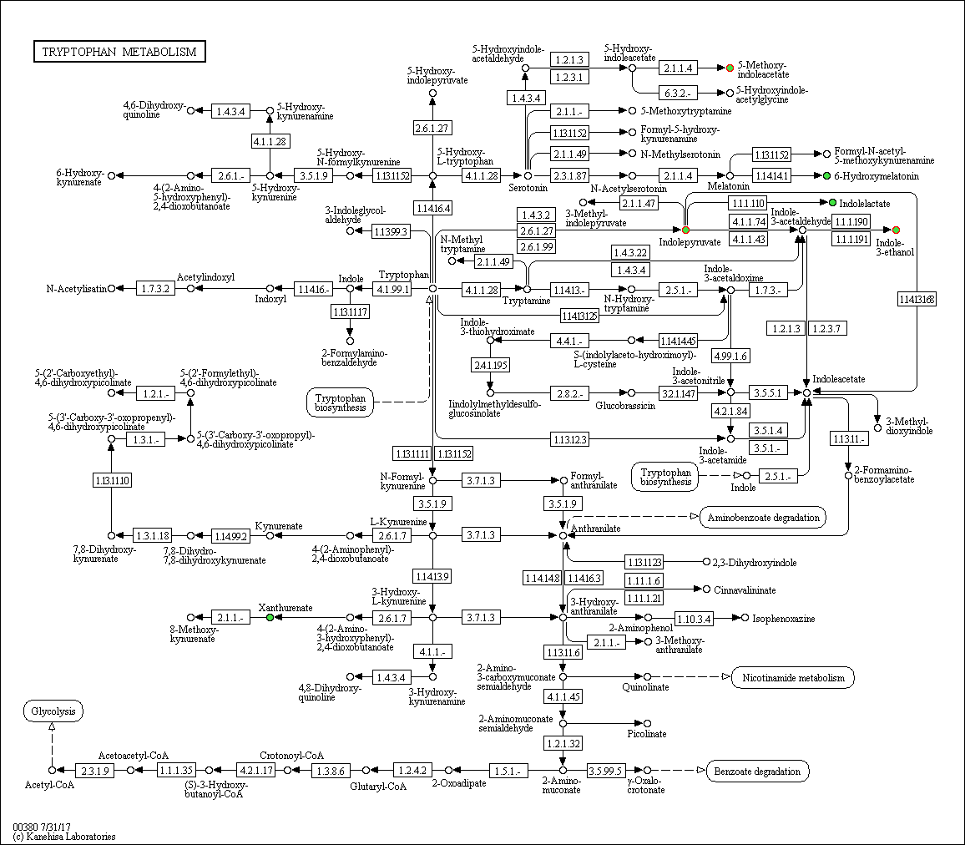
(b) Con vs CGL neg Tryptophan metabolism biosynthesis

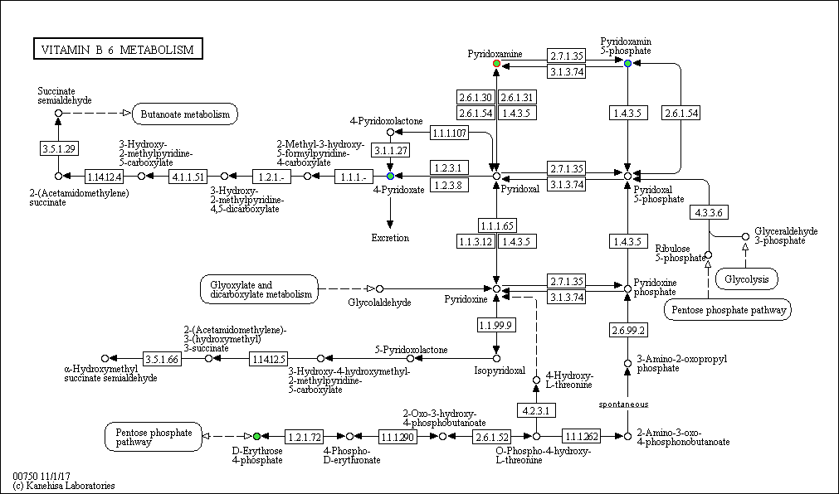
(c) Con vs CGL pos Vitamin B6 metabolism

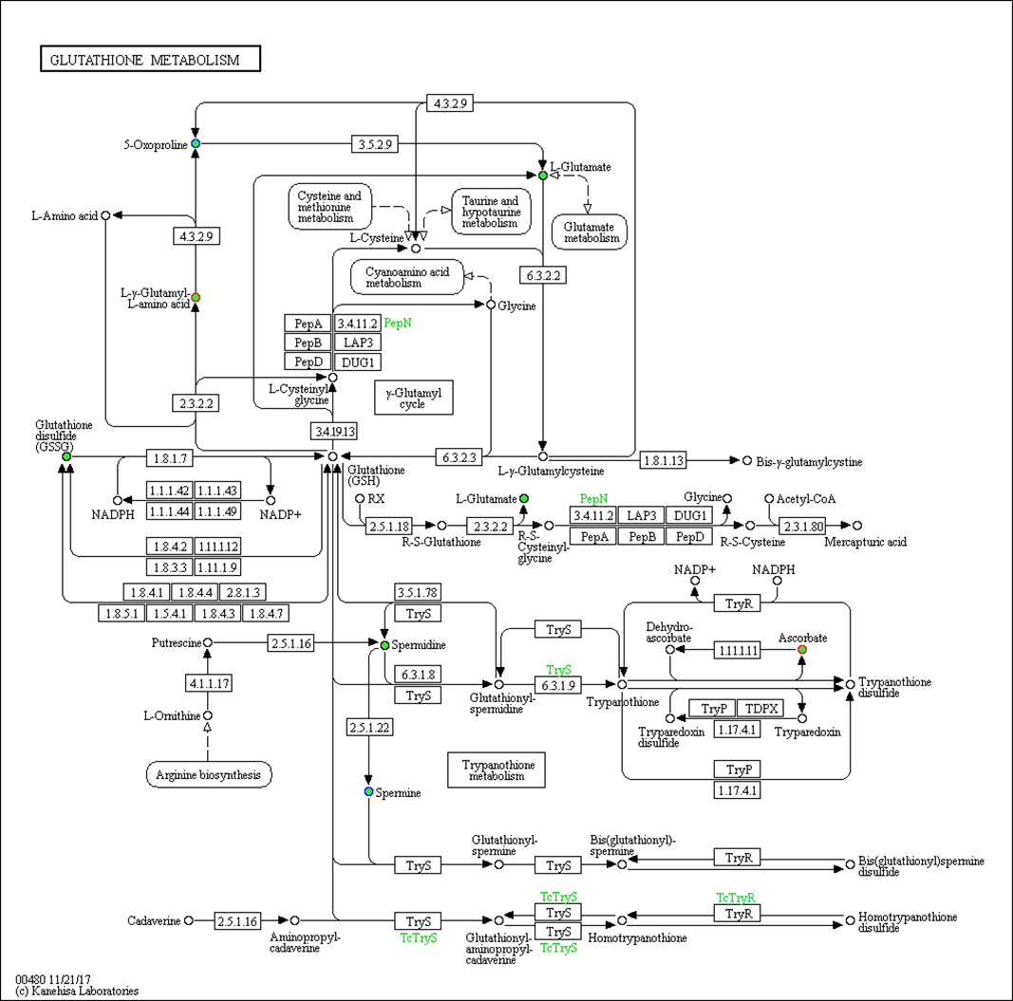
(d) CST vs CGL pos Glutathione metabolism

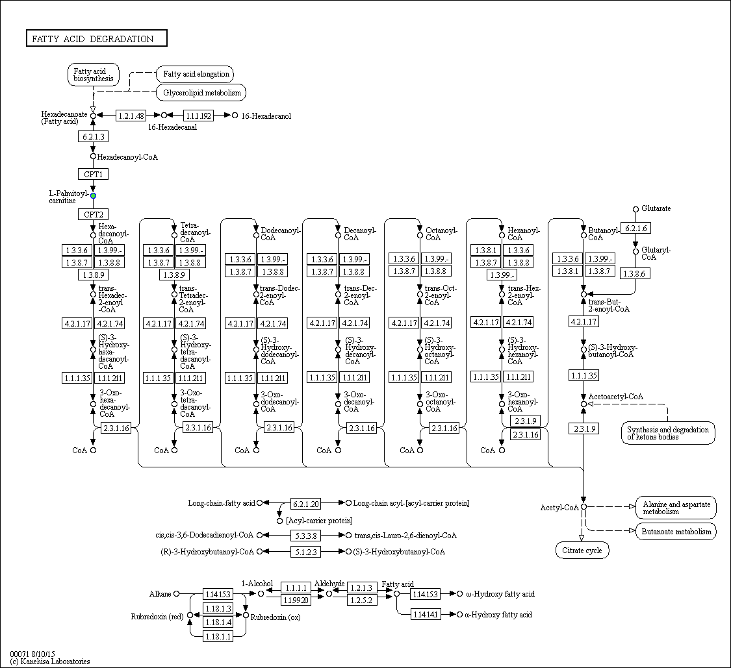
(e) CSL vs CGL pos Fatty acid degradation

Scheme 2 Differential metabolic pathway map. In the KEGG pathway map, circles represent metabolites, where green solid circles mark annotated metabolites, red circles mark upregulated differential metabolites, and blue circles mark downregulated differential metabolites.

