Redox-responsive Tumor Targeted Dual-drug Loaded Biocompatible Metal-organic Frameworks Nanoparticles for Enhancing Anticancer Effects
Chang Liu^{1,}, Xiaoyu Xu^{1,}, Junnian Zhou^{1,2,}, Jiaqi Yan^{1,3}, Dongqing Wang⁴, Hongbo Zhang^{1,4,}*
*Correspondence: hongbo.zhang@abo.fi
¹Pharmaceutical Sciences Laboratory and Turku Bioscience Center, Åbo Akademi University, FI-20520 Turku, Finland
²Experimental Hematology and Biochemistry Lab, Beijing Institute of Radiation Medicine, Beijing 100850, China. zhoujunnian@alu.fudan.edu.cn
³Guangdong Pharmaceutical University, Guangzhou 510006, China. 18624095792@163.com
⁴Department of Radiology, Affiliated Hospital of Jiangsu University, Jiangsu University, 212001 Zhenjiang, P.R. China. wangdongqing71@163.com

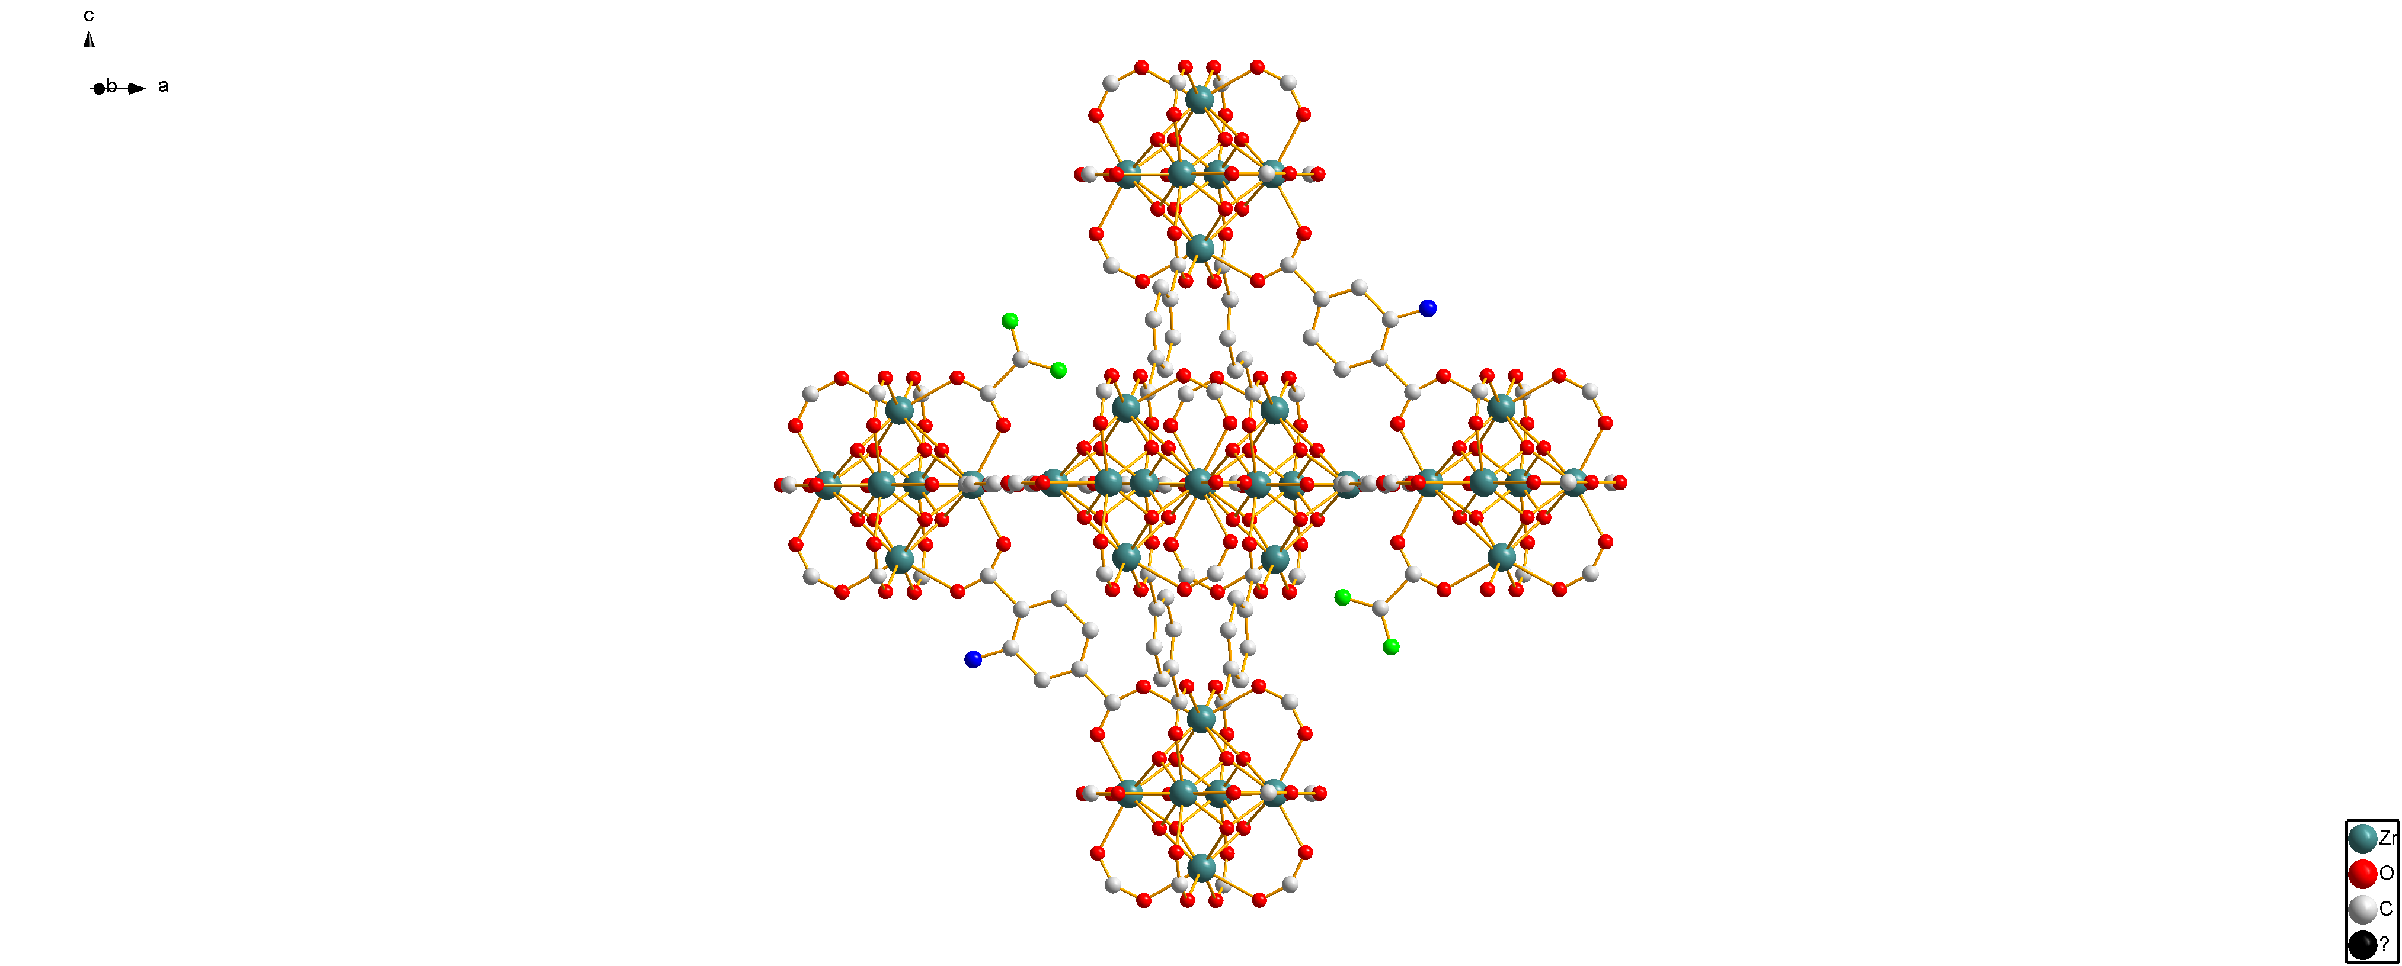
Fig. S1 Schematic of DCA-UiO-66-NH₂ with DCA capping Zr₆ clusters to form defects.
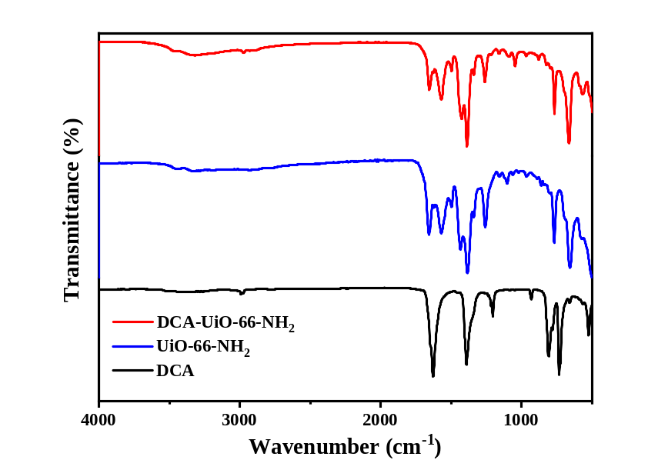
Fig. S2 Comparison of FTIR spectra of DCA-loaded UiO-66-NH₂ with the empty UiO-66-NH₂ and DCA
Fig. S3 The post-synthetic modification of DCA-UiO-66-NH₂ with 3,3’-dithiodipropionic anhydrides.
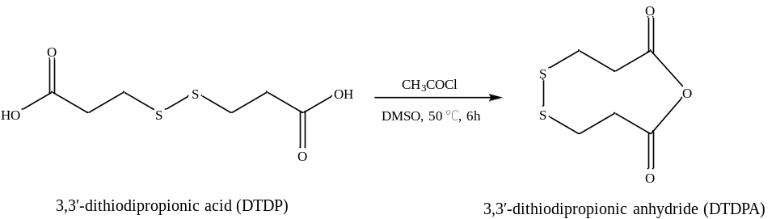
Fig. S4 The synthesis procedure of DTDPA from DTDP.
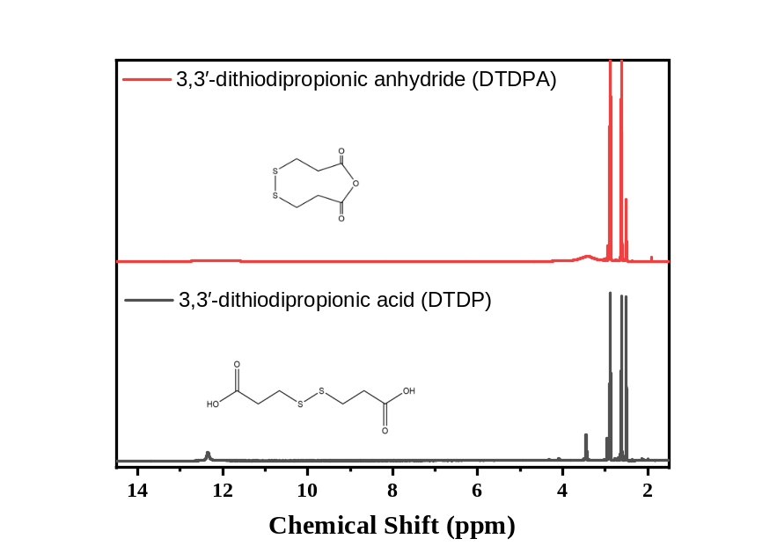
Fig. S5 ¹H NMR spectra of DTDP and DTDPA in DMSO-d₆.
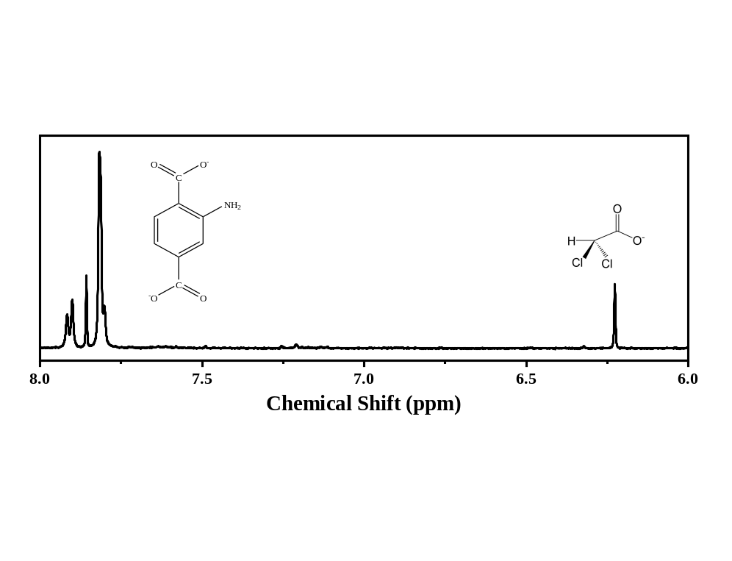
Fig. S6 ¹H NMR spectra of DCA-UiO-66-NH₂ in D₂SO₄/DMSO-d₆. The amount of DCA was quantified using the external standard method of ¹H NMR, the standard curve of DCA is y=0.234x-0.09447, R²=0.99869.
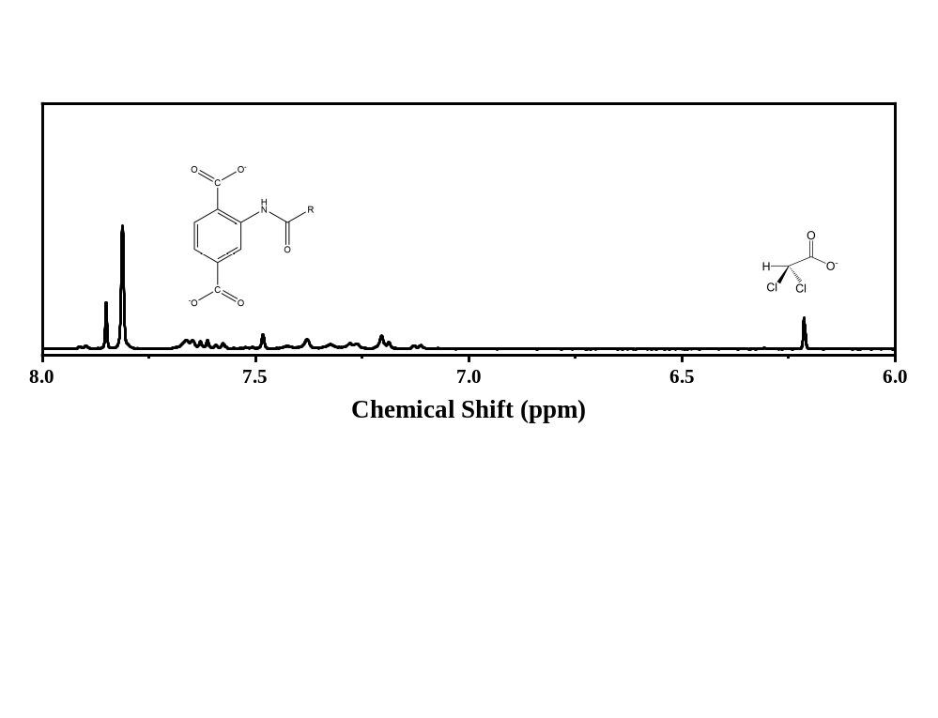
Fig. S7 ¹H NMR spectra of DCA-UiO-66-DTDP in D₂SO₄/DMSO-d₆.
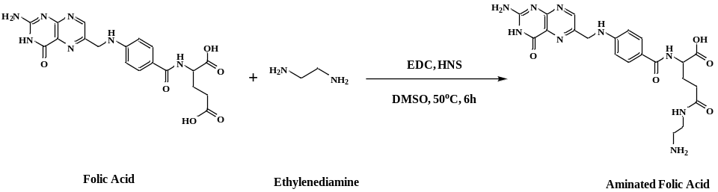
Fig. S8 The synthesis of aminated folic acid
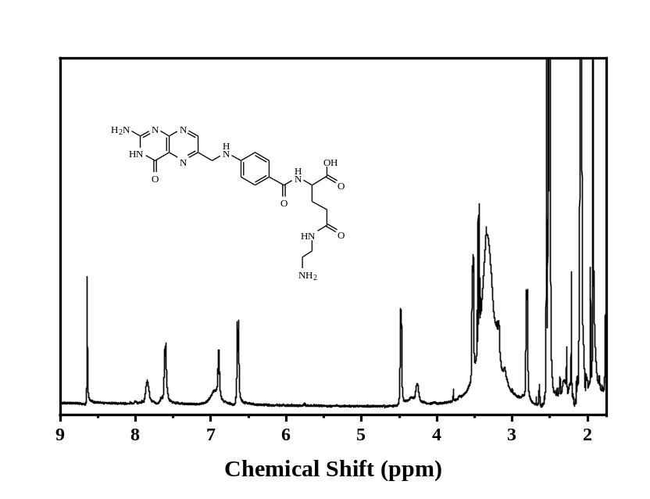
Fig. S9 ¹H NMR spectra of aminated folic acid in DMSO-d₆.
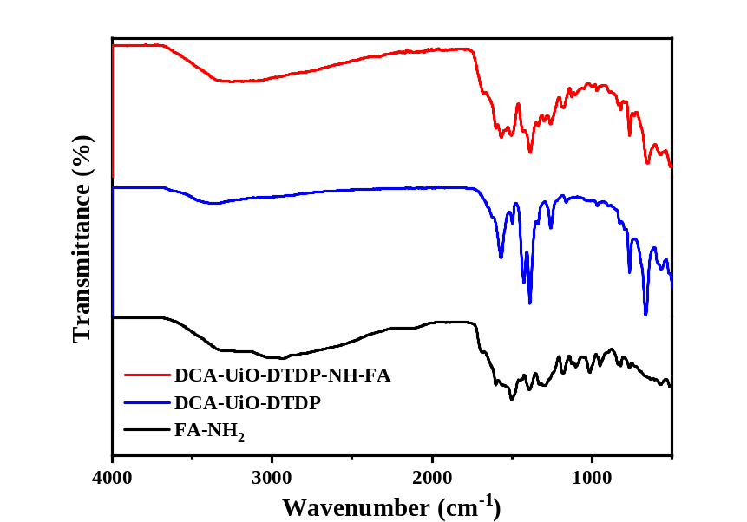
Fig. S10 Comparison of the FTIR spectra of the DCA-UiO-66-DTDP-FA and DCA-UiO-66-DTDP and FA-NH₂.
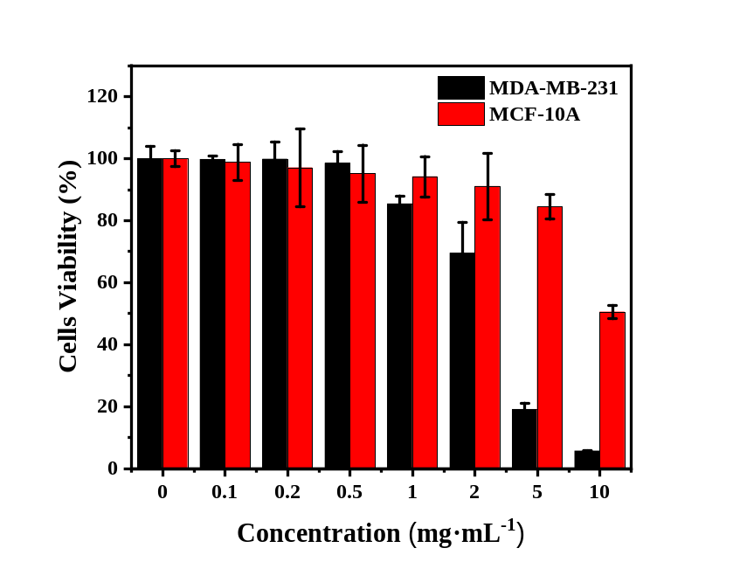
Fig. S11 Cells viability, as measured by WST-1 proliferation assay, of MDA-MB-231 and MCF-10A cells when incubated with different concentrations of NaDCA for 72 h.
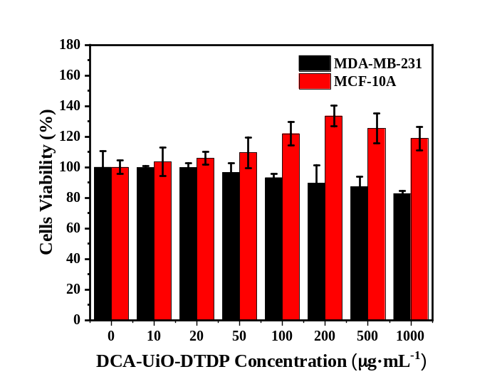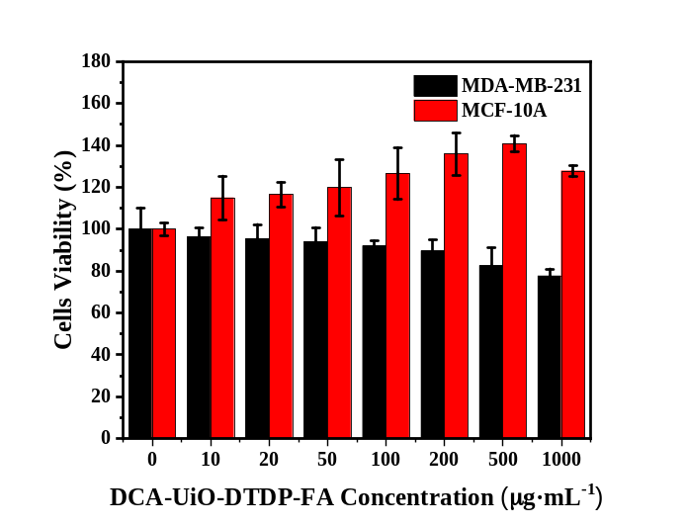
Fig. S12 Cells Viabilities, as measured by WST-1 proliferation assay, of MDA-MB-231 cancer cell and MCF-10A cells cultured with different concentrations of (a) DCA-UiO-DTDP and (b) DCA-UiO-DTDP-FA nanoparticles for 72 hours.
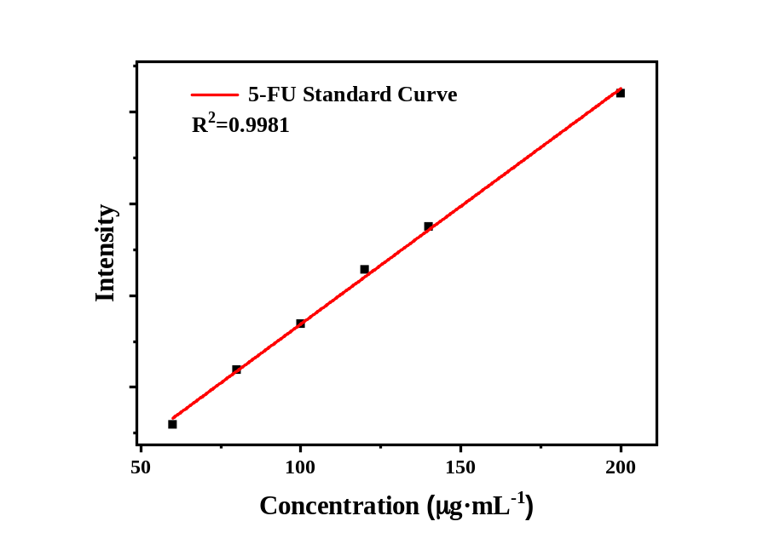
Fig. S13 The standard curve of 5-FU in MeOH (y=25.63677x+125.18739, R²=0.9981).
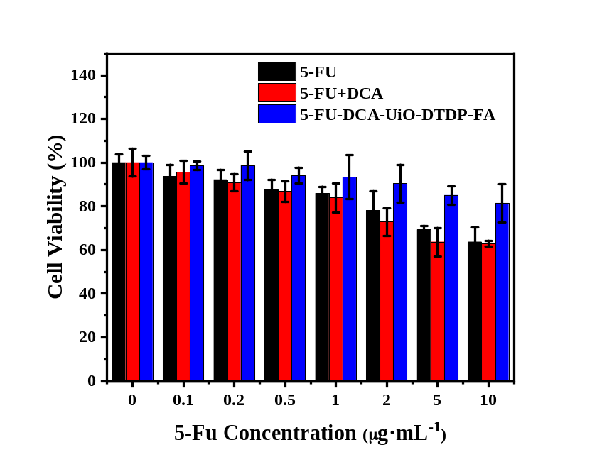
Fig. S14 The viabilities of MCF-10A normal cells cultured with 5-FU, 5-FU+DCA, and 5-FU-DCA-UiO-DTDP-FA.
Table S1 Determination of the 5-Fluorouracil loading efficiency.
Impregnation parameters |  | 5-FU/DCA-UiO/DTDP %
5-FU/material weight ratio | 2:1 | 15.5
5-FU/material weight ratio | 3:1 | 31.6
5-FU/material weight ratio | 4:1 | 20.3

