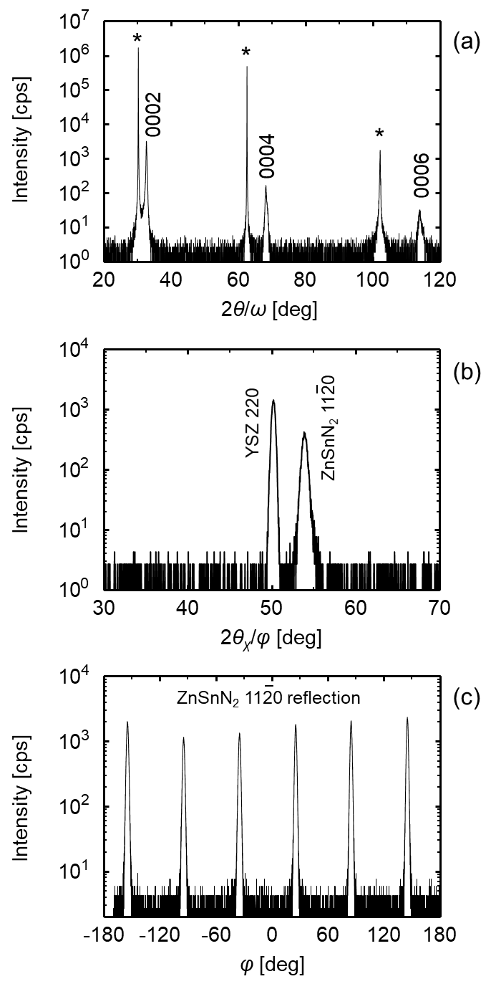
Figure S1 Typical XRD patterns scanned in (a) 2θ/ω (out-of-plane) and (b)2θ_{χ}/φ (in-plane) modes for ZnSnN_{2-x}O_{x} epitaxial film (x = 0.071). The bottom panel (c) represents a wide range 1120 rocking curve (φ scan). The peaks labeled with asterisk in part (a) are hhh reflections (h = 1, 2, 3) from the YSZ substrate. The diffraction pattern in part (a) indicates the out-of-plane epitaxial relationship of ZnSnN₂(0001) // YSZ(111), and the in-plane relationship of ZnSnN₂(1120) // YSZ(110) can be seen from the pattern in part (b). The six evenly spaced 1120 peaks in the φ-scan pattern (part (c)) illustrates the 6-fold rotational symmetry of the basal plane in the wurtzite ZnSnN₂.

