Supplementary materials
Table S1 Average concentrations of the VOC species identified in different manufacturing sectors
VOC species | Chemical sectors |  |  |  | Plastic sector | Metal sectors |  |  |  |  | Leather sector | Printing sectors
VOC species | Organic solvent | Synthetic resin | Acrylic resin | Polyester resin | Plastic tape | Integrated iron and steel | Aluminum foundry | Steel foundry | Metal product and machinery | Non-ferrous metal | PU leather | Plastic coating | Stencil printing
Propene |  |  |  |  | 0.0036 | 0.011 |  |  | 0.0012 | 0.0073
Isobutane | 0.0040 |  |  |  |  |  | 0.0044 | 0.013
1-Butene |  |  |  |  |  |  |  |  | 2.2
n-Butane |  | 0.0028 |  |  |  |  |  | 0.023 | 0.34
Cis-2-Butene |  |  |  |  |  |  |  |  | 1.0
Isopentane | 0.012 | 0.0080 | 0.010 |  |  | 0.0059 | 0.0065 | 0.0068 |  |  | 0.010
1-Pentene |  |  |  |  |  | 0.0056
Trans-2-Pentene |  |  |  |  |  |  |  |  | 0.078 | 0.0029
Isoprene |  |  |  |  |  | 0.0034 |  |  |  |  | 0.0033 | 0.010
2,2-Dimethylbutane | 0.0057 |  |  |  | 0.012
2,3-Dimethylbutane | 0.091 | 0.0095 |  |  | 0.13
2-Methylpentane | 0.012 | 0.0033 | 0.0055 |  |  | 0.0033 | 0.0031 | 0.0074 |  | 0.0036
3-Methylpentane | 0.47 | 0.043 |  |  | 0.77 |  |  | 0.010
1-Hexene |  |  |  |  | 1.0 | 0.0062
n-Hexane | 0.20 | 0.030 | 0.0066 |  |  |  | 0.0039 | 0.010 |  | 0.0046 |  |  | 0.025
2,4-Dimethylpentane |  | 0.0027 | 0.0036 |  |  |  |  | 0.0045 |  | 0.0027
Methylcyclopentane | 0.028 | 0.021 | 0.0041 |  | 0.50 | 0.0011 |  | 0.0062 |  |  | 0.0059
Benzene | 0.0056 | 0.0045 | 0.016 |  | 0.17 | 1.5 | 0.0054 | 0.013 |  | 0.0065 | 0.0075 | 0.011 | 0.037
2-Methylhexane |  |  |  |  |  |  | 0.0068 | 0.0086 |  |  | 0.011 | 0.014
Cyclohexane | 0.0037 |  |  |  | 0.018 |  |  | 0.0045 |  |  | 0.0047
2,3-Dimethylpentane |  |  |  |  |  |  |  | 0.0041 |  |  | 0.0042
3-Methylhexane | 0.0025 | 0.0038 | 0.0054 |  |  |  | 0.0010 |  |  | 0.0026 |  | 0.011
n-Heptane | 0.0029 | 0.0058 | 0.0057 |  | 0.0044 | 0.0020 | 0.0047 | 0.0034 |  | 0.0052 |  | 0.013
Methylcyclohexane |  | 0.32 |  |  | 0.032 | 0.0030 |  |  |  |  | 0.0048 |  | 0.030
2,3,4-Trimethylpentane |  |  |  |  |  |  | 0.044
2-Methylheptane |  |  |  |  |  |  | 0.0090
3-Methylheptane |  |  |  |  |  |  |  |  | 0.0027
Toluene | 2.1 | 0.16 | 0.36 | 0.19 | 14 | 1.4 | 0.40 | 0.032 |  | 0.083 | 4.7 | 3.6 | 33
n-Octane |  | 0.0019 |  |  |  | 0.0020 | 0.045 |  |  | 0.0020 | 0.0055
Ethylbenzene | 0.13 | 0.0057 | 2.9 | 0.0041 | 1.7 | 0.0067 | 0.011 | 0.0037 |  | 0.0043 | 0.016 |  | 0.091
m-Xylene | 0.43 | 0.0089 | 12 | 0.0048 | 3.2 | 0.0044 | 0.018 | 0.0035 |  | 0.0052 | 0.027 | 0.011 | 0.10
p-Xylene | 0.36 | 0.0088 | 8.2 | 0.0048 | 3.2 | 0.0043 | 0.015 | 0.0034 |  | 0.0051 | 0.027 | 0.011 | 0.10
n-Nonane |  | 0.0032 | 0.032 |  |  | 0.0030 | 0.073 |  |  | 0.0064 | 0.0025
Stryene |  | 0.0035 |  |  |  | 0.070 | 0.011 | 0.0057 |  | 0.0059 | 0.0059
o-Xylene | 0.30 | 0.0072 | 4.6 | 0.0065 | 1.5 | 0.0061 | 0.016 | 0.0045 |  | 0.0064 | 0.018 | 0.013 | 0.28
Isopropylbenzene | 0.15 | 0.0024 | 0.099 |  | 0.025 |  | 0.0091 |  |  |  |  |  | 0.71
n-Propylbenzene | 0.096 | 0.0036 |  |  | 0.020 |  | 0.0082 |  |  | 0.0061 |  |  | 2.4
m-Ethyltoluene | 0.45 | 0.0056 | 0.0026 | 0.0086 | 0.026 | 0.0077 | 0.011 |  |  | 0.0082 | 0.0080 |  | 9.4
p-Ethyltoluene | 0.52 | 0.0061 | 0.0026 | 0.010 | 0.028 |  | 0.010 | 0.0082 |  | 0.0091 | 0.0084 |  | 4.9
1,3,5-Trimethylbenzene | 0.28 | 0.0049 | 0.0038 |  |  |  | 0.0079 |  |  |  |  |  | 6.9
o-Ethyltoluene | 0.19 | 0.0068 | 0.0010 | 0.010 | 0.028 |  | 0.0093 | 0.0081 |  | 0.0090 | 0.013 |  | 4.2
n-Decane |  | 0.0046 |  |  |  | 0.018 | 0.035 |  |  | 0.012 | 0.0089 |  | 0.073
1,2,4-Trimethylbenzene | 0.50 | 0.0077 | 0.035 |  |  |  | 0.018 | 0.010 |  | 0.011 | 0.015 |  | 19
1,2,3-Trimethylbenzene | 0.23 | 0.0054 |  |  |  |  | 0.013 | 0.010 |  | 0.010 | 0.015 |  | 5.8
m-Diethylbenzene | 0.071 |  |  |  |  |  |  |  |  |  |  |  | 2.3
p-Diethylbenzene |  |  |  |  |  |  |  |  |  |  |  |  | 3.1
n-Undecane | 0.088 | 0.0079 |  |  |  | 0.028 | 0.013 |  |  | 0.015 | 0.015 |  | 0.14
n-Dodecane | 0.0038 |  |  |  |  | 0.0030 | 0.0041 |  |  | 0.0011
1,3-Butadiene |  |  |  |  |  | 0.071
Ethanol | 1.2 | 0.0075 |  |  |  | 0.029 | 0.039 | 0.014 | 1.6 |  | 0.029
Acrolein |  |  |  |  | 0.021 | 0.0049 |  |  | 0.30
Acetone | 5.4 | 1.1 | 0.026 |  | 0.036 | 0.023 | 0.028 | 0.029 |  | 0.083 | 0.053 | 1.4 | 0.23
Isopropyl Alcohol | 1.4 |  |  |  | 0.010 | 0.040
Methylene Chloride | 0.0055 | 0.0043 | 0.0016 |  | 0.00082 | 0.0013 | 0.00079 | 0.0014 |  |  | 0.0056 |  | 0.0029
Carbon Disulfide |  | 0.040 |  |  |  |  |  |  |  |  | 0.0037
Methyl Ethyl Ketone | 0.77 | 0.053 | 0.079 |  | 0.048 | 0.26 | 0.023 | 0.015 |  | 0.043 | 12 | 0.45 | 0.18
Ethyl Acetate | 19 | 0.027 | 0.032 | 0.94 | 5.1 | 0.071 | 0.098 | 0.0093 |  | 0.23 | 0.31 | 0.047 | 0.29
Chloroform |  | 0.0056
Tetrahydrofuran | 0.036
1,2-Dichloroethane |  | 0.0024
Trichloroethylene
1,2-Dichloropropane |  | 0.00083 |  |  | 0.0019 | 0.0013 |  |  |  | 0.0025
Methyl Methacrylate |  |  |  |  | 0.010 |  |  |  |  |  | 2.5
Methyl Isobutyl Ketone | 2.9 |  |  |  | 0.0086 |  | 0.0044
Tetrachloroethylene
Chlorobenzene
Bromoform
1,1,2,2-Tetrachloroethane |  |  | 0.0018
1,3-Dichlorobenzene |  |  | 0.067
1,4-Dichlorobenzene |  |  | 0.0071
1,2-Dichlorobenzene |  |  | 0.082
Naphthalene | 0.028 | 0.014 | 0.11 |  |  | 0.065 |  |  |  |  | 0.023 |  | 0.38
Total | 38 | 1.9 | 29 | 1.2 | 32 | 3.7 | 1.0 | 0.27 | 5.5 | 0.59 | 20 | 5.6 | 94
All concentrations are expressed as mg m⁻³.

Table S2 Emission factors of the VOC species identified in different manufacturing sectors
VOC species | Chemical sectors |  |  |  | Plastic sector | Metal sectors |  |  |  |  | Leather sector | Printing sectors
VOC species | Organic solvent | Synthetic resin | Acrylic resin | Polyester resin | Plastic tape | Aluminum foundry | Steel foundry | Metal product and machinery | Integrated iron and steel | Non-ferrous metal | PU leather | Plastic coating | Stencil printing
Propene |  |  |  |  | 2.8 |  |  | 2.2 | 0.18 | 0.13
Isobutane | 0.47 |  |  |  |  | 0.13 | 0.12
1-Butene |  |  |  |  |  |  |  | 4145
n-Butane |  | 0.059 |  |  |  |  | 0.23 | 645
Cis-2-Butene |  |  |  |  |  |  |  | 1878
Isopentane | 1.4 | 0.17 | 0.071 |  |  | 0.19 | 0.068 |  | 0.096 |  | 0.33
1-Pentene |  |  |  |  |  |  |  |  | 0.090
Trans-2-Pentene |  |  |  |  |  |  |  | 146 |  | 0.052
Isoprene |  |  |  |  |  |  |  |  | 0.054 |  | 0.11 | 0.027
2,2-Dimethylbutane | 0.67 |  |  |  | 9.1
2,3-Dimethylbutane | 10 | 0.20 |  |  | 104
2-Methylpentane | 1.4 | 0.070 | 0.039 |  |  | 0.091 | 0.073 |  | 0.053 | 0.066
3-Methylpentane | 55 | 0.91 |  |  | 608 |  | 0.10
1-Hexene |  |  |  |  | 782 |  |  |  | 0.10
n-Hexane | 23 | 0.64 | 0.047 |  |  | 0.11 | 0.098 |  |  | 0.083 |  |  | 113
2,4-Dimethylpentane |  | 0.057 | 0.025 |  |  |  | 0.044 |  |  | 0.049
Methylcyclopentane | 3.3 | 0.45 | 0.029 |  | 396 |  | 0.060 |  | 0.017 |  | 0.20
Benzene | 0.66 | 0.096 | 0.11 |  | 136 | 0.16 | 0.13 |  | 24 | 0.12 | 0.26 | 0.030 | 167
2-Methylhexane |  |  |  |  |  | 0.20 | 0.084 |  |  |  | 0.38 | 0.038
Cyclohexane | 0.43 |  |  |  | 14 |  | 0.044 |  |  |  | 0.16
2,3-Dimethylpentane |  |  |  |  |  |  | 0.040 |  |  |  | 0.14
3-Methylhexane | 0.30 | 0.080 | 0.038 |  |  | 0.028 |  |  |  | 0.047 |  | 0.031
n-Heptane | 0.34 | 0.12 | 0.041 |  | 3.5 | 0.14 | 0.034 |  | 0.032 | 0.093 |  | 0.037
Methylcyclohexane |  | 6.7 |  |  | 25 |  |  |  | 0.048 |  | 0.16 |  | 135
2,3,4-Trimethylpentane |  |  |  |  |  | 1.3
2-Methylheptane |  |  |  |  |  | 0.26
3-Methylheptane |  |  |  |  |  |  |  | 5.1
Toluene | 248 | 3.3 | 2.6 | 5.3 | 11050 | 12 | 0.31 |  | 22.9 | 1.5 | 161 | 9.9 | 149388
n-Octane |  | 0.041 |  |  |  | 1.3 |  |  | 0.032 | 0.036 | 0.19
Ethylbenzene | 15 | 0.12 | 20 | 0.11 | 1303 | 0.31 | 0.036 |  | 0.11 | 0.077 | 0.54 |  | 409
m-Xylene | 50 | 0.19 | 87 | 0.13 | 2516 | 0.52 | 0.034 |  | 0.071 | 0.094 | 0.93 | 0.032 | 469
p-Xylene | 42 | 0.19 | 58 | 0.13 | 2503 | 0.43 | 0.033 |  | 0.070 | 0.092 | 0.92 | 0.031 | 463
n-Nonane |  | 0.069 | 0.23 |  |  | 2.1 |  |  | 0.048 | 0.12 | 0.086
Styrene |  | 0.074 |  |  |  | 0.32 | 0.056 |  | 1.1 | 0.11 | 0.20
o-Xylene | 35 | 0.15 | 33 | 0.18 | 1168 | 0.47 | 0.044 |  | 0.10 | 0.11 | 0.60 | 0.036 | 1242
Isopropylbenzene | 17 | 0.052 | 0.70 |  | 19 | 0.27 |  |  |  |  |  |  | 3219
n-Propylbenzene | 11 | 0.077 |  |  | 16 | 0.24 |  |  |  | 0.11 |  |  | 10912
m-Ethyltoluene | 53 | 0.12 | 0.018 | 0.24 | 20 | 0.31 |  |  | 0.12 | 0.15 | 0.27 |  | 42390
p-Ethyltoluene | 61 | 0.13 | 0.018 | 0.27 | 22 | 0.29 | 0.080 |  |  | 0.16 | 0.29 |  | 22002
1,3,5-Trimethylbenzene | 33 | 0.11 | 0.027 |  |  | 0.23 |  |  |  |  |  |  | 31131
o-Ethyltoluene | 23 | 0.14 | 0.0073 | 0.27 | 22 | 0.27 | 0.080 |  |  | 0.16 | 0.43 |  | 19116
n-Decane |  | 0.10 |  |  |  | 1.1 |  |  | 0.30 | 0.23 | 0.30 |  | 328
1,2,4-Trimethylbenzene | 58 | 0.16 | 0.25 |  |  | 0.54 | 0.098 |  |  | 0.20 | 0.50 |  | 85003
1,2,3-Trimethylbenzene | 27 | 0.12 |  |  |  | 0.39 | 0.097 |  |  | 0.18 | 0.50 |  | 26372
m-Diethylbenzene | 8.4 |  |  |  |  |  |  |  |  |  |  |  | 10216
p-Diethylbenzene |  |  |  |  |  |  |  |  |  |  |  |  | 14141
n-Undecane | 10 | 0.17 |  |  |  | 0.38 |  |  | 0.45 | 0.27 | 0.50 |  | 627
n-Dodecane | 0.44 |  |  |  |  | 0.12 |  |  | 0.048 | 0.020
1,3-Butadiene |  |  |  |  |  |  |  |  | 1.1
Ethanol | 143 | 0.16 |  |  |  | 1.1 | 0.14 | 2944 | 0.46 |  | 0.99
Acrolein |  |  |  |  | 16 |  |  | 563 | 0.080
Acetone | 636 | 23 | 0.19 |  | 28 | 0.82 | 0.29 |  | 0.38 | 1.5 | 1.8 | 3.9 | 1026
Isopropyl Alcohol | 160 |  |  |  | 7.5 |  |  |  | 0.65
Methylene Chloride | 0.65 | 0.090 | 0.011 |  | 0.64 | 0.023 | 0.014 |  | 0.021 |  | 0.19 |  | 13
Carbon Disulfide |  | 0.86 |  |  |  |  |  |  |  |  | 0.13
Methyl Ethyl Ketone | 90 | 1.1 | 0.56 |  | 38 | 0.67 | 0.15 |  | 4.2 | 0.78 | 402 | 1.2 | 814
Ethyl Acetate | 2250 | 0.56 | 0.23 | 26 | 4040 | 2.8 | 0.091 |  | 1.1 | 4.1 | 11 | 0.13 | 1303
Chloroform |  | 0.12
Tetrahydrofuran | 4.2
1,2-Dichloroethane |  | 0.050
Trichloroethylene
1,2-Dichloropropane |  | 0.018 |  |  | 1.5 |  |  |  | 0.021 | 0.046
Methyl Methacrylate |  |  |  |  | 7.9 |  |  |  |  |  | 85
Methyl Isobutyl Ketone | 346 |  |  |  | 6.8 | 0.13
Tetrachloroethylene
Chlorobenzene
Bromoform
1,1,2,2-Tetrachloroethane |  |  | 0.013
1,3-Dichlorobenzene |  |  | 0.48
1,4-Dichlorobenzene |  |  | 0.051
1,2-Dichlorobenzene |  |  | 0.58
Naphthalene | 3.3 | 0.30 | 0.76 |  |  |  |  |  | 1.1 |  | 0.78 |  | 1723
All emission factors are expressed as mg-VOC g⁻¹.

Table S3 Carcinogenic inhalation risk factor of VOC species
VOCs | Risk factor  (µg m⁻³)⁻¹ | Source | Reference
Benzene* | 7.8 × 10⁻⁶ | IRIS | [1]
Chloroform | 2.3 × 10⁻⁵ | IRIS | [1]
Trichloroethylene | 4.1 × 10⁻⁶ | IRIS | [1]
Bromoform | 1.1 × 10⁻⁶ | IRIS | [1]
1,3-Butadiene | 3.0 × 10⁻⁵ | IRIS | [1]
IRIS; Integrated Risk Information System

Table S4 Comparison of ozone formation potential of VOC obtained in this study and with previous studies
Country/city | Industries | Emission sources | n | Top OFP VOC species for each source | References
Taichung city, Taiwan | Manufacturing industries | Metal product and machinery > Acrylic resin > Stencil printing > Plastic tape > Aluminum foundry > Plastic coating > Polyester resin > Non-ferrous metal > Steel foundry > Integrated iron and steel > Organic solvent > PU leather > Synthetic resin | 13 | 1-Butene > m-Xylene > 1,2,4-Trimethylbenzene > Toluene > Toluene > Toluene > Ethyl acetate > Ethyl acetate > Toluene > Toluene > Ethyl acetate > Toluene > Toluene | This study
Shanghai and Beijing, China | Typical industries | Vehicle > equipment > furniture > printing > electronics > bio-pharming | 6 | Benzenes >  Esters > Alcohols > Ketones > Alkenes > Chloroalkanes. | [2]
Northern China | Rubber footwear industry | Outlet of painting > outlet of vulcanizing > shaping workshop | 3 | Alkenes > Alkenes > Alkenes | [3]
China | Industries | Processes using VOC-containing products > Production of VOCs > Storage and transport > Industrial processes using VOCs as raw materials | 4 | Alkenes/Alkynes > Alkenes/ Alkynes > Aromatic > Aromatic | [4]
China | Printing | Other printing > Flexible packaging bonding > Offset printing > Gravure printing | 4 | - | [5]
China | Industrial coating industry | Automobile manufacturing > Industrial protective coating > Shipbuilding industry > Wood products industry | 4 | - | [5]
China | Paints and similar products industry | Paints and pigments industry > Ink industry | 2 | - | [5]
China | Pulp and paper industry | Paper products industry > Paper pulp industry |  | - | [5]

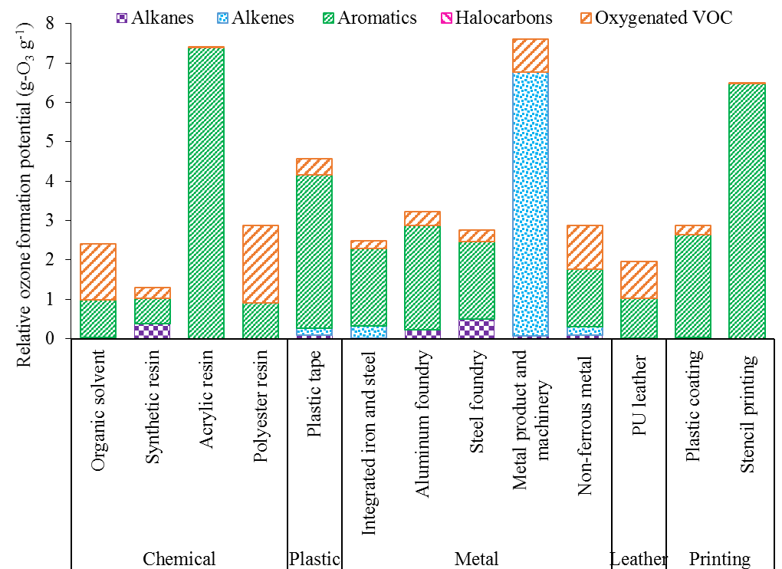
Fig. S1 Relative ozone formation potential of VOCs for different emission sources

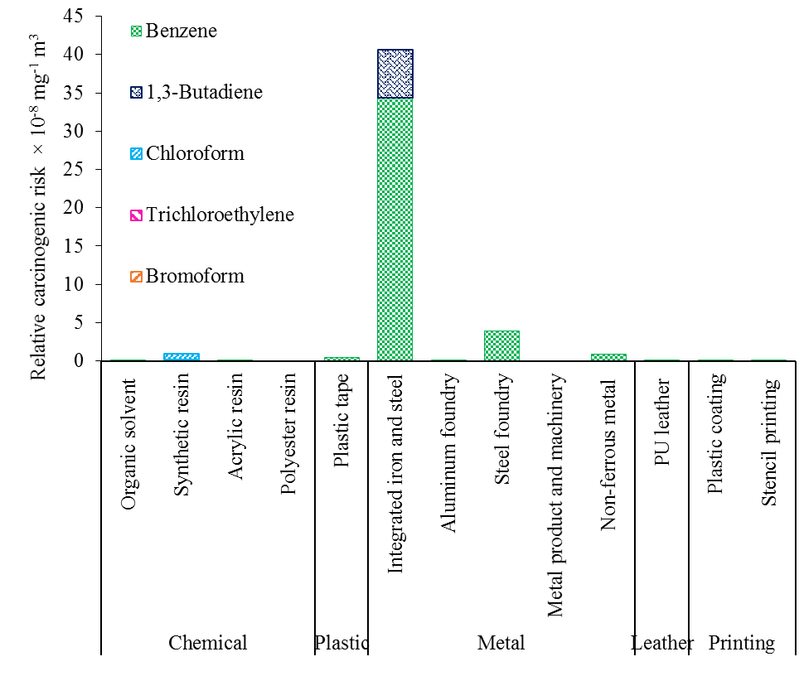
Fig. S2 Relative carcinogenic risk of VOCs for different emission sources

References
- USEPA. Integrated risk information system. Washington, DC: US Environmental Protection Agency; 2020.
- Wang HL, Nie L, Li J, Wang YF, Wang G, Wang JH, et al. Characterization and assessment of volatile organic compounds (VOCs) emissions from typical industries. Chinese Sci Bull. 2013;58:724–30.
- Li QQ, Su GJ, Li CQ, Wang MJ, Tan L, Gao LR, et al. Emission profiles, ozone formation potential and health-risk assessment of volatile organic compounds in rubber footwear industries in China. J Hazard Mater. 2019;375:52–60.
- Liang XM, Chen XF, Zhang JN, Shi TL, Sun XB, Fan LY, et al. Reactivity-based industrial volatile organic compounds emission inventory and its implications for ozone control strategies in China. Atmos Environ. 2017;162:115–26.
- Liang XM, Sun XB, Xu JT, Ye DQ. Improved emissions inventory and VOCs speciation for industrial OFP estimation in China. Sci Total Environ. 2020;745:140838.

