Appendix
Feminist Urban Living Labs and Social Sustainability: Lessons from Sweden (2021) (URBT-D-20-00009)
Content

- Table: Data collection- and analysis table - including steps and information about the UGM process and six different lab/workshops occasions.
- Survey 1: What do you think is important in public space?
- Survey 2: Rank public space features in order of importance
- Table: Survey 1 results
- Figure: Screenshot of the final proposal for Fittja square by the UGM project

Date | Data collection method and occasion | Data analysis
2018-09-26 | Participatory observation  Lab 1: A guided walk around Fittja square and its surroundings and discovering the challenges in the public spaces from the girls’ stories. 35 participants out of which 9 UGM girls. Collection of quotes and photos. | Thematic analysis: Themes like “greenery”, “multi-stakeholder groups”, “visual elements”, “hangout spaces”, “community”, “safety”, etc. occurred often in our notes which is why we (after lab 4) colour coded these themes to analyse their prevalence and later use them to enrich the interpretation of the illustrations in Minecraft (after lab 4).
2018-10-24 | Participatory observation  Lab 2: Participants study tools for urban development, identify challenges, describe needs, brainstorm about the potential of the place and its existing opportunities. In Fittja. 35 participants, out of which 15 UGM girls. Collection of quotes and photos. | Thematic analysis (ibid.)
2018-11-22 | Participatory observation  Lab 3: Participants formulate visions for the site, sketch concrete solutions and begin to illustrate ideas. In Norsborg, Botkyrka. 35 participants, out of which 14 UGM girls. Collection of quotes and photos. | Thematic analysis (ibid.)
2019-02-02 +  2019-02-03 (two days) | Participatory observation  Lab 4: Based on the results of the first three labs, the fourth lab visualize and develop the ideas and solutions digitally in 3D using the computer game Minecraft. It took place in Stockholm offices of Global Utmaning with 25 participants, out of which 10 UGM girls Collection of quotes and photos. | Thematic analysis (ibid.)
2019-02-03 | Survey 1: What do you think is important in public space? (available in appendix)  - 21 respondents, during Lab 4  Respondents ticked whether they were above or under 25 years old. In total, 21 participants joined the survey out of which 8 were above 25 years old and trained professionals in the field, and 13 respondents were under 25 years old, the majority (10) were girls from the Fittja area and the rest were students or other participants in the project. | To read the survey data for survey 1, we grouped and counted the replies into how many, and which ages, ticked “very important” to different items in the survey and then compared the groups with each other to see in which categories respondents’ replies created clusters.  “The majority” equals at least seven of the younger participants (who were 13 in total) and at least five of the working professionals (who were eight in total taking the survey). Since 10 out of 13 young respondents were the UGM girls some conclusions as for their specific viewpoints can be drawn from this data.  To focus on priorities, we processed the data from both surveys that displayed the respondents’ first choices, but not what was given low priority. Most of the reply alternatives were ranked highly, and professionals’ commented that “all features are important making it is very difficult to rank them”.
2019-02-03 | Survey 2: Rank public space features in order of importance (available in appendix)  - 5 respondents (professionals), during Lab 4 | We analysed this data by means of to which extent the priorities by professionals aligned with the statements and illustrations by the UGM girls
2019-02-15 | Site visit 1  No data collection | -
(Continuously) | Secondary sources:  UGM innovation lab reports (Global Utmaning 2019 B) | The project’s own lab reports were used to cross-check facts and observations and mirror observations made with the project’s own data.
(Continuously) | Secondary sources:  The girl’s final illustrations in Minecraft (see figure 3 in the paper) | Interpretative analysis: Taking note of which furniture, elements and designs the girls created (for example greenery, types of materials, compactness, etc.). The quotes collected during the observation helped inform the analysis of the Minecraft illustrations.
(Continuously) | Secondary sources:  Botkyrka Municipality design plan for Fittja square (Botkyrka kommun 2016). | Comparative analysis: We compared how the municipality had furnished the square with how the UGM girls chose to furnish the square.  Interpretative analysis: We focused on the prevalence of certain descriptive content (e.g., safe, clean, green) and we “read between the lines” (interpreted) the narratives from the municipality’s way of visioning the future of the square with the girls’
2019-03-11 | Site visit 2  Unstructured observation of Fittja square for ca. 1 hour: based on the girls’ identified priorities and themes (“mobility”, “activity opportunities”, “hang outs” and “visual elements/efforts”). I looked for “traces” or “signs” of the identified themes (Gehl & Svarre 2013:35) and took photos. | No concrete analysis of this data was used in the paper except photos and descriptions about the current design of the square
2019-04-01 | Participatory observation  Halftime exhibition of UGM in Fittja: Existing results together with the Minecraft designs are exhibited locally and digitally with the aim to collect broader input not least from citizens. In Fittja. 15 participants, out of which 7 UGM girls. | No concrete analysis of this data was used in the paper except for an image from the halftime exhibition overviewing the Minecraft illustrations in full (figure 5 in the paper)
2019-04-25 | Participatory observation  Lab 5: Transferring the work to architectural sketches and plans for the area at the office of the architect firm and project partner. 30 participants, out of which 4 UGM girls. | No concrete analysis of this data was used in the paper
2019-06-04 | Participatory observation  Lab 6: Focus is on implementation and participants make concrete policy recommendations and discuss it with the decision-makers in the area. In Fittja. | No concrete analysis of this data was used in the paper but the policy recommendations (Proposal 1) for the square are available in the appendix. We studied the statements in this proposal to cross-check whether it was in line with our previous observations.
Table: Data collection- and analysis table - including steps and information about the UGM process and six different lab/workshops occasions.
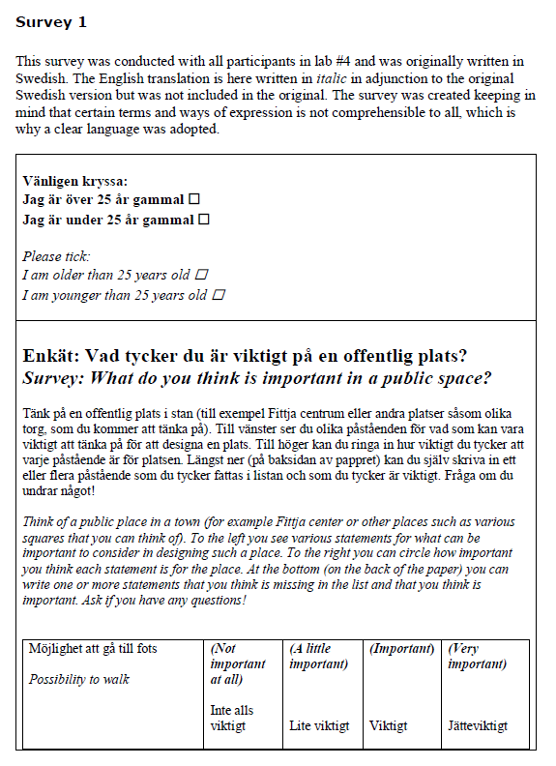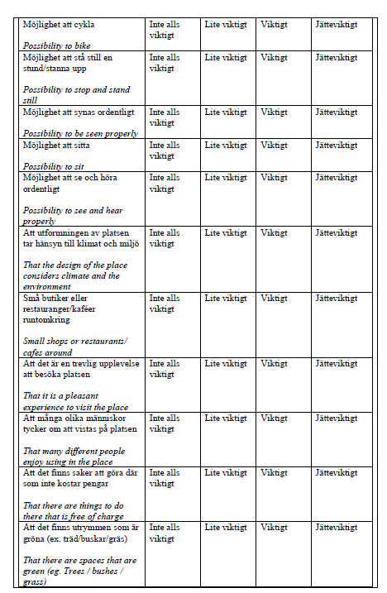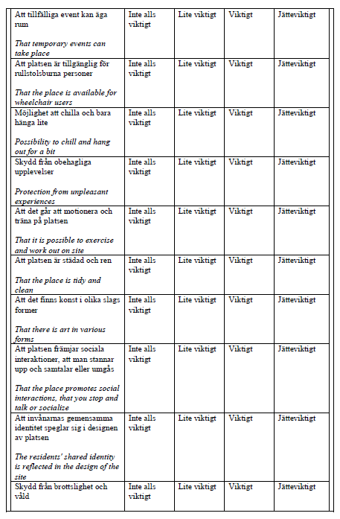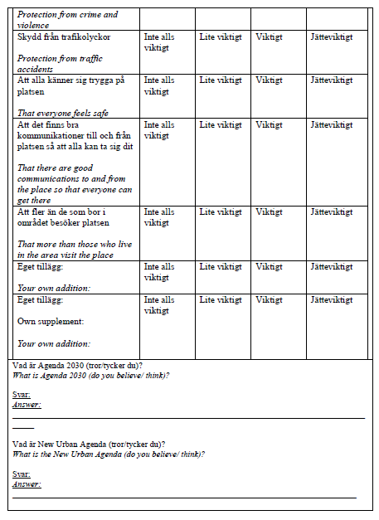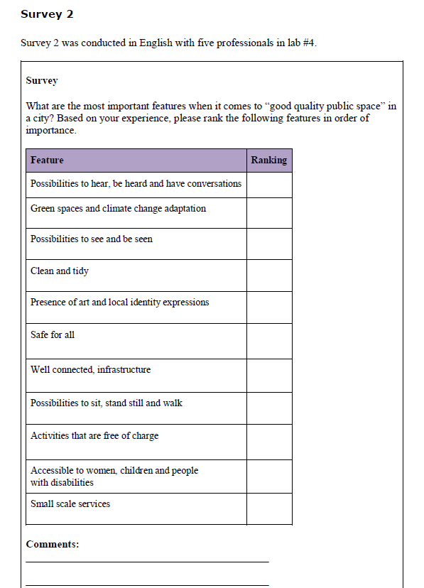

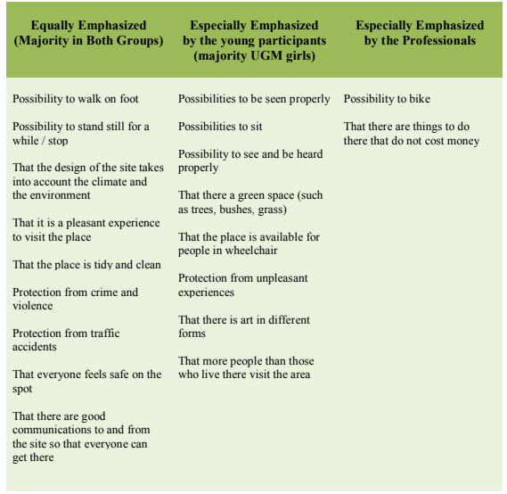
Table: Variations in “very important” features in good quality public space according to respondents in survey 1

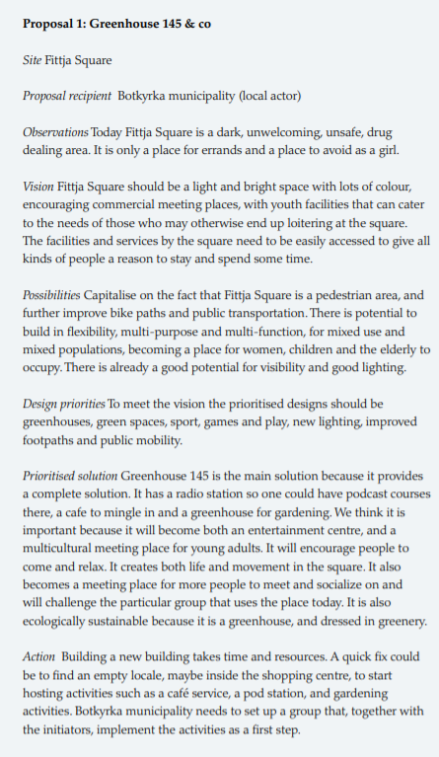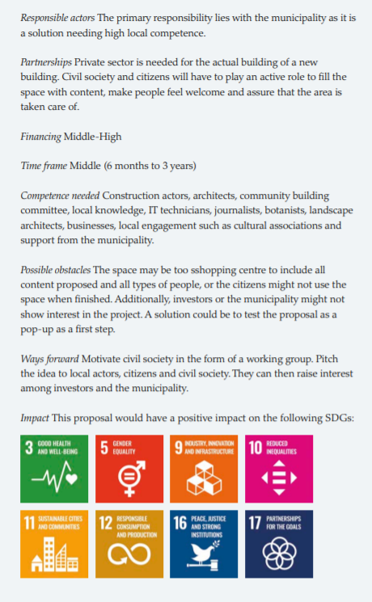
Figure: Screenshot of the final proposal for Fittja square by the UGM participants, handed over to the municipality. All proposals and project outputs are available in the Urban Girls Catalogue, see reference Global Utmaning B in the reference list.

