Electronic Supplementary Material

For the article
Mindset shifts and sustainability transformation journeys across Urban Labs in Latin America
by Flávia Guerra, Sneha Roy, Lionel Muñoz Rosas and Simone Sandholz

Contents
S1. Data collection questionnaires – pp. 2-6
S2. Factor loading tables – pp. 7-8
S3. KDE figures and descriptive statistics – pp. 9-11
S4. Centroid analysis and factor scores for the centroids – pp. 12-14
S5. Persona evolution in mathematical space across survey rounds – pp. 15-16
S6. Persona journeys across survey rounds – pp. 17-22
S7. Individual journeys of Urban Lab members across survey rounds – pp. 23-24

S1. Data collection questionnaires

Survey questionnaire (only relevant questions for this paper’s analyses)
- DEMOGRAPHICS

D1. Country/Urban Lab
Country | Urban Lab
- Argentina  - Brazil  - Mexico | - Buenos Aires (ARG)  - Recife (BRA)  - Teresina (BRA)  - León (MEX)  - Naucalpan (MEX)

D2. Date
Day: _______ Month: ____________________ Year: 20_____

D3. Stakeholder category
01. Government department or agency  02. Non-governmental organization (NGO)  03. Community/neighborhood associations  04. Religious or spiritual organization  05. Research institute or university | 06. Private sector  07. International NGO  08. Bilateral or multilateral donor  09. Media  10. Citizen (non-organized)  11. Other, please specify: ______________

D4. Please tell me how old you are.
______ years old

D5. Can you please tell me what gender do you identify with?
    - Man/male
    - Woman/female
    - Other: Specify

D6. What is the highest level of education you have completed?
(0) None  (1) Primary  (2) Secondary | (3) Bachelors-level  (4) Masters-level  (5) Above Masters-level

D7. For how many years have you lived in [city] now?
- Does not live in [city]
- Less than 1 year
- More than 1 but less than 5 years
- More than 5 but less than 10 years
- 10 years or longer

- MINDSETS

(Perceptions: CC importance)
M1. In your opinion, how important is the problem of climate change in [city]?
- Not a problem at all
- Somewhat unimportant problem
- Somewhat important problem
- Very important problem

(Worldviews)
M2. I will now read some statements to you that describe how one can understand the world. For each of these statements, please tell me if you ‘disagree strongly’, ‘disagree somewhat’, ‘agree somewhat’, or ‘agree strongly’.
  - Our world works according to ingrained rules and we cannot really do much to change them. (Fixed/Growth mindset)
  - Tackling climate change is only possible when many people and organizations work together. (Communitarian)
  - Guidance and leadership for climate action should mostly come from the government. (Hierarchical)
  - It feels pointless that I should take climate action if no one else does. (Fatalist)
  - A free society can only exist by giving companies the opportunity to prosper. (Individualist)
  - Community organizations and social movements are important drivers of climate action. (Communitarian)
  - Stricter legislation is the most important measure to make people behave more climate friendly. (Hierarchical)
  - The future is too uncertain for a person to make serious plans. (Fatalist)
  - If a person acquires wealth, that person should have the right to enjoy it the way he or she wants. (Individualist)

(Emotions, beliefs, perceptions and attitudes)
M3. Please tell me, based on your personal perspective, whether you ‘disagree strongly’, ‘disagree somewhat’, ‘agree somewhat’, or ‘agree strongly’ with each of the following statements.
  - I believe that the danger of climate change has been exaggerated by others. (Emotions: Doubt/Denial)
  - I feel like climate change does not concern me personally but it concerns people in other parts of the country or in other countries. (Beliefs: Distant phenomenon (geographically))
  - I feel like climate change does not concern me today but it concerns coming generations. (Beliefs: Distant phenomenon (temporally))
  - I think that tackling climate change is primarily the responsibility of countries in North America and Europe. (Beliefs: Global North Responsibility)
  - I am worried about climate change and its consequences. (Emotions: Worry)
  - I believe that reducing the city’s carbon emissions to zero is desirable. (Perceptions: Desirability)
  - I believe that reducing the city’s carbon emissions to zero is realistic. (Perceptions: Feasibility)
  - I think it is possible to further develop my city while reducing carbon emissions. (Perceptions: Compatibility)
  - I think that poverty and inequality are big problems in my city. (Perceptions: Poverty)
  - I believe that it is possible to tackle poverty and inequality in my city while reducing carbon emissions. (Perceptions: Compatibility)
  - I think that new technology will address most of the problems caused by climate change without people having to alter their lifestyle. (Attitudes: Technology)
  - I think that humans have to alter their lifestyle to address the problems caused by climate change. (Attitudes: Lifestyle changes)
  - Personally, I believe that I should do more to act on climate change. (Beliefs: Personal responsibility)
  - I am willing to change my behavior to address climate change. (Attitudes: Willingness to change)
  - I believe that my city must change its development model to address climate change. (Beliefs: Local responsibility)
  - I am hopeful that we as a society will tackle the climate crisis and build a better future for everyone. (Emotions: Hope)

(Attitudes)
M4. For each of these statements, please tell me whether you ‘disagree strongly’, ‘disagree somewhat’, ‘agree somewhat’, or ‘agree strongly’.
- Urban planning processes in [city] are generally open and participatory. (Attitudes: Participation (existence))
- The municipal government takes climate change seriously when making decisions. (Attitudes: Government takes CC seriously)
- The contributions of researchers are taken into consideration in urban policy. (Attitudes: Participation (researchers))
- I am satisfied with climate change action by the national government. (Attitudes: Satisfaction with national government)
- I am satisfied with climate change action by the city government. (Attitudes: Satisfaction with city government)
- Local communities should participate in urban decision-making processes. (Attitudes: Participation (local communities))

(Perceptions: Barriers)
M5. In your opinion, what are the biggest barriers that prevent your city from taking climate action? For each of the following barriers, please tell me how significant you think they are in the context of [city]. The response options are (1) ‘insignificant’, (2) ‘somewhat insignificant’, (3) ‘somewhat significant’, or (4) ‘very significant’.
- Political unwillingness (Political barriers)
- Economic interests (Economic barriers)
- Different political priorities (Political barriers)
- Absence of leadership (Technical barriers)
- Lack of collaboration across institutions (Social barriers)
- Lack of knowledge or capacity (Technical barriers)
- Lack of finances (Economic barriers)
- Citizens do not care (Social barriers)

(Values)
M6. For each of the following circumstances, please tell me what kind of impact they would have on your motivation to act on climate change. The options are: (1) ‘no or very low impact’, (2) ‘low impact’, (3) ‘high impact’, or (4) ‘very high impact’.
- If acting on climate change had lower or no cost. (Economic values)
- If I received economic benefits for taking action on climate (e.g. tax reduction). (Economic values)
- If my community and other people would face fewer climate hazards. (Social values)
- If my family, friends or neighbors also engaged in climate action. (Social values)
- If nature and planet would be protected. (Ecological values)
- If everyone could benefit from a greener environment. (Ecological values)
- If media would communicate climate change issues differently. (Cultural values)
- If I saw more public figures (e.g. artists and influencers) pursuing climate action. (Cultural values)

(Behavior)
M7. During the last 12 months, have you personally done any of the following to tackle climate change? [Underlined statements depict collective actions while non-underlined statements represent individual actions]
- Read and/or shared information about climate change on social media, local newspapers, science publications and/or other channels.
- Contacted a local politician or a public official to advocate for climate action.
- Taken part in a public demonstration, petition or climate strike to demand climate action.
- Considered climate change concerns when purchasing certain products.
- Changed everyday habits because of climate change concerns such as the use of energy or water or mobility choices.
- Formed or became a member of an organization or group working on climate change.
- Voted in a local government election based on candidates’ commitment to fighting climate change.
- Provided and/or received training or capacity development on climate change topics.
- Participated in meetings and/or projects where climate change issues were discussed.
- Considered climate change and/or related topics when making work-related decisions at my organization.

- CAPACITY

C1. How sufficient do you think your knowledge is to act on climate change personally?
- Very insufficient
- Somewhat insufficient
- Somewhat sufficient
- More than sufficient

C2. How would you rate your ability to influence or mobilize others to act on climate change?
- No or very low influence
- Somewhat low influence
- Somewhat high influence
- Very high influence

C3. How do you rate your organization’s current capacity to work on climate change?
- No or very low capacity
- Somewhat low capacity
- Somewhat high capacity
- Very high capacity

C4. How do you assess your organization’s current power to influence decisions in the city that are important for climate change?
- No or very low power
- Somewhat low power
- Somewhat high power
- Very high power

- TRUST

T1. For each of the institutions, please tell me whether you find them (1) untrustworthy, (2) somewhat untrustworthy, (3) somewhat trustworthy, or (4) very trustworthy.
- City administration
- Community associations
- NGOs
- Research institutes

Semi-structured interview guide (only relevant questions for this paper’s analyses)
Urban Lab involvement and work
- Since when and how often have you been participating in the Urban Lab?
- Currently, what motivates you to keep participating in the Urban Lab?
- In your own words, can you describe what the Urban Lab has been working on since you joined?
- From your perspective, what have been the main positive and negative aspects associated with the Urban Lab?
- How are different stakeholders benefiting from the Urban Lab?
  - Are there individuals and/or organizations that should still be involved?
- Thinking about the most relevant environmental and climate issues facing the intervention area, how do you think the work of the Urban Lab is addressing them?
  - How could they be addressed more effectively?
Changes related to the Urban Lab
- Has your understanding of climate change changed in any way in the past year?
  - If yes, what has changed and how?
  - How have these changes affected your individual behavior?
  - And the way your organization operates?
- Have the people and/or organizations you interact and work with changed in the past year?
  - If yes, what has changed and how?
- Have you noticed any significant changes within the Urban Lab itself so far? (e.g., types of stakeholders involved, topics of interest, participation levels, etc.)
- Have you observed any changes in the intervention area in the past year? (e.g., physical changes, changes in policy or administrative procedures, resource allocation)

S2. Factor loading tables
In this section, we present comprehensive tables of the factor loadings for all five factors identified in our analysis. Factor loadings, which represent the correlation between observed variables and their corresponding latent factors, are crucial for understanding how well each variable reflects the underlying factor. Higher loadings indicate a stronger relationship, with values closer to 1 (or -1) showing that the variable is a significant indicator of the factor.
To facilitate interpretation in the main text, we bolded the top four most highly correlated variables (mindset dimensions) for each factor in the supplementary tables below. The supplementary section includes all the variables and their associated loadings, providing a detailed view of how each variable contributes to the factors.

Factor 1 |  |  | Factor 2 |  |  | Factor 3
Question | Factor Loading |  | Question | Factor Loading |  | Question | Factor Loading
M2.3 | 0,208498 |  | M2.2 | -0,318718 |  | M2.1 | -0,291615
M2.5 | 0,33909 |  | M2.6 | -0,314534 |  | M2.4 | -0,353675
M2.9 | 0,243614 |  | M2.7 | -0,280825 |  | M2.5 | -0,421295
M3.8 | 0,303493 |  | M3.5 | -0,287476 |  | M2.8 | -0,252304
M3.11 | 0,262338 |  | M3.6 | -0,37847 |  | M2.9 | -0,45018
M4.1 | 0,771008 |  | M3.7 | -0,293165 |  | M3.1 | -0,435208
M4.2 | 0,799901 |  | M3.10 | -0,292307 |  | M3.2 | -0,25004
M4.3 | 0,347407 |  | M3.12 | -0,438906 |  | M3.3 | -0,326555
M4.4 | 0,222642 |  | M3.13 | -0,297315 |  | M3.11 | -0,457308
M4.5 | 0,897217 |  | M3.14 | -0,37783 |  | M4.4 | -0,206105
M5.1 | -0,340838 |  | M3.15 | -0,431952 |  | M5.6 | -0,212884
 |  |  | M4.6 | -0,251202

Factor 4 |  |  | Factor 5
Question | Factor Loading |  | Question | Factor Loading
M5.1 | -0,585176 |  | M2.1 | -0,224208
M5.2 | -0,372678 |  | M2.3 | -0,263061
M5.3 | -0,480785 |  | M2.4 | -0,264117
M5.4 | -0,501353 |  | M3.1 | -0,246217
M5.5 | -0,392226 |  | M3.4 | -0,703098
M5.6 | -0,309439
M5.7 | -0,367555
M5.8 | -0,376229

In addition to the limitations discussed in the main text of the manuscript, we want to disclose that the ordinal nature of our data posed a challenge, particularly in ensuring factor model stability across survey rounds. While ordinal data is typically handled using a polycoric correlation matrix in factor analysis, we found that a variance-covariance matrix yielded more stable results and explained more data variation after limiting the dataset to questions with consistent Likert scales and specific mindset dimensions (see factor loading tables above). Despite this adjustment, the high dimensionality of our dataset, characterized by numerous variables and relatively few observations, remained a significant challenge. Additionally, our factor model was based on R2 data applied to the other rounds, without differentiating respondents from different Urban Labs. R2 was selected over R1 because certain variables in R1 required transformation to align with the refined questionnaire and data structure of the later rounds. While a multi-group factor analysis could have accounted for potential lab-specific effects, our dataset’s dimensional complexity made this approach unfeasible.

S3. KDE figures and descriptive statistics
Despite using the same model and a consistent mathematical space across all factors, the clustering algorithm assigns cluster labels randomly, meaning these labels lack intrinsic significance. Consequently, a cluster labeled as “2” or “Bystander with Mixed Feelings” in R2 may not correspond directly to a cluster labeled as “2” or “Bystander with Mixed Feelings” in R1, rendering them incomparable across rounds. This requires the identification of cluster succession across the rounds. We employ two approaches for this.
First, we utilized Kernel Density Estimation (KDE), a nonparametric method used to estimate a dataset’s probability density functions, to analyze factor distributions for each persona across the three survey rounds. KDE was employed to visualize and compare the density of factor scores, allowing us to track how each persona’s defining characteristics evolved over time. Visual plots provide intuitive insights into the shape and spread of distributions, while descriptive statistics offer quantitative measures of distributional similarity.
The Bystander with Mixed Feelings consistently exhibited the highest values for Factor 2 and the lowest for Factor 3 across all rounds, as confirmed by descriptive statistics below. Conversely, the Skeptical Activist showed the highest KDE height for Factor 2 and a distinctive two-peaked shape in the distribution of Factor 1 in R1 and R3, along with the minimum values for Factor 1 in these rounds. The evolution for the Optimist Technocrat is traced out by the process of elimination and also confirmed by minimum values for Factor 1 in R1 and R3. This detailed KDE analysis thus provided a comprehensive view of persona stability and transitions across the rounds.
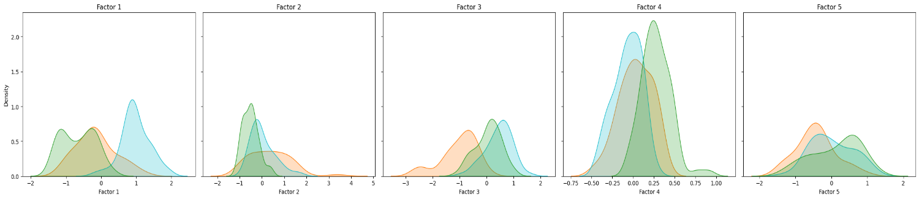
Figure. KDE figures pertaining to R1
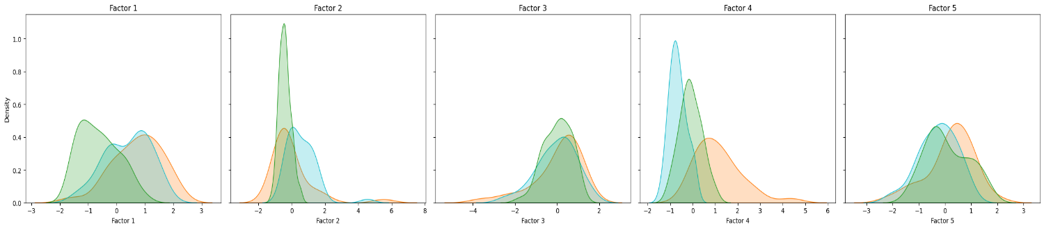
Figure. KDE figures pertaining to R2
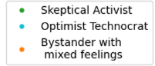
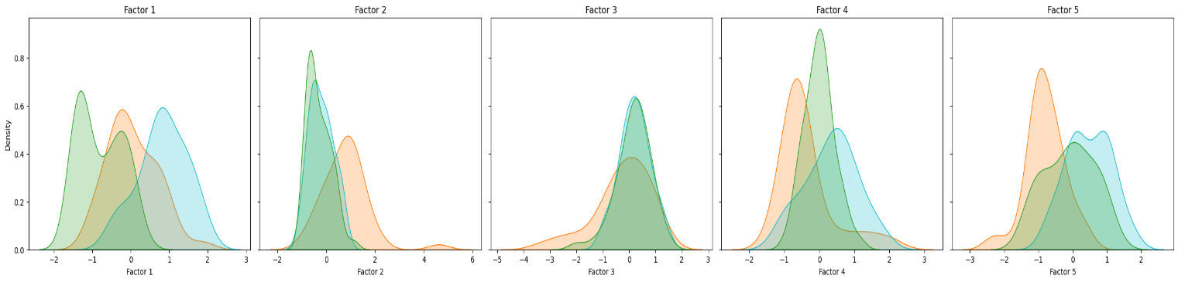
Figure. KDE figures pertaining to R3

Table. Descriptive statistics for the KDE distributions for R1
Factor | Cluster | Count | Mean | Std | Min | Max | Highest KDE
1 | Skeptical Activist | 69 | -0,6486 | 0,4786 | -1,3907 | 0,3007 | 0,6859
1 | Optimist Technocrat | 48 | 0,9706 | 0,4069 | -0,155 | 1,8884 | 1,0991
1 | Bystander w. Mixed Feelings | 36 | -0,146 | 0,5603 | -1,0363 | 1,1888 | 0,705
2 | Skeptical Activist | 69 | -0,5125 | 0,3559 | -1,151 | 0,446 | 1,045
2 | Optimist Technocrat | 48 | 0,0311 | 0,5567 | -0,7786 | 1,7183 | 0,8153
2 | Bystander w. Mixed Feelings | 36 | 0,3638 | 0,9304 | -0,9378 | 3,3689 | 0,3584
3 | Skeptical Activist | 69 | 0,0532 | 0,4805 | -1,1452 | 1,0179 | 0,8196
3 | Optimist Technocrat | 48 | 0,444 | 0,4972 | -0,9255 | 1,5688 | 0,805
3 | Bystander w. Mixed Feelings | 36 | -1,0214 | 0,6577 | -2,5882 | 0,0408 | 0,6602
4 | Skeptical Activist | 69 | 0,2777 | 0,1754 | -0,037 | 0,9139 | 2,2334
4 | Optimist Technocrat | 48 | -0,0667 | 0,1666 | -0,4167 | 0,2561 | 2,066
4 | Bystander w. Mixed Feelings | 36 | 0,0324 | 0,1986 | -0,4578 | 0,3425 | 1,6771
5 | Skeptical Activist | 69 | 0,1227 | 0,6776 | -1,3399 | 1,2509 | 0,5916
5 | Optimist Technocrat | 48 | 0,0088 | 0,5886 | -1,3112 | 1,1472 | 0,6047
5 | Bystander w. Mixed Feelings | 36 | -0,4304 | 0,5469 | -1,4339 | 0,9296 | 0,7644

Table. Descriptive statistics for the KDE distributions for R2
Factor | Cluster | Count | Mean | Std | Min | Max | Highest KDE
1 | Skeptical Activist | 60 | -0,621 | 0,6902 | -1,5778 | 0,95 | 0,5053
1 | Optimist Technocrat | 42 | 0,3844 | 0,7955 | -1,3367 | 1,6956 | 0,4409
1 | Bystander w. Mixed Feelings | 29 | 0,7281 | 0,858 | -1,5788 | 2,0526 | 0,415
2 | Skeptical Activist | 60 | -0,4079 | 0,349 | -1,1622 | 0,5033 | 1,0929
2 | Optimist Technocrat | 42 | 0,5869 | 0,9007 | -0,4665 | 4,5465 | 0,4615
2 | Bystander w. Mixed Feelings | 29 | -0,006 | 1,2983 | -1,1381 | 5,523 | 0,4548
3 | Skeptical Activist | 60 | 0,0177 | 0,6623 | -1,8146 | 1,1315 | 0,5145
3 | Optimist Technocrat | 42 | -0,039 | 0,9389 | -2,5219 | 1,5584 | 0,4014
3 | Bystander w. Mixed Feelings | 29 | 0,02 | 1,1635 | -3,5778 | 1,2885 | 0,4132
4 | Skeptical Activist | 60 | -0,0937 | 0,4903 | -1,1369 | 1,0259 | 0,7537
4 | Optimist Technocrat | 42 | -0,6605 | 0,3781 | -1,3953 | 0,0789 | 0,9884
4 | Bystander w. Mixed Feelings | 29 | 1,1505 | 1,0284 | -0,2727 | 4,3687 | 0,3951
5 | Skeptical Activist | 60 | 0,0884 | 0,8192 | -1,2899 | 1,6207 | 0,466
5 | Optimist Technocrat | 42 | -0,2767 | 0,7273 | -2,0824 | 0,9317 | 0,4844
5 | Bystander w. Mixed Feelings | 29 | 0,2179 | 0,8899 | -2,1185 | 1,9411 | 0,4846

Table. Descriptive statistics for the KDE distributions for R3
Factor | Cluster | Count | Mean | Std | Min | Max | Highest KDE
1 | Skeptical Activist | 49 | -0,7876 | 0,5684 | -1,5963 | 0,3253 | 0,6626
1 | Optimist Technocrat | 43 | 0,832 | 0,6345 | -0,5471 | 1,9548 | 0,5925
1 | Bystander w. Mixed Feelings | 42 | 0,0481 | 0,6478 | -0,9816 | 1,8772 | 0,5848
2 | Skeptical Activist | 49 | -0,2988 | 0,4808 | -0,9718 | 1,1175 | 0,8311
2 | Optimist Technocrat | 43 | -0,1949 | 0,4872 | -1,0967 | 0,7492 | 0,7068
2 | Bystander w. Mixed Feelings | 42 | 0,7846 | 0,9323 | -0,9757 | 4,6148 | 0,4745
3 | Skeptical Activist | 49 | 0,1566 | 0,6564 | -2,0055 | 1,4522 | 0,6315
3 | Optimist Technocrat | 43 | 0,2107 | 0,5766 | -0,9726 | 1,372 | 0,6384
3 | Bystander w. Mixed Feelings | 42 | -0,2571 | 1,0639 | -3,3554 | 1,2508 | 0,3857
4 | Skeptical Activist | 49 | -0,0043 | 0,4262 | -0,934 | 1,1355 | 0,9201
4 | Optimist Technocrat | 43 | 0,3339 | 0,7472 | -1,1648 | 1,8031 | 0,506
4 | Bystander w. Mixed Feelings | 42 | -0,3621 | 0,7801 | -1,3925 | 2,1297 | 0,7132
5 | Skeptical Activist | 49 | -0,1009 | 0,7317 | -1,3918 | 1,1777 | 0,4479
5 | Optimist Technocrat | 43 | 0,4673 | 0,641 | -0,7567 | 1,7465 | 0,4945
5 | Bystander w. Mixed Feelings | 42 | -0,8018 | 0,5632 | -2,4205 | 0,4669 | 0,7564

S4. Centroid analysis and factor scores for the centroids
We used centroid analysis to validate KDE findings. A centroid indicates the averaged position of a group of points in a multidimensional space. For our analysis, it indicates the center point (averaged position) of clusters and thus personas in our mathematical space. In our data, the centroid of the Skeptical Activist persona consistently records the shortest distance from the origin, while the centroid of the Bystander with Mixed Feelings consistently exhibits the greatest distance from the origin. The centroid for the Optimist Technocrat is positioned between these two extremes. This pattern helps us distinguish the personas and track their evolution across different rounds.
Table. Euclidean Centroid distances of each persona for the three survey rounds
Persona | R1 | R2 | R3
Skeptical Activist | 0.88 | 0.75 | 0.86
Optimist Technocrat | 1.06 | 1.00 | 1.05
Bystander with Mixed Feelings | 1.17 | 1.37 | 1.20

Table. Mahalanobis Centroid distances of each persona for the three survey rounds
Persona | R1 | R2 | R3
Skeptical Activist | 1.43 | 1.42 | 1.63
Optimist Technocrat | 2.56 | 2.34 | 1.87
Bystander with Mixed Feelings | 2.59 | 2.49 | 2.18

Table. Manhattan Centroid distances of each persona for the three survey rounds
Persona | R1 | R2 | R3
Skeptical Activist | 1.79 | 1.54 | 1.51
Optimist Technocrat | 1.61 | 1.78 | 2.05
Bystander with Mixed Feelings | 1.92 | 2.13 | 2.15

Next, we present a series of visualizations that illustrate the factor scores of the centroids for each persona—Skeptical Activist, Optimist Technocrat, and Bystander with Mixed Feelings—across all three rounds. These visualizations serve to track the evolution of each persona’s core characteristics over time. Factor scores represent the position of a centroid within the multidimensional space defined by the factors, essentially capturing the average profile of respondents within that persona. By analyzing the factor scores of the centroids, we can observe how each persona’s defining traits shift across rounds, offering insights into the stability or transformation of the underlying mindsets. The visualizations clearly demonstrate the relative positioning and movement of each persona’s centroid, which, when viewed collectively, provide a comprehensive picture of how mindsets develop and change over time within urban sustainability transformation processes.
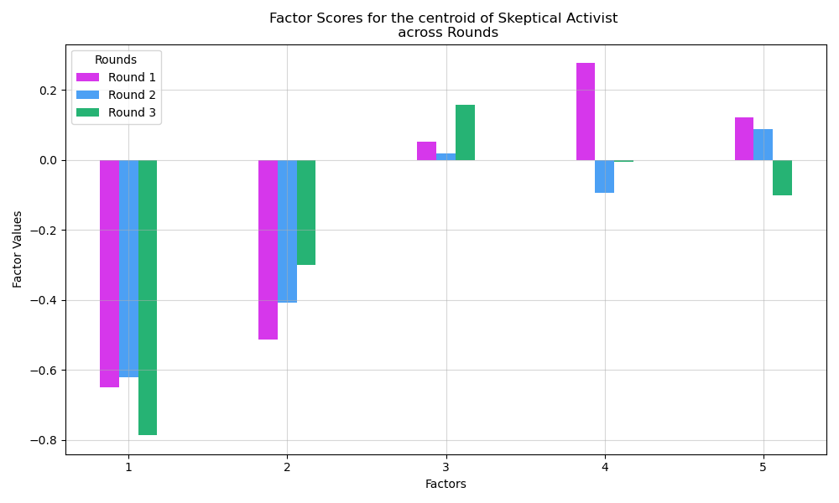Figure. Factor values for the centroid of the Skeptical Activist across rounds

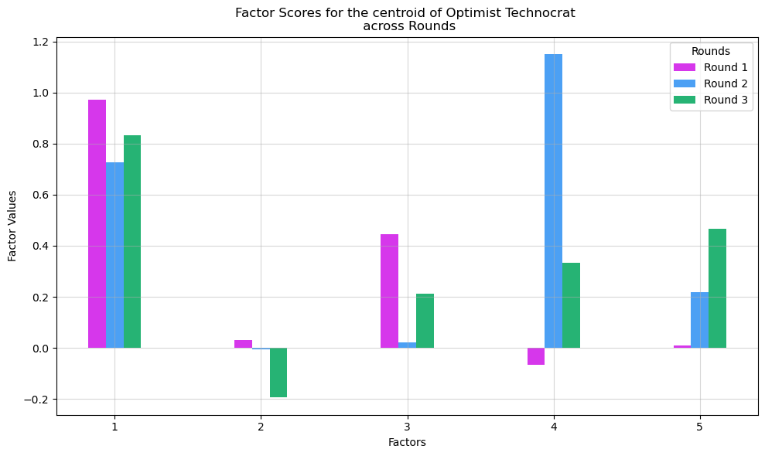Figure. Factor values for the centroid of the Optimist Technocrat across rounds
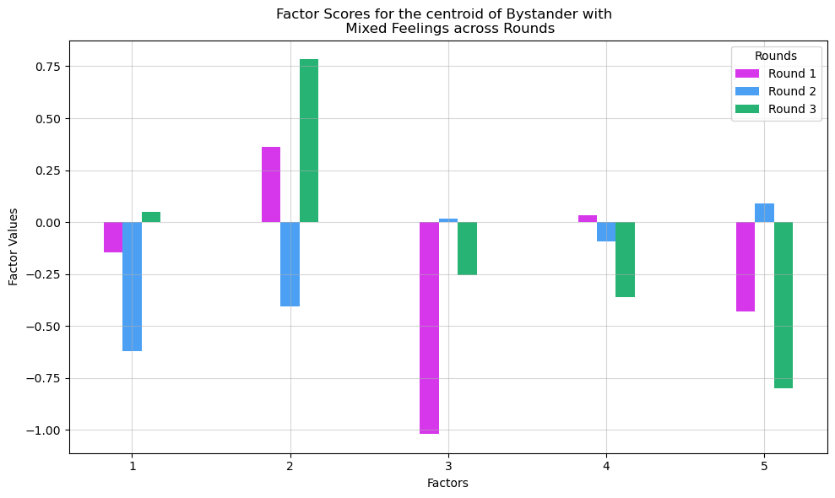
Figure. Factor values for the centroid of the Bystander with Mixed Feelings across rounds

S5. Persona evolution in mathematical space across survey rounds
Considering the evolution of the three personas across the three survey rounds, depicted in the three figures below, we observe that R1 and R3 share several structural similarities, with cluster positions and spreads appearing closer than in R2. This is likely due to participant turnover in R3, which introduced new individuals with less exposure to Urban Lab activities—resembling the mindset diversity at baseline. This trend reinforces the non-linear and context-sensitive nature of mindset transformation.

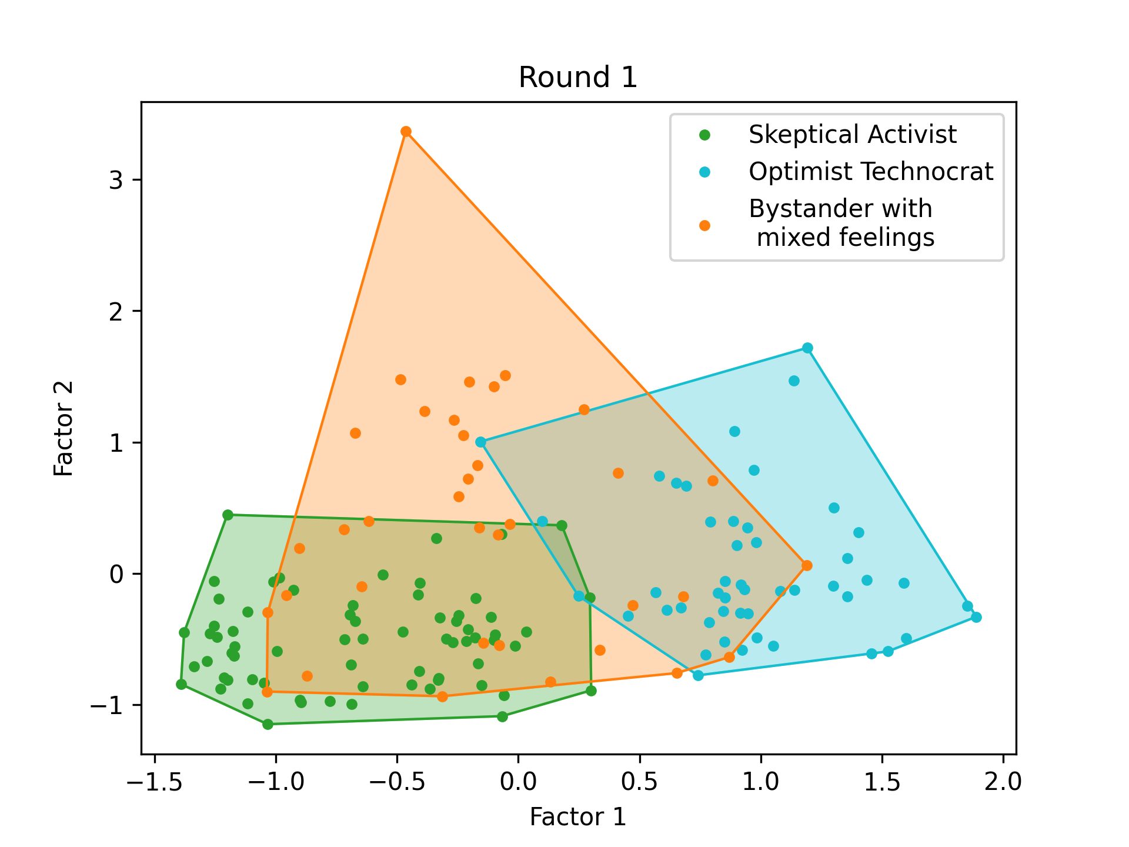
Figure. Position of personas in the mathematical space defined by Factors 1 and 2 in R1

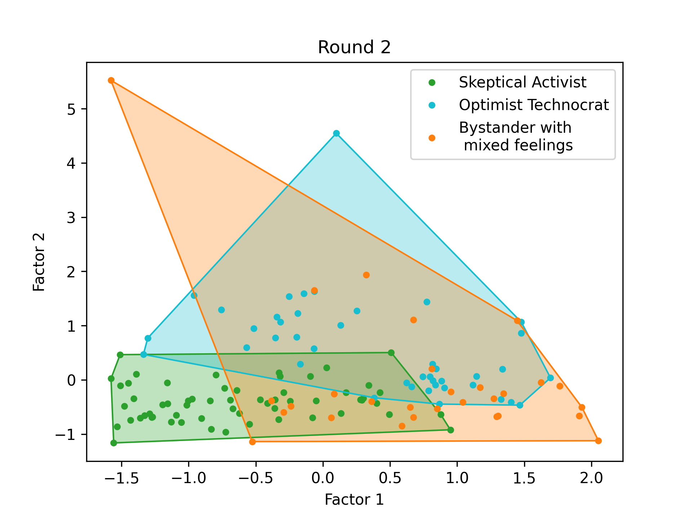
Figure. Position of personas in the mathematical space defined by Factors 1 and 2 in R2

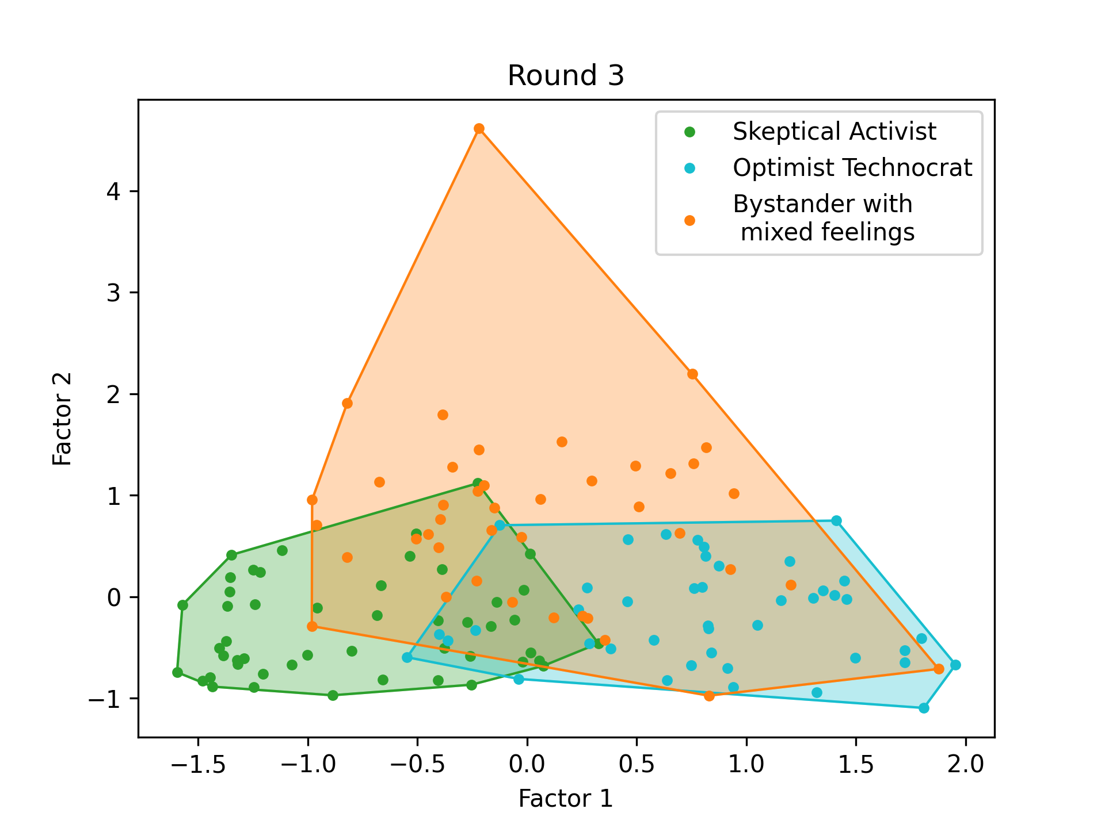
Figure. Position of personas in the mathematical space defined by Factors 1 and 2 in R3

S6. Persona journeys across survey rounds

6.1 The Skeptical Activist
The Skeptical Activist | R1 | R2 | R3
Mindsets
Beliefs
Distant phenomenon (geographically) | 6% | 0% | 12%
Distant phenomenon (temporally) | 12% | 13% | 8%
Responsibility (personal) | 97% | 93% | 84%
Responsibility (local) | 99% | 100% | 100%
Responsibility (Global North) | 41% | 40% | 47%
Emotions
Denial/doubt | 0% | 0% | 2%
Worry | 100% | 100% | 100%
Hope |  | 95% | 92%
Perceptions
CC important or very important | 99% | 100% | 100%
Desirability of zero-carbon goal | 93% | 95% | 98%
Feasibility of zero-carbon goal | 62% | 68% | 55%
Compatibility between urban development and decarbonization | 80% | 85% | 84%
Poverty as pressing urban issue | 97% | 98% | 100%
Compatibility between decarbonization and tackling poverty | 97% | 95% | 94%
Political barriers |  | 98% | 98%
Economic barriers |  | 86% | 84%
Technical barriers |  | 88% | 84%
Social barriers |  | 96% | 88%
Values
Social |  | 79% | 80%
Ecological |  | 93% | 96%
Economic |  | 59% | 53%
Cultural |  | 61% | 52%
Attitudes
Participation (existence) | 16% | 23% | 29%
Participation (researchers) |  | 43% | 29%
Participation (local communities) | 100% | 98% | 100%
Government (takes CC seriously) | 3% | 13% | 2%
Government (satisfaction city level) | 4% | 18% | 6%
Government (satisfaction national level) | 10% | 13% | 8%
Change (technology) | 14% | 18% | 8%
Change (lifestyle) | 100% | 100% | 100%
Change (willingness) | 100% | 100% | 100%

Worldviews
Communitarian | 93% | 94% | 93%
Hierarchical | 64% | 59% | 63%
Individualist | 36% | 40% | 35%
Fatalist | 9% | 9% | 6%
Behavior
Climate action metric (average total) | 5,05 | 8,07 | 7,84
Climate action metric (average individual) | 4,14 | 4,05 | 3,88
Climate action metric (average collective) | 1,5 | 3,97 | 3,99
Capacity
Individual knowledge | 72% | 73% | 84%
Individual ability to influence others | 64% | 67% | 59%
Organizational capacity | 48% | 81% | 78%
Organizational power | 9% | 59% | 54%
Trust
In city administration | 52% | 53% | 47%
In NGOs | 41% | 45% | 35%
In community associations | 91% | 82% | 90%
In research institutes/universities | 96% | 93% | 98%
Demographics
Age
Mean | 41 | 42 | 42
Gender
Female | 46% | 55% | 51%
Male | 52% | 43% | 47%
Other | 2% | 2% | 2%
Education
Bachelors-level or above | 93% | 95% | 88%
Years living in city
Does not live in city | 14% | 2% | 4%
10 years or longer | 75% | 83% | 80%
Number of respondents per main stakeholder category
Government agencies | 15 | 20 | 11
NGOs | 16 | 13 | 10
Community associations and non-organized citizens | 17 | 10 | 13
Research institutes | 13 | 10 | 10
Private sector | 8 | 7 | 5
Number of respondents per UL
UL Buenos Aires | 21 | 12 | 19
UL Recife | 11 | 11 | 4
UL Teresina | 6 | 7 | 4
UL León | 15 | 19 | 16
UL Naucalpan | 16 | 11 | 6
TOTAL | 69 | 60 | 49

6.2 The Optimist Technocrat
The Optimist Technocrat | R1 | R2 | R3
Mindsets
Beliefs
Distant phenomenon (geographically) | 8% | 5% | 2%
Distant phenomenon (temporally) | 10% | 19% | 19%
Responsibility (personal) | 94% | 98% | 100%
Responsibility (local) | 94% | 90% | 95%
Responsibility (Global North) | 42% | 40% | 19%
Emotions
Denial/doubt | 0% | 21% | 2%
Worry | 98% | 95% | 100%
Hope |  | 98% | 100%
Perceptions
CC important or very important | 100% | 98% | 100%
Desirability of zero-carbon goal | 98% | 95% | 93%
Feasibility of zero-carbon goal | 67% | 55% | 67%
Compatibility between urban development and decarbonization | 94% | 95% | 95%
Poverty as pressing urban issue | 100% | 98% | 93%
Compatibility between decarbonization and tackling poverty | 100% | 93% | 95%
Political barriers |  | 99% | 92%
Economic barriers |  | 96% | 90%
Technical barriers |  | 92% | 73%
Social barriers |  | 96% | 80%
Values
Social |  | 83% | 80%
Ecological |  | 96% | 93%
Economic |  | 69% | 70%
Cultural |  | 75% | 71%
Attitudes
Participation (existence) | 85% | 60% | 86%
Participation (researchers) |  | 57% | 84%
Participation (local communities) | 100% | 98% | 98%
Government (takes CC seriously) | 94% | 57% | 81%
Government (satisfaction city level) | 92% | 55% | 77%
Government (satisfaction national level) | 21% | 19% | 37%
Change (technology) | 23% | 26% | 14%
Change (lifestyle) | 100% | 98% | 98%
Change (willingness) | 100% | 98% | 100%

Worldviews
Communitarian | 98% | 87% | 93%
Hierarchical | 86% | 64% | 70%
Individualist | 45% | 46% | 55%
Fatalist | 4% | 6% | 10%
Behavior
Climate action metric (average total) | 4,72 | 7,19 | 7,56
Climate action metric (average individual) | 3,88 | 3,81 | 3,74
Climate action metric (average collective) | 0,85 | 3,17 | 3,77
Capacity
Individual knowledge | 73% | 67% | 91%
Individual ability to influence others | 77% | 60% | 67%
Organizational capacity | 60% | 82% | 95%
Organizational power | 13% | 61% | 67%
Trust
In city administration | 71% | 71% | 79%
In NGOs | 95% | 88% | 98%
In community associations | 89% | 88% | 93%
In research institutes/universities | 100% | 93% | 100%
Demographics
Age
Mean | 44 | 43 | 42
Gender
Female | 44% | 57% | 47%
Male | 56% | 43% | 53%
Other | 0% | 0% | 0%
Education
Bachelors-level or above | 94% | 83% | 93%
Years living in city
Does not live in city | 10% | 5% | 9%
10 years or longer | 73% | 76% | 67%
Number of respondents per main stakeholder category
Government agencies | 34 | 26 | 31
NGOs | 5 | 6 | 3
Community associations and non-organized citizens | 4 | 3 | 5
Research institutes | 3 | 3 | 1
Private sector | 1 | 3 | 3
Number of respondents per UL
UL Buenos Aires | 21 | 12 | 18
UL Recife | 14 | 9 | 2
UL Teresina | 2 | 11 | 0
UL León | 9 | 5 | 15
UL Naucalpan | 2 | 5 | 8
TOTAL | 48 | 42 | 43

6.3 The Bystander with Mixed Feelings
The Bystander with Mixed Feelings | R1 | R2 | R3
Mindsets
Beliefs
Distant phenomenon (geographically) | 22% | 7% | 12%
Distant phenomenon (temporally) | 36% | 10% | 12%
Responsibility (personal) | 100% | 93% | 86%
Responsibility (local) | 94% | 90% | 95%
Responsibility (Global North) | 39% | 28% | 71%
Emotions
Denial/doubt | 28% | 14% | 24%
Worry | 100% | 97% | 98%
Hope |  | 97% | 93%
Perceptions
CC important or very important | 97% | 100% | 98%
Desirability of zero-carbon goal | 89% | 93% | 90%
Feasibility of zero-carbon goal | 72% | 52% | 62%
Compatibility between urban development and decarbonization | 97% | 93% | 95%
Poverty as pressing urban issue | 100% | 86% | 100%
Compatibility between decarbonization and tackling poverty | 89% | 93% | 93%
Political barriers |  | 57% | 95%
Economic barriers |  | 76% | 85%
Technical barriers |  | 62% | 86%
Social barriers |  | 74% | 92%
Values
Social |  | 74% | 85%
Ecological |  | 84% | 96%
Economic |  | 59% | 79%
Cultural |  | 64% | 60%
Attitudes
Participation (existence) | 39% | 79% | 57%
Participation (researchers) |  | 72% | 43%
Participation (local communities) | 92% | 97% | 98%
Government (takes CC seriously) | 28% | 72% | 36%
Government (satisfaction city level) | 19% | 69% | 38%
Government (satisfaction national level) | 19% | 21% | 31%
Change (technology) | 42% | 24% | 29%
Change (lifestyle) | 97% | 90% | 98%
Change (willingness) | 97% | 97% | 98%

Worldviews
Communitarian | 96% | 88% | 81%
Hierarchical | 74% | 60% | 74%
Individualist | 63% | 57% | 38%
Fatalist | 21% | 16% | 17%
Behavior
Climate action metric (average total) | 4,13 | 7,76 | 7,38
Climate action metric (average individual) | 3,13 | 4,06 | 3,69
Climate action metric (average collective) | 1 | 3,66 | 3,69
Capacity
Individual knowledge | 61% | 72% | 62%
Individual ability to influence others | 72% | 76% | 64%
Organizational capacity | 42% | 73% | 78%
Organizational power | 6% | 74% | 67%
Trust
In city administration | 78% | 79% | 55%
In NGOs | 91% | 83% | 67%
In community associations | 83% | 93% | 88%
In research institutes/universities | 89% | 97% | 98%
Demographics
Age
Mean | 44 | 42 | 42
Gender
Female | 44% | 34% | 57%
Male | 56% | 66% | 40%
Other | 0% | 0% | 2%
Education
Bachelors-level or above | 72% | 86% | 79%
Years living in city
Does not live in city | 3% | 3% | 0%
10 years or longer | 86% | 76% | 83%
Number of respondents per main stakeholder category
Government agencies | 12 | 19 | 21
NGOs | 2 | 1 | 0
Community associations and non-organized citizens | 9 | 4 | 9
Research institutes | 6 | 1 | 5
Private sector | 7 | 4 | 7
Number of respondents per UL
UL Buenos Aires | 7 | 9 | 11
UL Recife | 8 | 3 | 10
UL Teresina | 14 | 1 | 17
UL León | 4 | 8 | 2
UL Naucalpan | 3 | 8 | 2
TOTAL | 36 | 29 | 42

S7. Individual journeys of Urban Lab members across survey rounds
Table. Prevalent persona in each Urban Lab: Comparison between full samples and retained respondents only
Urban Lab | Survey Rounds / Phases of Urban Sustainability Transformation
Urban Lab | R1  (coalition building) |  | R2  (visioning and co-design) |  | R3 (experimentation, learning and dissemination)
Buenos Aires (full) | Skeptical Activist | Optimist Technocrat | Skeptical Activist | Optimist Technocrat | Skeptical Activist
Buenos Aires (retained; 22) | Skeptical Activist |  | Skeptical Activist |  | Skeptical Activist
Recife (full) | Optimist Technocrat |  | Skeptical Activist |  | Bystander with Mixed Feelings
Recife (retained; 4) | Skeptical Activist | Optimist Technocrat | Skeptical Activist |  | Bystander with Mixed Feelings
Teresina (full) | Bystander with Mixed Feelings |  | Optimist Technocrat |  | Bystander with Mixed Feelings
Teresina (retained; 7) | Bystander with Mixed Feelings |  | Optimist Technocrat |  | Bystander with Mixed Feelings
León (full) | Skeptical Activist |  | Skeptical Activist |  | Skeptical Activist | Optimist Technocrat
León (retained; 9) | Skeptical Activist | Optimist Technocrat | Skeptical Activist |  | Skeptical Activist
Naucalpan (full) | Skeptical Activist |  | Skeptical Activist |  | Optimist Technocrat
Naucalpan (retained; 5) | Skeptical Activist | Bystander with Mixed Feelings | Skeptical Activist | Bystander with Mixed Feelings | Skeptical Activist | Optimist Technocrat

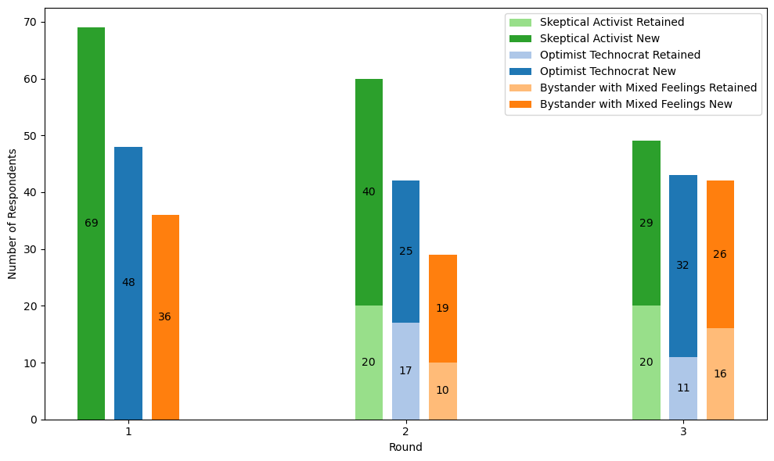Figure. Distribution of retained and new respondents per persona across rounds
Tables. Retained respondents’ movements between personas
Retained respondents R1-R2 |  |  |  | Retained respondents R2-R3
Skeptical Activist (SA) | Remained SA | 14 |  | Skeptical Activist (SA) | Remained SA | 14
Skeptical Activist (SA) | Changed to OT | 2 |  | Skeptical Activist (SA) | Changed to OT | 2
Skeptical Activist (SA) | Changed to BMF | 4 |  | Skeptical Activist (SA) | Changed to BMF | 4
Optimist Technocrat (OT) | Remained OT | 8 |  | Optimist Technocrat (OT) | Remained OT | 3
Optimist Technocrat (OT) | Changed to SA | 4 |  | Optimist Technocrat (OT) | Changed to SA | 2
Optimist Technocrat (OT) | Changed to BMF | 5 |  | Optimist Technocrat (OT) | Changed to BMF | 12
Bystander with Mixed Feelings (BMF) | Remained BMF | 1 |  | Bystander with Mixed Feelings (BMF) | Remained BMF | 0
Bystander with Mixed Feelings (BMF) | Changed to SA | 2 |  | Bystander with Mixed Feelings (BMF) | Changed to SA | 4
Bystander with Mixed Feelings (BMF) | Changed to OT | 7 |  | Bystander with Mixed Feelings (BMF) | Changed to OT | 6

Retained respondents R1-R3
Remained Skeptical Activist | 10
Remained Optimist Technocrat | 2
Remained Bystander with Mixed Feelings | 0

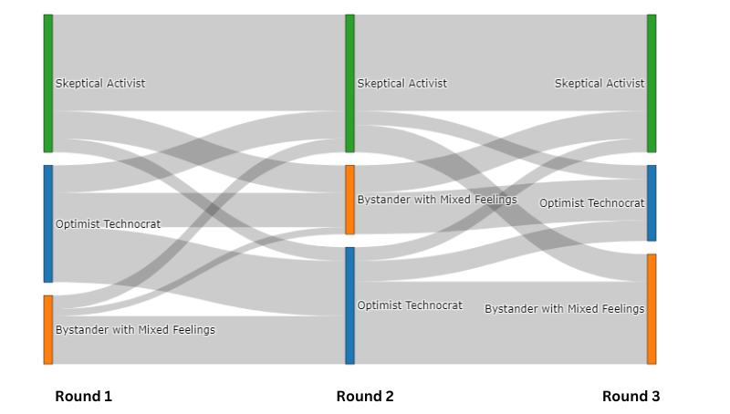
Figure. Sankey plot illustrating the flow of retained respondents’ movements between personas

Tarka, P. (2018). An overview of structural equation modeling: Its beginnings, historical development, usefulness and controversies in the social sciences. Quality & Quantity, 52(1), 313–354. https://doi.org/10.1007/s11135-017-0469-8; Holgado–Tello, F. P., Chacón–Moscoso, S., Barbero–García, I., & Vila–Abad, E. (2010). Polychoric versus Pearson correlations in exploratory and confirmatory factor analysis of ordinal variables. Quality & Quantity, 44(1), 153–166. https://doi.org/10.1007/s11135-008-9190-y

