Supplementary Material

Materials and Methods section
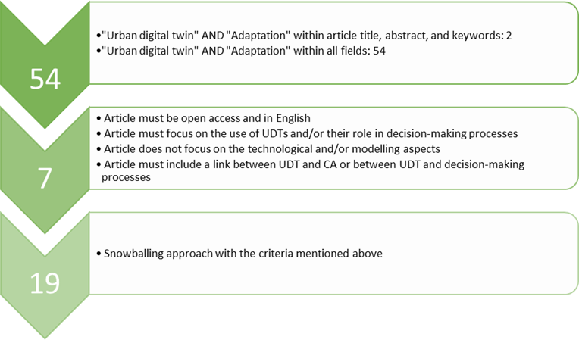
Figure A1: Selection process articles literature review
Table A1: European cities with an urban digital twin mentioned in the reviewed literature
Cities with UDT | In #articles | Reviewed Articles
Zurich | 6 | Ye et al. (2023), Ricciardi and Callegari (2023), Riaz et al. (2023), Pultrone (2023), Therias and Rafiee (2023), Caprari et al. (2022)
Helsinki | 5 | Ye et al. (2023), Ricciardi and Callegari (2023), Riaz et al. (2023), Therias and Rafiee (2023), Caprari et al. (2022)
Munich | 2 | Ricciardi and Callegari (2023), Caprari et al. (2022)
Rotterdam | 2 | Ricciardi and Callegari (2023), Caprari et al. (2022)
Lisbon | 2 | Riaz et al. (2023), Pultrone (2023)
Herrenberg | 3 | Ye et al. (2023), Therias and Rafiee (2023), Caprari et al. (2022)
Bologna | 1 | Pultrone (2023)
Tallinn | 1 | Therias and Rafiee (2023)
Dublin | 3 | Ye et al. (2023), Ricciardi and Callegari (2023), Caprari et al. (2022)
London | 1 | Caprari et al. (2022)
Gothenburg | 1 | Caprari et al. (2022)
Newcastle | 1 | Caprari et al. (2022)
Paris | 1 | Caprari et al. (2022)
Rennes | 1 | Caprari et al. (2022)
Cambridge | 1 | Caprari et al. (2022)

Table A2: General information about the interviews
Respondent | City | Date interview
Respondent 1 | Rotterdam | 11.03.2024
Respondent 2 | Tallinn | 12.03.2024
Respondent 3 | Bologna | 20.03.2024
Respondent 4 | Bologna | 20.03.2024
Respondent 5 | Rotterdam | 26.03.2024
Respondent 6 | Rennes | 27.03.2024
Respondent 7 | Stockholm | 22.04.2024
Respondent 8 | Munich | 08.05.2024

Summary of the interview guide
The various aspects that were raised during the interview are listed below.
- Background of your UDT, which includes professional background and your link with the urban digital twin (UDT) of your city, as well as some general questions about the history of your UDT and the current state of development and use of UDT.
- With relation to climate, biodiversity, and nature-based solutions, I would like to ask about the use of your UDT related to climate change, climate adaptation, biodiversity, and nature-based solutions will be asked (planning, monitoring, simulation, decision-making, and implementation), as well as what types of data that are included in your UDT. Also, I would like to ask about the (future) use of your UDT for planning, implementing, and evaluating climate adaptation measures (such as nature-based solutions), and the challenges and added values of this.
- Accessibility of the UDT (who, how, why).
- Users of the UDT, how they use it, and what the purpose is of their use.
- Specific examples of how the UDT has been used for climate related topics. I will also ask to what extent different perspectives are addressed in your UDT, the impact of the use of your UDT, and lessons learned.
- Questions on the (envisioned) future use of your UDT.

Ethics and Personal Data Processing
To obtain informed consent from the interviewees (Brinkmann and Kvale, 2018), a consent form was sent to the interviewees and signed by them before the interview. The information given in the consent form was clarified at the beginning of the interview, and the interviewees had the option to ask questions about it. Confidentiality (Brinkmann and Kvale, 2018) was achieved by replacing their names from the documentation with ‘Respondent ...’. Since the interviews conducted for this research do not focus on personal topics, no ethical approval was needed, and participation in the interviews has a low chance of leading to negative consequences for the participants personally and causing harm to them.
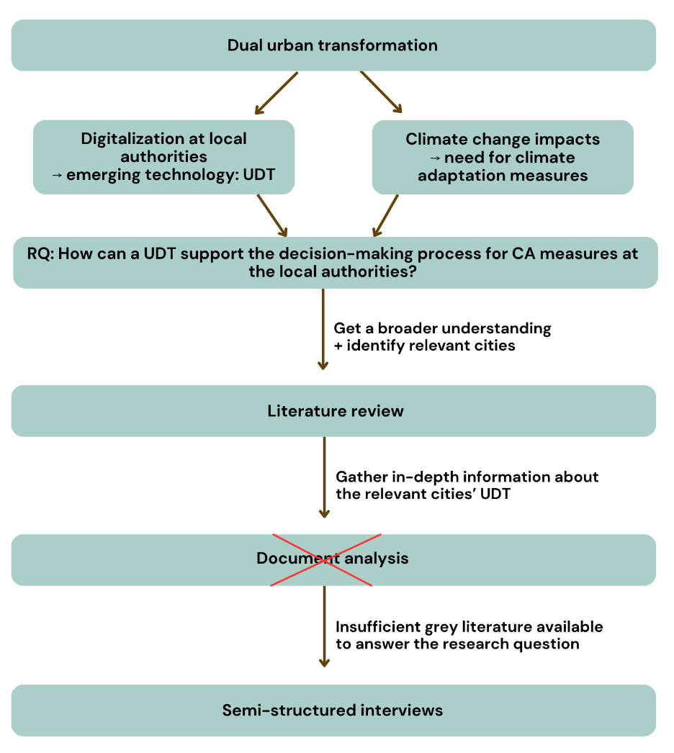
Figure A2: Graphic summary research design

Results section
Tabel A3: Descriptive information on the urban digital twins of the analysed cities
 | Main driver(s) | Focus areas
Rotterdam | Follow digital revolution | No specific focus
Tallinn | Mayor's interest in UDTs,  new added value | City assets management, energy efficiency, urban planning, urban greenery, traffic, underground infrastructure
Bologna | Political will, link various digital tools, support better decision-making | Energy, mobility, urban planning
Rennes | Strengthen cooperation with citizens for public policies | Solar panels, electromagnetic waves, future tram-bus-network
Stockholm | Connect information, more efficient way to update data | No specific focus
Munich | EU-funded project on smart city | No specific focus

