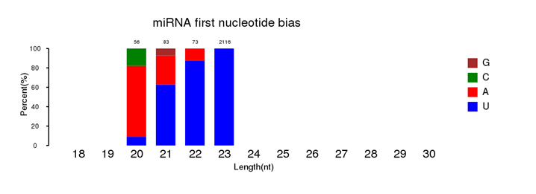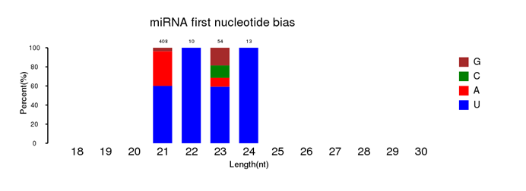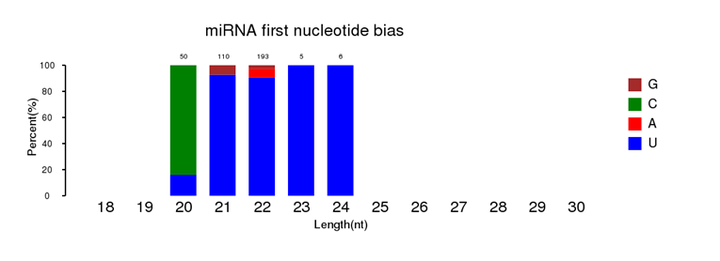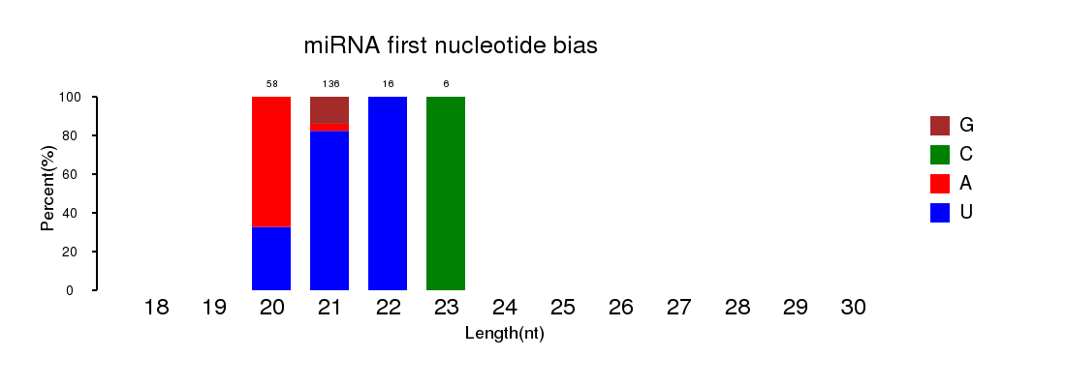Additional file 13: Figure S13 First nucleotide bias in novel Bd-milRNA candidates isolated from Botryosphaeria dothidea strains in (a) Mock, (b) LW-C, (c) LW-P and (d) LW-CP libraries.
a
b
d
c

