Additional file 14: Figure S14 Putative Bd-milRNAs (two novel and one known) detected by poly (A) RT-PCR.
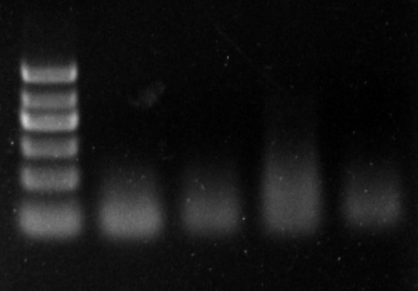
M Bd-milR6 Bd-milR12 Bd-milR1147.2 U6

