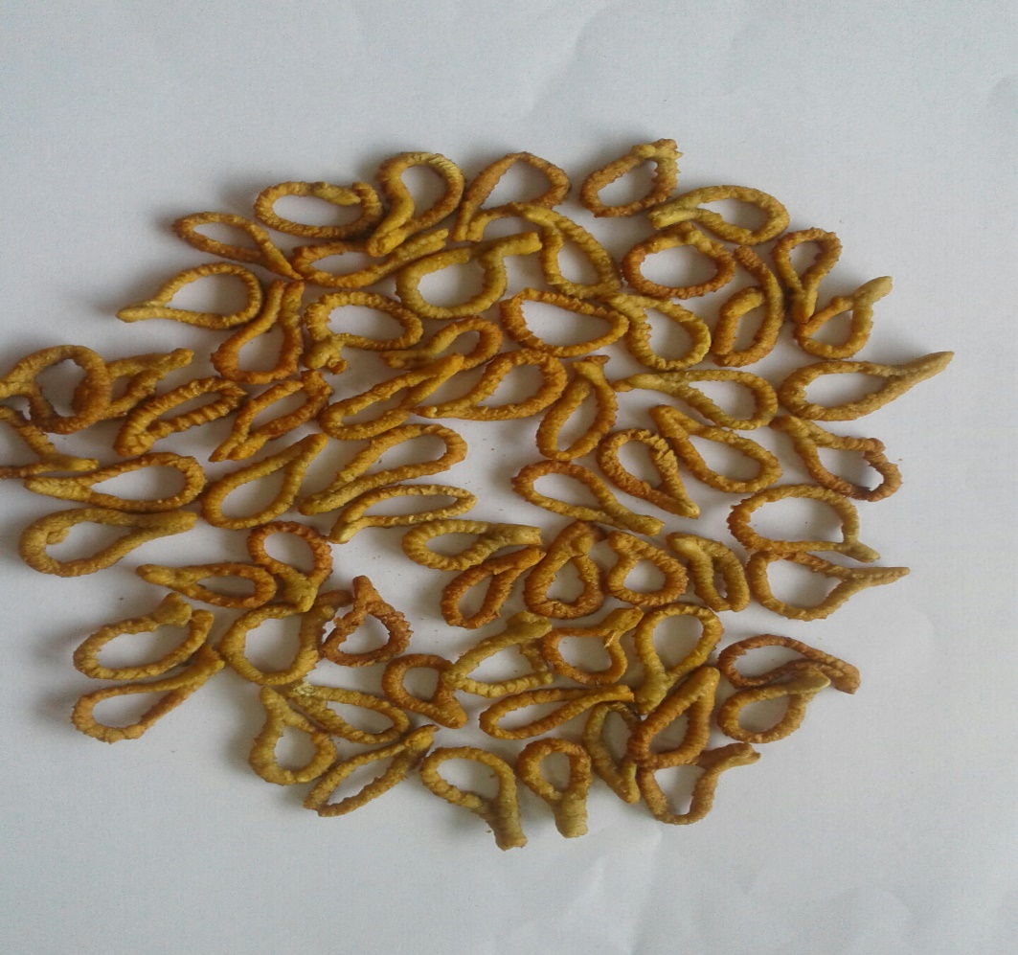

Plate S: Low-gluten pretzels from the blend of wheat flour (65%) and rice flour (35%)

