Table S1. Collected dairy-fermented food samples: size, source, pH range and appearance of colour
Size | Sample | Origin | pH range | Colour appearance
5 | Lassi | Cow (Bos taurus indicus) | 4.01-4.10 | White, slight creamy
5 | Dahi | Cow (Bos taurus indicus) | 3.98-4.49 | White, creamy
37 | Lassi | Buffalo (Bubalus bubalis) | 3.64-4.70 | White, slight creamy, Creamy, slight reddish,
17 | Dahi | Buffalo (Bubalus bubalis) | 3.67-4.48 | White, slight reddish, Slight cream
2 | Raabadi | Cow (Bos taurus indicus) | 4.22-4.39 | Dark cream
16 | Raabadi | Buffalo (Bubalus bubalis) | 3.89-4.91 | Dark cream

Table S2. Similarity index of identified lactobacilli with other lactobacilli strains available on NCBI database
Lactic isolates | Identified strains | NCBI strain | NCBI Accession Number | Similarity  (%)
MS001 | Limosilactobacillus fermentum | L. fermentum HBUAS70155 | OP000898 | 99.64
MS002 | Limosilactobacillus fermentum | L. fermentum HBUAS64073 | ON128686 | 100
MS003 | Limosilactobacillus fermentum | L. fermentum GK6-YC | ON999193 | 99.30
MS004 | Limosilactobacillus fermentum | L. fermentum GBJ | ON999190 | 100
MS005 | Limosilactobacillus fermentum | L. fermentum HBUAS53249 | MH392934 | 99.34
MS006 | Limosilactobacillus fermentum | L. fermentum FR-21 | ON681572 | 100
MS007 | Lactiplantibacillus plantarum | L. plantarum Sourdough_B14 | MG754576 | 99.13

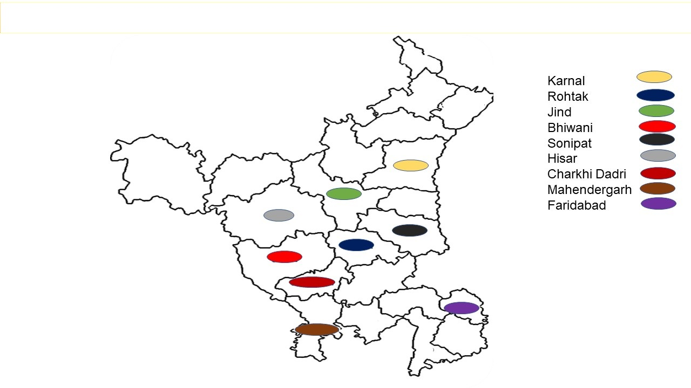
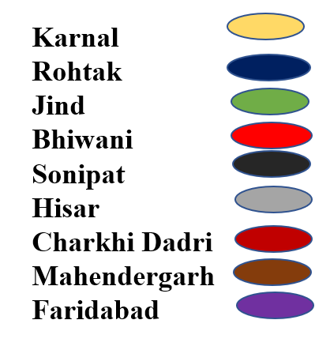

Fig S1. Districts of the Haryana covered to collect the fermented dairy food samples.

M 1 2 3 4 5 6 7
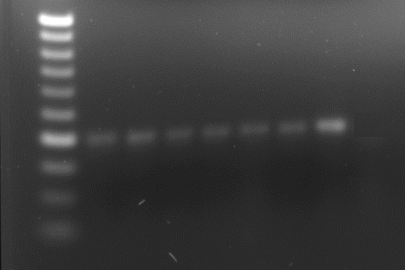
Fig S2. Gel electrophoresis of cultures genus (lactobacilli) confirmation:
Lane 1: MS001, 2: MS002, 3: MS003, 4: MS004, 5: MS005, 6: MS006, 7: MS007
Marker M: 50 bp

1 2 3 4 5 6 7 M
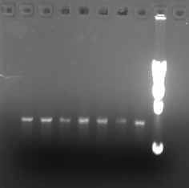

Fig S3. Gel electrophoresis of lactobacilli cultures using 16S rRNA primer:
Lane 1: MS001, 2: MS002, 3: MS003, 4: MS004, 5: MS005, 6: MS006, 7: MS007
Marker M: 1000 bp

