Title: L-Asparagine is the essential factor for the susceptibility of local pigs to Mycoplasma hyopneumoniae
Authors: Long Zhao^{1,2} , Fei Hao^{2,3,4} , Lulu Xu^{1,2}, Qiyan Xiong^{1,2,4}, Yanna Wei ^{2,4}, Lei Zhang^{2,4}, Rong Chen^{2,4}, Yanfei Yu^{2,4}, Yun Bai^{2,4}, Yuan Gan^{2,4}, Yongjie Liu¹，Guoqing Shao^{2,4}, Zhixin Feng^{1,2,4*}, Xing Xie^{1,2,3,4*}
Author affiliations:
¹ Joint International Research Laboratory of Animal Health and Food Safety, College of Veterinary Medicine, Nanjing Agricultural University, Nanjing 210095, China
² Key Laboratory for Veterinary Bio-Product Engineering, Ministry of Agriculture and Rural Affairs, Institute of Veterinary Medicine, Jiangsu Academy of Agricultural Sciences, Nanjing 210014, P.R. China
³ Key Laboratory of Control Technology and Standard for Agro-product Safety and Quality, Key Laboratory of Food Quality and Safety of Jiangsu Province-State Key Laboratory Breeding Base, Institute of Food Safety and Nutrition, Jiangsu Academy of Agricultural Sciences, Nanjing, China
⁴ GuoTai (Taizhou) Center of Technology Innovation for Veterinary Biologicals, Taizhou, 225300
*Corresponding authors: Dr. Zhixin Feng (fzxjaas@163.com)
&Dr. Xing Xie (xiexing@jaas.ac.cn)
Key Laboratory of Veterinary Biological Engineering and Technology, Ministry of Agriculture, Institute of Veterinary Medicine, Jiangsu Academy of Agricultural Sciences, Nanjing, China
Email: fzxjaas@163.com & xiexing@jaas.ac.cn
Telephone: +86-025-84391320
Fax: +86-025-84390330

Figure S1
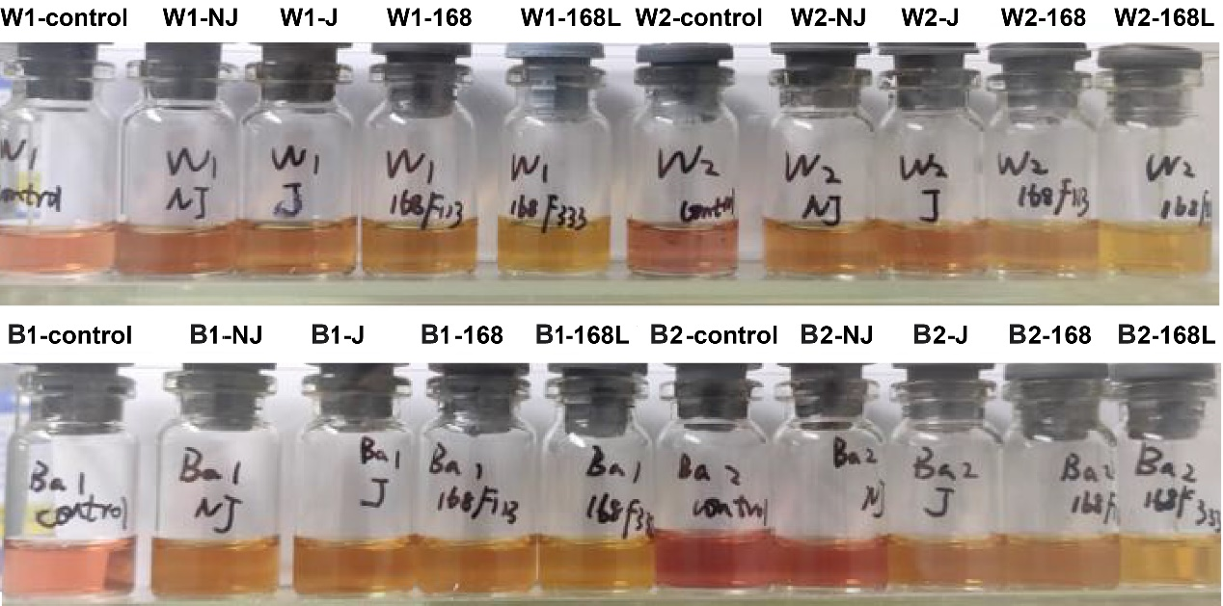
Fig. S1 Comparison of discoloring of different M. hyopneumoniae strains cultured in serum medium of representative introduced and local pig breeds Large white pigs, and Bama miniature pigs under in vitro conditions. The figure shows the color changes of different M. hyopneumoniae strains during 36-48 h of cultivation in a humidified incubator at 37°C. Control refers to the experimental control without the addition of M. hyopneumoniae.

Figure S2
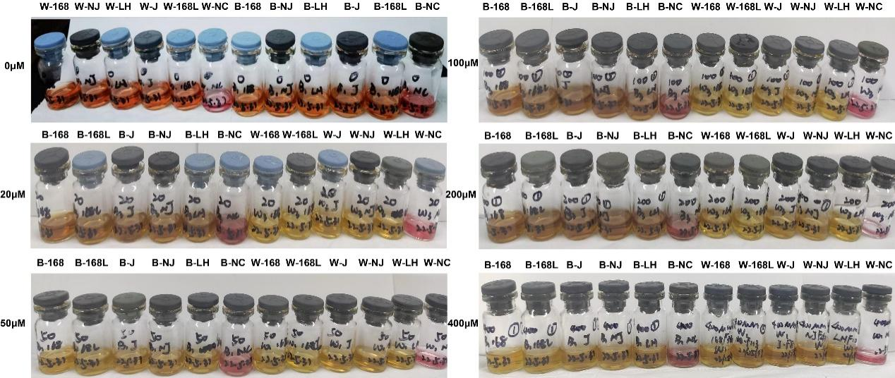
Fig. S2 Effects of different concentrations of L-Asn on the growth speed and discoloring of different M. hyopneumoniae strains (LH, NJ,168, J, 168L) in vitro cultured in serum medium of Large white pigs and Bama miniature pigs. The figure shows discoloring of different M. hyopneumoniae strains during 36-48 h of cultivation in a humidified incubator at 37°C. NC refers to the experimental medium control without the addition of M. hyopneumoniae.

