Supporting Information
Development of bilayer film of Persian acorn starch and zein nanofiber loaded with cinnamon essential oil for shelf-life extension of rainbow trout fillet
Mohieddin Kazemi ª, Javad Aliakbarlu ^{a,*}, Lin Lin ^{b}
ª Department of Food Hygiene and Quality Control, Faculty of Veterinary Medicine, Urmia University, Urmia, Iran
^{b} School of Food and Biological Engineering, Jiangsu University, Zhenjiang, China
* Corresponding author: Javad Aliakbarlu
E-mail: j.aliakbarlu@urmia.ac.ir
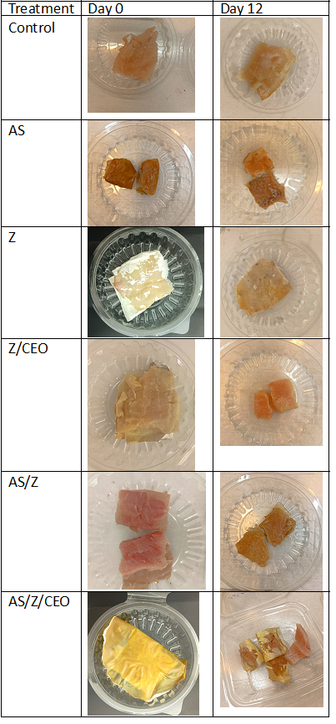
Figure 1S. The appearance of packaged fish samples on days 0 and 12 of refrigerated storage. AS: acorn starch film; Z: zein electrospun film; Z/CEO: zein electrospun film incorporated with 10 % CEO (v/v); AS/Z: bilayer acorn starch and zein film; and AS/Z/CEO: bilayer acorn starch and zein film incorporated with 10 % CEO (v/v).

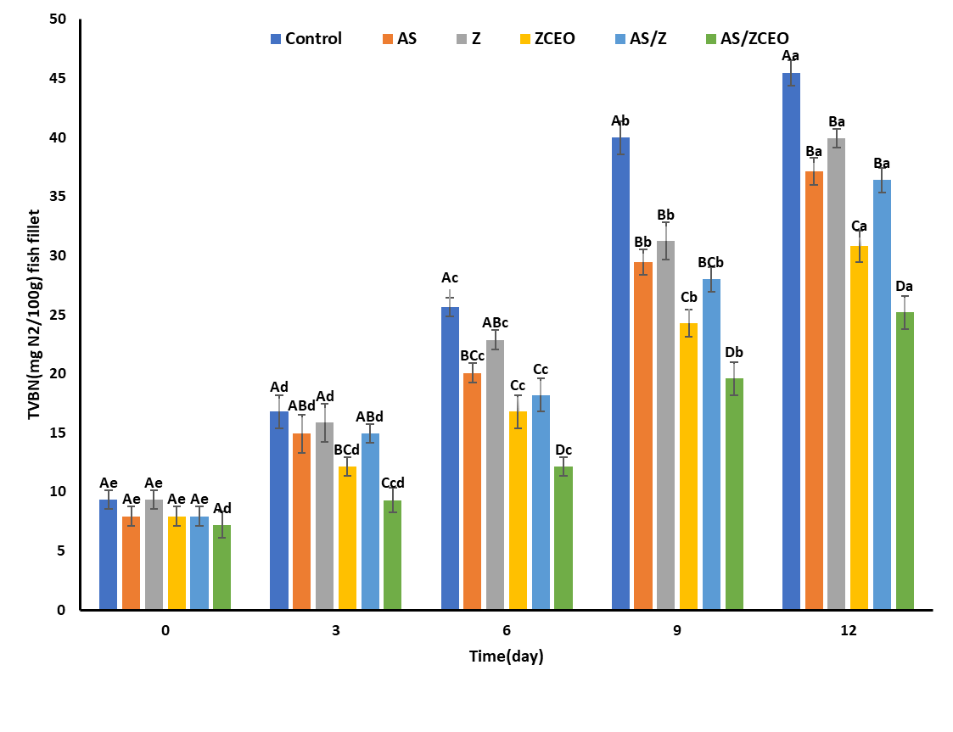
Figure 2S. TVB-N value of different treatments of fish fillets during storage at 4°C for 12 days. Control: non-coated samples; AS: samples coated with acorn starch film; Z: samples coated with zein electrospun film; ZCEO: samples coated with zein electrospun film incorporated with cinnamon essential oil (CEO); AS/Z: samples coated with bilayer acorn starch and zein film, and AS/ZCEO: sample coated with bilayer acorn starch and zain film incorporated with CEO 10%(v/v). A-D: different uppercase letters show differences between treatments for same storage times (p < 0.05). a-e: different lowercase letters show differences between the storage times within same analysis group (p < 0.05).

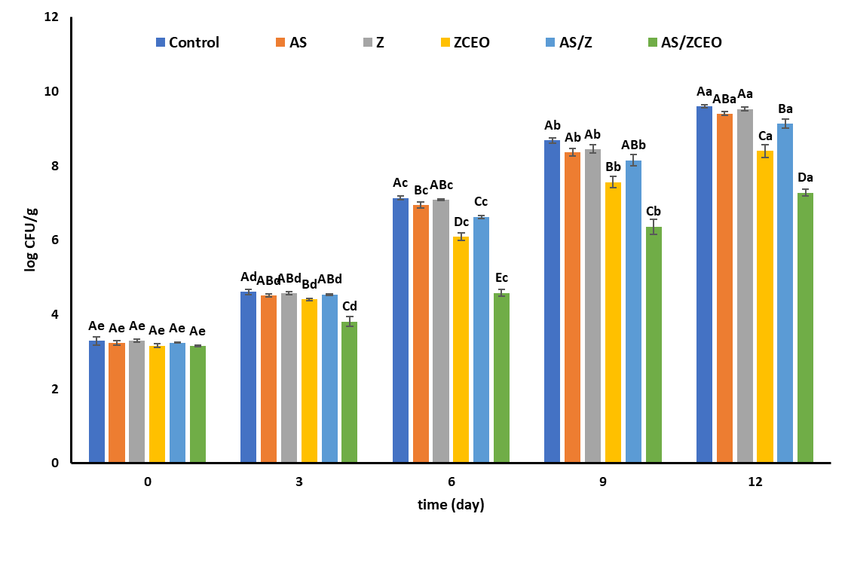
Figure 3S. Psychrophilic bacteria count in different treatments of fish fillets during storage at 4°C for 12 days. Control: non-coated samples; AS: samples coated with acorn starch film; Z: samples coated with zein electrospun film; ZCEO: samples coated with zein electrospun film film incorporated with cinnamon essential oil (CEO); AS/Z: samples coated with bilayer acorn starch and zein film, and AS/ZCEO: sample coated with bilayer acorn starch and zain film incorporated with CEO 10%(v/v). A-D: different uppercase letters show differences between treatments for same storage times (p < 0.05). a-e: different lowercase letters show differences between the storage times within same analysis group (p < 0.05).

