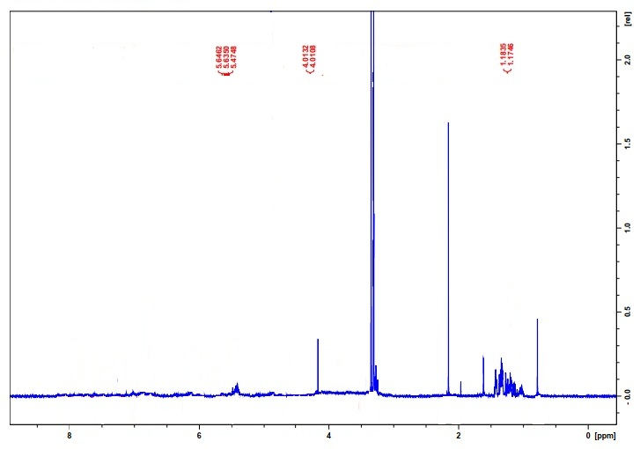
¹HNMR of Phytol compound (C 1)

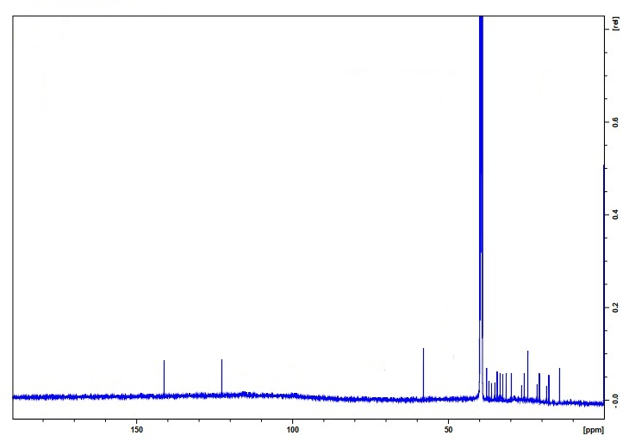
¹³CNMR of Phytol compound (C 1)

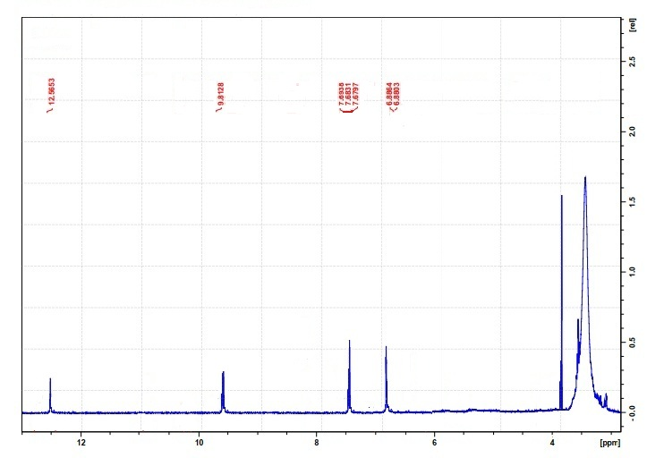
¹HNMR of Protocatechuic acid compound (C2)

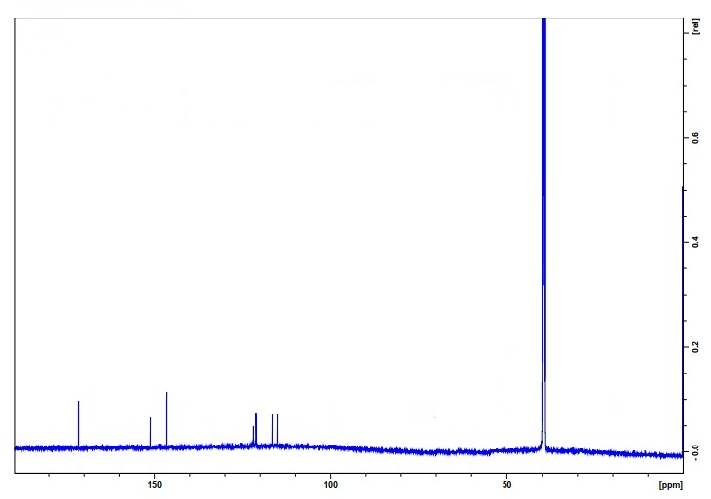
¹³CNMR of Protocatechuic acid compound (C2)

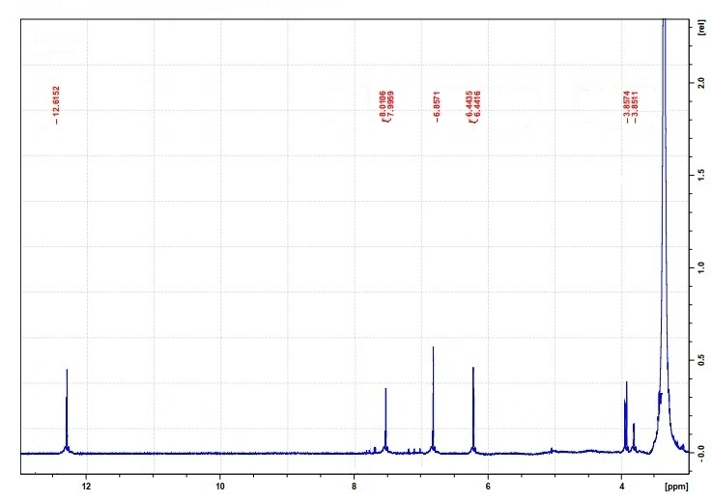
¹HNMR of 3,4,5- trimethoxycinnamic acid compound (C3)
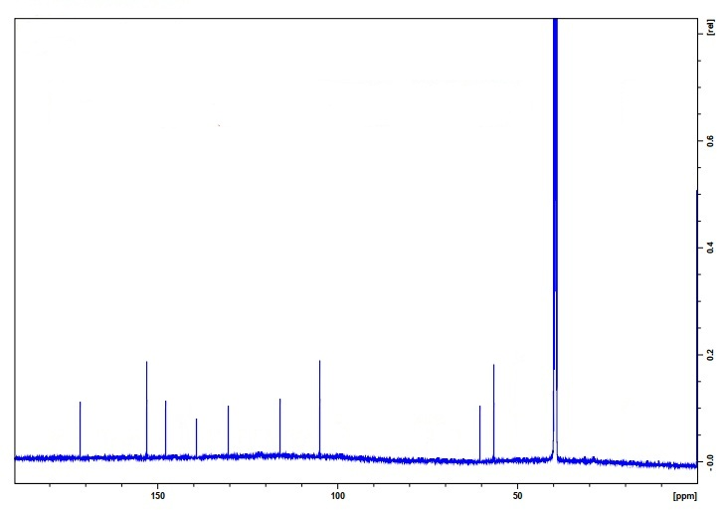
¹³CNMR of 3,4,5- trimethoxycinnamic acid compound (C3)

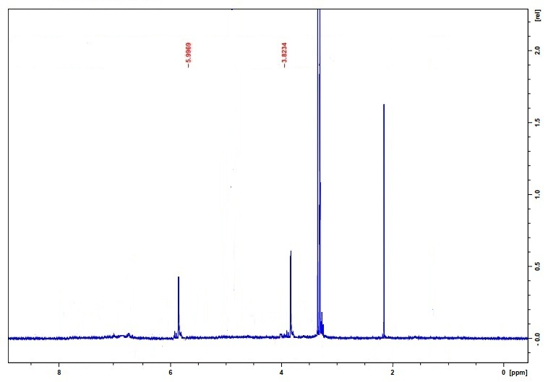
¹HNMR of 2,6-dimethoxybenzoquinone compound (C4)
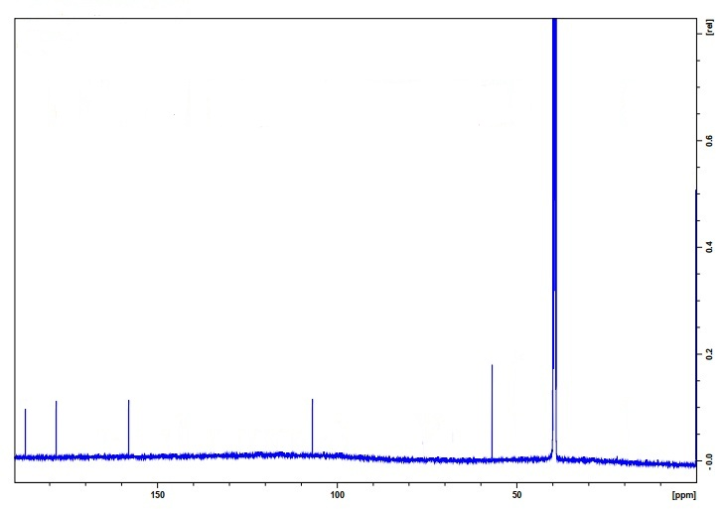
¹³CNMR of 2,6-dimethoxybenzoquinone compound (C4)
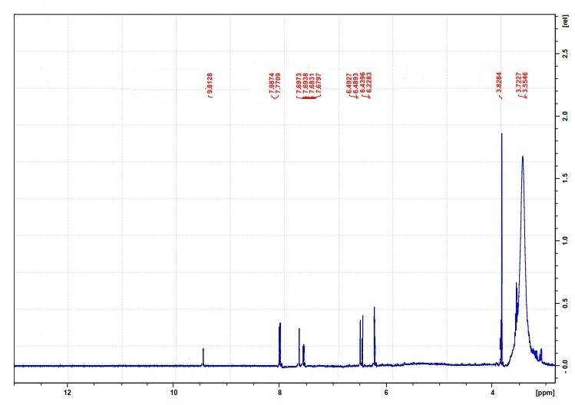
¹HNMR of 3′,4′,5,7-Tetra-O-methylquercetin compound (C5)

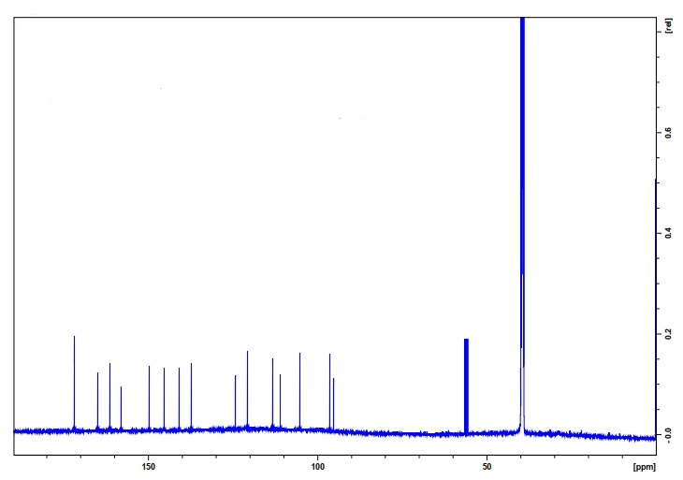
¹³CNMR of 3′,4′,5,7-Tetra-O-methylquercetin compound (C5)

