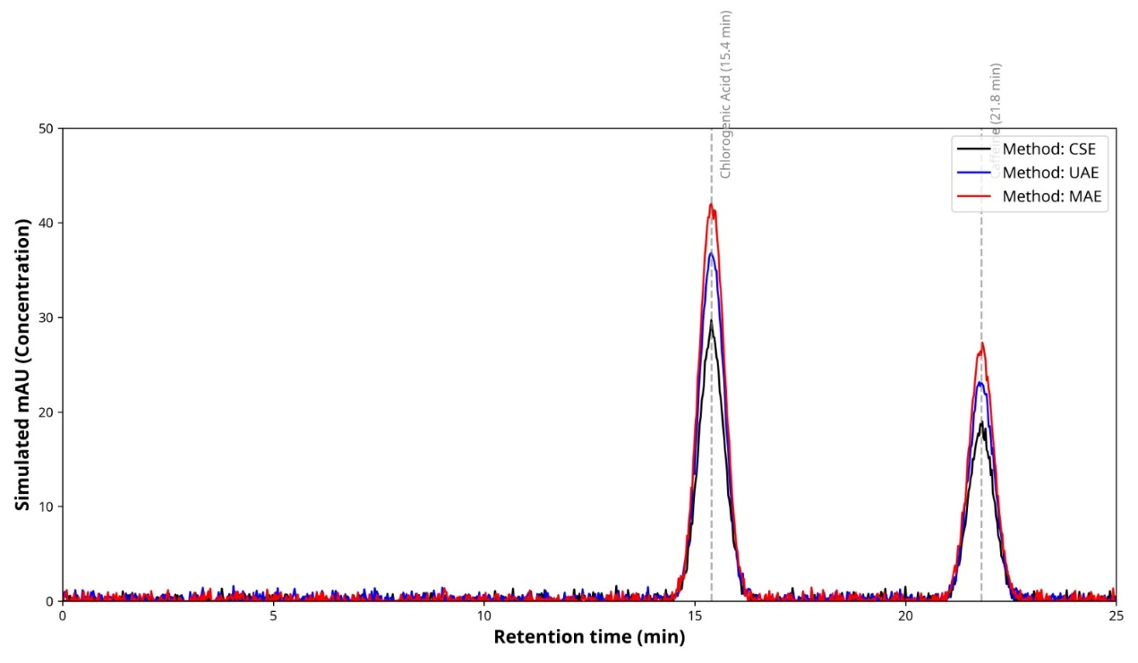

Figure S1. Raw HPLC chromatograms of chlorogenic acid and caffeine in espresso coffee ground extracts obtained using conventional solvent extraction (CSE), ultrasound-assisted extraction (UAE), and microwave-assisted extraction (MAE). Chromatograms represent experimentally measured data from direct injections under identical chromatographic conditions, showing consistent retention times without baseline extrapolation.

