Supplementary Figures
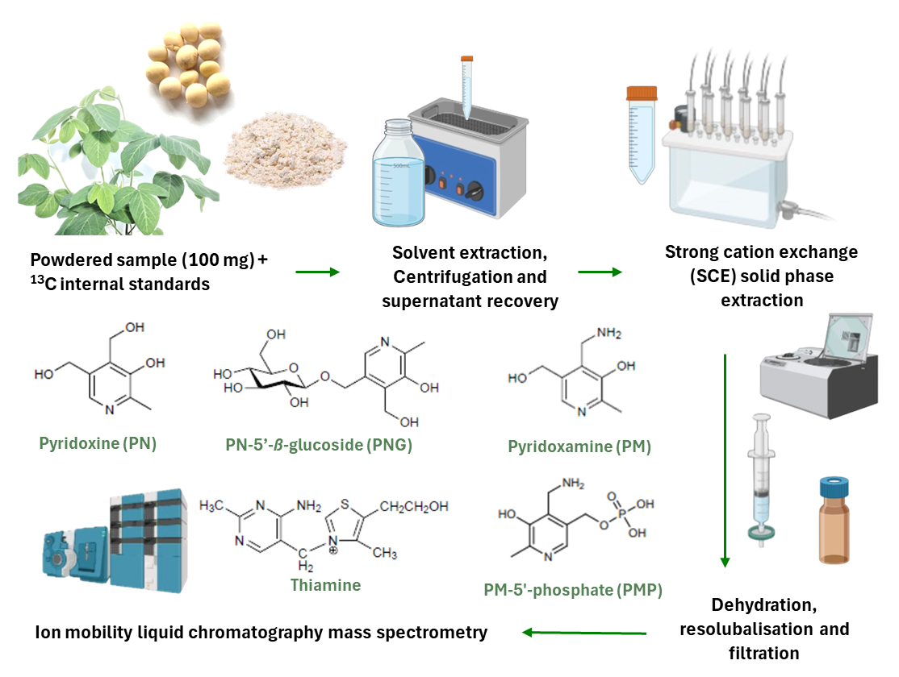

Additional file 1. Vitamin B₁ and B₆ quantification methodology

